Quick Reference Guide for Appendix 2 HSC monitoring confirmation in SPaRO

All | In SPaRO select the Curriculum tab
All | Select HSC on the left-hand menu and then HSC Appendix 2  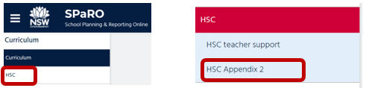
A reproduction of Appendix 2 HSC monitoring confirmation will appear.
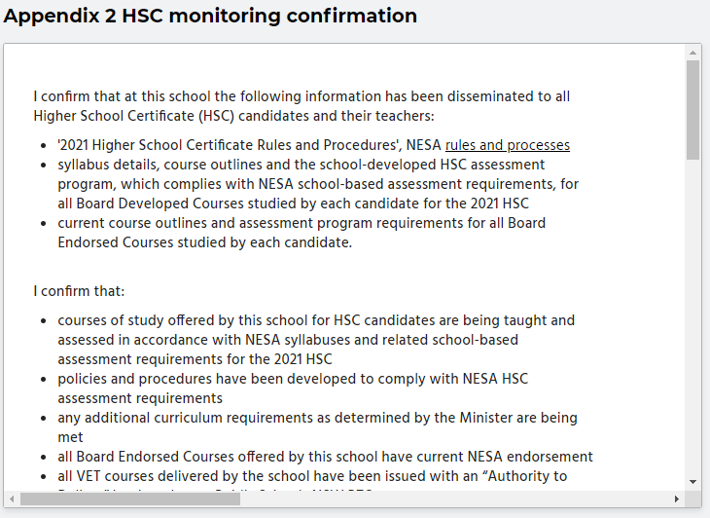
Scroll down to view the HSC monitoring declaration
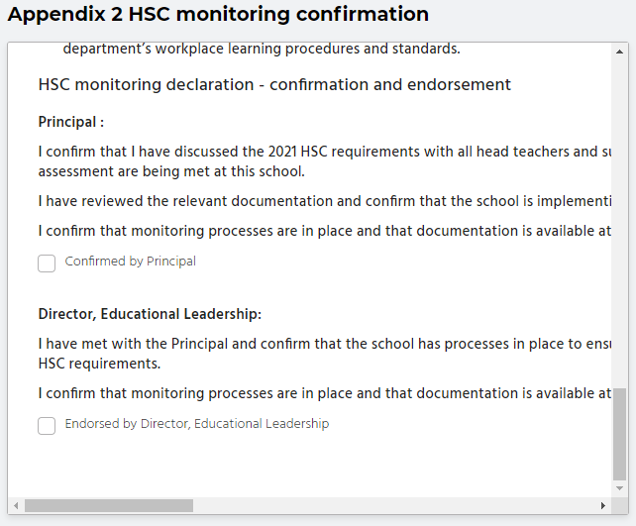
Principal | When you are satisfied that you have met the requirements of the declaration, use your mouse to check the box for Confirmed by Principal.
DEL | When you are satisfied that you have met the requirements of the declaration, use your mouse to check the box for Endorsed by Director, Educational Leadership.
 | Further information and contacts for advice are available on page 2.
You can view Appendix 2 in context in the 2021 HSC monitoring advice document.
This was emailed to schools by the deputy secretaries before publication in SchoolBiz on 13 November 2020.
A copy of the advice document is available on the Stage 6 web page: https://education.nsw.gov.au/teaching-and-learning/student-assessment/stage6
For advice and support in monitoring HSC requirements, principals can contact:
- their Director, Educational Leadership
- NESA Liaison Officer
- Director, Curriculum Secondary Learners
- Director, Inclusive Education.
Support may also be accessed from Curriculum Advisors located in Strategic Delivery teams.
The contact details for the Curriculum Secondary Learners, Stage 6 Advisor are available on the Stage 6 web page: https://education.nsw.gov.au/teaching-and-learning/student-assessment/stage6

