# MathXplosion – Pick A Block Of Dates, Any Block

**ABC ME screening details: Wednesday** 27 May 2020 at 11:45am

This episode can also be viewed on [ABC iView](https://iview.abc.net.au/show/mathxplosion).

**Key learning areas:** mathematics

**Level:** upper primary

**About:** A trick you can do by calculating the sum of a 3 by 3 block of dates on a calendar without using a calculator.

## Before the episode

1. What are some different ways you could complete this pattern?

| ___ | 5 | ___ | ___ | 20 | ___ |  |  |
| --- | --- | --- | --- | --- | --- | --- | --- |



1. Have a look at these growing and shrinking patterns. Can you work out what the pattern is?

| 3 | 6 | 9 | 12 | 15 | ___ | ___ | ___ |
| --- | --- | --- | --- | --- | --- | --- | --- |
| 2 | 4 | 8 | 16 | 32 | ___ | ___ | ___ |
| 1600 | 800 | 400 | 200 | 100 | ___ | ___ | ___ |

## After the episode

**Calendar Challenge**. Let’s explore ‘magical’ mathematical tricks you can do with a calendar.

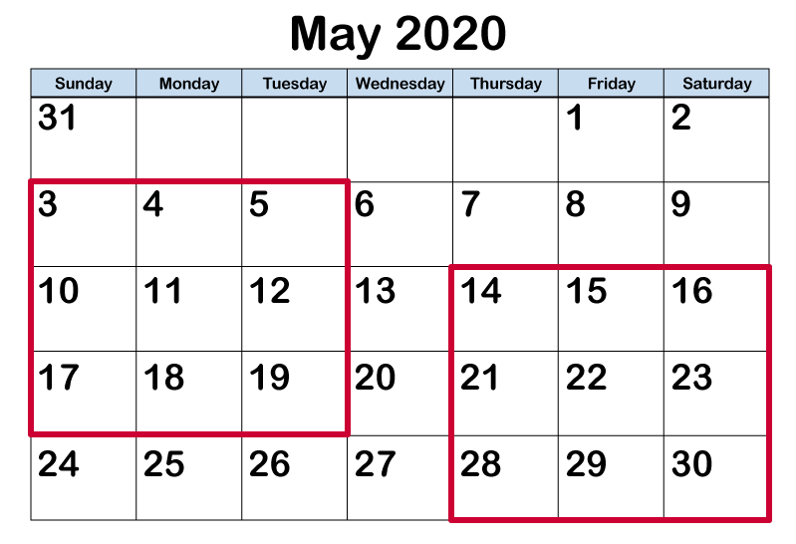

1. Choose a 3 by 3 square of dates from anywhere on the calendar.
2. Add the numbers in the four corners.
3. Try a few examples. What do you notice? Why do you think this happens?
4. Now try adding the numbers in each row, column and diagonal that passes through the centre number. What do you notice? Can you explain your results this time?

Adapted from <https://nrich.maths.org/>

**Follow-up activity:** How would your results change if you chose a 4 by 4 square? What other calendar patterns can you find?

# NSW Teacher notes

This is an optional standalone resource that could supplement student learning. The activities align with syllabus outcomes across stages and can be modified to meet the needs of your students. Students can complete the activities while learning at home and in the classroom. All activities can be completed without access to the internet or a device. Teachers could collect student work to offer feedback and as evidence of learning.

## Learning intentions

* To identify, continue and describe number patterns using a calendar

## NSW Mathematics K-10 Syllabus outcomes

|  |  |  |
| --- | --- | --- |
| Strands | Stage 2 | Stage 3 |
| Working mathematically | uses appropriate terminology to describe, and symbols to represent, mathematical ideas (MA2-1WM) | describes and represents mathematical situations in a variety of ways using mathematical terminology and some conventions (MA3-1WM) |
| Number and Algebra | generalises properties of odd and even numbers, generates number patterns, and completes simple number sentences by calculating missing values (MA2-8NA) | analyses and creates geometric and number patterns, constructs and completes number sentences, and locates points on the Cartesian plane (MA3-8NA) |

[NSW Mathematics K-10 Syllabus](https://educationstandards.nsw.edu.au/wps/portal/nesa/k-10/learning-areas/mathematics/mathematics-k-10) © 2012 NSW Education Standards Authority (NESA) for and on behalf of the Crown in right of the State of New South Wales. See the [NESA website](https://educationstandards.nsw.edu.au/wps/portal/nesa/mini-footer/copyright) for additional copyright information.