Look Kool – Measurement
ABC ME screening details: Monday 18 May 2020 at 11:20am
This episode can also be viewed on ABC iView after the scheduled screening time.
Key learning areas: mathematics
Level: upper primary
About: Hamza wants to measure everything about Koolkatt that has changed since he was a teeny-weeny little robot-kitten but how? Hamza finds out there are a lot of different ways to measure the world around us.

Before the episode
- What do you know about ‘measurement’? Draw, write or share your thinking.

After the episode
- In the Look Kool episode we learnt a lot about measurement. Time for you to be a mathematician!
Three cars are about to go on a journey. You will need to collect the following items to see where and how far they travel:
- 3 toy cars
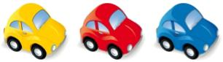
- a small ramp (what could you create a ramp out of?)
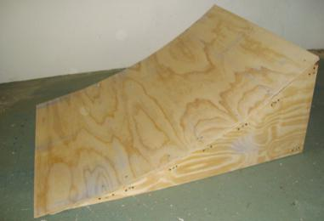
- If the ramp is wide enough, place all three cars at the top and LET GO! Or try one at a time. Which went the furthest? How do you know? How far did each one travel from the bottom of the slope?

- Try different ways of measuring how far the cars travelled. Record the ways that you used. Which way helped you measure accurately? How do you know?

- Here is part of a conversation between a group of children as they discuss a tall tree:
"I wonder how tall it is?" says Linus.
"I think we could find out" replies Raj.
"It could be difficult as it's very high." says Toby.
How do you think they each went about finding out the height of the tree?
Adapted from https://nrich.maths.org/

Follow-up activity: How would you find out how tall a large tree is?

NSW teacher notes
This is an optional standalone resource that could supplement student learning. The activities align with syllabus outcomes across stages and can be modified to meet the needs of your students. Students can complete the activities while learning at home and in the classroom. All activities can be completed without access to the internet or a device. Teachers could collect student work to offer feedback and as evidence of learning.

Learning intentions
- To compare different lengths and distances.
- To solve a problem involving measurement.

NSW Mathematics K-10 Syllabus outcomes
 | Stage 2 | Stage 3
Length | measures, records, compares and estimates lengths, distances and perimeters in metres, centimetres and millimetres, and measures, compares and records temperatures (MA2-9MG) | selects and uses the appropriate unit and device to measure lengths and distances, calculates perimeters, and converts between units of length (MA3-9MG)
Working mathematically | checks the accuracy of a statement and explains the reasoning used (MA2-3WM) | gives a valid reason for supporting one possible solution over another (MA3-3WM)
NSW K-10 Mathematics Syllabus © 2012 NSW Education Standards Authority (NESA) for and on behalf of the Crown in right of the State of New South Wales. See the NESA website for additional copyright information.

