Look Kool – Aerodynamics
ABC ME screening details: Wednesday 3 June 2020 at 11:20am
This episode can also be viewed on ABC iView.
Key learning areas: mathematics
Level: upper primary
About: To find out why some shapes go through air better than others, the gang is going to make a rocket with an astronaut, put bicycle "test pilots" to the test, and meet a rocket scientist who swims better than he walks.

Before the episode
- How do paper planes work? Write and draw to explain what helps them to fly.

After the episode
- Construct your own paper plane. You may want to these instructions for a basic dart or design your own. | 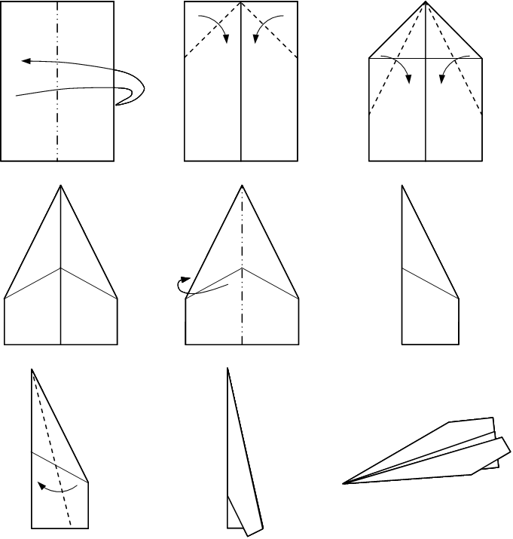
- How far can your plane fly? Use a tape measure to check.

After the episode
Hold your own paper plane flying competition! Which paper plane will fly the longest distance?
- Design and construct three different paper aeroplanes.
- Make a prediction. Which plane design do you think will fly the furthest and why? Draw and write to explain your reasoning.

- Test your planes. Measure and record the distances flown by each plane.
 | Test flight 1 | Test flight 2 | Test flight 3 | Total distance
Design 1
Design 2
Design 3
- Was your prediction correct?
Follow-up activity: What other paper plane variations can you create? What features are required for your plane to travel a long distance? Or do mid-air spin?

NSW Teacher notes
This is an optional standalone resource that could supplement student learning. The activities align with syllabus outcomes across stages and can be modified to meet the needs of your students. Students can complete the activities while learning at home and in the classroom. All activities can be completed without access to the internet or a device. Teachers could collect student work to offer feedback and as evidence of learning.

Learning intentions
- To measure and compare distances

NSW Mathematics K-10 Syllabus outcomes
Strands | Stage 2 | Stage 3
Working mathematically | uses appropriate terminology to describe, and symbols to represent, mathematical ideas (MA2-1WM) | describes and represents mathematical situations in a variety of ways using mathematical terminology and some conventions (MA3-1WM)
Measurement and geometry | measures, records, compares and estimates lengths, distances and perimeters in metres, centimetres and millimetres, and measures, compares and records temperatures (MA2-9MG) | selects and uses the appropriate unit and device to measure lengths and distances, calculates perimeters, and converts between units of length (MA3-9MG)
NSW Mathematics K-10 Syllabus © 2012 NSW Education Standards Authority (NESA) for and on behalf of the Crown in right of the State of New South Wales. See the NESA website for additional copyright information.

