Fierce Earth – World’s Driest Place
ABC ME screening details: Monday 1 June 2020 at 12:45pm
This episode can also be viewed on ABC iView.
Key learning areas: HSIE - geography
Level: upper primary
About: In this episode the team travel 6000 miles to the country of Chile and the Atacama Desert - officially the driest place in the world.

Before the episode
- Use the clues related to today’s episode to complete the crossword.
1 |  |  |  |  |  | 2
3 |  |  |  |  |  |  |  |  |  |  |  | 4
 |  |  |  |  |  | 5 |  |  | 6
 | 7
Clues
Across | Down
1 – The unit of measurement typically used to measure rainfall. | 1 – A drawing of a particular area. Can be used to find your way.
3 – Aloe vera is a type of _________ which can be used to treat injuries and sunburn. | 2 – An imaginary line drawn around the middle of the Earth.
5 – The ___________ Desert is known as the world’s driest place. | 4 – Essential for survival in extremely dry environments.
7 – A very dry biome. The Sahara, for example | 6 – A long, narrow country on South America’s western coast.

After the episode
- After watching the episode, complete any crossword clues that you couldn’t solve.
- This episode identifies three reasons why the Atacama Desert is the driest place on Earth. Use the images below to help identify these “rain blockers” and write a short summary of each.
Image | Summary
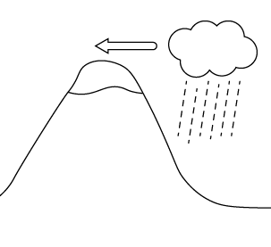
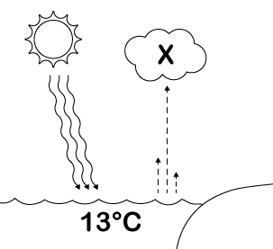
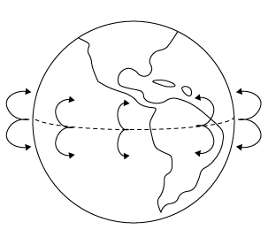
Follow-up activity: Find two plastic cups and half fill each with water. Use a pen to mark the water levels. Cover one cup with cling wrap but leave the other uncovered. Place both cups in a sunny place. What do you observe after a few hours? A few days? Explain to someone what you think is happening in this investigation.

NSW Teacher notes
This is an optional standalone resource that could supplement student learning. The activities align with syllabus outcomes across stages and can be modified to meet the needs of your students. Students can complete the activities while learning at home and in the classroom. All activities can be completed without access to the internet or a device. Teachers could collect student work to offer feedback and as evidence of learning.

Learning intentions
- To identify how dry places (such as deserts) are shaped by climate and natural characteristics

NSW Geography K-10 Syllabus outcomes
Stage 2 – The Earth’s Environment | Stage 3 – A Diverse and Connected World
examines features and characteristics of places and environments (GE2-1) | describes the diverse features and characteristics of places and environments (GE3-1)
describes the ways people, places and environments interact (GE2-2) | explains interactions and connections between people, places and environments (GE3-2)
examines differing perceptions about the management of places and environments (GE2-3)
NSW Geography K-10 Syllabus © 2015 NSW Education Standards Authority (NESA) for and on behalf of the Crown in right of the State of New South Wales. See the NESA website for additional copyright information.

