Fierce Earth – World's Coldest Places
ABC ME screening details: Tuesday 12 May 2020 at 12:45pm
This episode can also be viewed on ABC iView after the scheduled screening time.
Key learning areas: science and technology, geography
Level: upper primary
About: This Fierce Earth special takes viewers on a journey to one of the world's coldest and most hostile places on the planet - the Yukon Territory in Canada.

Before the episode
- Draw lines or colour to match the descriptions to the temperatures next to the thermometer.

Descriptions
The temperature inside your freezer.
A very cold day in Yukon, Canada.
The temperature at which water boils. Often called its “boiling point”.
The hottest temperature on Earth was recorded in El Azizia, Libya in 1922.
The temperature at which water freezes. Often called its “freezing point”.
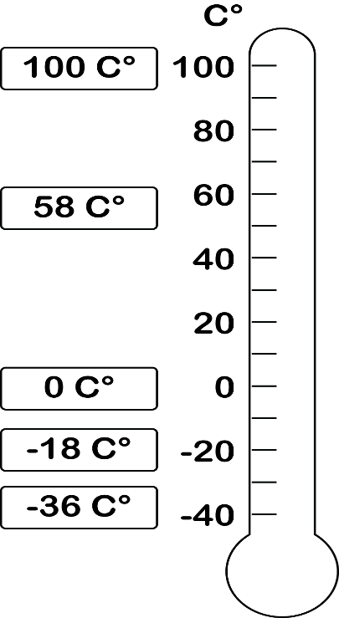

After the episode
- Sketch and label a drawing of the landscapes of Yukon, Canada from this episode. What were some of the natural and human features you observed?

- How important are animals for surviving in a place like Yukon, Canada? Write or draw some examples of how animals were used by humans to survive in this episode.

Follow-up activity: Write a short story or create a comic about a character who is forced to survive in the wilderness of Yukon, Canada. How does this character become stranded? What dangers do they face in the wild? What techniques will they use to survive?

NSW teacher notes
This is an optional standalone resource that could supplement student learning. The activities align with syllabus outcomes across stages and can be modified to meet the needs of your students. Students can complete the activities while learning at home and in the classroom. All activities can be completed without access to the internet or a device. Teachers could collect student work to offer feedback and as evidence of learning.

Learning intentions
- To identify temperature as a measure of how hot or cold something is.
- To identify the natural and human features of a cold environment.
- To consider how animals are used by humans to survive in extreme environments.

NSW Mathematics K-10 Syllabus outcomes
 | Stage 2 | Stage 3
Length | measures, records, compares and estimates lengths, distances and perimeters in metres, centimetres and millimetres, and measures, compares and records temperatures (MA2-9MG) | N/A

NSW Geography K-10 Syllabus outcomes
Stage 2 – places are similar and different | Stage 3 – factors that shape places
examines features and characteristics of places and environments (GE2-1) | describes the diverse features and characteristics of places and environments (GE3-1)
describes the ways people, places and environments interact (GE2-2) | explains interactions and connections between people, places and environments (GE3-2)
examines differing perceptions about the management of places and environments (GE2-3) | compares and contrasts influences on the management of places and environments (GE3-3)
NSW Mathematics K-10 Syllabus and NSW History K-10 Syllabus © 2012 NSW Education Standards Authority (NESA) for and on behalf of the Crown in right of the State of New South Wales. See the NESA website for additional copyright information.

