Fierce Earth – World's Coldest Places
ABC ME screening details: Tuesday 12 May, 2020 at 12:45pm
This episode can also be viewed on ABC iView after the scheduled screening time.
Key learning areas: HSIE, science
Level: secondary
About: This Fierce Earth special takes viewers on a journey to one of the world's coldest and most hostile places on the planet - the Yukon Territory in Canada.

Before the episode
- Where do we find the coldest places on earth? Locate them on the map below.
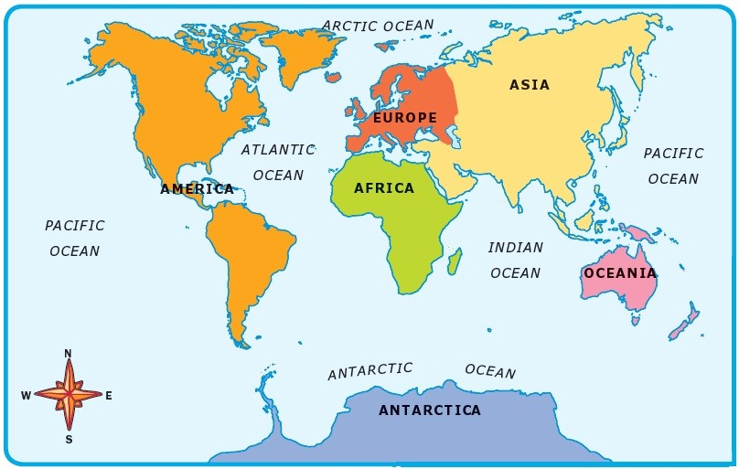
Source: World Map Europe Continent Drawing free image@
- Imagine living in one of these places, what are the essential items for survival?

During the episode
- Record key facts under each of the headings in the table below.
The Yukon | Huskies | Quinzhee | Food and clothing

After the episode
- Identify the three factors which make temperatures in The Yukon, Canada some of the coldest in the world

- What were the three things identified as essential in the ‘survival guide’ at the end of the program?

- Draw and annotate a diagram of a Quinzhee (snow shelter). How well does a Quinzhee meet the three requirements for survival in cold environments?

Follow-up activity: Create a survival guide for cold places. Use images as well as descriptions so that the guide is able to be followed by everyone.

NSW teacher notes
This is an optional standalone resource that could supplement student learning. The activities align with syllabus outcomes across stages and can be modified to meet the needs of your students. Students can complete the activities while learning at home and in the classroom. All activities can be completed without access to the internet or a device. Teachers could collect student work to offer feedback and as evidence of learning.

Learning intentions
- Identification of the key features and characteristics of cold places.
- To examine the changing interactions between people and the environments and how this impacts on peoples use of resources.

NSW Geography K-10 Syllabus outcomes
Stage 4 | Stage 5
locates and describes the diverse features and characteristics of a range of places and environments (GE4-1) | explains the diverse features and characteristics of a range of places and environments (GE5-1)
explains how interactions and connections between people, places and environments result in change (GE4-3) | analyses the effect of interactions and connections between people, places and environments (GE5-3)

NSW Science Years 7–10 Syllabus outcomes
Stage 4 | Stage 5
appreciates the importance of science in their lives and the role of scientific inquiry in increasing understanding of the world around them (SC4-1VA) | appreciates the importance of science in their lives and the role of scientific inquiry in increasing understanding of the world around them (SC5-1VA)
presents science ideas, findings and information to a given audience using appropriate scientific language, text types and representations (SC4-9WS) | presents science ideas and evidence for a particular purpose and to a specific audience, using appropriate scientific language, conventions and representations (SC5-9WS)
explains how advances in scientific understanding of processes that occur within and on the Earth, influence the choices people make about resource use and management (SC4-13ES) | explains how scientific knowledge about global patterns of geological activity and interactions involving global systems can be used to inform decisions related to contemporary issues (SC5-13ES)
NSW Geography K-10 Syllabus © 2015 and NSW Science 7-10 syllabus @2018 NSW Education Standards Authority (NESA) for and on behalf of the Crown in right of the State of New South Wales. See the NESA website for additional copyright information.

