Dates That Made History – 1347: The Black Death
ABC ME screening details: Wednesday 13 May, 2020 at 2:30pm
This episode can also be viewed on ABC iView
Key learning areas: HSIE, history
Level: secondary
About: Did the first outbreaks occur in China or in the Caspian Sea? Experts still argue. But how did the plague actually spread? After many controversies, it seems that the rat flea was the major carrier of this disease.

Before the episode
- Consider the title of this series, ‘dates that made history.’ Name one event that you think was important in history (it may be local, national or global) and explain why you think it is an important date.

During the episode
- As you watch this episode, mark the places on the map where the Black Death was found.
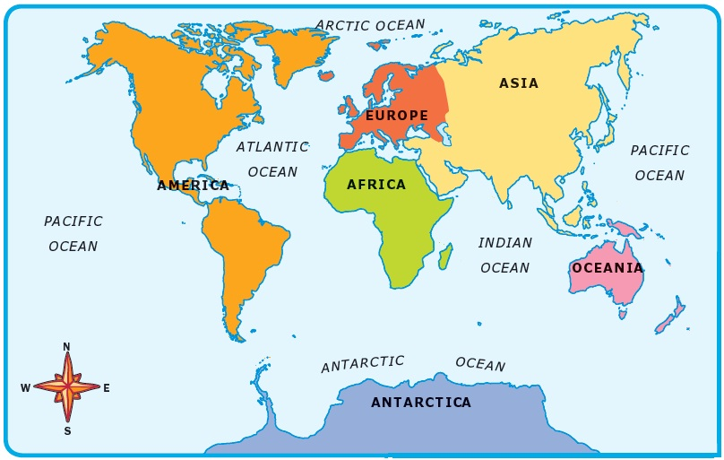
- What is meant by ‘the spaces in the archives’? Why are gaps in the historical records interesting for historians and what do they tell us about the Black Death?

- Explain why historians say that ‘the story of the spread of the plague is the story of commerce.’

- Why were some parts of Europe and the rest of the world unaffected by the Black Death?

After the episode
- According to the historian, why do we remember the date of the Black Death? What is interesting about the Black Death in relation to the impact it had on power and society in Medieval Europe?

Follow-up activity: This episode highlighted the development of the Black Death and European society’s approach to reducing the spread. Create a poster comparing the efforts made to reduce the Black Death to those currently being made to reduce the impact of Covid-19. Write a paragraph explaining what society learnt as a result of the Black Death that has helped with the current pandemic approach.

NSW teacher notes
This is an optional standalone resource that could supplement student learning. The activities align with syllabus outcomes in stage 4 mandatory history and stage 5 history elective and can be modified to meet the needs of your students. Students can complete the activities while learning at home and in the classroom. All activities can be completed without access to the internet or a device. Teachers could collect student work to offer feedback and as evidence of learning.

Learning intentions
- To understand and explain how trade and travel contributed to the spread of the Black Death
- To discuss the impacts of the Black Death throughout history

NSW History K-10 Syllabus outcomes
- describes and explains the causes and effects of events and developments of past societies over time (HT4-4)
- identifies and describes different contexts, perspectives and interpretations of the past (HT4-7)
NSW History K-12 Syllabus ©2012 NSW Education Standards Authority (NESA) for and on behalf of the Crown in right of the State of New South Wales. See the NESA website for additional copyright information.

