Learning from home: ABC TV Education resources

Secondary – week 3

11/05/2020 – 15/05/2020
Supplementary activities to support educational content broadcast on ABC ME during Term 2, 2020

About this resource
ABC Education, in collaboration with the NSW Department of Education, have planned a daily schedule of free to air educational programs supported by standalone resources that complement the ABC TV Education program airing during Term 2, 2020. All activities can be completed without access to the internet or a device and are suitable for lower primary, upper primary and secondary students.

Educational benefit
Student booklets include activities designed by curriculum experts to meet educational outcomes and are based on a selection of ABC programs that are of high educational value. Activities address topics from a range of subjects including: English; mathematics; science and technology; geography; history; PDHPE and creative arts.
These optional resources do not replace teaching and learning programs provided by schools but may be used by teachers and parents/carers to supplement student learning. Teachers may select activities relevant to their teaching and learning program and modify to meet student needs.

Recording student responses
Students complete activities before, during and after viewing selected daily episodes. Where appropriate, space is provided in each booklet for students to record their responses. Students may require additional writing paper or a separate workbook for some tasks. Completed student booklets may be collected by teachers and used as evidence of learning.

How to access ABC TV Education programs
The selected daily episodes can be viewed via the ABC TV Education broadcast on ABC ME (Channel 23) from 10am-3pm weekdays. Each day commences with programs suitable for lower primary students followed by upper primary and then secondary. Programs will also be available at abc.net.au/iview after the broadcast. A schedule of the selected episodes is included in each student booklet.

Episode schedule – week 3
The timetable below outlines the episode focus for each day. The full ABC TV Education program can be found at http://www.abc.net.au/tveducation/
 | Time | Program | Episode title | Key learning area | Pages
Monday  11/05/2020 | 11:45am | Ecomaths | Rainwater Harvesting | Mathematics, science | 4-5
Monday  11/05/2020 | 1:50pm | Get Into Textiles | ICT In Textiles: Design, Practice And Process | Technology mandatory, textiles technology, design and technology, textiles and design | 6-7
Tuesday  12/05/2020 | 12:45pm | Fierce Earth | World's Coldest Places | HSIE, science | 8-9
Wednesday  13/05/2020 | 2:10pm | The Russian Revolution |  | HSIE, Stages 5-6 history | 10-11
Wednesday  13/05/2020 | 2:30pm | Dates That Made History | 1347: The Black Death | HSIE, history | 12-13
Thursday  14/05/2020 | 2:20pm | BTN: Media Literacy | Media Ethics | English | 14-15
Friday  15/05/2020 | 1:30pm | Poetry Between The Lines | John Keats Bright Star | English | 16-17
Friday  15/05/2020 | 2:00pm | Your Paintings | Eileen Agar | Visual arts | 18-19
© State of New South Wales (Department of Education), 2020
The copyright material published in this document is subject to the Copyright Act 1968 (Cth), and is owned by the NSW Department of Education or, where indicated, by a party other than the NSW Department of Education.
Copyright material available in this document is licensed under a Creative Commons Attribution 4.0 International (CC BY 4.0) licence.
See http://education.nsw.gov.au/about-us/copyright for further details.

Ecomaths – Rainwater Harvesting
ABC ME screening details: Monday 11 May 2020 at 11:45am
This episode can also be viewed on ABC iView
Key learning areas: mathematics and science
Level: secondary
About: Stefan visits a huge hi-tech greenhouse to learn how much rain can be collected from a roof using ideas of conservation of volume and calculating area.

Before the episode
- Find 5 different shaped containers and, by estimating their capacity, arrange them from lowest to highest.
- By filling the containers with water, where possible, compare the capacities of the containers. Change the order of the containers where necessary.
- Consider the following statement, “taller containers always hold more volume”. Do you agree with this statement? Explain your reasoning.

During the episode
- Stefan shows three different containers with different measurements holding 1 litre of water. Make a list of these containers and their measurements, where possible.
- How much water does the greenhouse use in a year?

After the episode
- During the episode Stefan finds out that the rectangular roof is 61 000 m². What do you think the length and width of the roof might be? Explain your reasoning.
- Stefan explains that “for every millimetre of water that falls on a square metre of room, you get one litre of water”. In 2019, 1000 mm of rain fell in Kent, the location of the greenhouse. By calculating the volume of water in litres, determine whether this was enough water needed to run the greenhouse?
- Stefan shows 3 different container with a capacity of 1 litre. Two of the containers had square bases. Using the formula, $Volume = Area of base×Height$, show the square based containers hold the same volume.
- The third container was cylindrical. Estimate the radius of the circular base and the height of the container. Explain your thinking.
Follow-up activity: During the episode, Stefan attempted to estimate the length and width of the greenhouse by counting his steps. By first identifying your stride length, count your strides around a rectangular building or shed to determine its length and width.
Use this information to determine its area in square metres. If you could harvest the rainfall from this building, recommend the capacity of the rainwater tank needed?

Get Into Textiles – ICT In Textiles: Design, Practice And Process
ABC ME screening details: Monday 11 May, 2020 at 1:50pm
This episode can also be viewed on ABC iView
Key learning areas: technology mandatory, textiles technology, design and technology, textiles and design
Level: secondary
About: This resource looks at the impact of new technology on the global fashion and textile industry. A top fashion design house shows how ICT, CAD and CAM has revolutionised the way they communicate.

Before the episode
- List ways in which ICT could assist in the design and manufacture of textile items.

During the episode
- What is a mood board and how are they created? How are ICTs used in the development of the mood board?

- Outline three advantages of using specialist software to sketch textile items.

- How does ICT increase productivity and save time throughout the design and manufacturing process?

After the episode
- List a range of ICT technologies (scanners, for example) used in the design of textile items and outline how they speed up the design, manufacture, distribution and sale of textile items.

- The episode showed how data is more accessible and easier to analyse using ICTs. Outline how modern designers use data to improve designing, marketing and testing throughout the design process. How has the use of data in the textiles industry improved the experience for consumers?

Follow-up activity: Create your own mood board for re-styling your room. You can cut images out of magazines or newspapers.

Fierce Earth – World's Coldest Places
ABC ME screening details: Tuesday 12 May, 2020 at 12:45pm
This episode can also be viewed on ABC iView after the scheduled screening time.
Key learning areas: HSIE, science
Level: secondary
About: This Fierce Earth special takes viewers on a journey to one of the world's coldest and most hostile places on the planet - the Yukon Territory in Canada.

Before the episode
- Where do we find the coldest places on earth? Locate them on the map below.
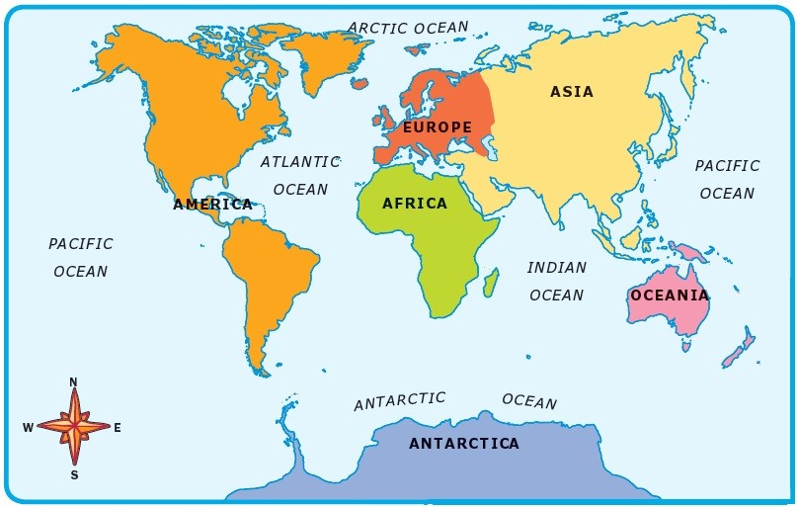
Source: World Map Europe Continent Drawing free image@
- Imagine living in one of these places, what are the essential items for survival?

During the episode
- Record key facts under each of the headings in the table below.
The Yukon | Huskies | Quinzhee | Food and clothing

After the episode
- Identify the three factors which make temperatures in The Yukon, Canada some of the coldest in the world

- What were the three things identified as essential in the ‘survival guide’ at the end of the program?

- Draw and annotate a diagram of a Quinzhee (snow shelter). How well does a Quinzhee meet the three requirements for survival in cold environments?

Follow-up activity: Create a survival guide for cold places. Use images as well as descriptions so that the guide is able to be followed by everyone.

The Russian Revolution
ABC ME screening details: Wednesday 13 May, 2020 at 2:10pm
This episode can also be viewed on ABC iView
Key learning areas: HSIE, Stages 5-6 history
Level: secondary
About: Learn about the downfall of the Romanov dynasty and the evolution of Lenin's Ulyanov family, the Bolsheviks, communism, the notorious Rasputin, rumours of cannibalism and acute poverty during the Russian Revolution.

Before the episode
- Complete the ‘people, events, questions’ chart to capture what you already know and understanding about the events of the Russian Revolution.
People | Events | Questions I have
Tsar Nicholas II | Bloody Sunday | When did Lenin become involved in the political world in Russia?

During the episode
- Explain why social attitudes and lifestyles in Russia were so different to other parts of Europe at the turn of the century.
Assess the significance of the ‘Bloody Sunday’ protest and aftermath. Why were these events regarded by many as the first attempt at revolution in this period?
Use the table to compare and contrast the February and October revolutions.
Item | February revolution | October revolution
Motivations
Methods
Outcomes

After the episode
- Outline Lenin’s vision of a “classless, communist society” in Russia. Identify any possible barriers to achieving his vision.
Write a paragraph explaining the role of each step of the revolution (Bloody Sunday, February revolution and October revolution) in the fall of the Romanov dynasty.
Follow-up activity: Create an annotated timeline for the period between 1900 and 1924. Your timeline should include the key events and a short description of what happened and who was involved.

Dates That Made History – 1347: The Black Death
ABC ME screening details: Wednesday 13 May, 2020 at 2:30pm
This episode can also be viewed on ABC iView
Key learning areas: HSIE, history
Level: secondary
About: Did the first outbreaks occur in China or in the Caspian Sea? Experts still argue. But how did the plague actually spread? After many controversies, it seems that the rat flea was the major carrier of this disease.

Before the episode
- Consider the title of this series, ‘dates that made history.’ Name one event that you think was important in history (it may be local, national or global) and explain why you think it is an important date.

During the episode
- As you watch this episode, mark the places on the map where the Black Death was found.
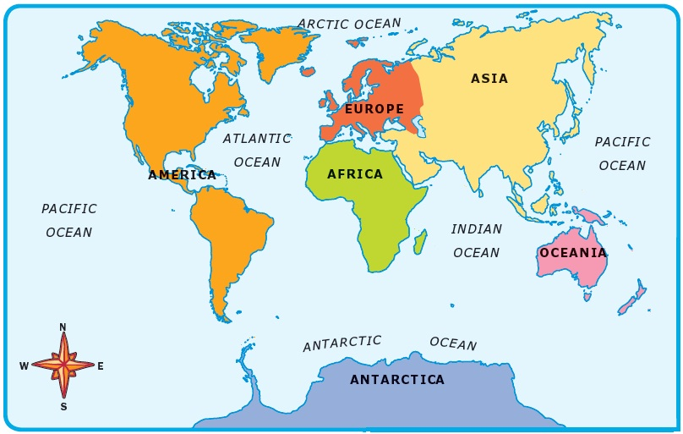
- What is meant by ‘the spaces in the archives’? Why are gaps in the historical records interesting for historians and what do they tell us about the Black Death?

- Explain why historians say that ‘the story of the spread of the plague is the story of commerce.’

- Why were some parts of Europe and the rest of the world unaffected by the Black Death?

After the episode
- According to the historian, why do we remember the date of the Black Death? What is interesting about the Black Death in relation to the impact it had on power and society in Medieval Europe?

Follow-up activity: This episode highlighted the development of the Black Death and European society’s approach to reducing the spread. Create a poster comparing the efforts made to reduce the Black Death to those currently being made to reduce the impact of Covid-19. Write a paragraph explaining what society learnt as a result of the Black Death that has helped with the current pandemic approach.

BTN - Media Literacy - Media Ethics
ABC ME screening details: Thursday May 14, 2020 at 2:20pm
This episode can also be viewed on ABC iView - Education
Key learning areas: English
Level: secondary
About: The news media can be a powerful force for good, but it doesn't always use its power in the right way. That's why news organisations often have codes of ethics of which journalists are expected to abide.

Before the episode
- Why is the superhero genre so popular for telling stories?
- List the qualities of Superman. What do you think this might have to do with the media?
- In your own words explain your understanding of the term popular culture.
- In your own words define the following: ethics, code of conduct, journalist, rules, standards and alliance.
- Consult 3 dictionaries and expand on your initial definitions.
- The Media, Entertainment and Arts Alliance (MEAA) initiated the creation of the MEAA Journalist Code of Ethics . These guidelines outline accepted rules of behaviour and outline behaviour standards for journalists. It helps journalists understand behaviour considered right and wrong. Why do you think journalists have a code of ethics? Why do you think it is important this is followed by all journalists?
- List the qualities of an ethical journalist.
- Complete the Venn diagram on page two outlining the similarities and differences between the qualities of a superhero and a journalist.

During the episode
- Based on the list in the episode, in your own words write down what you think the meaning of: honesty, accuracy, fairness, independence and respect means?
- List other qualities you think journalists should have.

After the episode
- Compose your own media ethics informative education poster, this should include the values from the episode and one or two of your own. When designing your visual text utilise conventions such as vectors, framing and composition to engage your audience.
- Write a short persuasive or informative news article about an event that has occurred recently in the media. This article can be creative and purposefully omit or embellish the facts. Share your article with a family member, discuss the event and how it has been represented and ask for their feedback.
- Write the same short article but this time follow the structures explored in this episode. As a reminder, journalists must be honest, accurate, fair, and independent of bias and respect the rights of others.
- Identify the differences in these two articles. How does it shift an audience's perspective of the information? Consider the compositional choices you made within the creative article?
Follow up activity: Describe what you have learnt about media ethics? Do you think we have ethical media organisations in this country? Give two examples that justify your perspective.

Poetry: Between The Lines – Bright Star by John Keats
ABC ME screening details: Friday May 15, 2020 1:30pm
This episode can also be viewed on ABC iView.
Key learning areas: English
Level: Stage 6
About: Hip-Hop star Akala explores John Keats' poem 'Bright Star' with the poet Daljit Nagra. They discuss how the poem focuses on the transient nature of life and eternal nature of love.

Before the episode
This text is a prescribed text for Advanced Module A: Textual conversations in the NSW syllabus for the Australian curriculum English Advanced Stage 6 syllabus (© 2019 NSW Education Standards Authority (NESA) for and on behalf of the Crown in right of the State of New South Wales).
The sonnet, ‘Bright Star’, by John Keats was written around 1819. It was composed during a time when Keats was dying of tuberculosis. The poem reveals the impact and reflection on the process of time, the fleeting nature of life and our own mortality in comparison with the natural world. The majesty and power of the natural world is contrasted with the frailty, tenderness and intimacy of human love and life.
Module A: Textual Conversations requires an exploration of the connection between the suite of poetry and Jane Campion’s 2009 film ‘Bright Star’. The film depicts the final three years of Keats’ life and provides contemporary audiences with a representation of his life and the Romantic period. For this episode students will be required to delve deeply into the ideas explored within the sonnet.
- Read the poem prior to viewing the episode (Read the poem prior to viewing the episode (Bright star, would I were stedfast as thou art” by John Keats © 2020 Poetry Foundation).
- Research the Romantic period and John Keats. Identify some of the significant contextual influences for the poem.
- Thinking about 19th century Romantic values identify examples of this influence within the poem.
- Thinking about the film and your engagement with this text and its context, does this poem resonate with Campion’s ‘Bright Star’ or is it a dissonance of ideals?

During the episode
- Make a list of the language devices that are analysed within the episode.
- List 4 key features from the poem identified by Daljit Nagra in the episode.
- Create a mind map representing the ideas and values explored in this episode and presented in the poem.

After the episode
- The religious allusions in the poem such as, ‘Eremite’, ‘priest like’ and ‘ablution’ denote more than just religious allegories, as the Romantics used religion as a comparison with nature. Explain why you think Keats has used religion as a vehicle for making meaning, specifically, in relation to those terms from the poem.
- The word ‘sublime’ is mentioned in the episode. Evaluate this term in relation to your knowledge of the Romantics and the connection to the poem (hint, you may wish to consider the idea of ‘the sublime’ in Romanticism).
- Explain how the mode of poetry, specifically the Elizabethan sonnet, creates meaning and evokes an emotive response.
- Explore how the conversation between the film and the poem impact on the meaning created for a 21st century audience.
- The repetition of language is significant in this poem, explain its purpose and impact.
- The opening stanza contains grand statements with the later stanzas shifting to intimate personal language. How does Keats create this shift whilst still engaging his audience?
- The Romantic elements of the poem are discussed in this episode. Identify the 3 mentioned and explain how they are evident in the suite of poems in this module.
- This is a pivotal poem in the exploration of the conversations between the texts in Module A: Textual Conversations. Explore the significant connection between this sonnet, the film and the other poems set for study within the module.
- Evaluate how Campion’s depiction and reframing of the Romantic period has been influenced Keats’ poetry. Explore how the film mirrors, aligns with and/or collides with Keats’ context and poetry. You must explore at least two poems.
Follow-up activity: Extended responses

Your Paintings – Eileen Agar
ABC ME screening details: Friday 15 May, 2020 at 2:00pm
This episode can also be viewed on ABC iView
Key learning areas: visual arts
Level: secondary
About: A statue come to life in a magical gallery and climbs into the painting ‘Bride of the Sea’ by Eileen Agar. Inside the painting our host explores Agar's use of collage techniques as well as looking at surrealism.

Before the episode
- Think about the terms collage and surrealism. Write or illustrate your ideas about these terms.

During the episode
- Eileen was always finding objects as she kept her eyes open. Make a list of the items/objects that Eileen found to use in her artwork.

- List 4-5 important points about Eileen Agar.

After the episode
- Think like a surrealist. Surrealists thought that normal was boring; ‘Thinking is not a straight line’. Explain the meaning of this.

- How did Eileen Agar adapt the concepts of surrealism in her paintings? What artistic techniques did she use?

- Without venturing outside make a list of items/objects that can be found in your backyard. Create a collage of your backyard using the artistic techniques employed by Eileen Agar in her artwork. You can use different types of paper (newspaper, coloured paper and gift wrap), colour pencils, paints, lead pencils and charcoal.
- Describe the techniques you used to create the effects of your collage.

Follow-up activity: Our thoughts can change direction using our imagination. Use your imagination to consider a unique technique of creating an artwork. List or illustrate your ideas.

