Wallykazam! – The Cake Monster
ABC ME screening details: Wednesday 29 April 2020 at 10:15am
This episode can also be viewed on ABC iView
Key learning areas: English
Level: lower primary
About: It is Ogre Doug’s birthday, but he has never had a cake so Wally and friends go to get him one while keeping it out of reach of the cake monster.

Before the episode
- Think about a party you have been to. Talk, draw or write about what happened at the party.

After the episode
- Draw or list items in your house that start with a ‘f’ sound.

- Trace the ‘f’. Have a go at writing ‘f’ in each box.
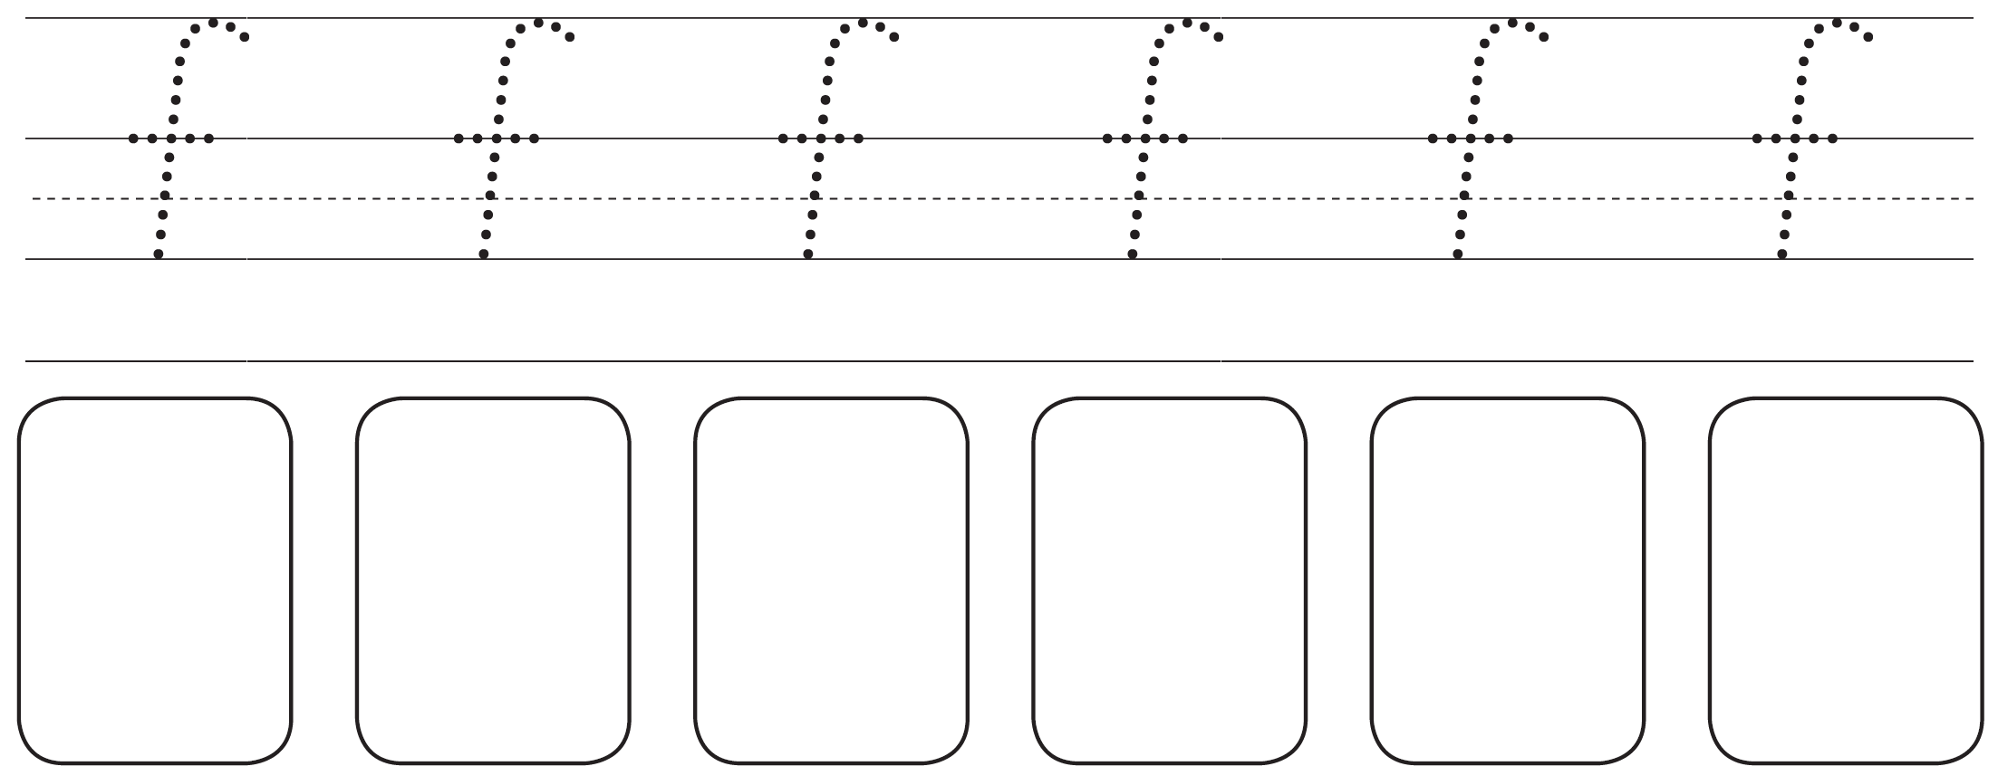
- List or draw your favourite party games.

- Plan a party for your toys. You can draw or write about the party. Which toys would you invite? Where would the party be? What food would you have at the party?

Follow-up activity: Create an invite for your toy party.

NSW teacher notes
This is an optional standalone resource that could supplement student learning. The activities align with syllabus outcomes across stages and can be modified to meet the needs of your students. Students can complete the activities while learning at home and in the classroom. All activities can be completed without access to the internet or a device. Teachers could collect student work to offer feedback and as evidence of learning.

Learning intentions
- To make connections to a text.

NSW English K-10 Syllabus outcomes
 | Early Stage 1 | Stage 1
Thinking imaginatively and creatively | thinks imaginatively and creatively about familiar topics, simple ideas and the basic features of texts when responding to and composing texts (ENe-10C) | thinks imaginatively and creatively about familiar topics, ideas and texts when responding to and composing texts (EN1-10C)
NSW English K-10 Syllabus © 2012 NSW Education Standards Authority (NESA) for and on behalf of the Crown in right of the State of New South Wales. See the NESA website for additional copyright information.

