Wallykazam! – Hopgoblin
ABC ME screening details: Monday 11 May at 10:15 am
This episode can also be viewed on ABC iView after the scheduled screening time.
Key learning areas: English
Level: lower primary
About: When Bob Goblin rides Hattie the Witch’s broom without asking, she turns him into a bunny. Today’s sound is ‘sl’ as in slide and slippers.

Before the episode
- Think of a time when you have helped a friend solve a problem. Draw or write about the problem. If you cannot think of a time you can use your imagination and create a problem to be solved.

After the episode
- Bob Goblin was turned into a bunny by Hattie the Witch. What animal would you liked to be magically turned into? Draw you as the animal below. Describe it to someone when it is finished.

- There was a problem in today’s story. Bob Goblin was turned into a bunny. The friends worked together to solve the problem. Retell, using drawings, how the friends worked together to solve the problem.
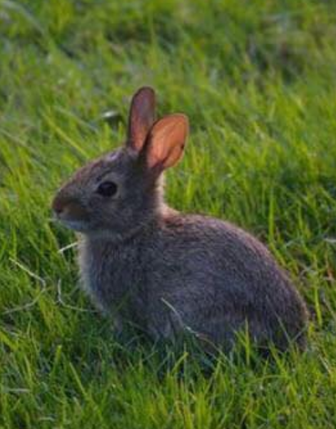
Follow-up activity: Wally was reading a story that started with ‘Once upon a time’. Draw or write a story starting with ‘Once upon a time’ that includes the animal that you have drawn. Share your story with someone you know.

NSW teacher notes
This is an optional standalone resource that could supplement student learning. The activities align with syllabus outcomes across stages and can be modified to meet the needs of your students. Students can complete the activities while learning at home and in the classroom. All activities can be completed without access to the internet or a device. Teachers could collect student work to offer feedback and as evidence of learning.

Learning intentions
- To create a character from their imagination.
- To create a story.
- To describe a problem and how to solve it.

Resources
- paper and pencils

NSW English K-10 Syllabus outcomes
 | Early stage 1 | Stage 1
Writing and representing | Composes simple texts to convey an idea or message (ENe-2A) | plans, composes and reviews a small range of simple texts for a variety of purposes on familiar topics for known readers and viewers (EN1-2A)
Expressing themselves | responds to and composes simple texts about familiar aspects of the world and their own experiences (ENe-11D) | responds to and composes a range of texts about familiar aspects of the world and their own experiences (EN1-11D)
NSW English K-10 Syllabus © 2012 NSW Education Standards Authority (NESA) for and on behalf of the Crown in right of the State of New South Wales. See the NESA website for additional copyright information.

