Play School Story Time – Debra Lawrance: Ginger
ABC ME screening details: Wednesday 27 May 2020 at 10:10am
This episode can also be viewed on ABC iView.
Key learning areas: English
Level: lower primary
About: Snuggle up with Debra Lawrance on the Story Time couch as she reads Charlotte Voake's "Ginger", an affectionate account of pet rivalry!

Before the episode
- Today’s story is about friendship. Think of a time when you had to share a toy with a friend or sibling but you did not want to. Draw, write or share your thinking with a friend or family member.

After the episode
- What a great story about making friends! Retell the story through a puppet show. Plan your show by drawing the beginning, middle and end of the story.
Beginning | Middle | End
- Let’s get creative!
- Create finger or sock puppets of Ginger and the kitten.
- You could use items out of your recycling or your toys instead.
- Practise acting out the story.
- Perform your puppet show for your class or family.
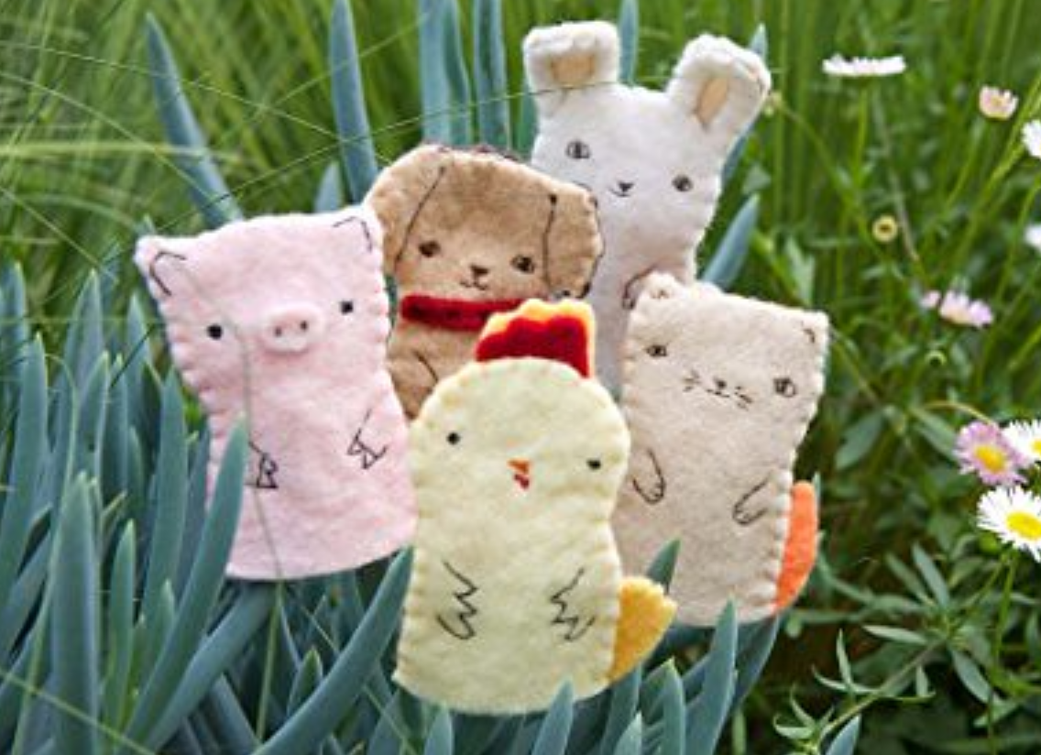
Follow-up activity: It is great that Ginger and kitten became friends. What do you think makes a good friend? Is it someone who listens to you or helps you? Describe, write or draw your ideas. What do you do to be a good friend?

NSW Teacher notes
This is an optional standalone resource that could supplement student learning. The activities align with syllabus outcomes across stages and can be modified to meet the needs of your students. Students can complete the activities while learning at home and in the classroom. All activities can be completed without access to the internet or a device. Teachers could collect student work to offer feedback and as evidence of learning.

Learning intentions
- To make connections between a text and personal experiences.
- To retell a story.

NSW English K-10 Syllabus outcomes
 | Early stage 1 | Stage 1
Thinking imaginatively and creatively | thinks imaginatively and creatively about familiar topics, simple ideas and the basic features of texts when responding to and composing texts (ENe-10C) | thinks imaginatively and creatively about familiar topics, ideas and texts when responding to and composing texts (EN1-10C)
NSW English K-10 Syllabus © 2012 NSW Education Standards Authority (NESA) for and on behalf of the Crown in right of the State of New South Wales. See the NESA website for additional copyright information.

