Numberblocks – Blast off!
ABC ME screening details: Monday 13 May 2020 at 10:00am
This episode can also be viewed on ABC iView after the scheduled screening time.
Key learning areas: mathematics
Level: lower primary
About: Ten promises to take the others on a trip to the moon, but blasts off on her own. How will they get there? Find out which pairs of numbers add together to make ten with the Numberblocks.

After the episode
- In Numberblocks today, we learned that some smaller numbers can sit inside Ten. Let’s play building towers to find smaller numbers that sit inside other numbers. If you would like to see the building towers game being played you can watch it here (internet access required) or follow the instructions.
You will need these items to play:
- number cards for each player with 5, 7, 11 and 3 on them.
- a dice
- some building bricks
Here is how to set up the game.
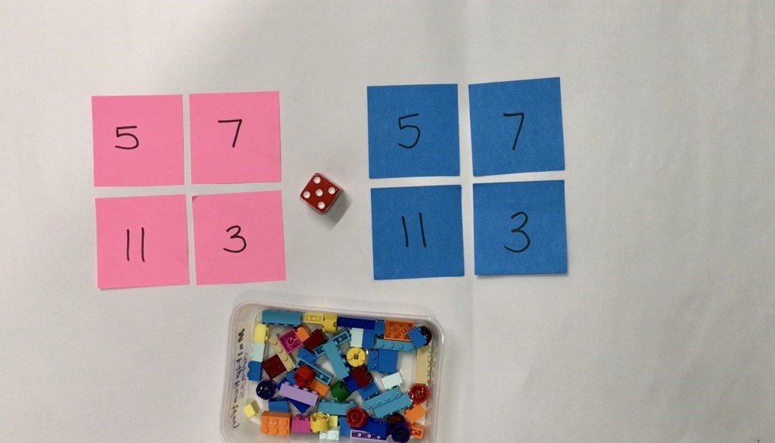

Building Towers
- Take turns to roll your dice and get that number of bricks to build up your towers.
- Towers can be built up in any way you choose.
- Build up your towers until one of you gets the exact roll to complete the last tower.
- Talk about how many you have, how many more you need.
- Here is a picture of some friends playing the game.
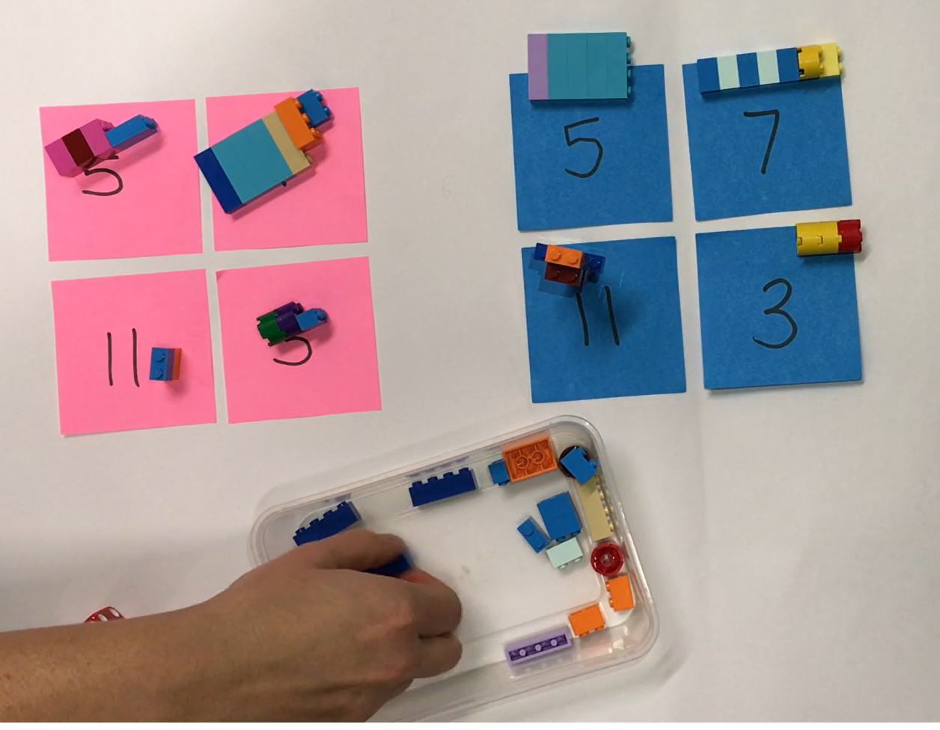
- Try playing the game in reverse by starting with complete towers. Take away blocks for each roll, until there are no blocks left. You could also play the game with larger numbers. Did this change the strategy you used?
- What did you find challenging about the game? What strategies helped you? Draw, write or share your thinking with a family member or friend.

Follow-up activity: Think of the tallest tower that you built. What numbers did you use to build the tower? Teach a friend how to play building towers.

NSW teacher notes
This is an optional standalone resource that could supplement student learning. The activities align with syllabus outcomes across stages and can be modified to meet the needs of your students. Students can complete the activities while learning at home and in the classroom. All activities can be completed without access to the internet or a device. Teachers could collect student work to offer feedback and as evidence of learning.

Learning intentions
- To find smaller numbers inside larger numbers.
- To add numbers to reach a given total.
- To select and discuss different strategies.

NSW Mathematics K-10 Syllabus outcomes
 | Early stage 1 | Stage 1
Addition and subtraction | combines, separates and compares collections of objects, describes using everyday language, and records using informal methods (MAe-5NA) | uses a range of strategies and informal recording methods for addition and subtraction involving one- and two-digit numbers (MA1-5NA)
Working mathematically | uses concrete materials and/or pictorial representations to support conclusions (MAe-3WM) | supports conclusions by explaining or demonstrating how answers were obtained (MA1-3WM)
NSW Mathematics K-10 Syllabus © 2012 NSW Education Standards Authority (NESA) for and on behalf of the Crown in right of the State of New South Wales. See the NESA website for additional copyright information.

