I’m a Fish – I’m a Rainbow Fish
ABC ME screening details: Wednesday 20 May 2020 at 10:05am
This episode can also be viewed on ABC iView after the scheduled screening time.
Key learning areas: science and technology
Level: upper primary
About: In Australia we meet the friendly Rainbow fish who tells us that they are schooling fish and that their colours become brighter when they are with their friends.

Before the episode
- Draw and write about what you know about fish.

After the episode
- Rainbow fish were described as beautiful, small and tiny. Colour the rainbow fish below. Describe the colours and what makes it special.
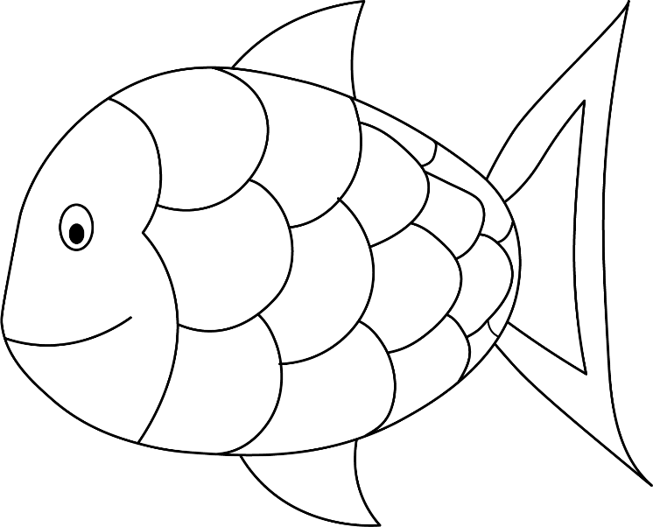

After the episode
- There are different types of rainbow fish that live in rivers and lakes in Australia. They are all colours of the rainbow and are peaceful, happy fish. They eat tadpoles, insects and other small fish. Add some of the food that the rainbow fish eats to your drawing above.
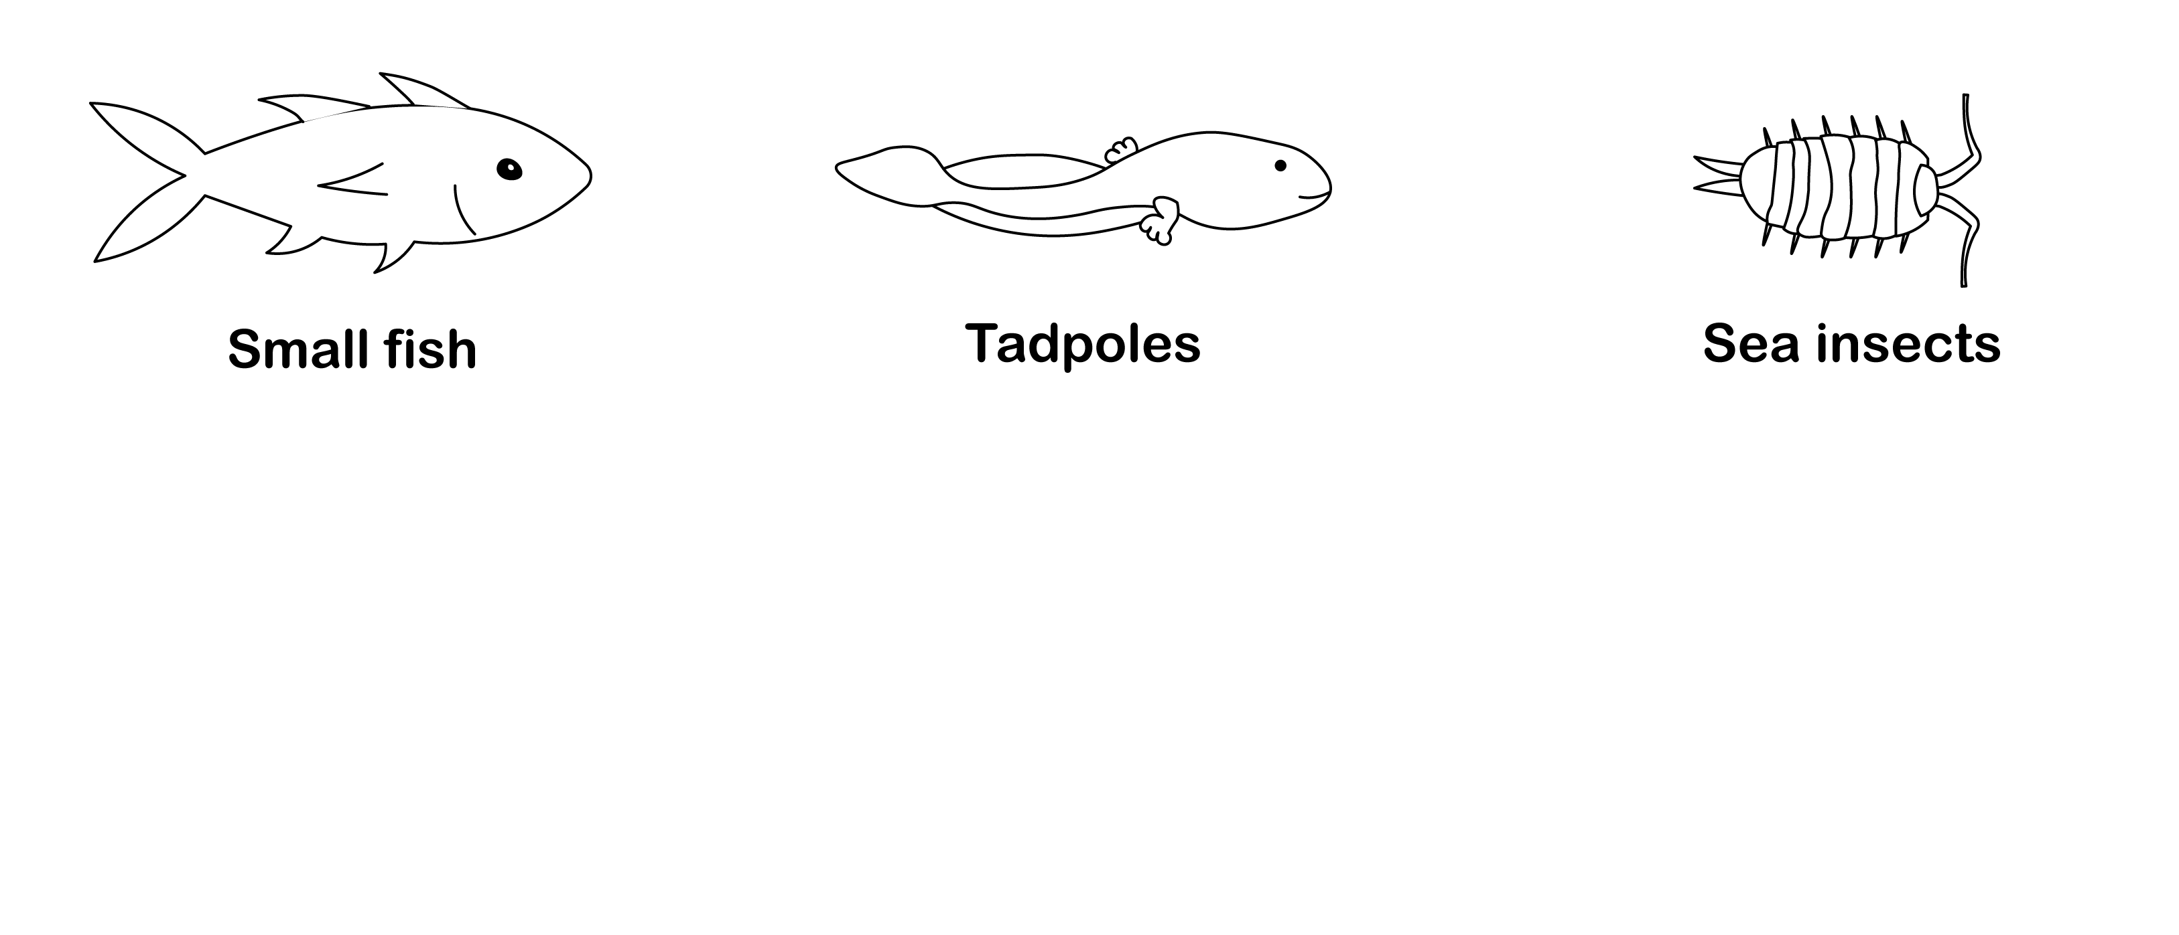
- Rainbow fish turn a brighter colour when they are with other fish in a school. Draw a picture of you when you feel happier and brighter when you are with your friends.

Follow-up activity: Create a fish tank with a school of rainbow fish. Make colourful scales to place on each fish. You can use different materials for example foil or coloured paper. The rainbow fish you make should be very brightly coloured because they are swimming with their friends.

NSW teacher notes
This is an optional standalone resource that could supplement student learning. The activities align with syllabus outcomes across stages and can be modified to meet the needs of your students. Students can complete the activities while learning at home and in the classroom. All activities can be completed without access to the internet or a device. Teachers could collect student work to offer feedback and as evidence of learning.

Learning intentions
- To explore and understand the characteristics of a rainbow fish.
- To create an environment for a school of rainbow fish to live in.

NSW Science and Technology K-6 Syllabus outcomes
 | Stage Early Stage 1 | Stage 1
Living World | explores the characteristics, needs and uses of living things (STe-3LW-ST) | describes observable features of living things and their environments (ST1-4LW-S)
NSW Science and Technology K-6 Syllabus © 2017 NSW Education Standards Authority (NESA) for and on behalf of the Crown in right of the State of New South Wales. See the NESA website for additional copyright information.

