I’m a Creepy Crawly - Snail
ABC ME screening details: Wednesday 3 June 2020 at 10:05am
This episode can also be viewed on ABC iView.
Key learning areas: mathematics, science and technology
Level: lower primary
About: Even though we can see this little snail, he can't see or hear us, good thing he can smell us! As he hangs upside down he tells us that most snails actually live underwater.

Before the episode
- Today’s episode is about snails. Draw five slimy snails slithering on the roof. Write any interesting facts you know about snails.
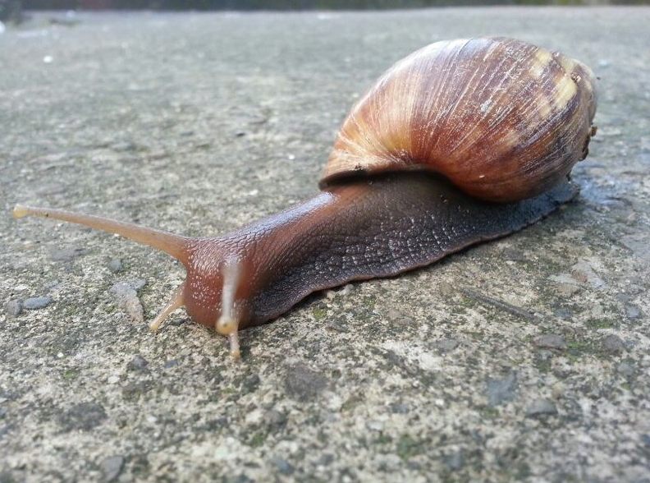

After the episode
- We learnt lots of interesting things about snails. Did you know that they could not hear? Draw or list some of the other facts that you learnt today.

- Snails without their shells would be called slugs. Draw or write two ways that snails use their shells?
Shell use – one | Shell use – two
- Draw a snail below. Label your drawing with eyes, tongue, shell, teeth and slime.

- Snails eat fruit, leaves, plants and bark. Some even eat mushrooms and fungi. Connect the snail to the type of food it would eat.
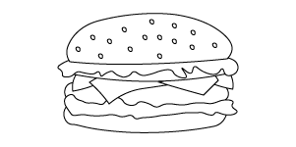 |  | 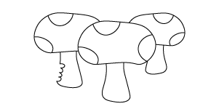
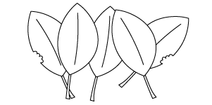 | 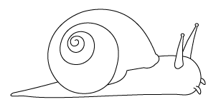 | 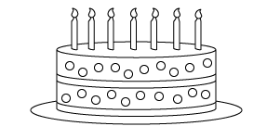
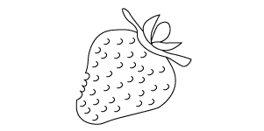 |  | 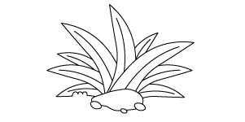
Follow-up activity: Snails hide in their shells when there are harsh conditions outside, when the weather is too cold or wet. Imagine you had to create a way to protect yourself from cold and the wet. Design a new type of house or a shell that could protect you.

NSW Teacher notes
This is an optional standalone resource that could supplement student learning. The activities align with syllabus outcomes across stages and can be modified to meet the needs of your students. Students can complete the activities while learning at home and in the classroom. All activities can be completed without access to the internet or a device. Teachers could collect student work to offer feedback and as evidence of learning.

Learning intentions
- To create a drawing of a snail that outlines the parts of its body.
- To identify the needs of snails.

NSW Science and Technology K-10 Syllabus outcomes
 | Early Stage 1 | Stage 1
Living World | explores the characteristics, needs and uses of living things (STe-3LW-ST) | describes observable features of living things and their environments (ST1-4LW-S)
NSW Science and Technology K-6 Syllabus © 2017 NSW Education Standards Authority (NESA) for and on behalf of the Crown in right of the State of New South Wales. See the NESA website for additional copyright information.

