Art with Mati and Dada – Dorothea Lange
ABC ME screening details: Monday 25 May 2020 at 10:35am
This episode can also be viewed on ABC iView.
Key learning areas: Creative arts
Level: lower primary
About: The right moment...take the picture now, Mati! Learning how to do a perfect composition with a camera is something easy with Dorothea beside you.

After the episode
- We learnt that Dorothea Lange was a photographer. Look at her photograph below:
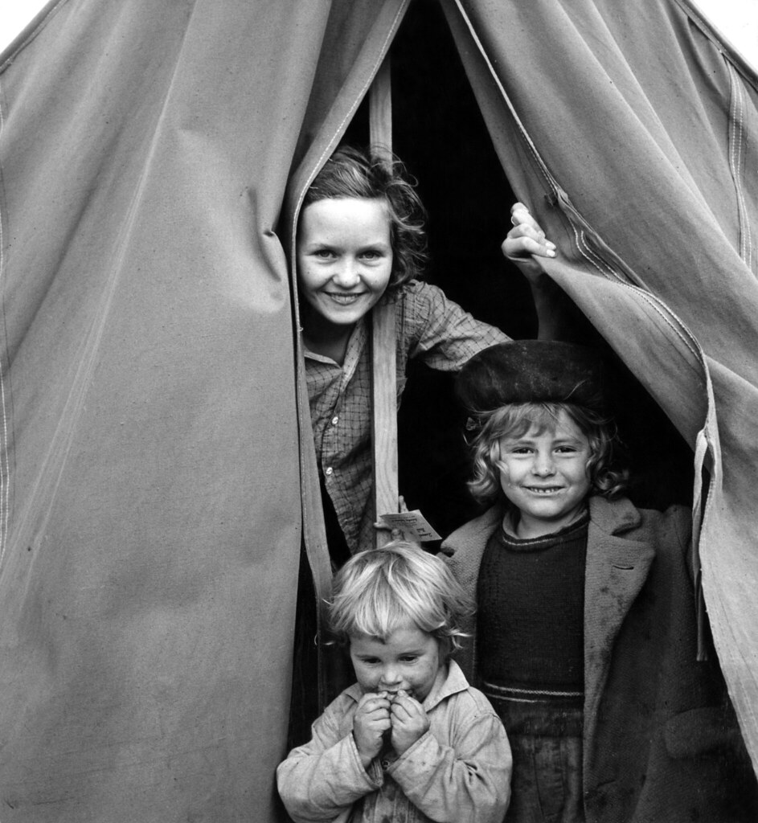
- Discuss these questions with a friend or family member.
- What did you look at first in the photo?
- What is happening in the photo? What do you think could be happening around the children that the photo does not show?
- Why do you think Dorothea did not include the whole tent in the photo? How are the children positioned in the tent?
- What does the photo tell you about the children’s lives? Do their facial expressions give you any clues?
- Do you think the effect of the photo would change if it was a colour photo? Why or why not?
- Can you find the light and dark parts in the photo?
- Dorothea taught us about framing your photo before taking it. Try it out. Create a frame out of paper by gluing or stapling four long strips of cardboard or paper to make a square outline.
- Collect two interesting small objects, such as a leave and a piece of fruit. Choose a fun way to position them on the floor, maybe one on top of another. Place your paper frame around them. Take a picture of your frame with a camera phone if you can. Here are some examples of ‘frame photos’.
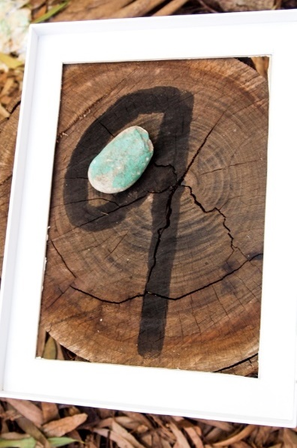 | 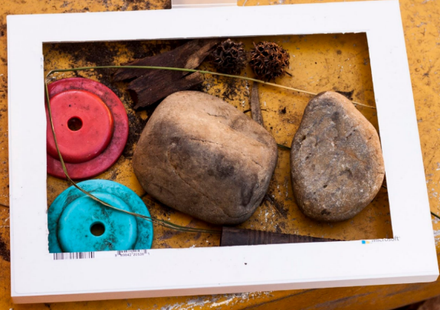
Experiment with angles, light and position.
- Move your objects around. Place your frame at a different angle around your objects.
- Are your objects in a dark or light space? Move to another part of your floor, maybe near a window.
- Take a picture of your frame if you can.
- How is it different to your first frame photo? Which do you prefer and why?
(Adapted from Camdenville Public School)
Follow-up activity: Take a photo of a friend or family member with a camera. Remember what Dorothea said, ‘frame it and make them smile.’ Experiment with different camera angles and standing in light or dark spaces. Remember to ask them to smile.

NSW Teacher notes
This is an optional standalone resource that could supplement student learning. The activities align with syllabus outcomes across stages and can be modified to meet the needs of your students. Students can complete the activities while learning at home and in the classroom. All activities can be completed without access to the internet or a device. Teachers could collect student work to offer feedback and as evidence of learning.

Learning intentions
- To share ideas about a photograph.
- To experiment with framing objects.
- To experiment with angles, positioning and light when taking a photo.

NSW Creative arts K-6 Syllabus outcomes
Artform | Early stage 1 | Stage 1
Visual arts | Making  Makes simple pictures and other kinds of artworks about things and experiences (VAES1.1)  Experiments with a range of media in selected forms (VAES1.2) | Making  Makes artworks in a particular way about experiences of real and imaginary things (VAS1.1)  Uses the forms to make artworks according to varying requirements (VAS1.2)
Visual arts | Appreciating  Recognises some of the qualities of different artworks and begins to realise that artists make artworks (VAES1.3)  Communicates their ideas about pictures and other kinds of artworks (VAES1.4) | Appreciating  Realises what artists do, who they are and what they make (VAS1.3)  Begins to interpret the meaning of artworks, acknowledging the roles of artist and audience (VAS1.4)
NSW Creative Arts K-6 Syllabus © 2006 NSW Education Standards Authority (NESA) for and on behalf of the Crown in right of the State of New South Wales. See the NESA website for additional copyright information.

