Art with Mati and Dada - Canaletto
ABC ME screening details: Monday 1 June 2020 at 10:35am
This episode can also be viewed on ABC iView.
Key learning areas: creative arts
Level: lower primary
About: Mati and Dada are transported into a marvellous journey in Venice, on a Gondola together with Canaletto in person!

Before the episode
- Canaletto created beautiful paintings of Venice, Rome and London. In this episode we will see some of his famous art works. He would sketch the drawings before painting. Look around where you are now.  - Choose something to sketch. It could be a chair or table or person. Remember when sketching hold your pencil lightly and use different forms of lines and shapes. | 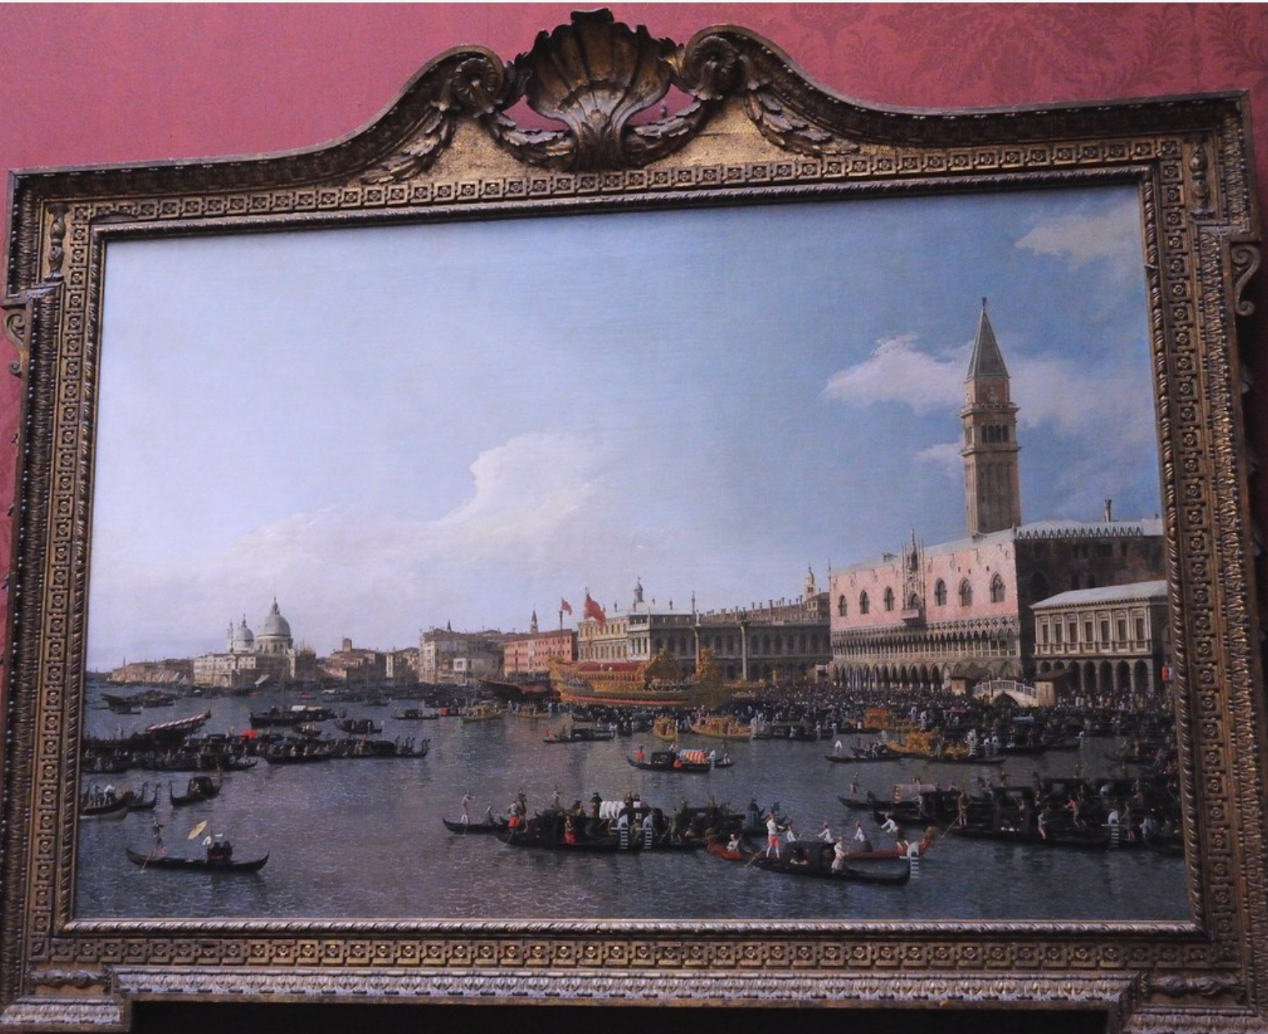

After the episode
- Canaletto would sketch his drawing from different angles before creating his final art work. He would draw a number of scaraboto or sketches with pencil and paper. Now it’s your turn to draw two scaraboto of the same view.
Look out a window of your house and sketch what you see. What do you see? You might see trees, grass and/or buildings. Draw what you see.

- Move to a different view. Draw your second scaraboto in the window below.

- Which sketch do you like the best? Colour your favourite sketch to be the final artwork.
Follow-up activity: Get a toilet roll or another roll that you can look through. Choose your favourite place, it could be your back yard or a park or your school. Your favourite place will be your veduta. Look through the roll, this is like the camera that Canaletto used, and create a scaraboto of your favourite place. When you have completed your sketch add people, animals and other interesting things to your sketch and create a veduta to share with your family and friends.

NSW Teacher notes
This is an optional standalone resource that could supplement student learning. The activities align with syllabus outcomes across stages and can be modified to meet the needs of your students. Students can complete the activities while learning at home and in the classroom. All activities can be completed without access to the internet or a device. Teachers could collect student work to offer feedback and as evidence of learning.

Learning intentions
- To create an artwork using different perspectives.
- To sketch an outline of an aspect of their local environment.

NSW Creative Arts K- 6 Syllabus outcomes
Artform | Early Stage 1 | Stage 1
Visual Arts | Making  Makes simple pictures and other kinds of artworks about things and experiences. (VAES1.1) | Making  Makes artworks in a particular way about experiences of real and imaginary things. (VAS1.1)
Visual Arts | Appreciating  Recognises some of the qualities of different artworks and begins to realise that artists make artworks. (VAES1.3) | Appreciating  Realises what artists do, who they are and what they make. (VAS1.3)
NSW Creative Arts K-6 Syllabus © 2006 NSW Education Standards Authority (NESA) for and on behalf of the Crown in right of the State of New South Wales. See the NESA website for additional copyright information.

