Learning from home: ABC TV Education resources

Lower primary – week 6

01/06/2020 – 05/06/2020
Supplementary activities to support educational content broadcast on ABC ME during Term 2, 2020

About this resource
ABC Education, in collaboration with the NSW Department of Education, have planned a daily schedule of free to air educational programs supported by standalone resources that complement the ABC TV Education program airing during Term 2, 2020. All activities can be completed without access to the internet or a device and are suitable for lower primary, upper primary and secondary students.

Educational benefit
Student booklets include activities designed by curriculum experts to meet educational outcomes and are based on a selection of ABC programs that are of high educational value. Activities address topics from a range of subjects including: English; mathematics; science and technology; geography; history; PDHPE and creative arts.
These optional resources do not replace teaching and learning programs provided by schools but may be used by teachers and parents/carers to supplement student learning. Teachers may select activities relevant to their teaching and learning program and modify to meet student needs.

Recording student responses
Students complete activities before, during and after viewing selected daily episodes. Where appropriate, space is provided in each booklet for students to record their responses. Students may require additional writing paper or a separate workbook for some tasks. Completed student booklets may be collected by teachers and used as evidence of learning.

How to access ABC TV Education programs
The selected daily episodes can be viewed via the ABC TV Education broadcast on ABC ME (Channel 23) from 10am-3pm weekdays. Each day commences with programs suitable for lower primary students followed by upper primary and then secondary. Programs will also be available at abc.net.au/iview after the broadcast. A schedule of the selected episodes is included in each student booklet.

Episode schedule – week 6
The timetable below outlines the episode focus for each day. The full ABC TV Education program can be found at http://www.abc.net.au/tveducation/
 | Time | Program | Episode title | Key learning area | Pages
Monday  01/06/2020 | 10:35am | Art With Mati And Dada | Canaletto | creative arts | 4-5
Tuesday  02/06/2020 | 10:00am | Numberblocks | Now we are 6-10 | mathematics | 6-7
Wednesday  03/06/2020 | 10:05am | I'm a Creepy Crawly | Snail | mathematics, science and technology | 8-9
Thursday  04/06/2020 | 10:10am | Grandpa Honeyant Storytime | There's A Hippopotamus On Our Roof Eating Cake | English | 10-11
Friday  05/06/2020 | 10:45am | Where in the World? | Angel, Rhys and Truc. Goes on an expedition | history | 12-13
© State of New South Wales (Department of Education), 2020
The copyright material published in this document is subject to the Copyright Act 1968 (Cth), and is owned by the NSW Department of Education or, where indicated, by a party other than the NSW Department of Education.
Copyright material available in this document is licensed under a Creative Commons Attribution 4.0 International (CC BY 4.0) licence.
See http://education.nsw.gov.au/about-us/copyright for further details.

Art with Mati and Dada - Canaletto
ABC ME screening details: Monday 1 June 2020 at 10:35am
This episode can also be viewed on ABC iView.
Key learning areas: creative arts
Level: lower primary
About: Mati and Dada are transported into a marvellous journey in Venice, on a Gondola together with Canaletto in person!

Before the episode
- Canaletto created beautiful paintings of Venice, Rome and London. In this episode we will see some of his famous art works. He would sketch the drawings before painting. Look around where you are now.  - Choose something to sketch. It could be a chair or table or person. Remember when sketching hold your pencil lightly and use different forms of lines and shapes. | 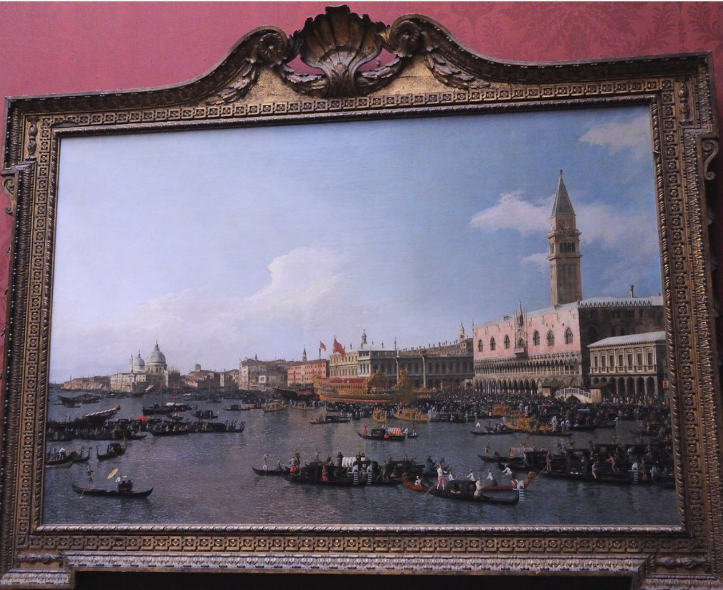

After the episode
- Canaletto would sketch his drawing from different angles before creating his final art work. He would draw a number of scaraboto or sketches with pencil and paper. Now it’s your turn to draw two scaraboto of the same view.
- Look out a window of your house and sketch what you see. What do you see? You might see trees, grass and/or buildings. Draw what you see.

- Move to a different view. Draw your second scaraboto in the window below.

- Which sketch do you like the best? Colour your favourite sketch to be the final artwork.
Follow-up activity: Get a toilet roll or another roll that you can look through. Choose your favourite place, it could be your back yard or a park or your school. Your favourite place will be your veduta. Look through the roll, this is like the camera that Canaletto used, and create a scaraboto of your favourite place. When you have completed your sketch add people, animals and other interesting things to your sketch and create a veduta to share with your family and friends.

Numberblocks – Now We Are 6 to 10
ABC ME screening details: Tuesday 2 June 2020 at 10:00am
This episode can also be viewed on ABC iView.
Key learning areas: mathematics
Level: lower primary
About: Are you sitting comfortably? Then we'll begin a bedtime story all about Numberblocks Six to Ten.

After the episode
- In today’s episode of Numberblocks, we learnt how you can count from Six to Ten by adding one each time. We also learnt how to count back from Ten to Six! Let’s count forwards to 20 and backwards from 20. Collect 20 items, for example pasta or blocks. Move your items in to a pile, one at a time, saying the count as you go until you reach 20.
- Now let’s count backwards. Move each item away until you reach zero! “Remember when you move away your first item you would say ‘19’ and then 18, 17, 16…..”.
- Time to have some more counting fun. Let’s make a number line! You will need the numbers 1 – 20. You could write each number on an old sock and peg the socks on a piece of hanging string or you could write number cards to place on the floor or to hang up. Here’s some pictures to help you.
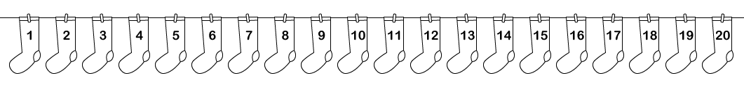
- Now that you have created your number line, follow these directions.
- Start at 6. Move forwards four steps. Count as you go. The first number you would say and move to is ‘7’ and then ‘8’, ‘9’ and ‘10’.
- Move three steps forwards from 10. What number did you land on?
- Try moving 7 steps back. Count back as you go if you can. Where did you end up? Was it where you started from?

- Time to have another go!
- Start at 15. Move forwards four steps. Say the numbers as you go. Which number are you at?
- Find the number that is one more than 7. Can you remember any clues from Numberblocks?
- Find the number that is one less than 10.
- How did you go? What was challenging or easy about following the directions? Draw, write or share your thinking with a family member or friend.

- Ask a family member or friend to play. Take turns directing each other. Here are some ways that you could ask your directions:
- Start at number ___ move forwards _____ steps. Say the numbers as you move.
- Start at number ____ move backwards ______ steps. Say the numbers as you move.
- Stand/point to the number that is one less than ____.
- Stand/point to the number that is one more than _______ .
Adpated from Developing Efficient Numeracy Strategies One http://www.resourcesformathematics.com.au/dens1/
Follow-up activity: How could you change this activity? Could you remove numbers from your washing line and ask a friend what is missing? Could you use larger numbers? Try making your directions more challenging. Draw or write how you changed the activity.

I’m a Creepy Crawly - Snail
ABC ME screening details: Wednesday 3 June 2020 at 10:05am
This episode can also be viewed on ABC iView.
Key learning areas: mathematics, science and technology
Level: lower primary
About: Even though we can see this little snail, he can't see or hear us, good thing he can smell us! As he hangs upside down he tells us that most snails actually live underwater.

Before the episode
- Today’s episode is about snails. Draw five slimy snails slithering on the roof. Write any interesting facts you know about snails.
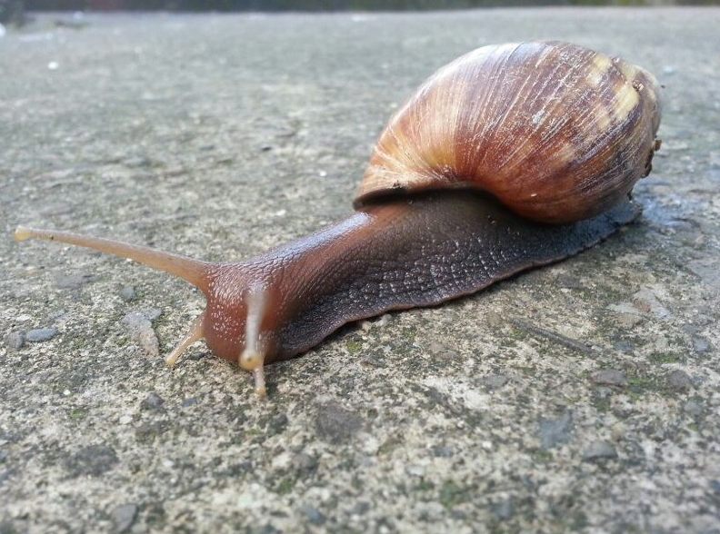

After the episode
- We learnt lots of interesting things about snails. Did you know that they could not hear? Draw or list some of the other facts that you learnt today.

- Snails without their shells would be called slugs. Draw or write two ways that snails use their shells?
Shell use – one | Shell use – two
- Draw a snail below. Label your drawing with eyes, tongue, shell, teeth and slime.

- Snails eat fruit, leaves, plants and bark. Some even eat mushrooms and fungi. Connect the snail to the type of food it would eat.
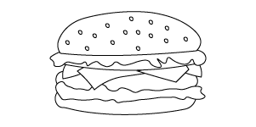 |  | 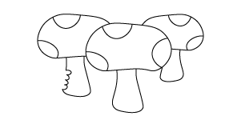
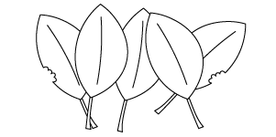 | 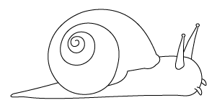 | 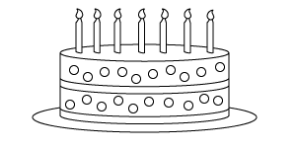
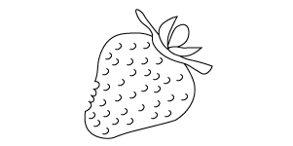 |  | 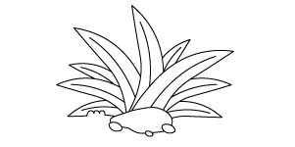
Follow-up activity: Snails hide in their shells when there are harsh conditions outside, when the weather is too cold or wet. Imagine you had to create a way to protect yourself from cold and the wet. Design a new type of house or a shell that could protect you.

Grandpa Honeyant Storytime – There's A Hippopotamus On Our Roof Eating Cake
ABC ME screening details: Thursday 4 June 2020 at 10:10am
This episode can also be viewed on ABC iView.
Key learning areas: English
Level: lower primary
About: A wonderful classic story about an imaginary hippopotamus friend who is on the roof eating cake.

Before the episode
- Have you ever seen a hippopotamus on the roof of a house? In the story, the girl sees a hippopotamus on a roof eating cake!
- Draw a picture below of what you think the hippo looks like and the cake it is eating. Do you think it would eat a chocolate cake or a cheesecake or a different type of cake?

After the episode
- What would you do if you found a hippo on your roof? Draw or write what you would do below. For example, you could ask it to get down off the roof and tell it to go and live on your friend’s roof.

- Would a hippo make a good pet? Why or why not? Draw or write the ways you think it would and would not be a good pet.
Good pet | Bad Pet
- If you had a hippo as a pet, what would be some of the fun things you would do together? Draw or write the fun things you would do. Share with a family member or a friend.

Follow-up activity: Imagine you look outside and see an animal on your roof. What is the animal? What is the animal doing? Draw and/ or write a story about the animal and the different activities it does on the roof.

Where in the World? – Angel, Rhys and Truc. Goes on an expedition
ABC ME screening details: Friday 5 June 2020 at 10:45am
This episode can also be viewed on ABC iView.
Key learning areas: history
Level: lower primary
About: In Peru, Angel and his cousin go on an expedition up a mountain; in Canada Rhys spends the day with his dog. And in Vietnam, Truc shops for her mum's favourite lunch and cooks it with her granddad.

Before the episode
- In today’s episode, Angel climbs to the top of a mountain and he sees different types of transport. Transport is the way of moving people or things, for example a truck. Draw three different types of transport.

After the episode
- Angel climbed to the top of a mountain. Imagine you are Angel and you are at the top of a mountain near your home. Draw what you would see from the top of your mountain. Don’t forget to include your home

- People help their families in different ways. Rhys helped his mum by taking care of their dog. Draw or write three jobs that you do to help your family.
Job 1 | Job 2 | Job 3
- Truc goes shopping at the market and buys food to cook her mum’s favourite meal. Truc cooks with the help of her grandad. Draw or write about something special that you would like to do for someone in your family.

Follow-up activity: Angel used his imagination. He imagined that a rock was a puma. Imagine that things around you have changed into other things. For example, you may go outside with a family member and look at the clouds. You may imagine that the clouds turn into a dragon. Draw what you imagined. Describe your drawing to someone.

