Learning from home: ABC TV Education resources



* 1. **Lower primary – week 5**
     1. **25/05/2020 – 29/05/2020**

Supplementary activities to support educational content broadcast on ABC ME during Term 2, 2020

* 1. **About this resource**

ABC Education, in collaboration with the NSW Department of Education, have planned a daily schedule of free to air educational programs supported by standalone resources that complement the ABC TV Education program airing during Term 2, 2020. All activities can be completed without access to the internet or a device and are suitable for lower primary, upper primary and secondary students.

* 1. **Educational benefit**

Student booklets include activities designed by curriculum experts to meet educational outcomes and are based on a selection of ABC programs that are of high educational value. Activities address topics from a range of subjects including: English; mathematics; science and technology; geography; history; PDHPE and creative arts.

These optional resources do not replace teaching and learning programs provided by schools but may be used by teachers and parents/carers to supplement student learning. Teachers may select activities relevant to their teaching and learning program and modify to meet student needs.

* 1. **Recording student responses**

Students complete activities before, during and after viewing selected daily episodes. Where appropriate, space is provided in each booklet for students to record their responses. Students may require additional writing paper or a separate workbook for some tasks. Completed student booklets may be collected by teachers and used as evidence of learning.

* 1. **How to access ABC TV Education programs**

The selected daily episodes can be viewed via the ABC TV Education broadcast on ABC ME (Channel 23) from 10am-3pm weekdays. Each day commences with programs suitable for lower primary students followed by upper primary and then secondary. Programs will also be available at [abc.net.au/iview](https://iview.abc.net.au/) after the broadcast. A schedule of the selected episodes is included in each student booklet.

* 1. **Episode schedule – week 5**

The timetable below outlines the episode focus for each day. The full ABC TV Education program can be found at <http://www.abc.net.au/tveducation/>

|  |  |  |  |  |  |
| --- | --- | --- | --- | --- | --- |
|  | Time | Program | Episode title | Key learning area | Pages |
| **Monday**  **25/05/2020** | 10:35am | Art With Mati And Dada | Dorothea Lange | creative arts | 4-5 |
| **Tuesday**  **26/05/2020** | 10:00am | Numberblocks | Once Upon A Time | mathematics | 6-7 |
| **Wednesday**  **27/05/2020** | 10:10am | Play School Story Time | Debra Lawrance: Ginger | English | 8-9 |
| **Thursday**  **28/05/2020** | 10:10am | Grandpa Honeyant Storytime | Caar Caaaar | English | 10-11 |
| **Friday**  **29/05/2020** | 10:45am | Where in the World? | Angel, Rhys and Tyra. Helps mum cook lunch | history | 12-13 |

© State of New South Wales (Department of Education), 2020

The copyright material published in this document is subject to the Copyright Act 1968 (Cth), and is owned by the NSW Department of Education or, where indicated, by a party other than the NSW Department of Education.

Copyright material available in this document is licensed under a Creative Commons Attribution 4.0 International (CC BY 4.0) licence.

See <http://education.nsw.gov.au/about-us/copyright> for further details.

# Art with Mati and Dada – Dorothea Lange

**ABC ME screening details:** Monday 25 May 2020 at 10:35am

This episode can also be viewed on [ABC iView](https://iview.abc.net.au/show/art-with-mati-and-dada).

**Key learning areas:** creative arts

**Level:** lower primary

**About:** The right moment...take the picture now, Mati! Learning how to do a perfect composition with a camera is something easy with Dorothea beside you.

## After the episode

1. We learnt that Dorothea Lange was a photographer. Look at her photograph below:

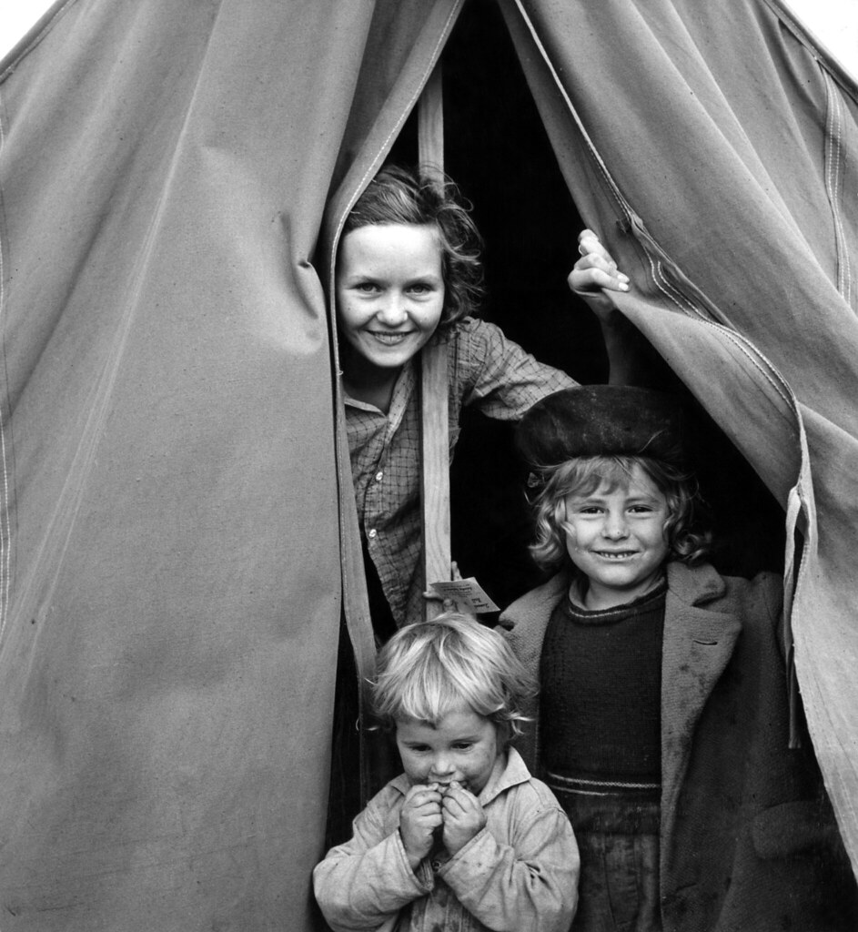

1. Discuss these questions with a friend or family member.

* What did you look at first in the photo?
* What is happening in the photo? What do you think could be happening around the children that the photo does not show?
* Why do you think Dorothea did not include the whole tent in the photo? How are the children positioned in the tent?
* What does the photo tell you about the children’s lives? Do their facial expressions give you any clues?
* Do you think the effect of the photo would change if it was a colour photo? Why or why not?
* Can you find the light and dark parts in the photo?

1. Dorothea taught us about framing your photo before taking it. Try it out. Create a frame out of paper by gluing or stapling four long strips of cardboard or paper to make a square outline.
2. Collect two interesting small objects, such as a leave and a piece of fruit. Choose a fun way to position them on the floor, maybe one on top of another. Place your paper frame around them. Take a picture of your frame with a camera phone if you can. Here are some examples of ‘frame photos’.

| A photo of a white cardboard frame with a painted number 9 and a rock placed inside it. | A photo of a cardboard white frame with 2 rocks and two plastic lids. |
| --- | --- |

1. Experiment with angles, light and position.

* Move your objects around. Place your frame at a different angle around your objects.
* Are your objects in a dark or light space? Move to another part of your floor, maybe near a window.
* Take a picture of your frame if you can.
* How is it different to your first frame photo? Which do you prefer and why?

(Adapted from Camdenville Public School)

**Follow-up activity:** Take a photo of a friend or family member with a camera. Remember what Dorothea said, ‘frame it and make them smile.’ Experiment with different camera angles and standing in light or dark spaces. Remember to ask them to smile.

# Numberblocks – Once upon a time

**ABC ME screening details:** Tuesday 26 May 2020 at 10:00am

This episode can also be viewed on [ABC iView](https://iview.abc.net.au/show/numberblocks).

**Key learning areas:** mathematics

**Level:** lower primary

**About:** Are you sitting comfortably? Then we'll begin a bedtime story all about the first five Numberblocks.

## After the episode

1. We met One, Two, Three, Four and Five in Numberblocks today. Share what you learnt about them with a friend or family member.
2. You are going to play a game using the numbers that we met! The game is a version of ‘Dotty 6’. To play you will need to make a set of number cards (1,1,2,2,3,3,4,4,5,5) and a playing board like below. You will also need two different coloured markers and a friend or family member to play with you.

| To win this game a player makes a row of boxes, with 6 dots in each box. | A 3 by 3 grid with the numbers 1 to 5 as playing cards |
| --- | --- |

**How to play:**

* Put your number cards in a pile. Take turns to turn over a card, write your number down and draw that number of dots in a box.
* When you reach 6 dots the box is full. You can write 6 in the box so that you remember. You cannot split your dots up.
* You can add on to each other’s dots, you don’t have to fill the boxes separately.
* The player who creates a row of full boxes wins, like in noughts and crosses it could be in a row, column or diagonally!

| Here is a picture of the game being played. Can you spot where each player has chosen to draw their dots? Which boxes are full? | A 3 by 3 grid with dots. Similar to noughts and crosses |
| --- | --- |
| The player with the red marker won this round by drawing a red dot in the top right corner box to make 6 dots, which then created three filled boxes. | A game similar to noughts and crosses |

1. Your turn to play! During the game you might think about these questions to help you:

* Where is the best stop to draw this number of dots?
* How many more dots I need to draw in this box to make 6?
* What will my friend do if I draw my dots here?

Adapted from <https://nrich.maths.org/7337>

If you would like to see another version of this game being played you can watch it on the [Thinking Mathematically site](https://sites.google.com/education.nsw.gov.au/get-mathematical-early-stage-1/contexts-for-practise/dotty-six) (internet access required).

**Follow-up activity:** Can you think of a different way to play the game? Could you draw more boxes or play with larger numbers? Have a go and teach your version to a friend.

# Play School Story Time – Debra Lawrance: Ginger

**ABC ME screening details:** Wednesday 27 May 2020 at 10:10am

This episode can also be viewed on [ABC iView](https://iview.abc.net.au/show/play-school-story-time).

**Key learning areas:** English

**Level:** lower primary

**About:** Snuggle up with Debra Lawrance on the Story Time couch as she reads Charlotte Voake's "Ginger", an affectionate account of pet rivalry!

## Before the episode

1. Today’s story is about friendship. Think of a time when you had to share a toy with a friend or sibling but you did not want to. Draw, write or share your thinking with a friend or family member.

## After the episode

1. What a great story about making friends! Retell the story through a puppet show. Plan your show by drawing the beginning, middle and end of the story.

| Beginning | Middle | End |
| --- | --- | --- |
|  |  |  |

1. Let’s get creative!

* Create finger or sock puppets of Ginger and the kitten.
* You could use items out of your recycling or your toys instead.
* Practise acting out the story.
* Perform your puppet show for your class or family.

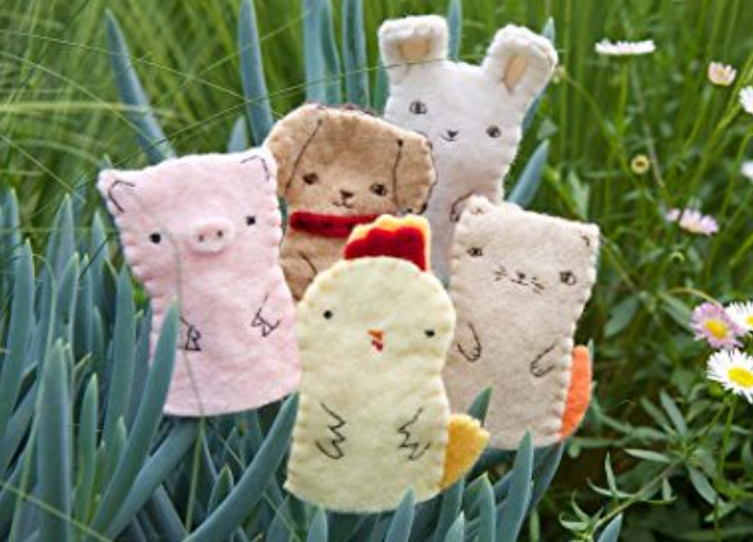

**Follow-up activity:** It is great that Ginger and kitten became friends. What do you think makes a good friend? Is it someone who listens to you or helps you? Describe, write or draw your ideas. What do you do to be a good friend?

# Grandpa Honeyant Storytime – Caar Caaar

**ABC ME screening details:** Thursday 28 May 2020 at 10:10am

This episode can also be viewed on [ABC iView](https://iview.abc.net.au/show/grandpa-honeyant-storytime).

**Key learning areas:** English

**Level:** lower primary

**About:** A very funny and charming story which uses the sounds of animals to relay an incident as it unfolds.

## Before the episode

1. In the story ‘Caar Caaar’, you will see and hear lots of animals. Draw or write about three animals that you know. What sounds do they make?

## After the episode

1. Wow! That was a busy story full of lots of sounds. Time to go on a sound hunt. Move around a room or go for a walk with a family member if you can. Draw, write or make the sounds that you hear.
2. You have just created a soundscape! Time to plan a story to match it. Close your eyes and picture all of the sounds that you heard. What events could go with these sounds? Does your story start with someone closing a door or a bird flying past? Draw or write the **beginning** of your story.

| Beginning |
| --- |
|  |

1. There was a big crash in the story, ‘Caar Caaaar’. What is a problem that could happen in your story and how could it be solved? Draw or write the middle and end of your story.

| Middle | End |
| --- | --- |
|  |  |

1. Time to create your story! Write a sentence or paragraph for each part of your story or you could act it out using props and costumes. Remember to include your sounds, a problem and the way it is solved.

**Follow-up activity:** Perform or read your story to a friend or family member. Ask them what sounds they heard and how the problem was solved in your story.

# Where in the World – Angel, Rhys and Tyra. Helps Mum Cook Lunch

**ABC ME screening details:** Friday 29 May 2020 at 10:45am

This episode can also be viewed on [ABC iView.](https://iview.abc.net.au/show/where-in-the-world)

**Key learning areas:** history

**Level:** lower primary

**About:** In Peru, Angel plays football with his cousins - once he has finished his chores, in Canada, Rhys plays games in school where it's warm, and outside in the chilly snow. And in Ghana, Tyra helps her mum cook lunch.

## Before the episode

1. Draw or write about your favourite food. Tell a member of your family or a friend why it is you favourite.

## After the episode

1. Angel has a number of jobs to do around the house before he can play soccer with his cousins. He has to wash the dishes and sweep. Draw or list the jobs that you do around the house. Which one do you enjoy and why?
2. Rhys lives in Canada where it is very cold in the winter and it snows. In the episode Rhys goes to school. What are the things that are the same and different between your school and Rhys’s?

| Same | Different |
| --- | --- |
|  |  |

1. Tyra pretended to do the washing like her mother.

**She pretended to:**

* Washed the clothes
* Hung the clothes out
* Brought the clothes in
* Washed the teddy
* Put the clean clothes on the clean teddy

Write or draw the steps you do when completing a job for your family.

| Step 1 | Step 2 | Step 3 | Step 4 | Step 5 |
| --- | --- | --- | --- | --- |
|  |  |  |  |  |

**Follow-up activity:** You learnt about families that live in different parts of the world. What is similar or different between your family and Rhys’s, Angel’s or Tyra’s? Share your thinking with a friend or family member.