School Name

My new school
All images in this document are owned by the NSW Department of Education under the Copyright Act 1968 (Cth) or licensed under the iStock Getty Images Content License Agreement

This is my new school. It is called [school name].

This is the gate where I go into my school.

This is my teacher whose name is [enter teacher name]. My teacher and the other teachers at school will look after me while I am at school. I can ask my teacher to help me if I need help. My teacher cares about me and likes to know about me.

I can have a lot of fun at school and learn a lot of things. I might see some old friends there and make some new friends.
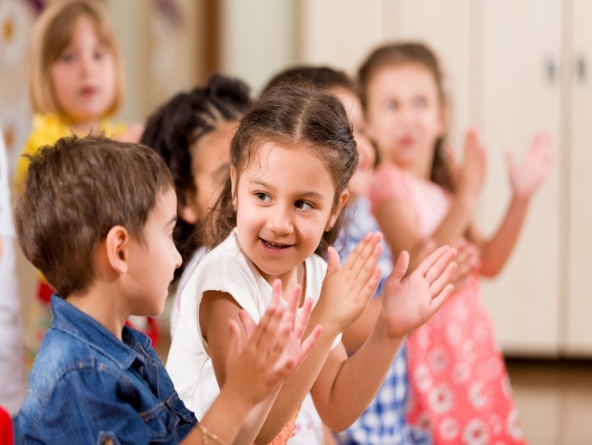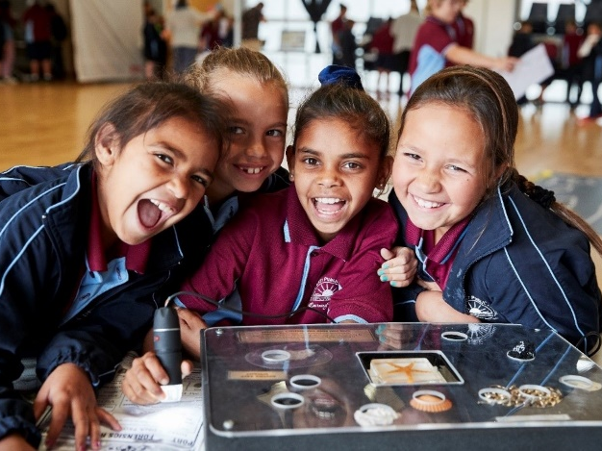

Sometimes I might miss my family while I am at school. Some children might even cry a little bit because they miss their family but the teachers will help them to feel better.
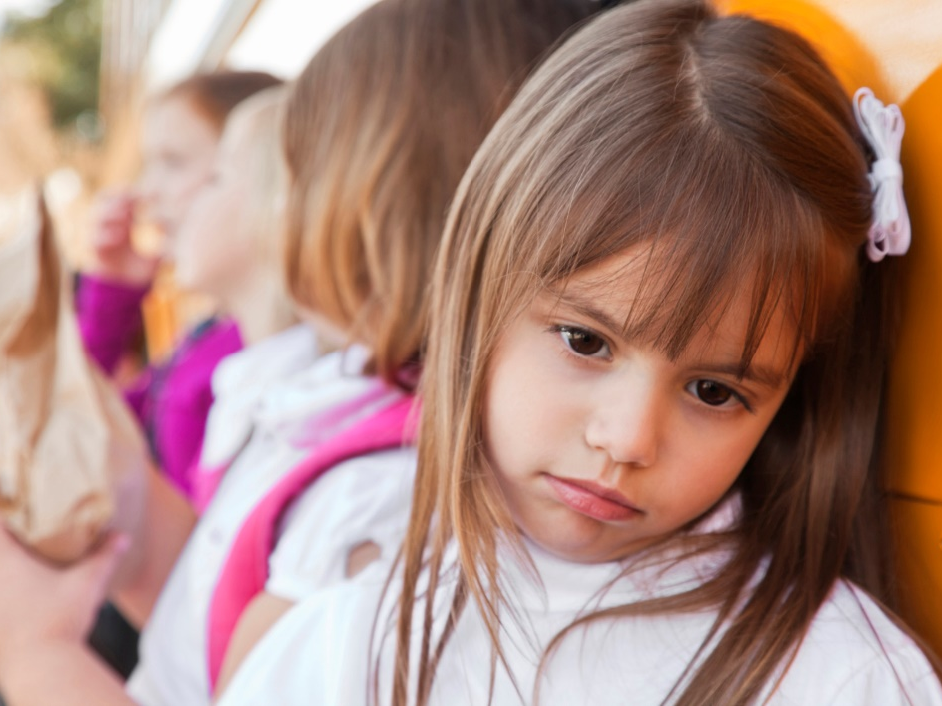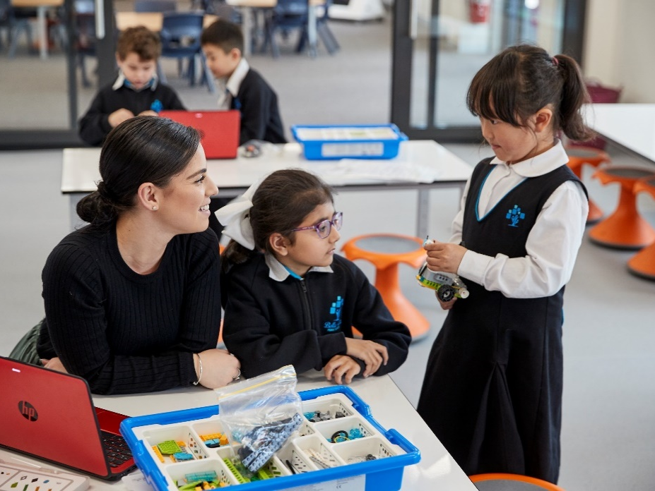

I wear my uniform to school. I wear my hat outside to protect me from the sun.
I have a school bag with my morning tea, lunch, and drinks inside. My name is on everything. This is where I put my bag when I am at school.

I eat my morning tea and lunch at school. I eat healthy food to help me feel good and to grow strong.
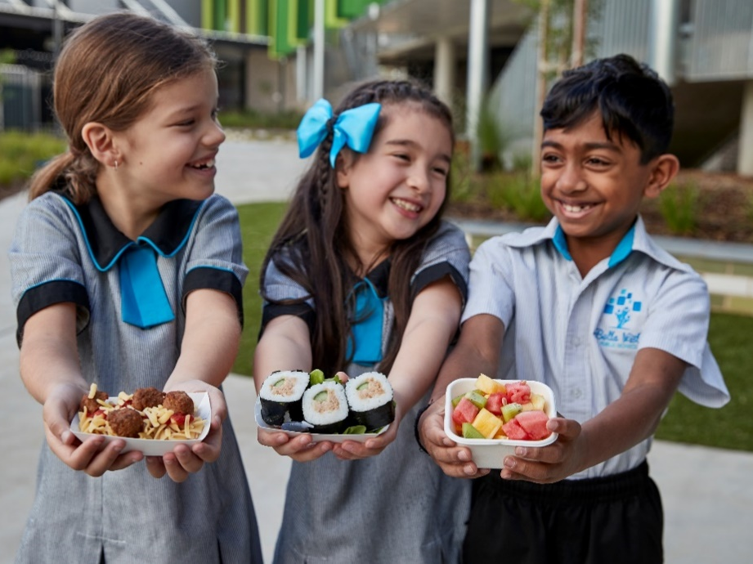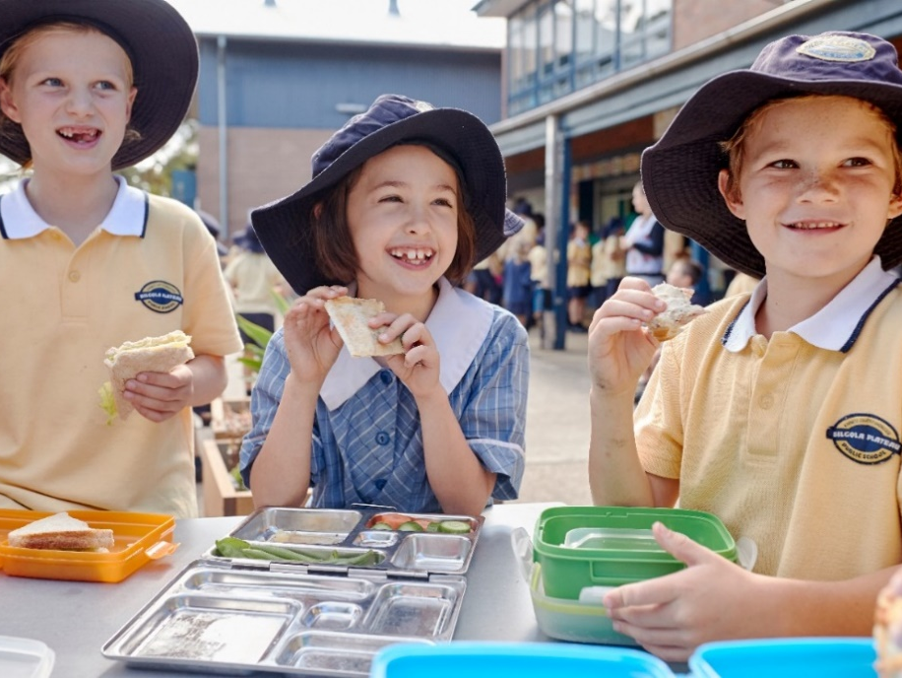

This is the principal whose name is [enter principal name].This is the principal’s office. The principal looks after all the children and the teachers at the school.

This is my classroom where I have fun and learn with the other children in my class. I like learning the names of all the other children and they learn my name as well.

I know how to do a lot of things at school because I have done them before. I draw, paint, paste, count, play, listen to stories and sing songs at school.
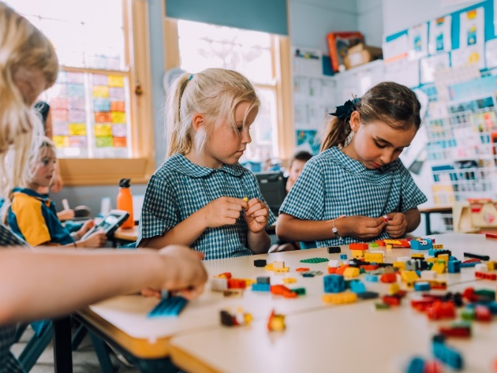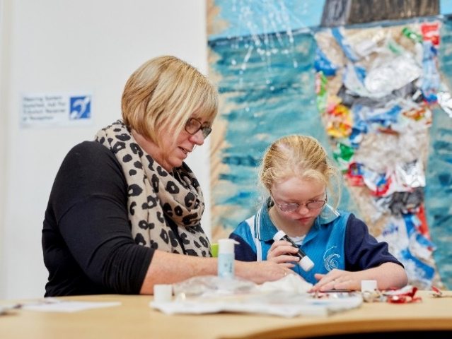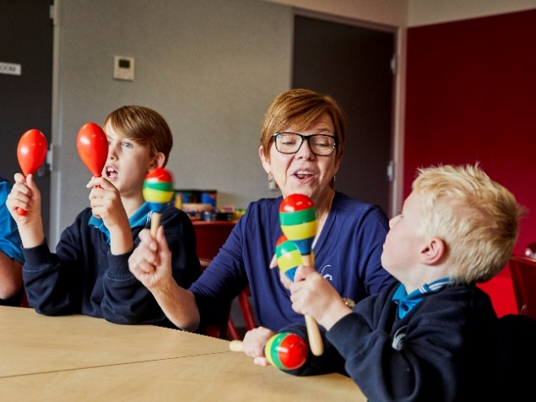

There are tables and chairs in the classroom and a mat where all the children can sit to listen to the teacher read us a story or to help us to learn new things. We learn about reading and maths and science and lots of things.
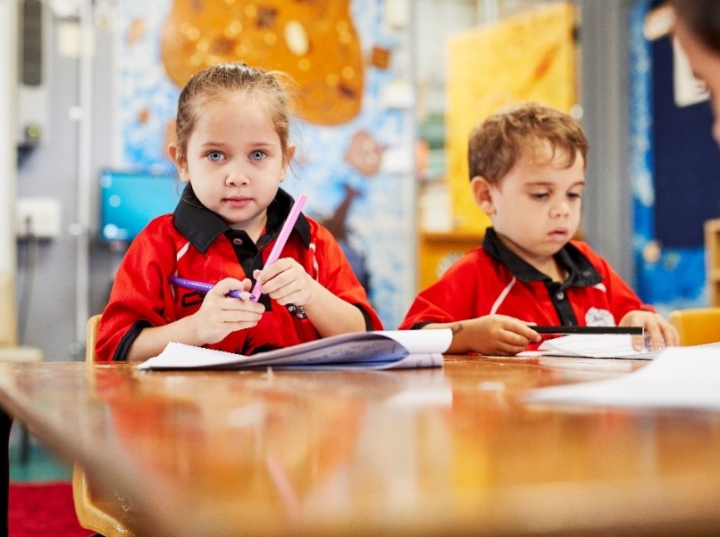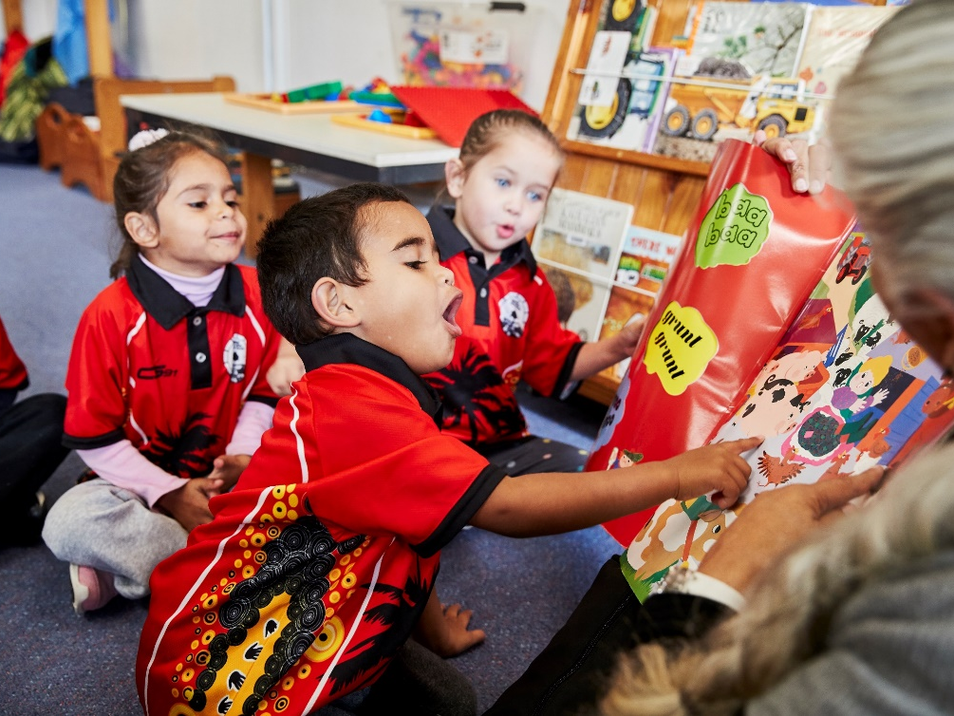

This is the playground. It is fun to talk and laugh and play with my friends in the playground at recess and lunch time.

There are big kids at school. The children in year 6 are the oldest and they look really big. Sometimes some of these big kids can be your friend or buddy at school and help you and play with you.
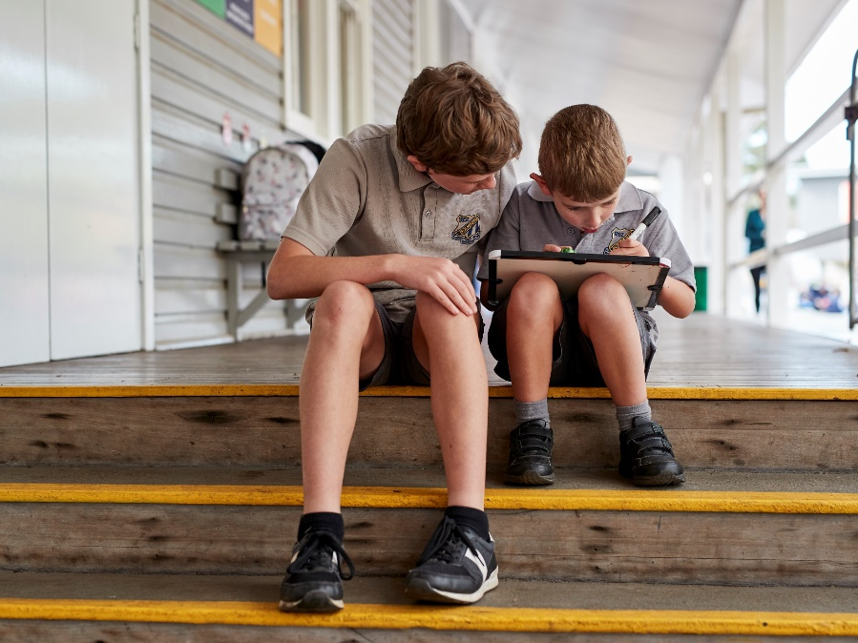

Another thing that you need to know is that there are school days, and weekends and holidays. Monday, Tuesday, Wednesday, Thursday and Friday are school days and Saturday and Sunday are the weekend days. You don’t go to school on the weekend or in the holidays.
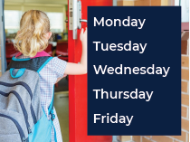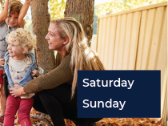

This is the school office. This is [enter name] who works in the office. Sometimes children take messages to the office. I would like to do that one day.

My school has a special room called a library with lots of wonderful books. I can take some books home in my library bag so my family can read them with me.
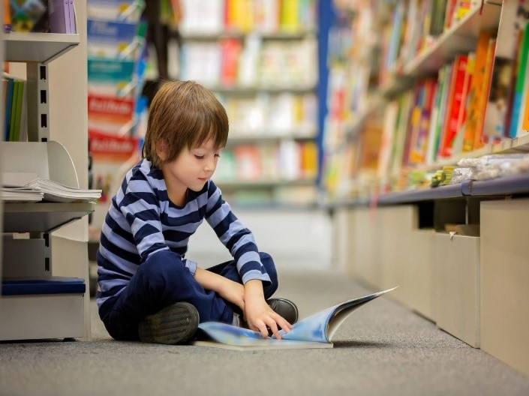

There are toilets at my school. The teachers teach all of the new children about where the toilets are and how to use them. I am glad about that because it is very important to know about the toilets. There are toilets for the boys and toilets for the girls. I always flush and wash my hands after I use the toilet.
All of the children have someone who picks them up after school. The teachers look after me until I am picked up. Some children might go home with their mum or dad or grandma or another person who looks after them. Some children might go to afterschool care and then get picked up from there and go home after that. Some children even go home on a bus.
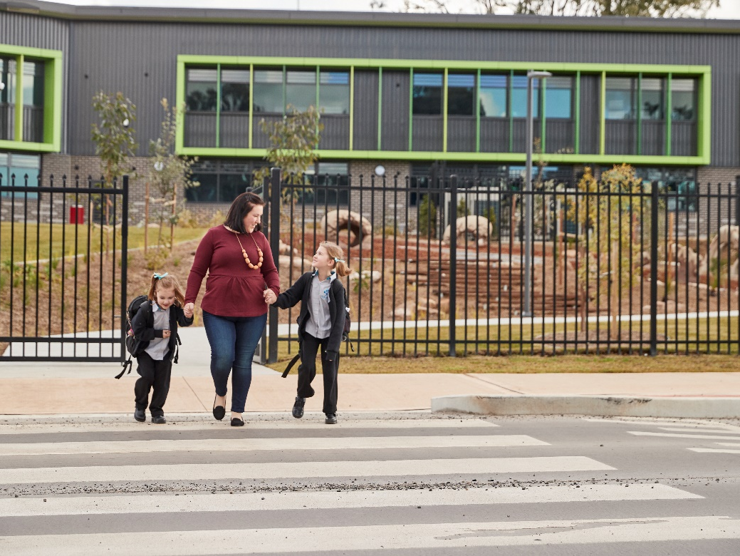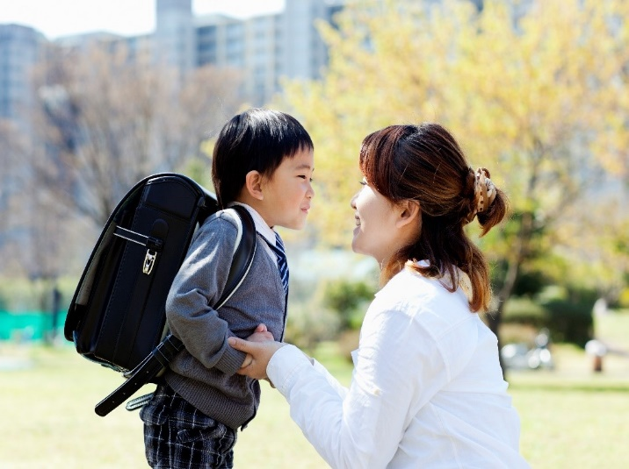

When I am going home I say goodbye and smile and wave to the teachers and the other children.
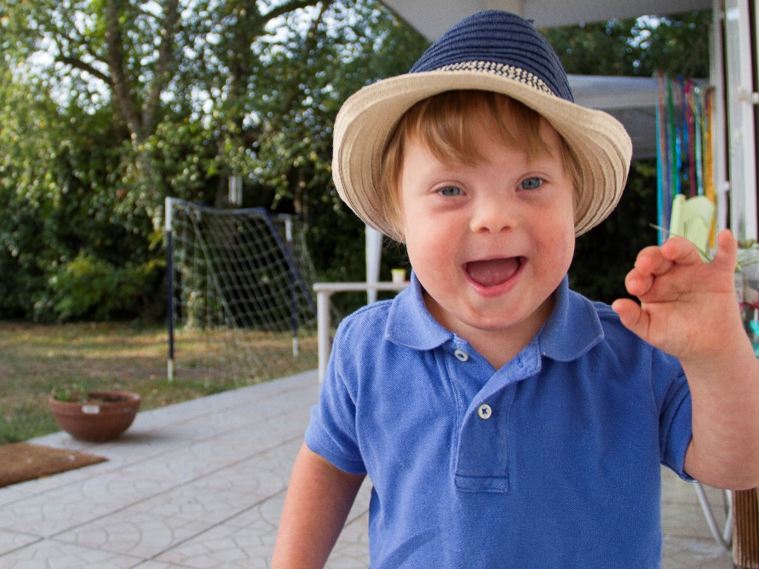
So, is there anything else you would like me to tell you about my new school?

