Presenter tips for Zoom webinars

Spotlight video
For your participants to be able to see you and your presentation, you will need to spotlight your video.
When you share your screen, hover over the video thumbnails. Click on the ellipses. Select spotlight video. Your participants will then be able to see you and your presentation.
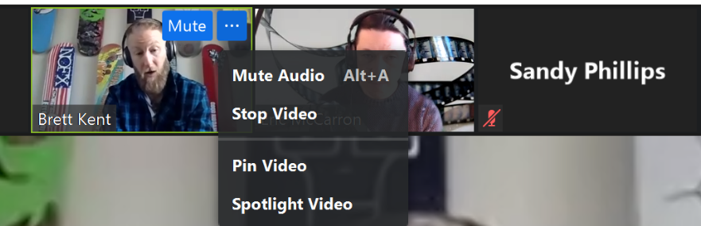

Participant chat
In the chat, it will by default be sending a message to the panelists only. If you want to send a message to the attendees, click on the arrows and select All panelists and attendees. If you want to talk to one person, click on their name in the chat.
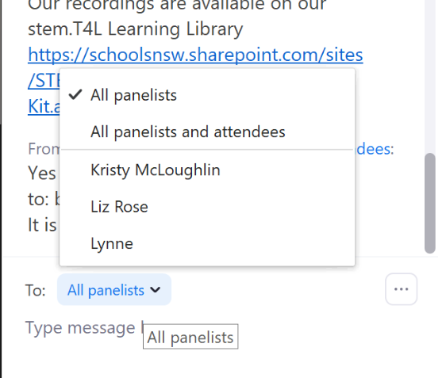

Annotations
You can annotate your screen if you are presenting. Click on view options. Select annotate, and you can draw onto the screen. To annotate on someone else’s screen, move mouse up or down (varies on different devices) to view the View Options at the top of the screen. Click on annotate.
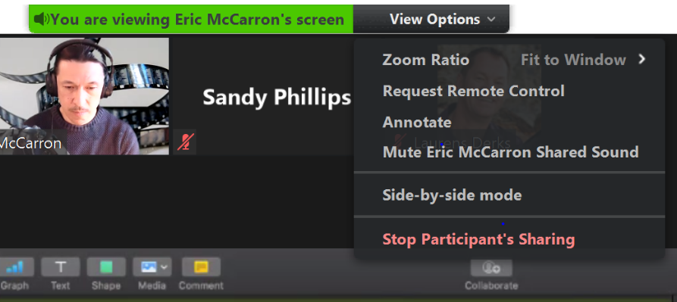
To annotate on your screen, while you are presenting, go to screen share, and choose the document you wish to share. Once sharing, move your mouse to see your toolbar. One of your options is to annotate.
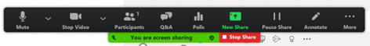
After selecting Annotate, you will see a new toolbar. Under draw, stamp and spotlight there are a number of different options allowing you to customise your annotations. You can save your annotations by clicking on the save button. A screen shot will drop into a zoom folder in your documents.
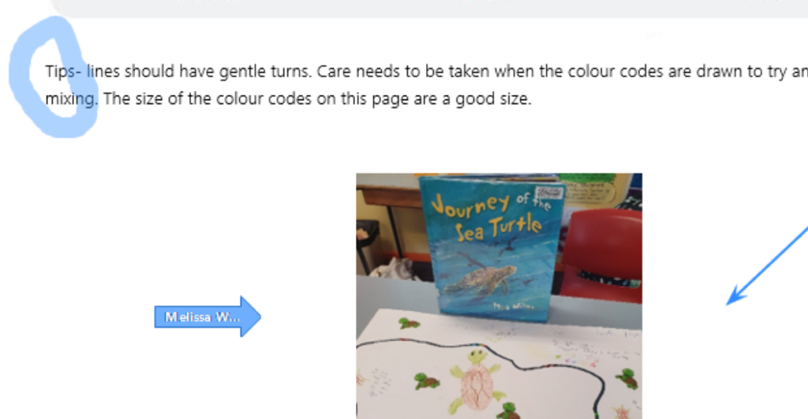
You can also click on the clear button, which will allow you to clear all annotations, only annotations made by others or annotations made by you.

Keyboard shortcuts
To use Zoom keyboard shortcuts, you will need to turn them on. In the Zoom app, open your settings, and check that the shortcuts you would like to use are selected.

Commonly used keyboard shortcuts
Zoom app full list at: https://support.zoom.us/hc/en-us/articles/205683899-Hot-Keys-and-Keyboard-Shortcuts-for-Zoom
Controls | Windows | Mac | iOS | Linux
Always show meeting controls - on/off | Alt | Ctrl + \ |  | Alt
Switch to active speaker view | Alt+ F1 | Command + Shift + W
Switch to gallery speaker view | Al2 + F2 | Command + Shift + W
Pause or resume recording | Alt + P | Command + Shift + P |  | Alt + P
Show/hide floating meeting controls | Ctrl + Alt + Shift + H | Ctrl + Option + Command + H
Close current chat session | Ctrl + W |  | Command + Shift + H | Ctrl + W
Move to next chat session | Ctrl + Up | Command + K

Screen sharing
In a webinar, you will usually want the host and the panellists to be able to share their screen.
Before the webinar starts broadcasting, the host will need to ensure that the panellists have permission to share. In the tool bar at the base of the screen (you may need to move your mouse to be able to see it) you will see a share screen button, with a small arrow beside it. Click on the small arrow.
An options box will pop up. Make sure that you have selected All Panelists in both sections.
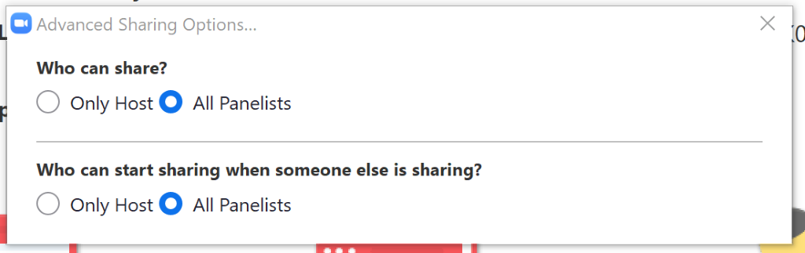
When you are ready to share, click on the share screen button. If you are sharing a video, you will need to select Share computer sound and optimize Screen Sharing for Video Clip.
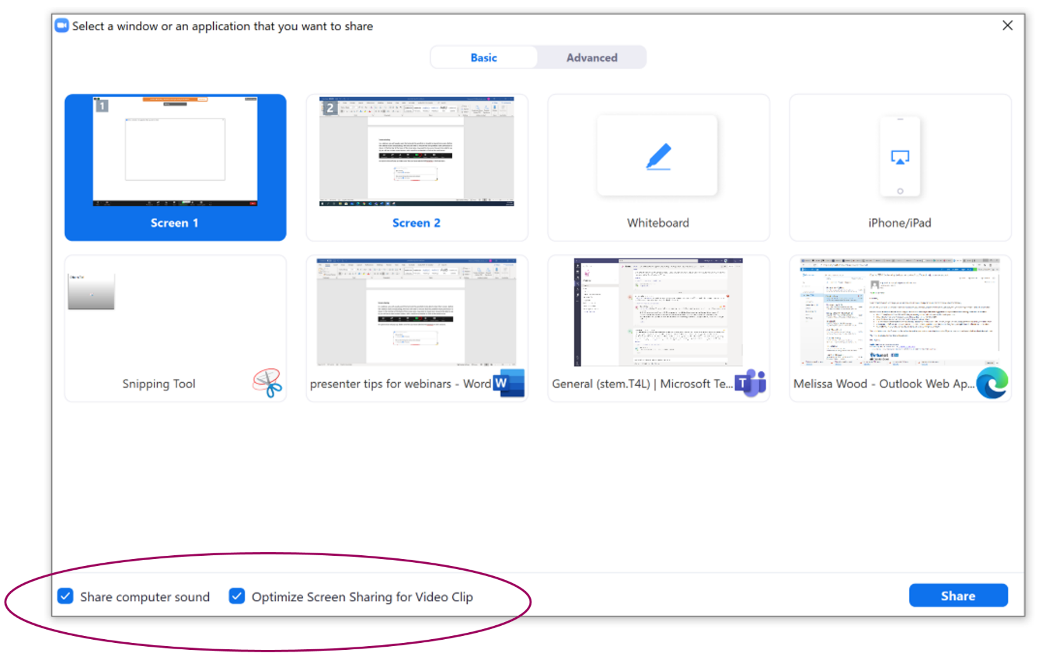
Select the screen you would like to share, and click on the share button.

