Using Zoom on your interactive whiteboard
Displaying Zoom on your interactive whiteboard (IWB) allows a wider cohort access to the Zoom meeting or webinar.
To ensure that the sound comes through the IWB speakers, you may need to change the speaker setting. To do this, join you Zoom meeting or webinar. Move your mouse, or click Alt to display the Zoom toolbar. Click on the arrow beside the mute microphone icon. This will bring up audio settings options. Identify which speakers you are currently using, and toggle to the IWB speakers.
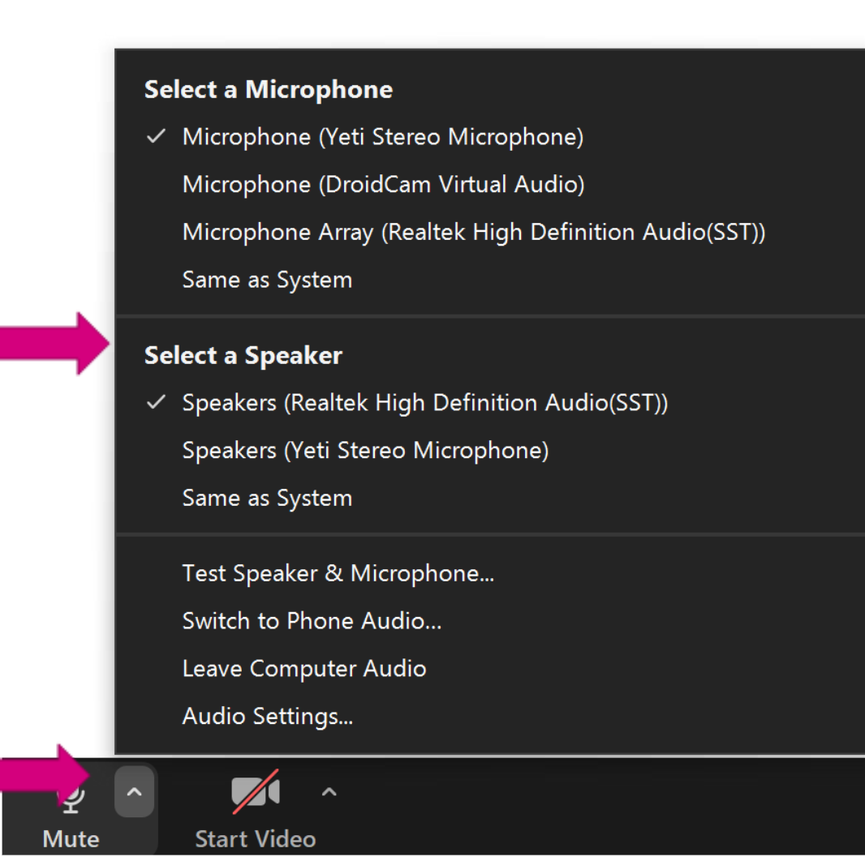

Tip
If you are joining a meeting and the computer connected to your IWB does not have a webcam, consider joining a second time with a laptop that does have a camera. Just remember to mute the sound on the second device.

