Screen sharing in a Zoom Webinar
In a webinar, you will usually want the host and the panellists to be able to share their screen.
Before the webinar starts broadcasting, the host will need to ensure that the panellists have permission to share. In the tool bar at the base of the screen (you may need to move your mouse to be able to see it) you will see a share screen button, with a small arrow beside it. Click on the small arrow.
An options box will pop up. Make sure that you have selected All Panellists in both sections.
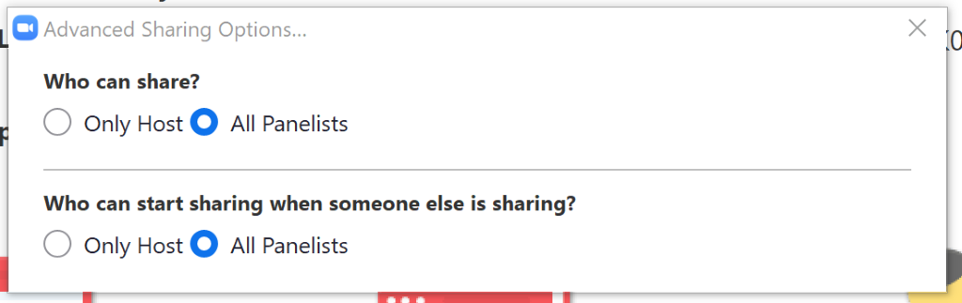
When you are ready to share, click on the share screen button. If you are sharing video, you will need to select Share computer sound and optimize Screen Sharing for Video Clip.
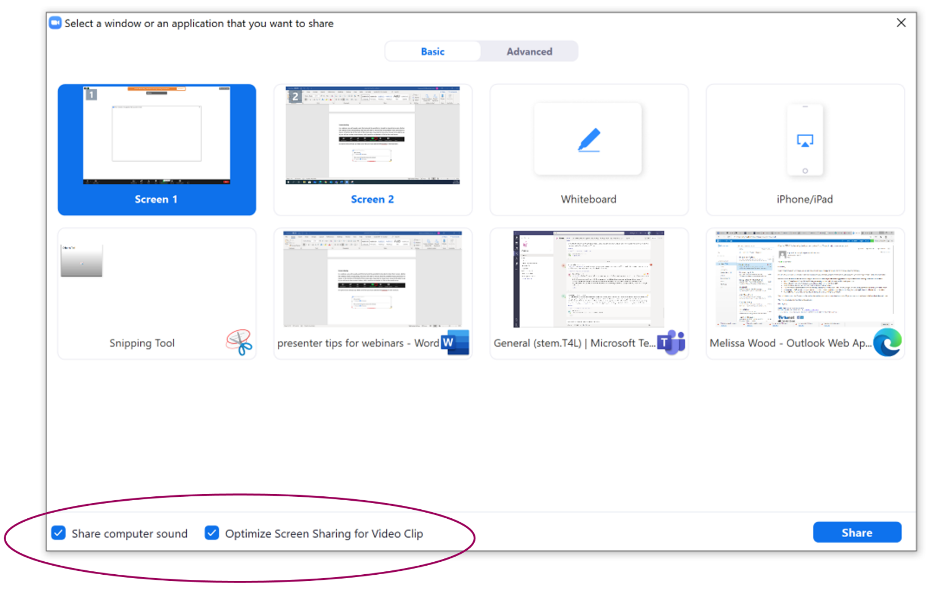
Select the screen you would like to share, and click on the share button.

