Stage 5 Graphics Technology

‘Here be Dragons!’

Student booklet
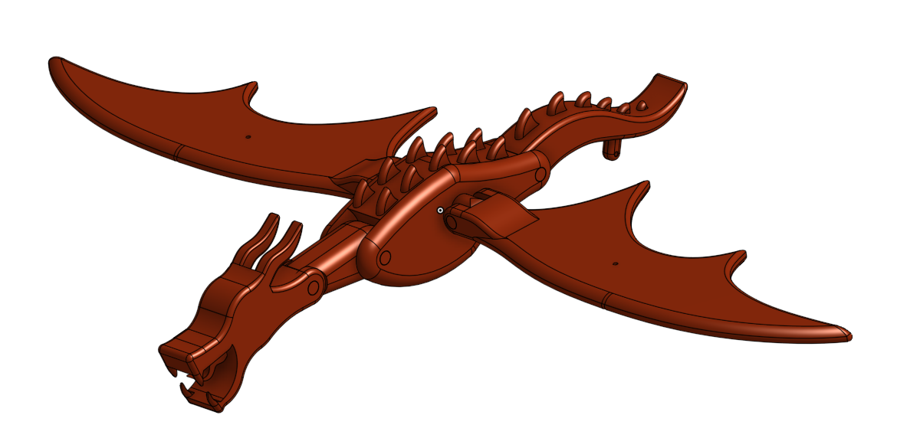

Student name: _____________________________________
Class: ____________________________________________
Teacher name: _____________________________________

Contents
Unit overview 3
Assignment overview 3
Glossary 4
The design and production process 6
Workplace health and safety 7
ICT in the graphics industry 8
CAD versus Instrument drawing 9
Computer-aided manufacture (CAM) 10
CNC milling machine 10
Water, plasma and laser cutters 11
Lathes 11
3D Printers 11
CAD output 12
ASCII 12
DWG 12
DXF 12
OBJ 12
STL 13
Slicing software 13
G-code 13
3D printers 14
So, what exactly is FFF? 14
Computer aided design 16
ISO versus ANSI 16
Planes 17
Designing 19
The body 19
The tail 20
The head 21
Assembly 22
Mates 22
Animation 25
Generated drawings 26
Evaluation 28

Unit overview
This unit addresses Core Module 2: Computer-aided design (CAD) and is intended to be run alongside Core Module 1: Instrument drawing so that content learned in one module can be applied and reinforced in the other.
In this unit you will develop a fundamental understanding of the significance of graphical communication and the techniques and technologies used to convey technical and non-technical ideas and information.
You will take on the role of the graphic designer and complete of a series of exercises using both computer-aided design (CAD) and manual drafting techniques. Theoretical principles learned in this unit will be applied to design, build and animate a simple automaton, that can be physically created through the use of rapid prototyping technologies.

Assignment overview
You will work individually and as a team to complete the work in this booklet. Each student must complete the tasks using the skills demonstrated by their teacher for each of the tools or features within the chosen CAD package. Once you have completed all of the tasks, you will assemble the components and animate the final automaton.
As an extension activity it is possible to physically build the automaton using a combination of 3D printing, laser cutting (if available) and manual hand building skills.

Glossary
Complete the following table with definitions as you progress through the unit.
Term | Definition
Articulation
Automaton
CAD
CAM
Chamfer
CNC milling machine
DXF
Ergonomics
Exploded view
Extrusion
FFF
Fillet
Laser cutter
Lathe
Loft
Offset
Plane
Plasma cutter
Rendering
Revolve
Section view
Shell
SLA
STL
Sweep
Walkthrough
Water jet cutter

The design and production process
Throughout the study of graphics technology, students use a design process and apply it to the development of their project.
The design and production process:
- involves a sequence of organised steps which provide a solution to design needs and opportunities
- may take a few seconds or minutes, such as when you select what clothes to wear, or may take years as in the case with the design of a motor vehicle
- may involve one person or, many people
- may be simple or complex, depending on the task
- involves the designer questioning (or evaluating) throughout the process.
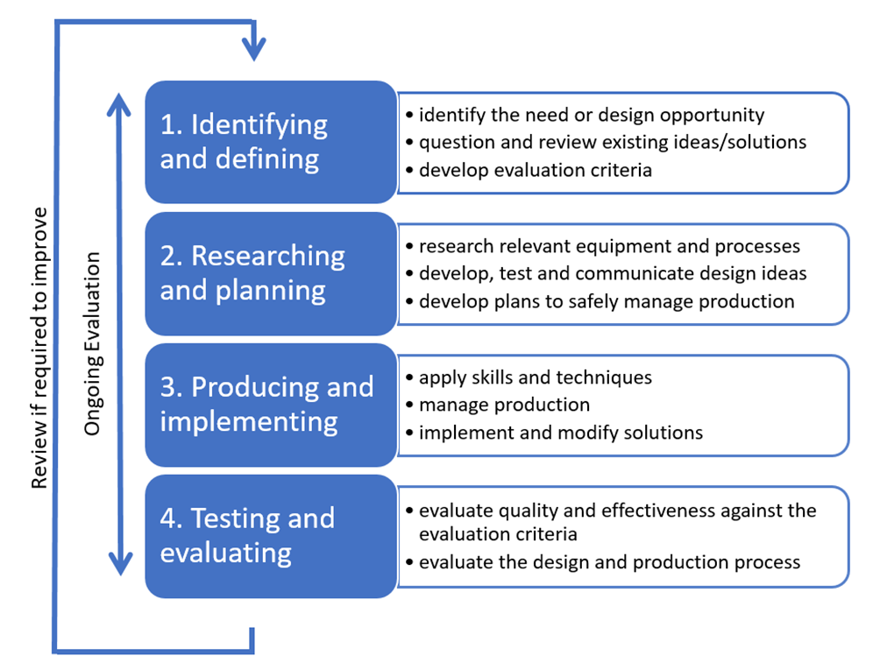

Workplace health and safety
In schools we have access to a range of technology that has the potential to harm if misused or used incorrectly. Many schools have 3D printers, laser cutters, Computer Numerical Controlled (CNC) milling machines and printers, all of which are used to output the work developed within a CAD package. All of these have the potential to cause harm, however, we must also consider the potential harm to the operator whilst developing the files they send to the specific technology.
Ergonomics is the study of how we interact with our environment and how that interaction can be altered to improve our wellbeing and minimise the risk of harm. If we consider the chair that you are sitting on, the desk you are working at, the monitor you are looking at and the keyboard and mouse you use to input information and commands, they all need to be ergonomically designed, in order to minimise the potential hazards in using them.
In small groups, use the Work Health and Safety (WHS) bubble below, to create a mind map of potential WHS issues related to digital technologies and Information Communication Technology (ICT) within the graphics industry.

ICT in the graphics industry
Working in pairs, fill out the table below by identifying how and where the following professions use ICT in their roles. Include details about both software and hardware used.
Profession | ICT used in role
Computer animator
Draftsperson
Engineer
Graphic designer
Industrial designer

CAD versus Instrument drawing
Computer-aided design (CAD) can be seen as an evolution of instrument drawing, but that is not to say there is no longer a place for the latter. You have already started to develop your manual drafting skills, and these form the foundation for everything you will do using CAD.
Some of the benefits that CAD has over instrument drawing include the ability to:
- draw full scale so you do not need to make scaling calculations, reducing the chance of errors
- modify a drawing without having to completely redraw it from scratch or make time consuming changes by painstakingly scratching away ink, in pen and ink drawings
- print off multiple copies for different people or replace copies lost or damaged without having to redraw them
- make a change in real time while the client is there, so they can see the effect it will have
- share the files and email them all over the world instantaneously, allowing collaboration with other professionals or clients not in the same location
- create 3D representations of the plans to allow visualisation of the final design for those that struggle with 2D plans
- animate and create interactions between parts, which allows you to check clearances and operation
- generate a range of working drawings including sections, details and dimensions all from the original 3D file rather than having to redraw them manually
- create 3D walkthroughs of architectural plans so that clients can visualise themselves in the space
- create photo-realistic rendering of models by applying texture maps, backgrounds and lighting to make it look real
- incorporate VR to create an immersive experience and interact with the design before production or even a prototype.
One of the other benefits of CAD is the ability to output the files created to a range of sources. One of the most common ways is to print them off, so you have physical drawings that can be used as reference for making the item in a workshop or building site where there may not be computers available. They can also be used to easily to make notes and sketches about alterations, or even just be something tangible that a client can hold and use.
CAD also allows us to do so much more. One way we can do this is through the use of computer-aided manufacture (CAM), including 3D printing, laser cutting and CNC machining.

Computer-aided manufacture (CAM)
So, what exactly is computer-aided manufacture?
CAM can be defined as the use of software and computer-controlled machinery to facilitate and automate a manufacturing process. But what does this mean? In your own words provide a short explanation of what CAM is. Have a look at the Autodesk blog for help.
CAM is the process that turns our ideas into reality, but in order to do this, it needs three distinct parts:
- software used to draw the model, such as PTC Creo, SolidWorks, Fusion 360 and Onshape
- software that deciphers the drawing and converts it into something the machinery can understand, such as a slicer software that generates G-code
- the machinery itself which produces your model.
For now, if we consider the machines that make it all possible. The list below is some of the technology you may be able to utilise depending on what your school has, or what you may be able to outsource.
For each of the identified pieces of equipment provide some information on what they are and what they can do.

CNC milling machine

Water, plasma and laser cutters

Lathes

3D Printers

CAD output
The first step of the CAD or CAM process is the use of CAD software to produce a 3D model, which you will be attempting yourself later on in this booklet. Once you have drawn your model you will need to save it and prepare it for what it will become.
CAD programs use a range of file types to save their parts, such as OBJ, DWG and DXF. These allow the program to understand what you have done, but these do not necessarily talk to the machine, that is where the STL file extension is used.
Before we move on, we need to look at these file types:

ASCII
ASCII stands for American Standard Code for Information Interchange. It was originally used for telegraph machines but has become the common denominator between programs and applications that do not import each other’s formats. If both applications can import and export ASCII (text based) files, you can transfer your files between them.

DWG
Files with the .dwg extension were originally created for the very first launch of the AutoCAD software back in 1982. It contains all the information that a user enters in a CAD drawing. This includes the vector image data and metadata that describes the content of the file. DWG files are related to DXF files, which are ASCII versions of DWG files. Files in DWG format can be opened with Autodesk AutoCAD, IMSI TurboCAD, Graphisoft ArchiCAD, Adobe Illustrator and others.

DXF
Files with the .dxf extension are a data file saved in a format developed by Autodesk and used for CAD vector image files, such as AutoCAD documents. DXF files are similar to DWG files, but are more compatible with other programs since they are ASCII (text) based. The DXF format was developed as a universal format so that AutoCAD documents could be opened more easily with other programs. For example, you can export 3D models as DXF files, which can be opened and edited with other 3D modelling programs.

OBJ
Files with the .obj extension are more formally a Wavefront 3D Object File, which was developed by Wavefront Technologies. It is a file format that has been adopted by a number of 3D graphics packages and is used for a three-dimensional object containing 3D coordinates (polygon lines and points), texture maps, and other object information. Object files can be in ASCII format (.obj) or binary format (.mod). It supports both polygonal geometry, which uses points, lines, and faces to define objects and free-form geometry, which uses curves and surfaces. Files in OBJ format can be opened with Autodesk Maya, Blender, Microsoft 3D Builder, Adobe Photoshop, MeshLab and others.

STL
Files with the .stl extension describe the surface geometry of a three-dimensional object without any representation of colour, texture, or other common model attributes. STL stands for stereo lithography, with lithography being a process of printing on a flat surface or single layer and stereo adding those extra layers to create a better image, or in this case a 3D form, hence stereo lithography. The STL file format is the most commonly used file format for 3D printing. When used in conjunction with slicing software, it allows a computer to communicate with a 3D printer.

Slicing software
Slicing software is the term used to describe the software that forms the link between your drawing and the machinery by converting the 3D model into a set of specific instructions for the machine.
What it does is to create paths for a 3D printer, CNC mill or router to follow. These paths are instructions for geometry and tell a device how fast to go for various points and in the case of 3D printing the thickness of the layer being laid down, or for milling the depth of cut being performed. Most of the more advanced software packages also take into account Geometric Dimensioning and Tolerancing (GDT) which allows you to create information about the part’s design intent and tolerances so that the finished part is suitable for longer term end use.
In essence, the slicing software translates the 3D model into something the machine can understand and create. It does this by turning your design into G-code which is a simple control language that machines can understand.

G-code
G-code stands for geometric code. Its main function is to instruct a machine head how to move geometrically in 3 dimensions. However, it can also instruct a machine to do non-geometric things. For example, G-code commands can tell a 3D printer to extrude material at a specified extrusion rate or change its bed temperature.
G-code can be thought of as sequential lines of instructions, with each line telling the machine to do a specific task. The machine executes the lines one by one until it reaches the end.

3D printers
These machines cover a wide range of technologies but the key difference between them and the other computer aided manufacturing tools is that 3D printers build up material, using additive technology whereas other methods remove material, which is known as subtractive technology.
The most common type of 3D printer in schools is the relatively basic filament printer that comes in all shapes and sizes. This type of printer is more correctly known as either fused filament fabrication (FFF) or fused deposit modelling (FDM). The difference between them is nothing, it is a trademark issue. The term FDM was trademarked by a company called Stratasys Inc. and as a result the term FFF was then introduced and used by others in the industry as an alternative for the same process, just a term they wouldn’t get sued for using.

So, what exactly is FFF?
With fused filament fabrication we begin with a reel of filament which is fed into the printer at a consistent rate, heated to a useable temperature and then forced through a heated nozzle of a smaller diameter. The print head then places the molten material in the correct location on the x, y and z axes, gradually forming the 3D part.
FFF allows for the use of a range of different materials including ABS, PLA, TPU, PET and Nylon, each of which provide different properties and suitability for printing different parts.
Using the 3D Hubs website, in the table below identify what the material is (in other words, its full name) and what properties make it desirable for 3D printing. Provide examples for their potential usage and the temperatures at which they are printed.
Material | Description
ABS
PLA
TPU
PET
Nylon
These are by no means the only filaments you could use in your 3D printer at school, but many of the other materials are more tricky to print with or in some cases require a specialised print head in order to handle printing with them.
FFF is not the only type of 3D printing available, although some of them are not suitable for the school situation, but some of the more commonly used techniques are:
- stereo lithography apparatus (SLA)
- digital light processing (DLP)
- selective laser sintering (SLS)
- selective laser melting (SLM)

Computer aided design
Now that we know what we can do with our drawings it is almost time to make some.
AS1100 is the Australian Standard for technical drawing and it defines the general principles for technical drawing including both architectural and mechanical designs.
These standards set out specifications and procedures to make sure a material, product, method, or service can do what it is meant to do and perform consistently the way it is meant to perform.
In the case of our Standard, AS 1100.101-1992, it specifies:
- the use of abbreviations
- materials, sizes and layouts of drawing sheets
- the types and minimum thicknesses of lines to be used
- the requirements for distinct uniform letters, numerals and symbols
- recommended scales and their application
- methods of projection and of indicating the various views of an object
- methods of sectioning
- recommendations for dimensioning including size and geometric tolerancing
- conventions used for the representation of components and repetitive features of components.
Most of these will be controlled by the CAD package after you set it up the first time.
Each of the CAD packages available will differ slightly and your teacher will show you exactly how to do this for the one you use in your school. Below are some of the settings you will need to alter.

ISO versus ANSI
Many CAD packages offer some simple customisation in the choice of ISO or ANSI. These are another form of standards like the Australian Standard we already looked at. ISO stands for the International Organisation for Standardisation, which is based in Switzerland and there are 164 national standards organisations worldwide who are members. They define standards for all manner of things from manufacturing, to food safety and healthcare. On the other hand, ANSI is the American National Standards Institute and is based in the USA, they too coordinate the US standards with international standards so that US products can be used worldwide. They are also a member of ISO.

So, what are the differences when it comes to technical drawing? Some of the differences generally are:
- ANSI dimensions are written horizontally, whereas ISO dimensions are parallel to the dimension line.
- ANSI dimensions are generally centred in the middle of the dimension line, whereas ISO dimensions are still generally centred but placed above the dimension line.
- ANSI tends to use abbreviations, whereas ISO uses symbols. (for example: RAD, DIAM, 3 PLACES versus R, Ø, 3X)
- ANSI uses 3rd Angle projection, whereas ISO use 1st Angle projection.
In terms of what that means for you as a user, if there is an ISO option choose that one but then modify it to use 3rd Angle projection.

Planes
In geometry, a plane is a flat surface that extends forever in two dimensions but has no thickness. It is difficult to visualize a plane because there is nothing like it in real life. We can use the surface of a wall, the floor, or even a piece of paper to represent a part of a geometric plane. Just remember that unlike these real-world examples of parts of planes, geometric planes have no edge to them. The ones shown here are from a CAD program called Onshape and they are similar to the ones used in CREO.
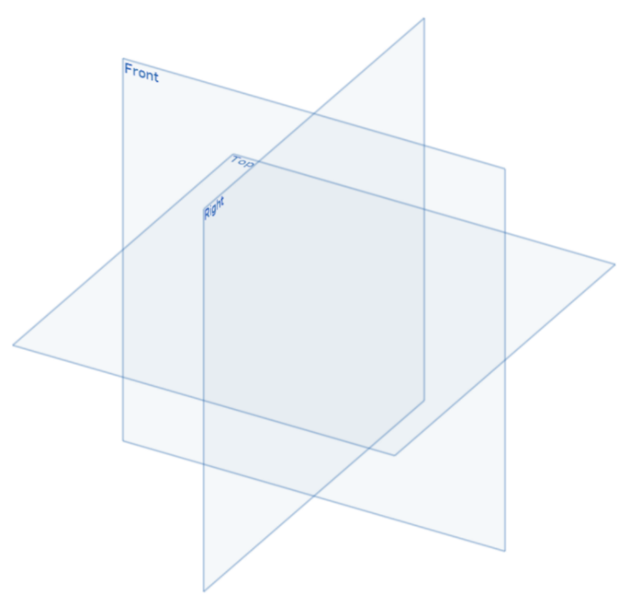
They tell the software where it is in space that you are drawing and how your drawing is going to interact with other drawings and components. Effectively they refer to planes or surfaces in space that relate to the X, Y and Z axes. However, by labelling them as front plane, top plane and right plane, there is no need to concern yourself at the start with whether you are drawing in third angle or first angle as the front of your object will always be drawn on the front plane and you select the angle of projection only when generating the drawing from your 3D model. When creating your sketch, the centre of the three planes is called the origin point, which would equate to 0,0,0 on the three axes.

Other programs have different ways of displaying this and Autodesk products refer to theirs as the user coordinate system (UCS).
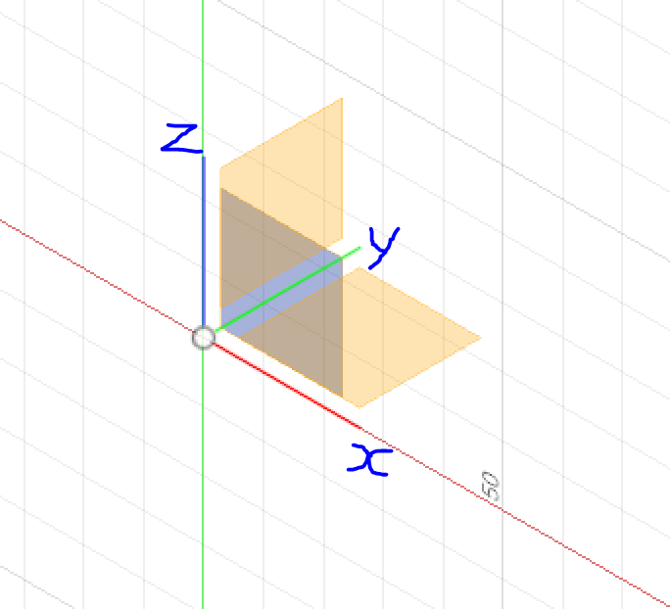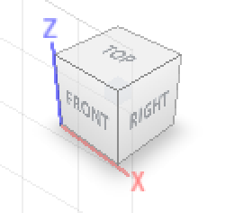
In order to make the setup as close to AS1100 as possible, during the setup for Fusion 360 you need to tell the software that you want to draw in third angle projection in the preferences section. This reorientates the UCS icon so that it looks like the one on the left (minus the letters). But it still does not tell you which of the three planes you are drawing on. For that you need to check the navigation cube, which can be found in the top right-hand corner of the screen whilst in Fusion (shown on the right above).

Designing
In the CAD Exercises workbook there are occasions when you are required to customise the design for some of the components used in the Dragon Automaton such as the body, tail and head. This is so that each automaton will be slightly different and allows more creativity in the design.

The body
In the space below, sketch some possible different body shapes or features you could use for your design.

The tail
In the space below, experiment with ideas for the tail by generating some sketches of what it might look like.

The head
In the space below, sketch some quick ideas of features you would like your dragons head to have. You may want to do some research online to get some more ideas.

Assembly
Now that you have all of the components necessary to make your automaton you will need to start to assemble them so that you can animate them.
Even if you were not intending to animate your design you can use the tools within your CAD package to align and locate the different parts and components of the design in the correct location so that it looks correct, but that doesn’t mean the software knows how they will actually interact. In order to animate the design in some way, you will need to use “mates” to control the way the parts interact with each other.

Mates
The names of mates will differ between software packages, and depending on what is available in your school your package may have one type but not another, in some cases the name is all that is different but the function is the same. All of the following headings are from Onshape, but you are free to use whatever software you want. For each of the mates listed, suggest a potential location where the mate could be used or will be used on your automaton.

Fastened mate
This is also known as a Rigid Mate in Fusion 360, or a Lock Mate in Solidworks. This involves connecting two entities together at a known point and removing all degrees of freedom between them. Identify where a fastened mate could be used in your dragon below.

Revolute mate
Mate two entities allowing rotational movement about the Z axis. Identify where a revolute mate could be used in your dragon below.

Slider mate
Mate two entities allowing translational movement along the Z axis. Identify where a slider mate could be used in your dragon below.

Planar mate
Mate two entities allowing translational movement along the X axis and the Y axis, and rotational movement about the Z axis. Identify where a planar mate could be used in your dragon below.

Cylindrical mate
Mate two entities allowing translational movement along the Z axis and rotational movement about the Z axis. Identify where a cylindrical mate could be used in your dragon below.

Pin slot mate
Mate two entities allowing rotational movement about the Z axis and translational movement along the X axis. Identify where a pin slot mate could be used in your dragon below.

Ball mate
Mate two entities allowing rotational movement about the X, Y and Z axes. Identify where a ball mate could be used in your dragon below.

Parallel mate
Mate two entities allowing individual translational movement along any axis, and parallel rotation along any axis. Identify where a parallel mate could be used in your dragon below.

Tangent mate
Mate two entities tangent to the selected faces, edges, or vertices. Identify where a tangent mate could be used in your dragon below.

Animation
Once your dragon automaton has been correctly assembled you will be able to check and make sure all of the mates and assemblies are correct by attempting to animate it.
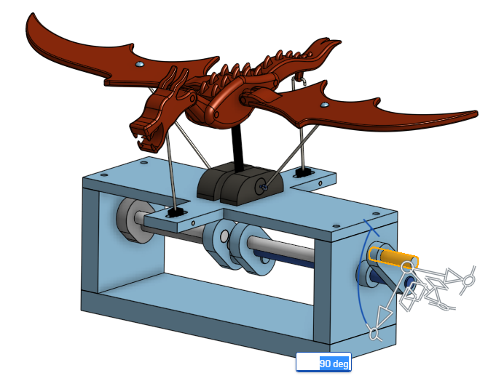
What you should see when the handle is wound, is that the body forms a wave motion, and the wings move up and down.
You will need to follow the instructions in the CAD exercises booklet and use a screen capture tool to record the movement of your automaton and submit it to your teacher as proof that everything is assembled correctly.

Generated drawings
Once your automaton is assembled you will need to produce an orthogonal drawing of the final design. This drawing should include the three main views, a detail view, some basic dimensions, a title block, callouts and a parts list. It should be laid out on an A3 page following AS1100 conventions. An example of what it should look like is shown below.
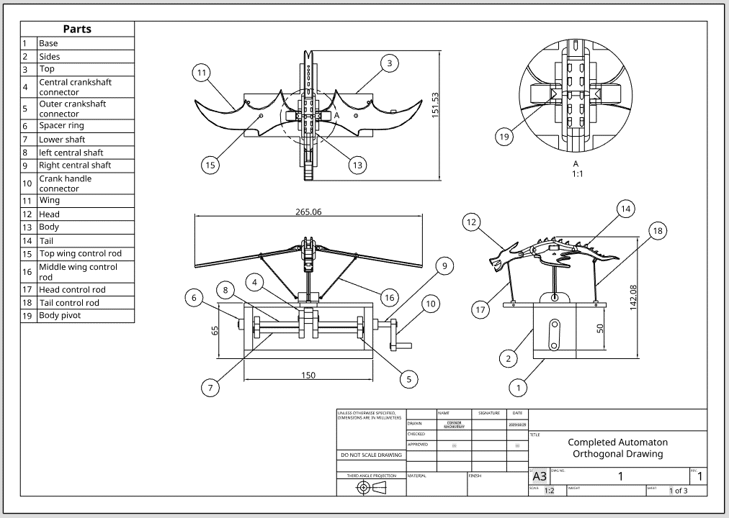
Follow the instructions in the CAD exercises booklet to generate an orthogonal drawing of your dragon automaton.
You will also need to generate a pictorial drawing using isometric projection at an appropriate scale, using the same A3 sheet with title block. An example of what it should look like is shown below.
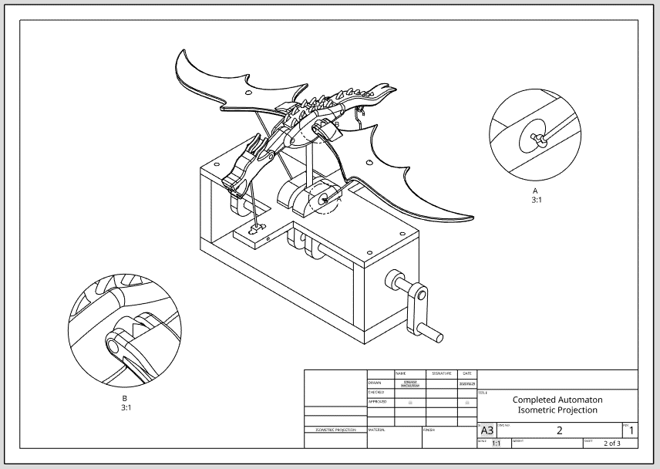
And finally, you will need to orientate your dragon automaton into the best 3D view that showcases your work. Then take a screen capture of that view and upload the image into Onshape to use in generating the final drawing. This time use an A4 sheet with a title block. An example of what it should look like is shown below.
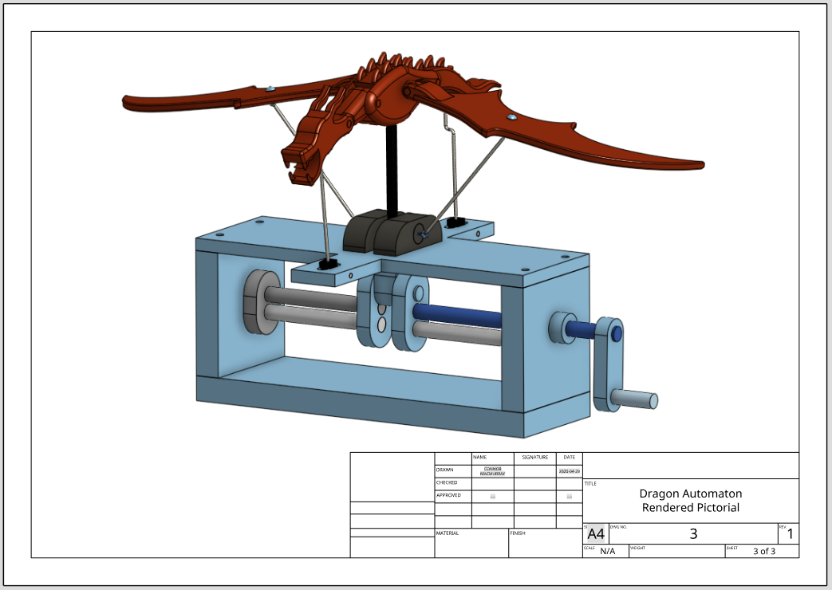
You will need to print out all three of the drawings and submit them for marking along with this student work booklet.
Your final design should be digitally shared with your teacher through Onshape.

Evaluation
Answer the following in the spaces provided.
- Identify the main challenges or difficulties you faced when drawing your automaton.
- What changes have you made to the original design or would you like to make to the original design and why?
- Does your automaton function as intended? If it does, do you think there is any way of improving it? If it doesn’t, what troubleshooting have you done to get it to work?

