Physics Module 6: electromagnetism

Table of contents
Table of contents 2
Teaching the year 12 modules 4
Course overview 4
Module summary 6
Big ideas 6
Charged particles interact with electric and magnetic fields 6
Work and Conservation of Energy 7
There is a symmetry between electric and magnetic fields 7
Applications of physics in the development of technologies 7
Relationship to other modules 7
Core concepts 9
Motion of charged particles in electric and magnetic fields 9
The Motor Effect 10
Electromagnetic induction 10
Operation of technologies 11
Opportunities for extended concepts 11
Operation of particle accelerators and detectors 11
Rates of change and Faraday’s law 12
Exploring the 2018 revision of the SI 12
Exploring eddy currents 12
The operation of other AC devices 12
Alternative conceptions and misconceptions 13
Relating induced emf to magnetic flux rather than change in flux 13
Newton’s third law in electromagnetism 13
Confusing electric and magnetic fields 14
Further reading 14
Conceptual difficulties 15
Rates of change and proportionality 15
Working with vectors in three dimensions 15
Emf and potential difference 17
Lenz’s Law and predicting the direction of an induced emf and/or current 17
Applying the correct ‘right-hand rule’ 18
Suggested teaching strategies 18
Drawing on prior knowledge 18
Charged particles and fields 18
The Motor Effect 19
Electromagnetic induction 19
Operation of technologies 20
Suggested investigations 21
The motor effect 21
Eddy currents 21
Back emf 21
Appendix 1: The motor effect pre-test 22
Question 1 22
Question 2 22
Question 3 23
Question 4 23
Appendix 2: The motor effect investigation 24
Appendix 3: Past HSC questions mapped to similar current Stage 6 concepts 26
Appendix 4: Inducing eddy currents in a copper block 27
Appendix 5: Scaffold for predicting the direction of induced currents 29
Appendix 6: Three right-hand rules for electromagnetism 31
Resources 33
Websites 33
Studies and papers 34
Resources outlining the 2018 revision of the SI 34

Teaching the year 12 modules
The new Stage 6 Physics course was implemented in NSW schools in 2018-2019. This syllabus incorporates new content and learning activities such as Depth Studies. The syllabus is designed around inquiry questions and formal assessment tasks emphasise the skills for working scientifically.
The Year 12 course provides avenues for students to apply the concepts they were introduced to in Year 11 to motion in two dimensions, electromagnetism, theories of light, the atom and the Universe.
Therefore, pedagogies that promote inquiry and deep learning should be employed in the Physics classroom. The challenge presented by the additional content and the change in pedagogical approach were the catalysts for the preparation of these module guides for Stage 6. These guides are intended to assist teachers deliver Physics effectively by outlining overarching concepts (big ideas), core and extended ideas, strategies for teaching the modules, uncovering of alternative conceptions, and strategies to address them. The guides support the teacher in facilitating the development of deep knowledge structures, such as the relationships between concepts. The module guides do not cover all aspects of the syllabus, as that was not within the scope of the project.
It is essential that teachers note that the module guides do not substitute the syllabus, but only support teachers to teach it. The information contained in these documents are correct at the time of publication. While every effort has been made to eliminate errors, any errors or omission that are identified after the release of these documents will be corrected and released as resource updates. It is recommended that teachers access the Curriculum website for the latest version of these documents.

Course overview
The Year 11 course introduces fundamental concepts of motion, forces, fields, energy and momentum. It provides opportunities for students to develop skills in Working Scientifically, including skills related to the quantitative analysis and modelling of physical systems.
The Year 12 course further develops these concepts and applies them to the analysis of phenomena and technologies that are relevant to society and to contemporary physics. The Law of conservation of energy, along with the development of theories and models form common themes across each of the modules. The role of scientific investigation and evidence in advancing our understanding is explored in detail in Modules 7 and 8.
Inquiry questions are included in the course content and are used to frame the syllabus. The depth of understanding required to fully address the inquiry questions may vary. This allows for differentiation of the course content to cater for the diversity of learners.
During the teaching of the Year 11 course, it is expected that students have been provided opportunities to develop all seven of the Working Scientifically skills. Ideally, these would be embedded into the teaching of the Knowledge and Understanding components of the course. In preparation for the Year 12 course, students in Year 11 could benefit from work that engages them in the following areas:
- Propose hypotheses, design and conduct valid and reliable practical investigations that effectively use technologies to collect and analyse data. Teachers should look for opportunities to engage students in these beyond where the syllabus explicitly states the need to conduct a practical investigation.
- Construct and analyse graphical data for both primary and secondary sources. This should include describing relationships between variables, particularly time-varying quantities such as displacement and velocity. Emphasis should be placed on extracting qualitative and quantitative information from the gradient and/or the area under a graph.
- Evaluate and improve the quality of data collected. Students should be encouraged to recognise errors, uncertainty and limitations in the data they collect. Practical investigations provide opportunities to practice quantifying errors, including the calculation of absolute and relative errors, along with techniques such as the use of a line-of-best fit to minimise the impact of random errors in measurement.
- Assess the uses, benefits and limitations of various types of scientific models. Models are a powerful tool in science, allowing phenomena to be more easily explained and predicted by capturing and highlighting only the most important features of a system. For example, when analysing gravitational potential energy (GPE) in Module 2, it is beneficial to employ a model in which acceleration due to gravity is a constant 9.8 ms⁻² and arbitrarily set $GPE=0$ at the Earth’s surface. This model is suitable for analysing the motion of objects close to the Earth’s surface including projectiles, pendulums and rollercoasters. However, students should also be encouraged to consider the limitations of such models. For example, the model above would not be appropriate, or effective, for analysing the motion of satellites as acceleration due to gravity cannot reasonably be considered constant over large distances.
- Study the rates of change of quantities including displacement, velocity, temperature and energy to support deeper insights into physical phenomena. Rates of change are particularly important to the understanding of electromagnetism in Year 12.
- Collect relevant information from secondary sources and determine the accuracy, reliability and validity. Many of the investigations will require students to obtain information from the Internet or other sources. Students will benefit from learning how to access suitable information and appreciate how new evidence can change prevailing views.
- Develop an awareness of the interconnectedness of physics concepts, including the application of conservation of energy and momentum to the understanding of diverse phenomena.
- Develop confidence in the selection and manipulation of units for physical quantities. Students should be provided opportunities to practice converting units, along with calculating and communicating quantities using scientific notation.
- Create and analyse diagrams that represent vector quantities including free-body, field and ray diagrams. Students should develop confidence in resolving 2-dimensional vectors into their components and in adding multiple vectors to find the resultant.

Module summary
Electromagnetism is one of the four fundamental interactions in nature. Electric and magnetic fields are intrinsically related, with a changing electric field generating a magnetic field and conversely a changing magnetic field producing an electric field. This interaction is called the electromagnetic induction. Electromagnetic induction is the basis of operation for induction motors, electrical generators and transformers. Electromagnetism has large impact on our daily lives.
Ordinary matter takes its form as a result of intermolecular forces between individual molecules in matter. Electromagnetism is also the force which holds electrons and protons together inside atoms, which are the building blocks of molecules.
Module 6 explores the following inquiry questions:
- IQ6-1: What happens to stationary and moving charged particles when they interact with an electric or magnetic field?
- IQ6-2: Under what circumstances is a force produced on a current-carrying conductor in a magnetic field?
- IQ6-3: How are electric and magnetic fields related?
- IQ6-4: How has knowledge about the Motor Effect been applied to technological advances?

Big ideas

Charged particles interact with electric and magnetic fields
The forces acting on charged particles in electric or magnetic fields can be used to make predictions of their trajectories and provides a basis for understanding the Motor Effect and electromagnetic induction. Furthermore, the trajectory of a particle in an electric or magnetic field can be used to determine its properties, such as its charge and momentum. This is explored further in Module 8 and is one of the core principles underpinning the operation of modern particle detectors.

Work and Conservation of Energy
Work and the law of conservation of energy provides an effective framework for analysing the operation of transformers and DC motors along with the behaviour of charged particles in electric fields. The ideal transformer model is useful in explaining and predicting the respective currents and voltages in the primary and secondary coils of a transformer. The model assumes that energy is conserved across the coils of the transformer and that its operation is 100% efficient, resulting in the power input equalling the power output. In practice this is not the case, however, the law of conservation of energy provides insights into the impact of inefficiencies.
The law of conservation of energy can also be applied to the motion of charged particles in electric fields in that the work done, and resultant kinetic energy of a charged particle moving between two charged plates can be determined directly from the voltage across the plates. This method provides significant economy in calculation compared to methods invoking newtons laws of motion and is revisited in Module 7 when determining the maximum kinetic energy of photoelectrons.

There is a symmetry between electric and magnetic fields
Maxwell's equations are highly symmetrical. Faraday’s law of electromagnetic induction describes the induction (generation) of an electric field by a changing magnetic field. This is analogous to the generation of a magnetic field by a changing electric field. This module introduces one side of this symmetry, embodied in Faraday’s law (which includes Lenz’s law). Developing a sound understanding of magnetic flux, Ф, is crucial to the successful application of Faraday’s law and Lenz’s law. This symmetry is explored further in Module 7 in the investigation of Maxwell’s contribution to the classical theory of electromagnetism.

Applications of physics in the development of technologies
This module explores the role of scientific knowledge in the development of useful technologies. Applying an understanding of the Motor Effect, the law of conservation of energy, Faraday’s law and Lenz’s law, students investigate the operation of transformers, AC/DC electric motors and generators and magnetic braking.

Relationship to other modules
Module 4 introduces students to the field model for electric and magnetic fields. Prior to commencing Module 6, students should be confident in using field diagrams to describe qualitatively the direction and strength of electric and magnetic fields and in applying the relevant equations for calculating the magnitude and effect of the electric fields between parallel plates and the magnitude of magnetic fields produced by wires and solenoids. Module 4 also introduces the concept of work and energy in electric fields.
The study of projectile and uniform circular motion provided in Module 5 serves as valuable introduction to the behaviour of moving charged particles in electric and magnetic fields respectively. Developing student understanding of the principles of these special cases of motion, initially through practical investigations and observable phenomena, will support their understanding of the particle physics applications introduced in this module.
The range of examples used to demonstrate and practise applying the equations describing forces and energy transformations experienced by charged particles in electric and magnetic fields should be chosen strategically. Practising calculations involving relevant applications to Modules 7 and 8 may assist in reducing the load on students when subsequently engaging with these challenging concepts. Examples include:
- Calculating work done on an electron travelling between parallel charged plates is applied in Module 7 to the photoelectric effect.
- Calculating and balancing the forces due to electric and magnetic field experienced by cathode rays is applied in Thomson’s charge-to-mass ratio experiment in Module 8.
- Calculating and balancing the forces due to electric and gravitational fields experienced by charged objects is applied in Millikan’s oil drop experiment.
- The manipulation of streams of charged particles using electric and magnetic fields is crucial to the operation of particle accelerators which is discussed in Module 8.
The relationships between electric and magnetic fields developed in this module also feature in Maxwell’s unification of electricity and magnetism and the electromagnetic wave model of light discussed further in Module 7.
During Modules 1 and 2, students develop the numerical reasoning required to analyse and communicate rates of change observed in uniformly accelerated or non-accelerated linear motion. Analysis of displacement, velocity and acceleration-time graphs including finding gradients and areas under graphs representing motion and their subsequent interpretation (such as calculating of acceleration from gradient of v-t graphs or displacement from the area under the graph). In this module, students are required to apply these skills and understanding when predicting the electromotive force (emf) induced by changes in magnetic flux.

Core concepts

Motion of charged particles in electric and magnetic fields

Electric fields
All charged objects create an electric field that extends outwards into the space around it. Electric fields are vector fields, having both a magnitude and a direction at every point in space.
The magnitude of the field, or electric field strength, at any point is described by the force that would be exerted on a positive test charge if it were placed at that point. That is, the force exerted per unit charge, or $\vec{E}=\frac{\vec{F}}{q}$where $\vec{E}$ is the electric field strength and its standard units are newtons per coulomb (NC⁻¹).The direction of the field is likewise defined as the direction of the force experienced by a positive test charge. The arrows above the $\vec{E}$ and $\vec{F}$ in the previous equation are used to identify these as vector quantities, with the direction of $\vec{F}$ being in the same direction as $\vec{E}$.
Uniform electric fields can be produced between parallel charged plates. Using the principal of superposition to sum the fields produced by positive and negative charges located along the surface of each plate, produces a uniform electric field between the plates.
The electric field strength can be determined if the voltage, $\text{V}$, across and distance, $d$, between the plates are known using the relationship, $$E=\frac{v}{d}$$
The units for electric field strength in this case would be volts per meter ($Vm^{-1}$), however they are equivalent to the standard units, $NC^{-1}$. That is, $1 Vm^{-1}=1 NC^{-1}.$
Students apply their knowledge of forces, work and energy to the motion of charged particles in uniform electric fields. By applying
$$\vec{F}=m\vec{a}$$
$$W=Fs\cos{θ}$$and
$$K=\frac{1}{2}mv^{2}$$
students derive a range of expressions for the energy, acceleration and velocity of charged particles located within or moving through uniform electric fields.

Magnetic fields
In Module 4, students investigated the origins of magnetic fields, including the quantitative description of the magnetic field strength, $B$, produced by wires and solenoids.
With $B=\frac{μ_{0}I}{2πr}$ for wires and $B=\frac{μ_{0}NI}{L}$ for solenoids.
Charged particles, when moving through a magnetic field, experience a force that is proportional to their charge, the magnetic field strength and the component of their velocity that is perpendicular to the magnetic field. That is, $F=qvB\sin{θ}$. This differs notably from the force acting on a charged particle in an electric field in that no magnetic force acts on a stationary charged particle. This is discussed further in the alternative conceptions section.
The direction of the force is at right angles to the magnetic field, and can be determined using, for example, the right-hand push rule. When considering electromagnetic induction later in this module, students may be required to apply this same rule to predict the emf generated by the relative motion of magnets, straight conductors, metal plates and solenoids. In many of these cases, students can apply the left-hand push rule to determine the direction of the force acting on movable electrons in a conductor to predict any charge separation and resulting emf.

The Motor Effect
If electric current is modelled as the net flow of positive charge through a conductor, then the motor effect can be effectively predicted using the right-hand push rule as described above.
This same model of the motor effect can be extended to account for the force between parallel current-carrying wires. By reframing the force between parallel conductors as the motor effect acting on one wire due to the magnetic field produced by the other/others, students can again apply the right-hand push rule to predict the direction of the force experienced. This approach may also assist in addressing the alternative conception described below under ‘Newton’s third law in electromagnetism’.
The SI definition of the ampere referred to in the syllabus has since been superseded, however, it remains a suitable context to study the interconnectedness of seemingly diverse areas of investigation in physics.

Electromagnetic induction
Magnetic flux is introduced in this module as the total magnetic field passing through a given area. It is a useful quantity for predicting the magnitude and direction of an induced emf and is included in the statement of Faraday’s Law,
$$ε=-N\frac{ΔΦ}{Δt}$$
Analysing how the magnetic flux through a surface changes over time is a critical starting point for successfully predicting and explaining a wide variety of electromagnetic phenomena. Magnetic flux is also applied when explaining the operation of transformers and generators.
Students are required to apply their understanding of electromagnetic induction to the operation and application of transformers. In evaluating the ideal transformer model, students are also required to analyse the energy transfers and transformations that occur in real transformers and consider how inefficiencies are mitigated.

Operation of technologies
Advances in our understanding of electromagnetism has led to significant technological advances. The development of transformers and high-voltage energy transmission networks, electric motors and generators exemplify the interconnectedness of science and technology.
Electromagnetic concepts introduced in this module, including the Motor Effect and electromagnetic induction, along with the law of conservation of energy are applied to investigate and analyse the operation of motors and generators. Magnetic braking and back emf are also introduced as applications of Lenz’s Law.

Opportunities for extended concepts

Operation of particle accelerators and detectors
Detector physics, activity 2, in the Perimeter Institute Contemporary Physics resources provides a sound introduction into the structure and operation of particle detectors. The activity guides students through the process of measuring the energy of a particle from its trajectory through the magnetic field in a particle detector.
S’Cool LAB, a physics education research facility at CERN, have produced worksheets to guide students in analysing real bubble chamber pictures. The worksheets include background information on how a bubble chamber works. Student worksheet: Bubble chamber pictures.
The above activities support concepts studied in Module 8. However, they could be completed at the end of this module to allow students to apply their understanding of electromagnetism. Completing them at this time reinforces the interconnectedness of physics concepts and may also facilitate the introduction of particle physics concepts in Module 8.

Rates of change and Faraday’s law
The syllabus demands that students can predict the direction of an induced emf produced by a given change in flux, along with its magnitude if the rate of change is provided. However, rotor coils in a generator and wire loops of shapes other than rectangles do not experience uniform rates of change in flux, making determinations of the magnitude of emf more challenging. As an exercise, students could be asked to sketch flux versus time graphs for different shaped wire loops entering and leaving a uniform magnetic field. For each loop a second graph showing emf versus time could then be produced.

Exploring the 2018 revision of the SI
In 2018, at the General Conference on Weights and Measures, member states of the Bureau International des Poids et Mesures (BIPM) voted unanimously to revise the International System of Units (SI). As a result, from 20 May 2019, the definitions for four of seven base units (kilogram, ampere, kelvin and mole) have been revised. The rationale for doing so was to ensure long-term stability of these units which is important for reliable and valid measurements and comparisons. The stability of the SI has been ensured by fixing the value of seven constants of nature to exact values.
Exploring this topic can support discussions of reliability, accuracy and validity. Also, the redefinition of the kilogram using a Kibble (or watt) balance is just one example of the continued importance of electromagnetism to modern physics. A class can even build a DIY Kibble balance using Lego (duration 10:33) and simple electronics. Further reading on this topic is provided in the useful resources section.

Exploring eddy currents
How can eddy currents be effectively controlled to maximise or minimise energy transformations?
In the context of electromagnetic braking, students could undertake a more detailed investigation of factors affecting the magnitude of eddy-current braking using metal cylinders or pendulums. A predict-observe-explain format could be used to investigate the braking produced when changes are made to the apparatus including using different materials, changing their thickness or adding slits. This exercise will allow students to develop and test their models for eddy current braking and will also provide opportunities for students to practise communicating using scientific diagrams.

The operation of other AC devices
Loudspeakers are AC devices that utilise the motor effect to oscillate a speaker cone, creating sound waves in air with a frequency and amplitude that is controlled by the signal voltage/current. Their simple construction allows them to be built and modified by students using equipment readily available in most science labs.
They provide clear and immediate feedback to students as changes are made, making them an engaging way to investigate the motor effect, waves, and energy transformations. By connecting a speaker directly to an oscilloscope instead of an AC voltage source, students can also investigate electromagnetic induction. Demonstrating that speakers can act as microphones can be used to reinforce the similarities between motors and generators.

Alternative conceptions and misconceptions

Relating induced emf to magnetic flux rather than change in flux
Many students incorrectly relate the magnitude of the magnetic flux through the circuit to the induced emf. For example, the greater the flux through the circuit, the greater the induced emf. This conception is similar to the conflation of velocity and acceleration.
Employing qualitative representations of magnetic flux and emf, particularly for exploring rates of change supports effective reasoning around electromagnetic induction. Graphing the relationship between magnetic flux and time is a useful starting point for discussion and problem solving as it allows the changes in flux over time to be analysed before considering any induced emf.

Newton’s third law in electromagnetism
As discussed in the alternative conceptions for Module 5 relating to Newton’s law of Universal gravitation, students often have difficulties in correctly applying Newton’s third law to non-contact forces. When considering the example of two parallel wires with unequal currents, students may attribute a greater force acting on the wire with the smaller current due to the stronger influence of the other wire, as they often do for the analogous case of the Earth and Moon.
Formative assessments involving qualitative, true-false or multiple-choice questions can be useful in identifying and exploring student conceptions in the classroom. A sample pre-test has been provided in the Appendix. Considering separately the factors affecting the forces acting on each wire due to the field of the other, may provide a framework for students to understand the necessity for Newton’s third law to be upheld in this case. That is, increasing the current in one wire will increase the force in both wires, on itself due to an increased motor effect, and for the other wire by providing an increased magnetic field.

Confusing electric and magnetic fields
The most common alternative conceptions of students related to electromagnetism involve students applying properties of electric fields incorrectly to magnetic fields. Electric and magnetic fields share many similarities:
- they extend their influence unseen but felt at distance from their sources
- they are both described using common terminology and diagrammatical conventions
- polarity is used to describe the opposite natures of both north/south and positive/negative, and
- field lines are drawn north/south and positive/negative.
The similarities and symmetries are useful in making general predictions about the effects of fields but become problematic when considering the force experienced by charged particles in magnetic fields. Incorrectly assigning a positive charge to the north pole of a magnet may result in the incorrect prediction that a magnet exerts a force on a stationary charged particle. Further description of other conceptions of magnetism can be found in the science continuum archive provided by Victoria’s department of Education and Training.
In comparing the equations of the forces acting on a charged particle in electric and magnetic fields the similarities are evident. Highlighting both the similarities and differences is important. The differing dependence on velocity is exploited in Thomson’s investigation of the electron, which is studied in Module 8.

Electric field
$\vec{F}=q\vec{E}$ The force is independent of velocity which is evident from the absence of a term for $v$

Magnetic field
$F=qv_{∥}B$ where $v_{∥}=vsin{θ}$ is the perpendicular component of the velocity
This alternative conception of magnetism can begin to be addressed during Module 4. Asking students to draw a diagram to explain how a magnet works to attract a piece of iron may quickly identify this conception.

Further reading
Further discussion of alternative conceptions commonly held by students with relation to electromagnetism concepts are outlined in Fields, Force, Energy and Potential: alternative conceptions, analogies and learning. This PowerPoint Presentation from vicphysics.org/unit3resources addresses issues associated with the use of gravity as an analogy for electric fields and the terminology required to correctly describe electromagnetic phenomena.

Conceptual difficulties

Rates of change and proportionality
In order to correctly apply Faraday’s law, students are required to analyse the rate of change in magnetic flux through a surface. This is a demanding task, and one which challenges many students.
The basic calculation of gradient or rate of change from a straight-line graph is an example of proportionality and can be obtained very easily by drawing a right-angled triangle with part of the line as its hypotenuse. The ratio of y-difference/x-difference ($\frac{Δy}{Δx}$, or rise over run) gives the rate of change. However, understanding and applying derivative, as is required in Faraday’s law, requires students to have more than just procedural competence in determining gradients.
Applications of Faraday’s law involving changes in magnetic flux are often non-linear, for example, the increasing rate of change in flux as a magnet falling though a solenoid or AC applications including transformers. Understanding the induced emf in these situations requires students to have sound numerical reasoning along with the skills to determine and interpret the gradient or rate of change from curves and particularly for sinusoids.

Working with vectors in three dimensions
Problem solving involving the Motor Effect, electromagnetic induction and the operation of motors and generators challenges students to interpret, process and communicate vectors in three dimensions.
Students are particularly challenged by the vector description of area required to analyse magnetic flux and the operation of motors and generators. Students should be familiar with the normal vector as it is included in Modules 2, 3 and 5. Specifically,
- in Module 2, students apply the normal force when analysing friction and the motion of objects on inclined planes
- in Module 3, angles of incidence, reflection and refraction are defined with reference to the normal vector
- in Module 5, the normal force must be considered when analysing objects undergoing uniform circular motion on banked tracks
Each of these cases reinforces the normal vector as being perpendicular to the surface. However, students do not automatically associate the normal vector with the direction of the area and thus, many students still conceive area as a scalar quantity.
Building on students’ knowledge of the normal vector and explicitly describing areas using an area vector (as shown in the example below) will support their reasoning and problem solving in electromagnetism. For example, students are often confused about which angle to use when calculating magnetic flux or the torque on a coil. The previous Stage 6 Physics course had students use a different angle when calculating the torque on a coil so students will likely encounter conflicting instructions from older resources and in past HSC questions.
The area vector, A, has the same direction as the normal vector (perpendicular to the surface) and a magnitude proportional to the size of the area. For the rotor coil of a motor or generator, the magnitude of the area vector is constant throughout its rotation, that is, it remains the same size, but its direction is constantly changing. The angle between the area vector and the magnetic field can be used to calculate both the magnetic flux through and the torque on the coil.
Rotor coil of a motor/generator at various points in its rotation.
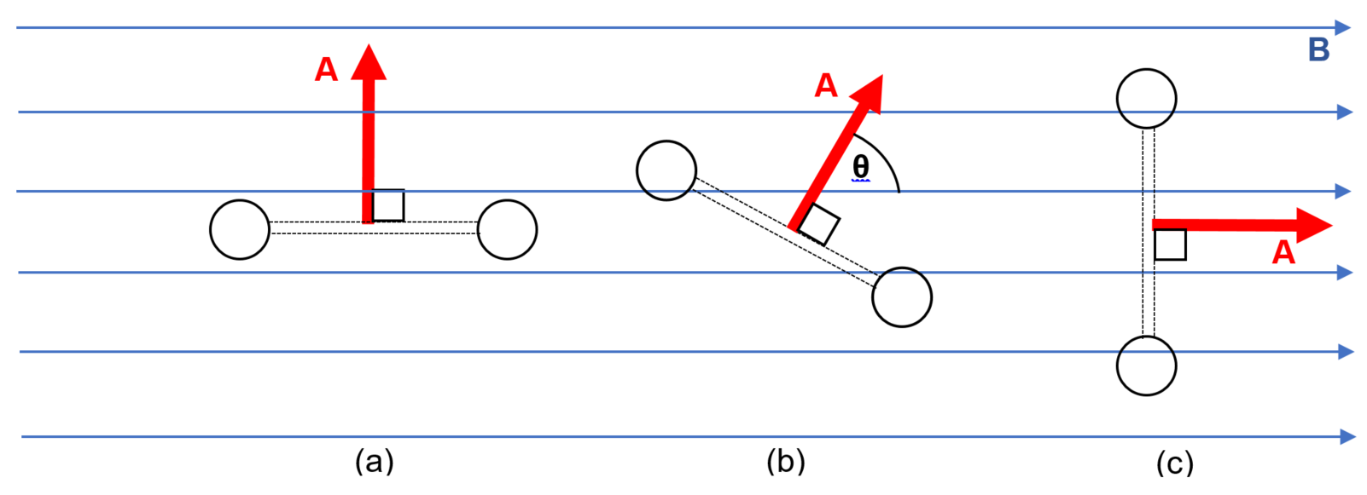
The diagram shows the rotor coil of a motor/generator at various points in its rotation within an external magnetic field. The area and normal vectors are directed perpendicular to the plane of the rotor coil as shown and the magnetic field is uniform and directed left to right across the page.
Quantity | Position (a) | Position (b) | Position (c)
Angle between Area vector and magnetic field, θ | $$θ=90°$$ | $$θ=60°$$ | $$θ=0°$$
Magnetic flux,  $Φ=BA\cos{θ}$ | $$Φ=BA\cos{(90)}=0$$ | $$Φ=BA\cos\left(60\right)=\frac{1}{2}BA$$ | $$Φ=BA\cos{(0)}=BA$$
Torque on coil,  $$τ=nIAB\sin{θ}$$ | $$τ=nIAB\sin{(90)}=nIAB$$ | $$τ=nIAB\sin{(60)}$$ | $$τ=nIAB\sin{(0)}=0$$

Emf and potential difference
Students often have difficulty applying the concepts of emf and potential difference to describe electric circuits and electromagnetic induction with most students using the two concepts interchangeably. In many cases, ignoring the subtle distinction between the two concepts does not result in significant problems for students at the HSC level. However, distinguishing between these two concepts can improve the accuracy of students’ explanations and clarify their application of work and energy concepts to electromagnetism.
In the context of electric circuits, potential difference describes the difference in potential energy per unit of charge between two points in the circuit. The battery (or other source) generates this potential difference by creating a charge separation across its terminals. The potential difference is the energy used to move the unit of charge between the terminals outside the battery. In contrast, the emf is defined as the work done per unit of charge by the battery in order to produce and maintain this electrical potential difference that ultimately drives the circuit current.
The correct application of these concepts becomes more important when considering currents induced by changing magnetic flux. Duffy (2018), uses a skiing analogy to highlight a key difference between the concepts when applied to electromagnetic induction.
We can use a skiing analogy to get at the difference between a voltage from a battery and that induced by a changing magnetic flux. Thinking of a circuit as a ski hill, a battery acts much like a ski lift, producing a potential difference and raising the potential energy of the charges. We switch to cross-country skiing for induced emf: for a complete circuit, the changing flux gives rise to something like wind, always at their backs, that propels the charges around a loop.
From this, it should be appreciated that the emf in both cases describes the energy added (or work done) per unit of charge, either by the ski lift or by the wind. However, a potential difference is only produced in the case of the ski lift with skiers at the top of the lift having a greater potential energy than those at the bottom.

Lenz’s Law and predicting the direction of an induced emf and/or current
Faraday’s Law of electromagnetic induction describes the emf induced by changes in magnetic flux and can be stated mathematically as $ε=-N\frac{ΔΦ}{Δt}$, where $ΔΦ$ is the change in magnetic flux. The negative sign at the front is important as it describes the direction of any induced emf. Lenz’s Law states that the induced emf will create a current and magnetic field that oppose the change in magnetic flux. This is represented by the negative sign.
Describing changes in flux through a conducting loop and predicting the direction of the induced current is challenging, because:
- changes in flux may occur due to changes in field strength, B, the direction of either field or area vectors or changes in the size of the area
- the direction of the change in flux may be the same or different to that of the net flux
- problem solving often requires students to interpret three dimensional diagrams
Structured problem-solving routines can provide an effective scaffold for students when practising applying Lenz’s Law. A sample routine and links to practice problems are included in the appendix.

Applying the correct ‘right-hand rule’
Students are often encouraged to apply ‘the right-hand rule’ to solve electromagnetic problems involving the determination of the direction of magnetic fields and/or forces. A major difficulty encountered by students when asked to apply the right-hand rule is that there are three such right-hand rules, each different in their purpose and application. A summary of these rules is included in the appendix. The rules used to determine the orientation of magnetic fields are introduced in Module 4 with the remaining rule for determining direction of the magnetic force being introduced later in Module 6.
Reviewing all these rules at the beginning of Module 6 is advisable to clarify the distinctions between each. Using clearly differentiated names for each rule, and avoiding calling them all the right-hand rule, may also assist students in correctly identifying the applying the correct rule when problem solving. For example, the rules could be referred to as the grip rule, the solenoid rule and the push rule respectively.

Suggested teaching strategies

Drawing on prior knowledge
Student understanding of potential energy and energy transformations in gravitational fields can provide a useful analogy for understanding electric fields. Torque in the rotation of mechanical systems is first introduced in Module 5, and students are required to apply it in this module in their analysis of electric motors.

Charged particles and fields
When using gravitational fields as an analogy for electric fields, the field between parallel charged plates could be modelled as an inclined plane. Students can be asked to predict how this model would need to be adjusted to represent fields of different strengths and predict the effect on the force/acceleration of a particle if the plates were placed closer together or further apart while maintaining the same potential difference. This model can also be used to model the projectile motion of a charged particle in an electric field in a similar fashion to Galileo’s demonstrations using inclined planes. This model can be extended to represent the fields produced by point sources also. Further description of classroom activities provided by the Perimeter Institute can be found in the resources section.
As outlined above in the conceptual difficulties section, it is timely at this point to review the various right-hand rules used to predict electromagnetic phenomena. Details of the three right-hand rules is provided in the appendix.
Students should initially be provided the opportunity to practise determining the direction of the magnetic force in a wide variety of qualitative problems before moving onto to quantitative problem solving. Examples of variations could include:
- Changing the orientation of the magnetic field and/or particle velocity
- Predicting the impact that changes to the magnetic field strength, particle charge or mass would have on the force and/or trajectory of the particle.
- Working forwards (to predict the direction of force) and working backwards (to predict the direction of the magnetic field or particle velocity)
- Introducing non-orthogonal particle velocities to analyse the impact on the magnetic force and particle trajectory

The Motor Effect
Demonstrations or qualitative investigations provide a useful introduction for students to the interaction between current carrying wires and external magnetic fields. Demonstrations including a current swing, detailed in the motor effect explained (duration 9:22) or a rotating wire similar to Faraday’s as shown in The Motor Effect HD (duration 1:44) similar to Faraday’s early investigations are simple to setup and are useful in highlighting the factors affecting the direction and magnitude of the force experienced due to the motor effect.
A quantitative investigation of the motor effect can be found in the appendix. This investigation provides an opportunity to practice the problem solving using the gradient of the line-of-best-fit. Also, collecting data from each experimental group and analysing the inevitable variation in their results can stimulate discussions around errors, accuracy and reliability. Improvements to methodology could also be suggested, implemented and evaluated.
A pre-test for student understanding of the motor effect is provided in the appendix.

Electromagnetic induction
Magnetic flux can be a challenging quantity for students to understand, but it is a powerful tool for predicting and explaining electromagnetic induction and the operation of technologies. Developing a sound understanding of how magnetic flux is defined and changed over time is crucial to the application of Faraday’s and Lenz’s law to the operation of technologies.
Student understanding of magnetic flux can be supported by exploring the significance of terms in its definition, $Φ=B_{∥}A=BA\cos{θ}$, where $θ$ is the angle between the magnetic field and the area vector. As outlined in the conceptual difficulties section on Lenz’s law, changes to value of any term on the right-hand-side of the equation can lead to a change in magnetic flux. This video Induction- An Introduction: Crash Course Physics #34 (duration 9:49) provides a clear introduction to magnetic flux that is supported by animations.
Faraday’s and Lenz’s law are used to explain and predict induced emfs and currents resulting from changes in magnetic flux. Providing students with structured problem solving routines for determining the direction and magnitude of induced emfs and currents will improve their ability to problem solve in novel situations.

Operation of technologies
Analysing the operation of motors and generators is made more challenging for students by 2-dimensional representations of motors offered by most texts and online sources. A simple, 3D model of the rotor in a motor or generator can be built using thick wire, for example from a wire coat hanger, and removable arrows to represent currents. Viewing the demonstration rotor coil from different angles will aid in the explanation of motor and generator operation. Alternatively, UNSW Physclips electric motors and generators has a range of simulations that can be used for the same purpose.
Analysing the forces acting on each side of a square rotor coil as the rotor completes one revolution is a crucial step in developing the model of motor torque expressed in the equation $τ=nIABsinθ$. Students often erroneously relate the sinusoidal nature of the motor torque to a changing magnitude of the force acting on each of the outer sides of the rotor coil rather than the changing angle of the axis relative to this force. 3D models can assist in demonstrating the constant 90 degrees angle between current and magnetic field and this can be supported by end-on diagrams of the rotor coil at rotor angles of 0, 45 and 90 degrees as shown below.
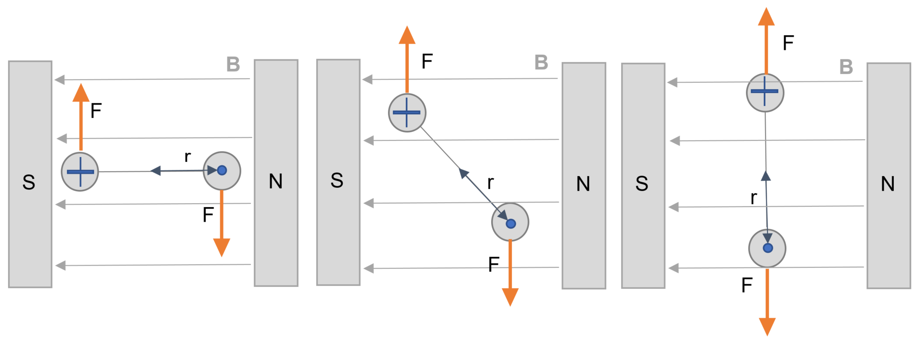

Suggested investigations

The motor effect
Investigations involving the quantitative measurement of the motor effect can be completed either using purpose built current balances or using basic laboratory equipment and digital scales. Using digital scales, students could estimate the magnetic field strength of the magnets they use in class. An outline of this investigation is provided in the appendix. The same methodology could also be used to investigate the strength of electromagnets by replacing the permanent magnet with a solenoid connected to a variable voltage source.

Eddy currents
A strong magnet and thick copper plate can be used to provide an engaging introduction to eddy currents. Care must be taken in storing and handling strong magnets; however, the tactile nature of the demonstration is useful in reinforcing the relationship between rate of change in flux and induced emf. Students will be able to move the strong magnet easily across the surface of the copper plate if it is moved slowly, however, attempts to move fast will be met by strong resistance. Neodymium magnets and copper plate with a thickness of around 1.0 cm will be required to produce an appreciable resistance to motion. Heating of the copper block can also be used to explore concepts of conservation of energy and sources of inefficiency in transformers. Further details of this demonstration are provided in the appendix.
Dropping a small neodymium magnet down an aluminium tube is another impressive demonstration of the production of eddy currents and can be used to introduce magnetic braking. Further investigations into this effect are outlined in the extended concepts section.

Back emf
Adding an ammeter to an operating motor circuit is a simple way of observing the effect of back emf. Low-torque fans such as exhaust fans or CPU cooling fans are suitable as they can be run from a laboratory power pack or a dry cell. They are generally safe to handle but due care should always be taken with a moving rotor. Digital multimeters provide a clear reading of the changing current though the circuit as the rotor speed increases up to its maximum operating speed. It is important to note that current does not drop to zero at maximum speed as the motor is still under load, if only from internal friction. Other demonstrations could include simulating a load by manually applying braking to the motor or changing the supply voltage and observing the impact on its operating speed and current drawn.

Appendix 1: The motor effect pre-test

Question 1
A current-carrying wire is in an external magnetic field as show in the diagram below.
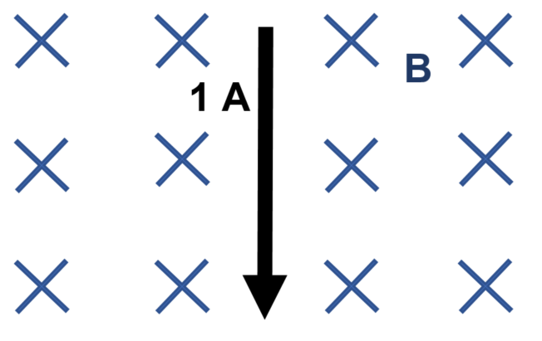
Circle the correct response in each of the following sentences.
- Doubling the strength of the external magnetic field, B, will cause the force experience by the conductor to be (doubled / unchanged / halved).
- If the current flowing in the conductor is halved, the force due to the motor effect will be (doubled / unchanged / halved).

Question 2
In Module 4, you investigated the magnetic field produced by current-carrying wires. The following equation describes the magnetic field produced by a wire, where
$μ_{0}=magnetic permeability constant=4π×{10}^{-7} NA^{-2}$.
$$B=\frac{μ_{0}I}{2πr}$$
Sketch the relationships between magnetic field strength, current and distance indicated by the labels on the following axes.
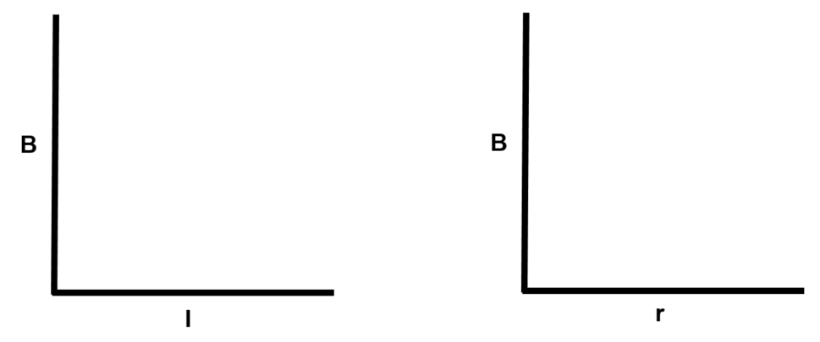

Question 3
Two current-carrying conductors are shown in the diagram below
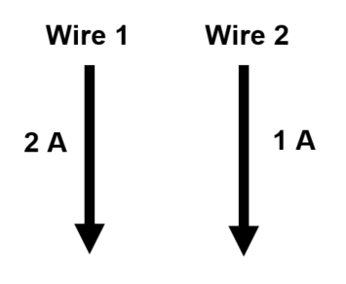
Circle the correct response in each of the following sentences.
- Wire 1 produces a (stronger / same / weaker) magnetic field than Wire 2
- Increasing the current in Wire 1 will increase the force experienced by (Wire 1 / Wire 2 / both wires).
- Doubling the current in Wire 1 will (double / not affect / halve) the magnetic field strength it produces.
- Increasing the current in Wire 2 will (increase / not affect / decrease) the force acting on Wire 1
- Wire 1 exerts a (greater / same / weaker) force on Wire 2 than Wire 2 does on Wire 1.

Question 4
Rank the following in terms of the magnitude of the force experienced, from most to least.
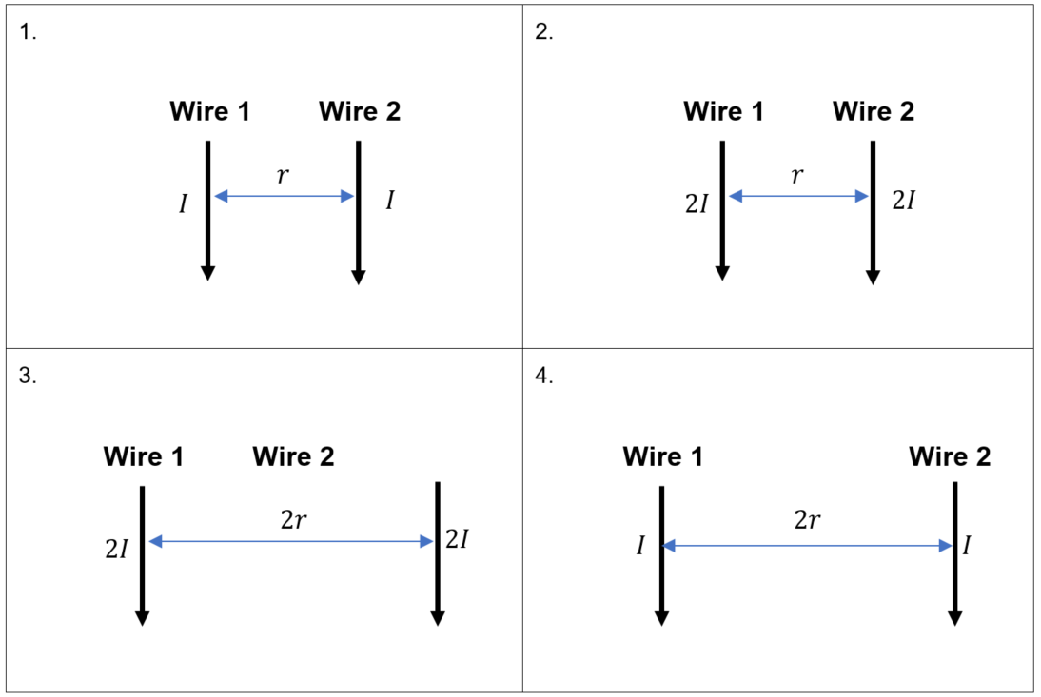

Appendix 2: The motor effect investigation
A simple experiment that students can complete to quantitatively investigate the motor effect is outlined below.
Questioning and predicting
Set students the task of determining the strength of the magnetic field produced by magnets (preferably horseshoe) available at school using the motor effect. This questioning may also consider whether all the school magnets are of similar strength.
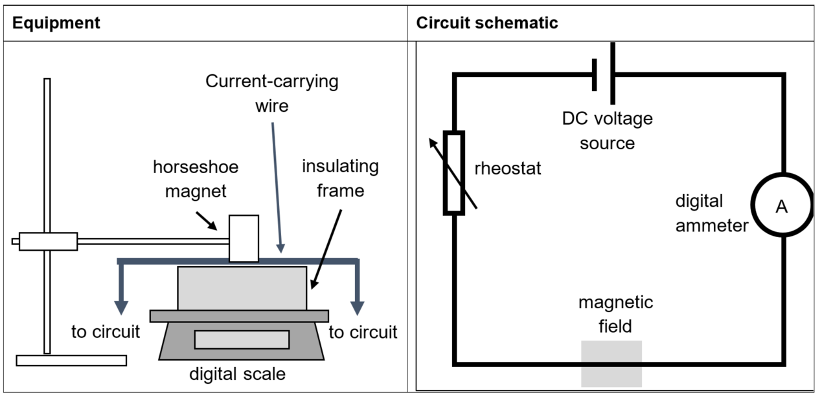
Planning and conducting the investigation
Using the same of similar magnets for each group will enable results to be compared and discussed more easily after data collection. A packaging foam or timber block will provide a suitable insulating frame. Ensure that the current-carrying wire is securely taped to the insulating frame to avoid any movement when collecting data. An alternative setup could be used in which the magnet rests on the scale and the wire is suspended. Using the rheostat to adjust the current through the circuit, students record the mass change on the scale for a variety of current values. Zeroing the scales before switching on the voltage source for each reading is recommended. Encourage students to collect data for a wide range of circuit currents including currents of less than one ampere.
Processing and analysing data
Students are to produce a table of results that can be easily shared with the class for discussion. Each student produces a graph of force versus current. Measurements from the digital scales will first need to be processed, converting grams to newtons, where 1 g=0.0098 N (which could reasonably be approximated to 0.01 N to facilitate quick conversion). Plotting force versus current should produce a linear graph and calculating the gradient of the line of best fit will allow the magnetic field, B, to be estimated if the length of wire in the field is assumed to be the width of the magnet.
$$B=\frac{gradient}{length of wire}$$
Collecting all student data and comparing plots of each dataset on the same set of axes can be used as stimulus for discussing the reliability of the investigation and sources of error.
Sample student results
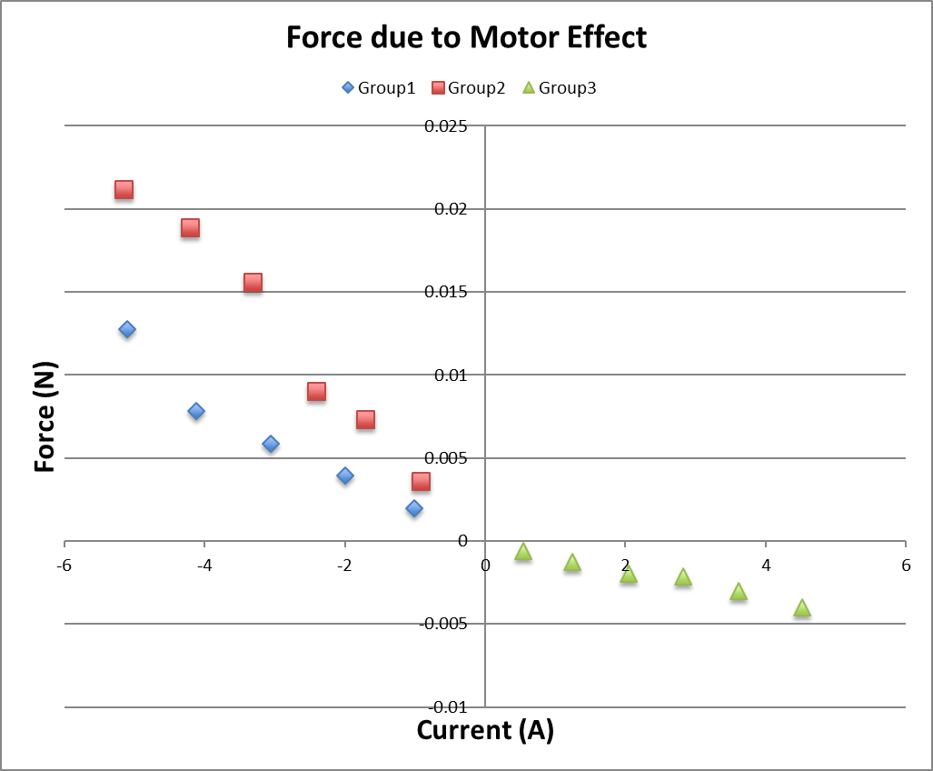

Appendix 3: Past HSC questions mapped to similar current Stage 6 concepts
Please note that the table below is not an exhaustive list of relevant questions. It is intended to provide a small sample of questions that may be useful for revision and classroom use. Be aware that the angle used in the equation for calculating the torque of a simple DC motor was previously defined differently. Care is advised when using any sample responses for from pre-2019 HSC exams for this reason.
Concept | Relevant HSC questions  [Year, Question number(marks)]
Charged Particles, Conductors and Electric and Magnetic Fields | [2007, Q11(1)] [2007, Q13(1)] [2009, Q15(1)] [2009, Q19(6)] [2009, Q25(5)] [2011, Q7(1)] [2011, Q19(1)] [2012, Q30(5)] [2013, Q14(1)] [2013, Q26(5)] [2014, Q17(1)] [2014, Q18(1)] [2014, Q28b(3)] [2015, Q8(1)] [2015, Q24(7)] [2019, Q16(1)] [2019, Q5(1)] [2019, Q29(3)] [2019, Q33(4)]
The motor effect | [2006, Q20(8)] [2009, Q21(6)] [2009, Q23(6)] [2010, Q28(4)] [2012, Q8(1)] [2013, Q25(4)] [2012, Q17(1)] [2014, Q23(3)] [2015, Q7(1)] [2015, Q9(1)] [2019, Q7(1)] [2019, Q28(3)]
Electromagnetic Induction | [2006, Q8(1)] [2006, Q10(1)] [2007, Q8(1)] [2010, Q11(1)] [2010, Q26(5)] [2011, Q14(1)] [2012, Q10(1)] [2012, Q14(1)] [2012, Q22(6)] [2013, Q7(1)] [2013, Q10(1)] [2013, Q13(1)] [2014, Q7(1)] [2014, Q8(1)] [2015, Q15(1)]
Applications of the Motor Effect | [2007, Q7(1)] [2007, Q21(5)] [2009, Q11(1)] [2010, Q20(1)] [2012, Q1(1)] [2012, Q16(1)] [2013, Q17(1)] [2013, Q27(7)] [2013, Q29(5)] [2019, Q18(1)]

Appendix 4: Inducing eddy currents in a copper block
Material specifications
Copper Sheet: dimensions of copper: 8mm thick, by 10cm x 30cm. Using a thicker copper plate would enhance the effect.
Nedymium magnet: the neodymium magnet is 5cm diameter by 8mm thick. Using a more powerful magnet is not recommended for safety reasons.
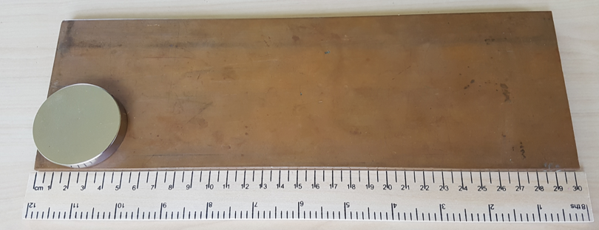
Sourcing materials
The copper plate and magnet can be purchased from any of a range of web-based suppliers in Australia.
Instructions
Ask students to pay attention, then drop the magnet onto the copper from a height of 5cm (Note: any higher and the magnet will be going too fast to stop gently). Expect the half of the class that was actually watching to go “Whoa!” and then for the other half of the class who wasn’t watching to pay attention for the second drop.
Next, have a few students at a time to come up the front and “feel the physics” by dragging the magnet just above the surface of the copper. This physical experience of eddy currents can be used to reinforce concepts including conservation of energy and Lenz’s law.
The copper plate can also be placed on rollers and the magnet to accelerate the block without contact. This can be used to demonstrate the principles of electromagnetic braking along with the operation of linear induction motors.
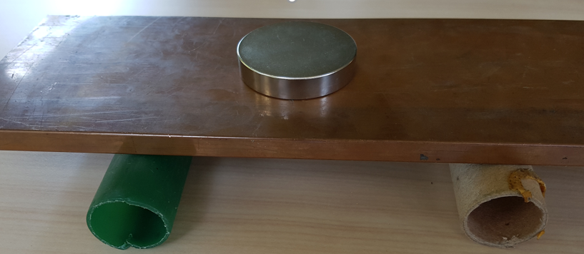
Safety
There is a risk of serious pinch injuries if the magnet is used near any ferromagnetic materials such as steel which is often abundant in a science lab. Care must be taken to remove anything made of steel from the area where it will be used and its use limited to that area and under strict supervision. Students should be given a quick safety briefing on this issue also.
The magnet is brittle and may break into shards if broken so ensure that all students wear eye protection.
To safely store the magnet, wrap it in bubble-wrap and store in a large plastic jar with a screw top lid. Store away from ferromagnetic objects and in a secure location.

Appendix 5: Scaffold for predicting the direction of induced currents
Below is an example of a four-step scaffold for predicting changes in magnetic flux. When introducing the scaffold, consider initially limiting the direction of the magnetic field to be along a single axis, for example, into/out of the page before moving on to a wider variety of orientations.
Diagram | Direction of B | Change in flux, $ΔΦ$ | Direction of $B_{induced}$ | Direction of $I_{induced}$
Instruction | Example: into the page, to the left, up the page | Is the magnitude of the flux through the loop increasing or decreasing? | The induced magnetic field is always opposite to the change in flux | Use the right hand rule for solenoids. Your thumb should point in the direction of induced magnetic field.
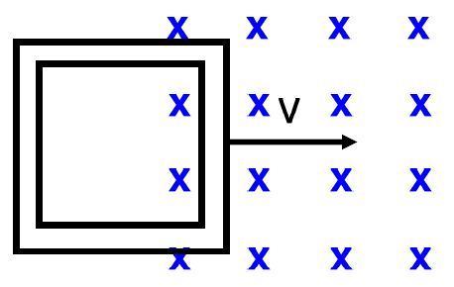 | Into page | Increasing | Out of page | Counter-clockwise
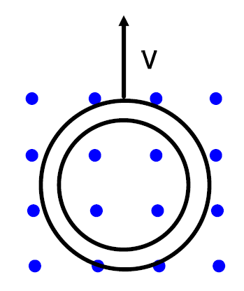 | Out of page | Decreasing | Out of page | Counter-clockwise
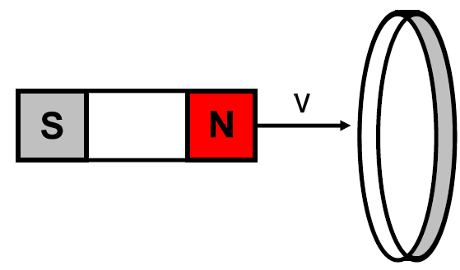 | To the right | Increasing | To the left | Counter-clockwise when viewed from LHS
Students should be encouraged to support their working with diagrams, vector arrows and other scientific formats to save time and improve accuracy of their descriptions.
For example,
- B →
- $∆Φ$ increasing
- $B_{ind}$ ←
- $I_{ind}$ anticlockwise as viewed from LHS
Further examples using a similar approach are provided in the Laws of Faraday & Lenz - Worksheet and A pictorial approach to Lenz’s Law from physics.bu.edu. Either would provide a suitable introduction to the basic problem solving technique. However, changes in magnetic flux through a circuit or conducting loop can also be produced by changes in the area of the loop, changing current in an adjacent conductor or concentric loop or changes in the angle between the magnetic field and the area vector of the loop. For this reason, students should be familiar with applying Lenz’s Law in other situations. Further examples can be found at Lenz’s Law at Tualatin Physics and in the Spiral Physics Downloads collection.

Appendix 6: Three right-hand rules for electromagnetism
The three right-hand rules commonly used in electromagnetism.
Rule | Synonyms and alternatives | Purpose | Application | Diagram
Right-hand grip rule | Oersted’s rule  Ampere’s rule | To find the direction of magnetic field around a current carrying conductor | Thumb points along direction of current  Fingers curl along the direction of the magnetic field lines | 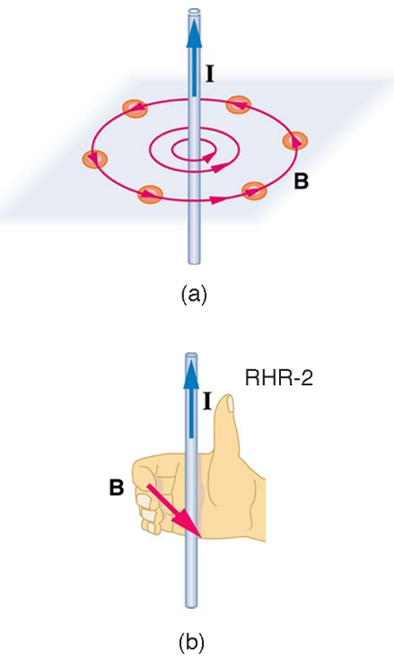  Image credit: OpenStaxCollege (CC BY 4.0)
Right-hand grip rule for solenoids | Right-hand grip rule | To find the direction of a magnetic field produced by a current carrying solenoid or conducting loop | Fingers wrap around solenoid in the direction of current  Thumb points in the direction of the north pole | 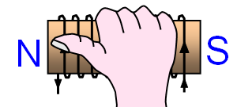Image credit:  www.schoolphysics.co.uk
Right-hand push rule | Cross product  Right-hand palm rule  The Right-hand rule | To find the direction of magnetic force experienced by moving charge in a magnetic field | Thumb points along direction of particles velocity  Fingers point along direction of magnetic field lines  Palm points in direction of magnetic force (the push) | 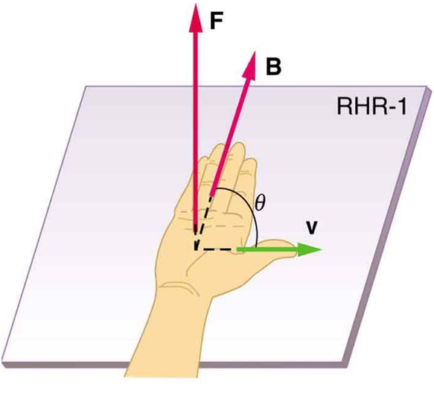  Image credit: OpenStaxCollege (CC BY 4.0)
Note that the first two rules are both commonly referred to as the right-hand grip rule.

Resources

Websites
- VISUAL PHYSICS ONLINE offers a comprehensive range of pdf’s that are tailored to support the Stage 6 Physics course in NSW. Each resource includes clear explanations, activities and makes good use of diagrams to support understanding. Most resources also include differentiated levels of explanation that can be tailored to suit the needs of your students.
- Perimeter Institute – fields. The resource contains a set of five activities. Activity 2: Making electric fields real provides an engaging way to introduce students to fields by representing a range of electric fields using stretch fabric and marbles and would be appropriate for use in Module 4. The fabric model presented could be revisited in this model when investigating the trajectory of charged particles in electric fields. Part 3 of this activity has students investigating the electric field between plates using LED’s. This resource, including video, lesson notes, classroom worksheets and assessments with worked responses can be downloaded for free from the Perimeter Institute website after registering for a free account. They have an extensive collection of resources available to support learning and teaching of other concepts relevant to the Stage 6 Physics course.
- Fathoming physics website contains an extensive collection of notes to support learning and teaching of the Stage 6 Physics course. The physics concepts are presented in detail and are well supported by diagrams and images. The site also contains practice questions and assessment materials.
- Past HSC Physics exam packs. Many of the concepts included in the current Stage 6 syllabus are similar to those that were examined in the previous syllabus (2001-2018). For this reason, some of the previous HSC exam questions may be useful as either practice questions for students to complete, as part of classroom activities, and/or for assessing student understanding. A list of sample questions relating to similar concepts in the current Stage 6 course can be found in the appendix.
- AP Physics Collection OpenStax and Rice Online Learning is a free, online resource includes a detailed textbook with explanatory notes, examples, problem sets and instructional videos. It is aligned to the Advanced Placement (AP) Physics course administered by the College Board, a not-for-profit organisation whose mission is to support the successful transition of students into university studies, however, it covers many of the concepts included in the Stage 6 Physics course in NSW. The content included is all algebra based and is suitable for use with most students but it should be noted that the challenging level to which it develops most concepts at times exceeds that required by the NSW course and differentiation may be required when using it in a classroom.
- Online Physics Tutorials website offers explanations, worked examples as well as practise questions and solutions for a wide range of physics topics. Whilst it is not aligned with the NSW Physics syllabus, the resources are well illustrated, and include clear diagrams and equations. Variations in notation used in equations (for example using ‘i’ for current rather than ‘I’) and the inclusion of concepts outside of the syllabus require care to be taken when using this site.
- Physics simulations from PhET provide a range of simulations that can be used to explore phenomena relevant to the Stage 6 Physics course. Many of the newer simulations have been produced in HTML5, which allows them to be run directly in a web browser, on most devices, or downloaded and embedded into an online learning management system. Simulations relevant to this module include:
  - Faraday’s law
  - Electric field hockey
- Physclips Electric motors and generators contains a range of animations of DC motors and generators. Most animations include graphical representations of the changing torque or emf respectively.

Studies and papers
- Duffy, A. (2018) ‘A Pictorial Approach to Lenz’s Law’, The Physics Teacher. American Association of Physics Teachers (AAPT), 56(4), pp. 224–225. doi: 10.1119/1.5028236.
This paper describes a pictorial approach to Lenz’s law that involves following four steps and drawing three pictures to determine the direction of the current induced by a changing magnetic flux.
- Garzón, I. et al. (2014) ‘Probing university students’ understanding of electromotive force in electricity’, Citation: American Journal of Physics, 82, p. 72. doi: 10.1119/1.4833637.
The goal of this study is to identify students’ difficulties with learning the concepts of electromotive force (emf) and potential difference in the context of transitory currents and resistive direct-current circuits. To investigate these difficulties, a questionnaire was developed, based on an analysis of the theoretical and epistemological framework of physics, which was then administered to first-year engineering and physics students at universities in Spain, Colombia, and Belgium. The results of the study show that student difficulties seem to be strongly linked to the absence of an analysis of the energy balance within the circuit and that most university students do not clearly understand the usefulness of and the difference between the concepts of potential difference and emf.

Resources outlining the 2018 revision of the SI
The following websites provide clear descriptions of the SI base units and their underlying constants as well as outlining the reasons for the revision.
- National Physical Laboratory (NPL) the UK's National Measurement Institute
- National Institute of Standards and Technology (NIST) the US physical science laboratory responsible for measurement standards
- Bureau International des Poids et Mesures (BIPM) the intergovernmental organisation that acts on matters related to measurement science and standards
- A LEGO Watt balance: An apparatus to determine a mass based on the new SI (AAPT)

