Stage 6 Biology M3 Adaptations.

Considerations for programming virtual classrooms
BIO11-10 - describes biological diversity by explaining the relationships between a range of organisms in terms of specialisation for selected habitats and evolution of species
© NSW Education Standards Authority (NESA) for and on behalf of the Crown in right of the State of New South Wales, (2017)
Guiding questions for establishing learning expectations and communication processes
Guiding question: How do adaptations increase the organism’s ability to survive?
What are your students going to learn? (Objectives) | Students  - can identify and explain how structural, physiological and behavioural adaptations increase organisms’ ability to survive.  - Evaluate hypotheses for scientific investigation  - Select, process and analyse information
How are they going to learn it? (Resources and Strategies) | This resource can be sent to students as a digital document using the platform your school uses (for example MS Teams, Google Classroom). Students will need access to the internet to view the articles and links in the articles. For those that do not have internet access, a printed hardcopy of each article needs to be supplied.
Target date for completion | This task should take 2 hours to complete.
How are you going to know that they learned it? (Success criteria) | Students will successfully answer questions
Collecting evidence of student learning (Verification) | Answers to questions could be discussed in a synchronous lesson.  Alternatively, students could submit their answers via the platform your school is using or as a hard copy.
Feedback (Evaluation) | Feedback will be  - oral if a synchronous lesson is available.  - as comments on the document if submitted electronically or as a hard copy.
Communication | Teachers and students will use the school’s preferred platform for communication. Students should be encouraged to contact teachers via the platform to ask questions and seek clarification.

Adaptations
Inquiry question: How do adaptations increase an organism’s ability to survive?

Activity 1: whales
Read the article: Why are whales so big, but not bigger?
Answer the following questions.
- Explain the difference between the feeding habits of filter feeding whales and toothed whale species.
- Explain why the structural adaptation of filter feeding whale species allows some of them (the Blue Whale for example) to grow to a larger size than the toothed whales.

Activity 2: egg shells
Read the article: Darker eggs have their purpose
Answer the following questions.
- What question were the scientists investigating in this article?
- What was their hypothesis?
- Why was the initial evidence about shell colour inconclusive?
- What process did the scientists undertake to test investigate their question?
- How did their findings support their hypothesis?
- In summary: What is the adaptation being investigated and why does it increase the birds’ ability to survive in their environment?

Activity 3: leopard seals
Read the article and view the links in the article: Fierce leopard seals can be unexpected ‘buffet buddies’
- Explain the ‘normal’ feeding behaviour of leopard seals.
- What was the changed behaviour observed in the leopard seals in South Georgia?
- Identify two hypotheses that have been proposed to explain this behaviour. For each hypothesis state one piece of evidence that supports the hypothesis.

Activity 4: living at altitude
Read the article: How do sherpas thrive up here?
- Use the following graph and the information in the article to explain why altitude affects where humans can live.
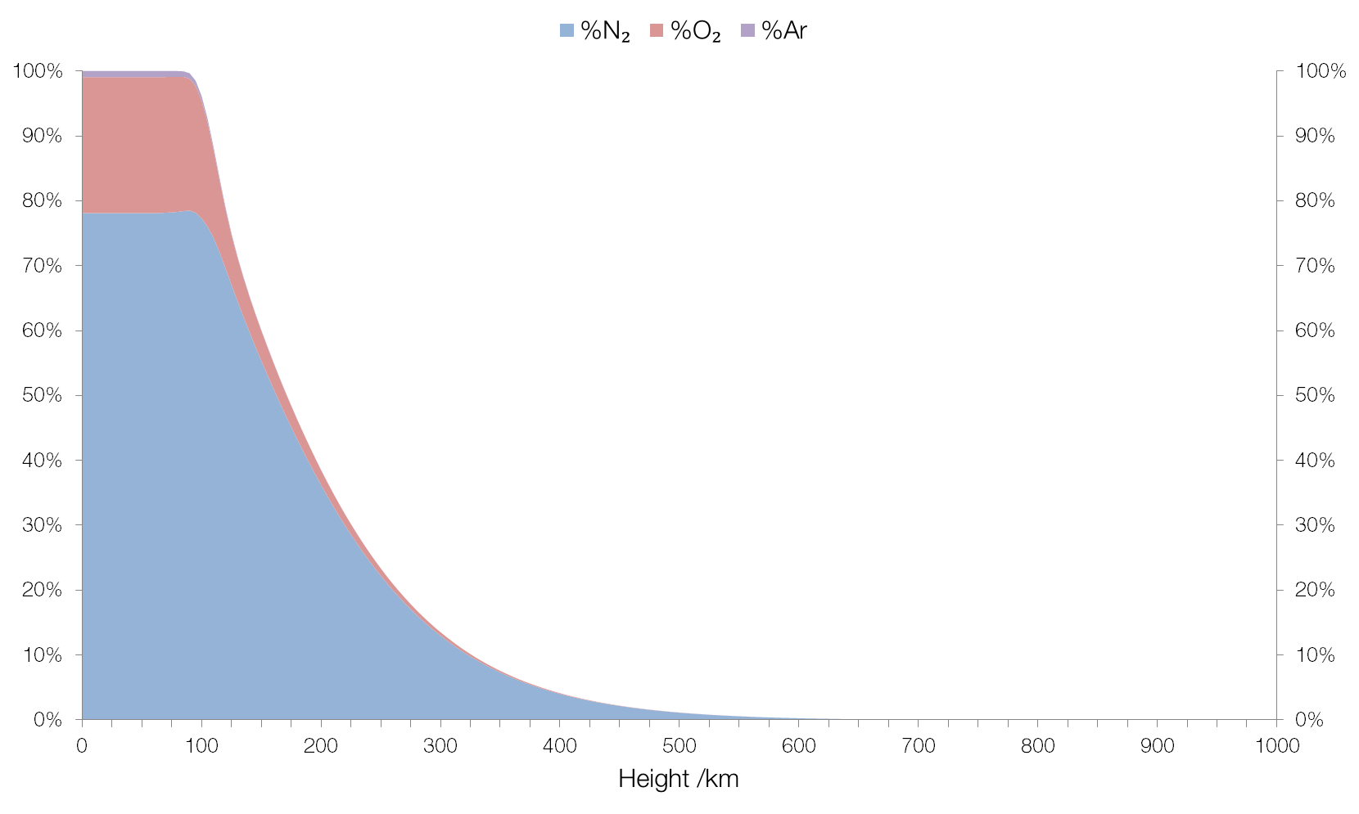
physics.stackexchange.com/questions/247637/why-does-the-composition-of-the-air-does-not-change-with-altitude
- What physiological adaptation do humans have that allows them to live at high altitudes?
- Why can this adaptation be a problem?
- How did the red blood cell concentration of the Sherpa of the Tibetan Plateau compare to that of the people from the Peruvian Andes? Why was this considered to be unusual?
- After rejecting the presence of a particular gene as the reason for the Sherpa’s ability to survive at high altitude, what hypothesis did Mike Stenbridge ultimately propose?
- What evidence did he find that supported his hypothesis?
What adaptation would need to be present in the kidneys of the Sherpa for this hypothesis to be further supported?

