Assessment task – oral presentation

Module 6 - Technologies
What comes first – knowledge or technology?
Due date/presentation date: [to be set]
Weighting: recommended 20% (15% Working Scientifically, 5% Knowledge and understanding)

Outcomes assessed
- INS 11/12-4 Selects and processes appropriate qualitative and quantitative data and information using a range of appropriate sources
- INS 11/12-5 Analyses and evaluates primary and secondary data and information
- INS 11/12-7 Communicates scientific understanding using suitable language and terminology for a specific audience or purpose
- INS 12-13 Describes and explains how science drives the development of technologies

Context
The federal science minister is planning to cut federal funding to the country's science institutions, stating "…the focus of the future is new technology, and the cuts to science will be redirected to the technology sector."
Due to your participation in the Investigating Science course, you think the statement is illogical. You join an Australia-wide movement organised by members of the scientific community to send videos to local MPs and the federal science minister explaining the important link between science and technology

Task description and submission details
You will present for 5-8 minutes on the relationship between technology and scientific understanding using an example chosen below. You will have a choice of submitting the video file for marking or presenting in front of a live audience (which will still be recorded on video)
To aid your presentation you must interact with aides (these can include posters, models, PowerPoint presentations or similar, etc). On the due date you must submit a transcript of your speech and reference list (and video file if appropriate).

Possible topics
The following are possible topics that can be adapted by students. They state the (a) technology, (b) scientific concept and (c) application. The topics present a relationship between technology and scientific understanding.
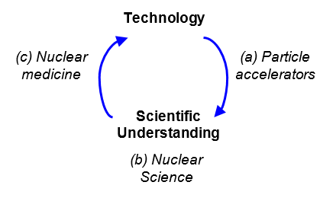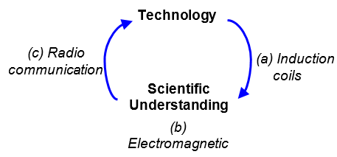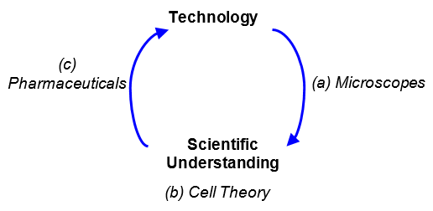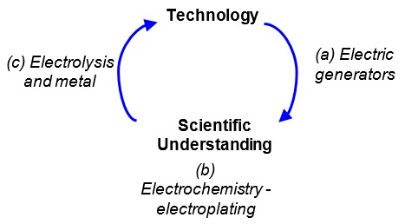
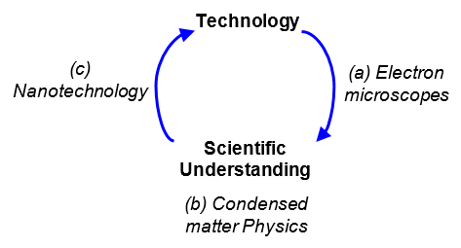

Presentation
Your presentation must cover the following 7 points.
- Briefly describe your foundation technology (a).
- Describe your chosen scientific concept (b).
- Explain how (b) leads to (a).
- Describe the application (c).
- Explain how (b) led to (c).
- Assess the societal and global impacts of the development of the application of your technology.
- Conclude by providing an analysis on the relationship between knowledge and technology

References
You must use current references to justify your argument. Resources may include journal articles, websites, podcasts, books, opinion pieces such as newspaper articles, etc.
It is recommended that you use an appropriate referencing format for your reference list, such as Harvard. For more information, use available online resources such as citethisforme. http://www.citethisforme.com/harvard-referencing

Marking rubric

Knowledge and understanding
Criteria | Not evident | Developing | Evident
Briefly describes foundation technology. INS 12-13
Describes chosen scientific concept. INS 12-13
Explains how foundation technology led to scientific concept. INS 12-13
Describes the newer technology. INS 12-13
Explains how scientific concept led to newer technology. INS 12-13
Assesses the impacts (on the wider world) of the development of the newer technology. INS 12-13
Provides analysis on the relationship between knowledge and technology. INS 12-13

Working scientifically
Criteria | Not evident | Developing | Evident
Clear and concise introduction to topic. INS 11/12-7
Presentation is well structured, and clarifies the link between technology and knowledge in a succinct manner. INS 11/12-7
Presentation is delivered in the time limit. INS 11/12-7
Presentation is delivered with student using tone, pace and projection of voice. Eye contact is maintained throughout and minimal reference to palm cards or prompt sheet. INS 11/12-7
Use of appropriate scientific terminology. INS 11/12-7
Information presented demonstrates a high level of processing by student. Student demonstrates a deep understanding of material. INS 11/12-5
Use of support material in presentation is consistent and inclusive (referred to often, it enhances the presentation). INS 11/12-4
Reference list correctly uses an appropriate referencing style. INS 11/12-5
Reference list demonstrates extensive research. INS 11/12-5

Comments
Area | Comments
Topic
Duration
General

Teacher notes

Notes on the marking rubric
The marking rubric allows teachers to report on students achievement of the outcomes to be assessed.
Possible variations, differentiation and scaffolding.
- As written, some students may require significant scaffolding with this task, especially around the verbs used (explain how, describe, judge).
- Teachers may provide students with a set of 'readings' or a 'resource pack' to support and streamline the time students spend on researching. Note that the working scientifically marking criteria around the references should be amended if this is the case. it is also possible if providing the references teachers could build in a literature review, with class time allocated to do this.
- Students may work in pairs, to complete the task, possibly taking a 'half' each and then linking things together.
- Teachers may provide a worked example of what a video on a topic would look like (with students then unable to do that topic for the task)

Possible uses as a depth study
This task could also be amended for use as a depth study. With 'questioning' a key requirement for depth studies, the 'possible topics' could be removed, and students could investigate topics that interest them. This may be challenging for students which may require scaffolded examples and models before posing their own questions. Considerations around 'proving chosen topics, and checks of student understanding are recommended if this route is taken.
Teachers need to refer to Depth Studies: Year 11 and 12 to ensure all requirements are met, such as the inclusion of Working Scientifically outcomes of Questioning and Predicting and Communicating:
- INS 11/12-1 Develops and evaluates questions and hypotheses for scientific investigation
- INS 11/12-7 Communicates scientific understanding using suitable language and terminology for a specific audience or purpose

Recording
Teachers should check that all students have an authority to publish. It is recommended that teachers provide students with written information that they are to be recorded for the purposes of assessment with details about how the recording will be used. Students may wish to opt out of recording and this should be taken into account when delivering assessment.

