Problem set: Year 12 Investigating Science

## Introduction

This document contains questions to probe students’ understanding of various concepts in the Year 12 course of the Stage 6 Investigating Science syllabus[1]. The questions in this problem set have been designed by NSW Investigating Science teachers who attended the ‘Teaching the Year 12 modules in Stage 6 Science’ workshops in 2019, as well as the science curriculum support officers at the Learning and Teaching Directorate. The problem set may be used as classroom activities or in assessments to evaluate student understanding. Teachers are free to adapt or modify the questions in this problem set to suit the learning needs of their students.

## Acknowledgements

The Learning and Teaching Directorate at the NSW Department of Education developed this resource for science teachers. The Department acknowledges the efforts of the Investigating Science teachers at the ‘Teaching the Year 12 modules in Stage 6 science’ workshops for contributing to this resource.

## Question 1 (Module 5)

Assess the appropriateness of the methodology that Marshall and Warren used for to investigate into the cause of peptic ulcers (6 marks).

### Marking criteria

|  |  |
| --- | --- |
| Criteria | Marks |
| * Demonstrates a thorough understanding of the work of Marshall and Warren in their discovery of the cause of peptic ulcers * Provides a thorough assessment of various aspects of the methodology | 6 |
| * Demonstrates a sound understanding of the work of Marshall and Warren in their discovery of the cause of peptic ulcers * Provides a sound assessment of various aspects of the methodology | 4-5 |
| * Demonstrates a basic understanding of the work of Marshall and Warren in their discovery of the cause of peptic ulcers * Provides some information on one aspect of the methodology | 2-3 |
| * Any relevant information | 1 |

### Sample answer

Before the research conducted by Marshall and Warren, it was thought that peptic ulcers were caused by poor diet or stress and were treated mostly with antacid medications. Marshall and Warren discovered that the main cause of peptic ulcers was exposure to the bacterium, *Helicobacter pylori.* To discover this, they conducted investigations with a methodology that had aspects of good scientific practice and others that were considered unconventional and potentially dangerous.

Marshall and Warren needed to determine the cause and effect relationship between the presence of *H. pylori* and peptic ulcers in humans. To do this, they first identified the presence of the bacterium in stomach biopsies taken from all affected patients. However, this alone was not enough to determine the bacterium as the sole cause of peptic ulcers.

The next step would be to infect a healthy individual with the same bacterium to see if they would produce symptoms of the disease. Infecting humans with a potentially harmful pathogen is not considered to be ethical practice, so they investigated animal models as potential hosts. None of them was able to show symptoms after exposure to the bacterium, so Marshall and Warren decided to do something unconventional.

Marshall predicted the bacterium was only capable of causing the disease in humans, so he decided to experiment upon himself by drinking a culture of the organism that he obtained from the biopsies of affected patients. It led to him developing symptoms of a peptic ulcer which he later treated with antibiotics, effectively curing himself. So, in this instance, while he was criticised by many in the scientific community for putting his own health at risk, this unconventional procedure actually helped with the discovery. Further experimentation from other scientists confirmed the link between *H. pylori* and peptic ulcers in humans and new and fast-acting antibiotic treatments were administered for affected people.

## Question 2 (Module 6)

The image below describes the motion of a building when an earthquake occurs. The arrow indicates the direction of ground motion.

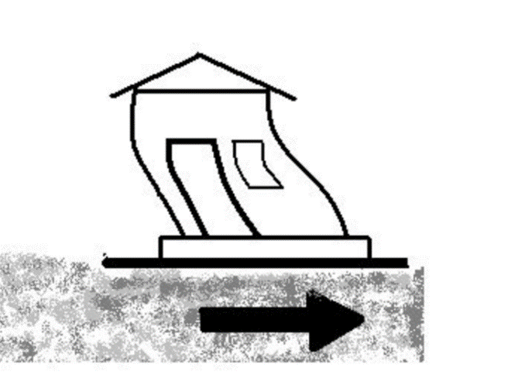

Image credit: [Architect Javed](http://www.architectjaved.com/)

Justify the need for modern buildings in earthquake-prone areas to be built with an understanding of ONE of Newton’s Laws of Motion (4 marks).

### Marking criteria

|  |  |
| --- | --- |
| Criteria | Marks |
| * Demonstrates a sound understanding of ONE of Newton’s Laws of Motion * Relates understanding of the law to the way that buildings shake during an earthquake | 3-4 |
| * Demonstrates a basic understanding of ONE of Newton’s Laws of Motion * Describes the motion of a building during an earthquake | 1-2 |

### Sample answer

An understanding of inertia, Newton’s First Law of Motion, is important when designing buildings to withstand collapse from earthquakes. When the ground shakes horizontally during an earthquake, the base of a building would also shake, but the roof would be at rest because there is no direct force acting on it. However, since the walls are attached to the roof, it would also be dragged with the base, as shown in the diagram. The tendency of the roof to remain in its original position is called inertia. This resistance causes shearing stress on the walls and sometimes collapse of the building. So, structures need to be in place to withstand these stresses. Otherwise, they will be prone to collapse.

## Question 3 (Module 5)

A class was divided into four groups to measure the pH of a local waterway that existed near an industrial site. Each group took multiple readings of the pH from water samples. A sample was also submitted to Sydney Water for comparison. The pH was determined by Sydney Water to be 5.0. The results of the 4 groups are shown in the graph below:

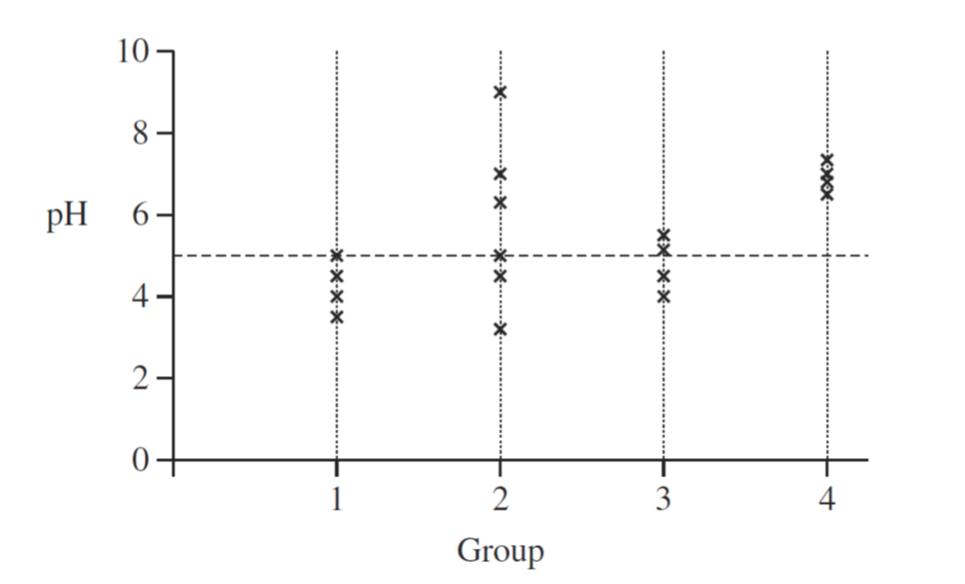

Image credit: NESA

* 1. Identify the dependent variable in the investigation (1 mark).
  2. Justify the group with the most accurate results (2 marks).
  3. Justify the group with the most reliable results (2 marks).

### Marking criteria (a)

|  |  |
| --- | --- |
| Criteria | Marks |
| * Identifies pH as the dependent variable | 1 |

### Sample answer

pH.

### Marking criteria (b)

|  |  |
| --- | --- |
| Criteria | Marks |
| * Identifies that Group 3 had the most accurate results * Relates the reason to be that the readings are closest to Sydney Water measurements | 2 |
| * Any of the above | 1 |

### Sample answer

Group 3 had the most accurate results, as their readings were closest to the accepted reading by Sydney Water of 5.0.

### Marking criteria (c)

|  |  |
| --- | --- |
| Criteria | Marks |
| * Identifies that Group 4 had the most reliable results * Relates reason to the repeated measurements having the lowest spread around the mean | 2 |
| * Any of the above | 1 |

### Sample answer

Group 4 had the most reliable results. This is because the data from repeated measurements had the lowest spread around the mean.

### Question 4 (Module 5)

A student was investigating the concept of density, which can be calculated by dividing the mass of an object by its volume. Part of the investigation is shown in the diagram below. A steel bolt has been placed inside the measuring cylinder to show how the water level changes.

Left measuring cylinder contains water up to 25 a value of 25. The right one has a steel bolt inside showing a rise in water level to 35.

Image credit: TALE

* 1. The steel bolt was found to weigh 80g. Calculate its density, showing all working (2 marks).
  2. Explain how the student could determine the accuracy and reliability of these results (3 marks).

### Marking criteria (a)

|  |  |
| --- | --- |
| Criteria | Marks |
| * The correct answer of 8.0g/cm3 or 8.0g/ml, obtained showing all working | 2 |
| * The correct answer, obtained without showing all working   OR   * The incorrect answer, obtained with some correct working | 1 |

### Sample answer

Volume = 35ml – 25ml = 10ml

Density = mass ÷ volume

= 80g ÷ 10ml

= 8.0g/ml or 8.0g/cm3

### Marking criteria (b)

|  |  |
| --- | --- |
| Criteria | Marks |
| * Explains how both accuracy and reliability, clearly distinguishing between the two terms | 3 |
| * Explains how either accuracy or reliability could be determined | 2 |
| * Provides any relevant information on the accuracy or reliability of data | 1 |

### Sample answer

The accuracy of the measurement could be compared to the known value for the density of steel. This could be obtained by researching credible sources to see if the value of 8.0g/cm3 matches this known value. For measuring the volume of liquid, volumetric flasks could provide a more accurate result to measure changes in the displacement of water. The reliability could be determined by repeating the experiment multiple times to see if similar results are obtained for the calculation of density. If they are, then the measured values could be considered reliable.

#### Question 5 (Module 6)

The table below shows the results of a practical investigation into the effect of water temperature on the level of dissolved oxygen.

|  |  |  |  |  |  |  |  |  |  |  |
| --- | --- | --- | --- | --- | --- | --- | --- | --- | --- | --- |
| Temperature (°C) | 20 | 22 | 24 | 26 | 28 | 30 | 32 | 34 | 36 | 38 |
| Oxygen (mg/L) | 9.1 | 8.7 | 8.4 | 8.1 | 7.8 | 7.5 | 7.3 | 7.0 | 6.8 | 6.6 |

1. Plot the data on the graph below (3 marks).

Empty grid.

1. Propose and explain a hypothesis for the investigation (2 marks).
   1. Justify reasons why the use of an electronic probe to measure the dissolved oxygen in this investigation as opposed to colour indicators which can also indicate the presence of dissolved oxygen (2 marks).
   2. Suggest one possible implication for these results for fish living in shallow waterways in central Australia (2 marks).

### Marking criteria (a)

|  |  |
| --- | --- |
| Criteria | Marks |
| * Both axes labelled with units, all points plotted with minimal errors and a line is drawn | 3 |
| * Both axes labelled, points plotted with some errors, a line is drawn | 2 |
| * Some relevant information added | 1 |

### Sample answer

### Marking criteria (b)

|  |  |
| --- | --- |
| Criteria | Marks |
| * Suitable hypothesis provided with plausible reasoning | 2 |
| * Suitable hypothesis provided without reasoning | 1 |

Sample answer: As the water temperature is increased, the level of dissolved oxygen will decrease. This may be due to the movement of heated water molecules that allow less room for dissolved oxygen molecules to exist in the spaces between the water.

### Marking criteria (c)

|  |  |
| --- | --- |
| Criteria | Marks |
| * Provides two reasons for benefits of using an oxygen probe (e.g. accuracy/precision of measurement, ease of use) | 2 |
| * Provides one reason for the benefits of using an oxygen probe | 1 |

### Sample answer

An electronic probe will provide a more accurate reading that should resemble the true value being measured, in this case, a numerical value to one decimal point. A colour indicator could only provide a relative measurement of dissolved oxygen level, which is less accurate. An electronic probe is easy to use and transport, while colour indicators may be hazardous (care must be taken during use and transport).

### Marking criteria (d)

|  |  |
| --- | --- |
| Criteria | Marks |
| * Provides a suitable implication for the survival of the fish * Explains that the temperature and dissolved oxygen available in a shallow waterway | 2 |
| * Provides a suitable implication for the survival of the fish without reasoning | 1 |

### Sample answer

Shallow waterways in central Australia could be prone to extreme temperature changes. If the water gets too warm, it could mean dissolved oxygen becomes very low. As oxygen is essential for their survival, it could cause death for a lot of fish.

## Question 6 (Module 7)

The following information was obtained from a student search in July of 2019 of the Australian Bureau of Statistics website: [abs.gov.au](http://www.abs.gov.au/)

**Correlation** is a statistical measure that describes the size and direction of a relationship between two or more variables. A correlation between variables, however, does not automatically mean that the change in one variable is the cause of the change in the values of the other variable.  
  
**Causation** indicates that one event is the result of the occurrence of the other event; i.e. there is a causal relationship between the two events. This is also referred to as cause-and-effect.

* 1. Justify whether the information in the article should be considered to be valid (2 marks).
  2. Explain how correlation and causation were misinterpreted in the investigation into the Mozart Effect on child development (4 marks).

### Marking criteria (a)

|  |  |
| --- | --- |
| Criteria | Marks |
| * Explains that the information is valid based on the credibility of the source of information | 2 |
| * Any relevant information | 1 |

### Sample answer

The information should be regarded as accurate since it has been published by a government website (as indicated by the domain .gov). This means it has been verified by experts in the area of study and has been reviewed by members of the scientific community and not based on opinion. The article was also published very recently, so it is unlikely to be outdated.

### Marking criteria (b)

|  |  |
| --- | --- |
| Criteria | Marks |
| * Demonstrates a sound understanding of the investigation into the Mozart effect on child development * Explains why it is an example of correlation, rather than causation | 3-4 |
| * Demonstrates a basic understanding of the investigation into the Mozart effect on child development * Demonstrates some understanding of the difference between correlation and causation in this investigation | 2 |
| * Any relevant information | 1 |

### Sample answer

In the investigation, it was found that students listening to Mozart would perform better in spatial intelligence tests than those in the control group (no music), at least for a short amount of time. When results were published, the popular media presented these results as evidence of causation – that listening to Mozart can make students more intelligent. However, the effect is more likely to be a correlation, as other factors may contribute to the observed relationship. The study actually supported the idea that listening to any type of music (not specifically Mozart), if it was enjoyed by the listener, helped the listeners to perform well in the spatial intelligence tests as it stimulated parts of the brain that allowed them to perform better.

## Question 7 (Module 6)

Examine the importance of technology on the discovery of the structure of DNA and the implications for the development of genetically modified organisms (6 marks).

### Marking criteria

|  |  |
| --- | --- |
| Criteria | Marks |
| * Demonstrates a thorough understanding of the discovery of DNA * Explains the role of technology in the discovery * Relates how genetically modified organisms have been made with this knowledge | 5-6 |
| * Demonstrates a sound understanding of the discovery of DNA * Describes the role of technology in the discovery * Describes some understanding of genetically modified organisms | 3-4 |
| * Demonstrates a basic understanding of the discovery of DNA * Includes some aspect of technology   OR   * Includes some understanding of genetically modified organisms | 1-2 |

### Sample answer

Although the double-helix structure of DNA is largely credited to have been discovered by molecular biologists Watson and Crick, there is no doubt that without the contributions of biophysicists Franklin and Wilkins that they would not have been able to come to their conclusions when they did. In particular, it was the technologies used by Franklin that were crucial to this discovery. While Wilkins was already using X-ray crystallography to try and solve the problem, it was Franklin that was able to produce two sets of high-resolution photos of crystallised DNA fibres from a machine she had herself refined. This method uses beams of X-rays to determine the precise positions of atoms in a molecule. Wilkins later showed the images Franklin had produced to Watson and Crick, who then deduced the structure of the DNA molecule.

Since the discovery of the structure of DNA, much more has been discovered about the way it works, including how it codes for the production of proteins. Given that the DNA found in all living things and has been shown to have the same structure in all organisms – a double-helix molecule built from nucleotides – it has meant that the development of transgenic species has been possible. Therefore, sections of DNA from one species can be removed and inserted into the genome of completely different species, allowing them to express traits not normally found in them. Some examples of the ways that species have been modified through transgenics include the production of disease-resistant or faster-growing crops, as well as bacteria that can produce insulin for diabetics. Without knowledge of DNA structure, this would not have been possible.

## Question 8 (Module 5)

Some species of mammals can be affected by a disease that limits the growth of young individuals. In an experiment to test the effectiveness of a new drug to treat this condition, 50 mice with the disease were divided randomly into two groups of 25 animals each. Mice in Group X were given the drug in their food, and those in Group Y were given only food with no drug. Each mouse was weighed regularly with a digital balance, and the average weights of mice in each group over six weeks are shown below.

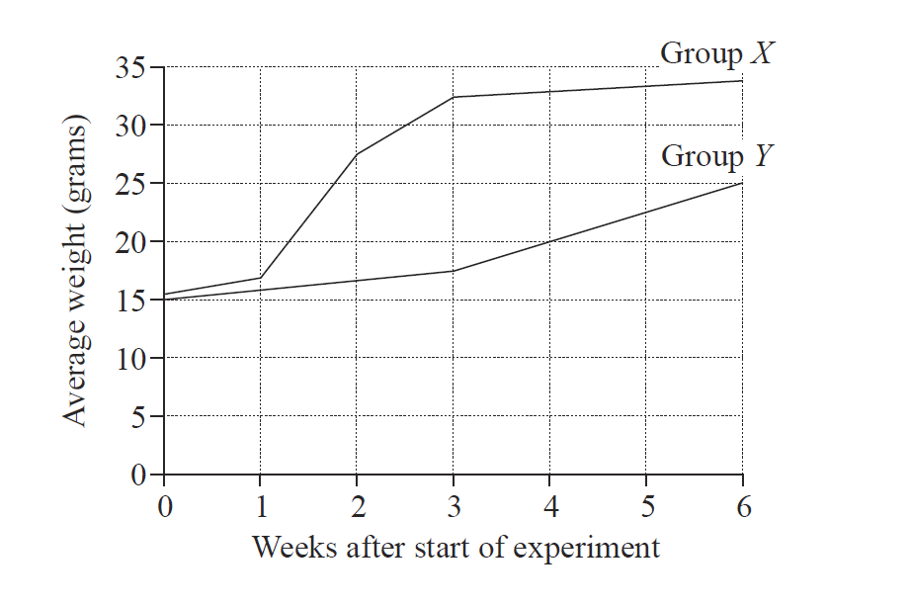

Image credit: NESA

* 1. State when the greatest difference between the average weights of mice in both groups occurs (1 mark).
  2. Justify the independent variable for this investigation (2 marks).
  3. Justify the need for Group Y (2 marks).
  4. Describe one potential systematic error from this investigation (1 marks).

### Marking criteria (a)

|  |  |
| --- | --- |
| Criteria | Marks |
| * Identifies that the greatest difference in weights between the groups occurs at 3 weeks | 1 |

### Sample answer

3 weeks.

### Marking criteria (b)

|  |  |
| --- | --- |
| Criteria | Marks |
| * Stated correct independent variable with correct reasoning | 2 |
| * Stated correct independent variable without reasoning | 1 |

### Sample answer

The independent variable is the factor that has been deliberately changed by the investigator so that its effects on the dependent variable can be validly observed. Therefore, the independent variable in this study is the treatment, i.e., whether the mice received the drug or not.

### Marking criteria (c)

|  |  |
| --- | --- |
| Criteria | Marks |
| * Identifies that Group Y acts as the experimental control * Links the use of an experimental control to improving the validity of the investigation | 2 |
| * Any of the above | 1 |

### Sample answer

Group Y is needed as the experimental control. This allows for comparison with the changed variable and therefore adds to the validity of the investigation.

### Marking criteria (d)

|  |  |
| --- | --- |
| Criteria | Marks |
| * Identifies a correct systematic error | 1 |

### Sample answer

One possible systematic error is that the electronic balance is incorrectly calibrated, giving incorrect readings for the weights of the mice.

## Question 9 (Module 7)

A company called “Raisin’ Up!”has claimed that their brand of raisin toast contains at least 25% mass made up by raisins in each slice of bread. An Investigating Science student has decided to test this claim in a practical investigation by removing the raisins with forceps and taking some measurements using some electronic scales. She tested a single slice of bread and produced the following results:

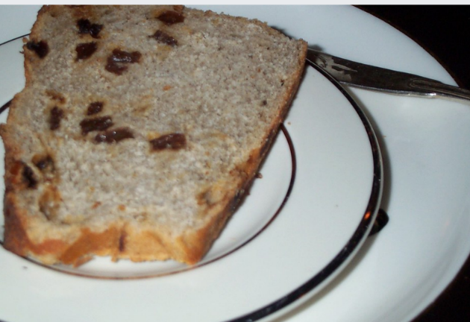

|  |  |
| --- | --- |
| Mass of bread | 44.5g |
| Mass of raisins | 14.5g |
| Percentage of raisin bread made up of raisins |  |

Image credit: Creative commons

* 1. Calculate and complete the missing value in the table. Show any necessary working (2 marks).
  2. Using your understanding of experimental design, evaluate whether these results could be used to verify the claim made by “Raisin’ Up!” (3 marks).

### Marking criteria (a)

|  |  |
| --- | --- |
| Criteria | Marks |
| * Calculates correct response, showing working | 2 |
| * Calculates correct response, without showing working   OR   * Calculates incorrect response, showing correct working | 1 |

### Sample answer

Percentage mass made up of raisins = mass or raisins ÷ mass of bread x 100%

= 14.5g ÷ 44.5g x 100%

= 32.6%

### Marking criteria (b)

|  |  |
| --- | --- |
| Criteria | Marks |
| * Identifies that it is not sufficient to support the claim * Supports by explaining evidence relating to the reliability of data gathered OR accuracy of the procedure | 3 |
| * Identifies that it is not sufficient to support the claim * Identifies the need for more replications OR a factor that improves the accuracy of the procedure | 2 |
| * Identifies that it is not sufficient to support the claim | 1 |

### Sample answer

Even though the result of 32.6% is higher than the claim made by the company, it alone cannot be used to support the claim due to poor experimental design. The student should have tested many more slices and from different randomly selected packets to determine if a reliable result could be obtained. In doing so, the student could have taken an overall average of all measurements to remove likelihood of error affecting the results, such as the possibility that bread is also removed when using the forceps to remove the raisins.

## Question 10 (Module 7)

Pseudoscience articles are never published in peer-reviewed scientific journals, even though those articles may contain scientific words. Using an example of pseudoscience, explain why this is so (3 marks).

### Marking criteria

|  |  |
| --- | --- |
| Criteria | Marks |
| * Identifies an area of pseudoscience that often uses scientific language * Provides TWO appropriate reasons why the article would appear only in a newspaper / not appear in a scientific journal | 3 |
| * Identifies an area of pseudo-science that often uses scientific language * Provides ONE appropriate reason why the article would appear only in a newspaper / not appear in a scientific journal | 2 |
| * Any relevant information | 1 |

### Sample answer

Astrology articles often will appear in newspapers and magazines and can contain scientific language (e.g. Mars is in retrograde). This may seem to add to the credibility of the information for the reader. However, these articles will not appear in scientific journals. Newspaper articles do not need to be peer-reviewed by other experts in the field of study, nor do they need to rely on testable hypotheses and gathering of evidence that could support them. These are essential for articles that are published in scientific journals, as those articles must demonstrate evidence-based reasoning.

## Question 11 (Module 5)

A practical investigation was carried out to determine the effect of a chemical on its ability to react with bread. The reaction causes the bread to dissolve completely.

beaker 1 - 20 degrees, bread pieces;
beaker 2 - 4 degrees, bread crumbs;
beaker 3 - 40 degrees, bread pieces;
beaker 4 - 60 degrees, bread pieces;
beaker 5 0 60 degrees, bread pieces, double the volume of solution inside.

Image credit: NESA

* 1. Propose a hypothesis for this investigation (1 mark).
  2. Identify the independent and dependent variables (2 marks).
  3. Justify which beakers would be required to test the hypothesis fairly (3 marks).

### Marking criteria (a)

|  |  |
| --- | --- |
| Criteria | Marks |
| * Provides an appropriate hypothesis | 1 |

## Sample answer

Higher temperatures will result in a quicker reaction between the bread and the chemical.

### Marking criteria (b)

|  |  |
| --- | --- |
| Criteria | Marks |
| * Correctly identifies both independent and dependent variables | 2 |
| * Correctly identifies either the independent OR dependent variables | 1 |

### Sample answer

Independent – temperature. Dependent – the time taken for the bread to dissolve.

### Marking criteria (c)

|  |  |
| --- | --- |
| Criteria | Marks |
| * Identifies only beakers 1, 3 and 4. * Describes the need to control all necessary variables besides temperature * Relates the description to the validity of the investigation | 3 |
| * Identifies only beakers 1, 3 and 4. * Describes the need to control all necessary variables besides temperature   OR   * Relates the description to the validity of the investigation | 2 |
| * Identifies ANY TWO of the beakers 1, 3 or 4. | 1 |

Sample answer: Only Beaker 1, Beaker 3 and Beaker 4 should be used for this investigation as the only factor that is different between them is the temperature of the chemical. This ensures the student is fairy testing the aim and other factors won’t contribute to the result. In Beaker 5 the water level is higher, and in Beaker 2 the bread is in crumbs so if either of these are used, it would be an invalid experiment.

## Question 12 (Module 5)

The following is an excerpt taken from the website Radiation Health Risks: [radiationhealthrisks.com/wifi-create-health-problems](https://www.radiationhealthrisks.com/wifi-create-health-problems/)

It’s clear radiation from cell phones and Wi-Fi can cause major health problems. Several countries around the world are taking a closer look at the health effects Wi-Fi may have on children in the classroom and at home. Just about every school is equipped with Wi-Fi, laptops and other high tech devices. According to researchers Wi-Fi can cause kids to have a hard time focusing, sleep problems, irregular heartbeats, anxiety, depression, nausea and headaches.

“A lot of times unfortunately, parents are not associating these illnesses with the installation of the Wi-Fi at the school. So kids are going out and getting diagnosed with all sorts of different things and they are missing the source. When parents do figure out that this is the source, they are forced to keep them away and not attend school,” Frank Clegg, Former President of Microsoft Canada.

Explain whether the information in the article should be considered trustworthy (4 marks).

### Marking criteria

|  |  |
| --- | --- |
| Criteria | Marks |
| * Explains in detail various aspects that affect the credibility of the information given | 3-4 |
| * Explains in detail one aspect that affects the credibility of the information given   OR   * Describes two ways the credibility of the information can be determined | 2 |
| * Describes one way the credibility of the information can be determined | 1 |

### Sample answer

The website itself cannot be regarded as a provider of accurate information. There is no indication that the author has qualifications in the field of research, or that it has been peer-reviewed. The domain used is “.com” which means it could be created by anybody, unlike a government website or educational institution, which needs to be reviewed by experts in the field of interest. There is also no indication of when the information was published, which means the information could be outdated. The author refers to “researchers” but does not provide any names of the authors of the research or articles so these could not be verified to determine reliability. While a person is quoted, there is no indication that they have the qualifications required to be commenting on the topic from a scientific basis.

## Question 13 (Module 5)

An Investigating Science student wanted to determine the effect of the concentration of soluble plant fertiliser on the growth of lettuce over 4 weeks. Design a valid and reliable practical investigation that would allow the student to test this by obtaining quantitative data. Include a justification for the use of any technologies to measure either the independent or dependent variables (7 marks).

### Marking criteria

|  |  |
| --- | --- |
| Criteria | Marks |
| * All steps are outlined succinctly, logically, and consistently using correct and precise scientific terms * Independent and dependent variables are clearly stated or inferred, and quantitative data can be obtained * Clear measures are taken to ensure the experiment is valid and reliable * Justification for the use of appropriate technology to measure either the independent and dependent variables are given and are related to the accuracy of measurement | 7 |
| * Most steps are outlined succinctly, logically, and consistently using correct and precise scientific terms * Independent and dependent variables are clearly stated or inferred, and quantitative data can be obtained * Clear measures are taken to ensure the experiment is valid OR reliable * Description of the use of technologies to measure either the independent and dependent variables are given | 5-6 |
| * Most steps are outlined in a logical sequence * Independent OR dependent variables are clearly stated or inferred, and quantitative or qualitative data is obtained * Some attempt to maintain a valid or reliable experiment is made * Appropriate use of technology is identified | 3-4 |
| * Some steps are outlined in a logical sequence * Independent OR dependent variables are clearly stated or inferred   OR   * Appropriate use of technology is identified | 1-2 |

### Sample answer

1. Measure and then pour exactly 100ml of distilled water into each of 5 beakers.
2. Using a calibrated electronic balance to weigh out exactly 5g, 10g, 15g and 20g of the fertiliser.
3. Pour each into the separate beakers and stir until dissolved. Leave one without fertiliser as the experimental control.
4. Plant single seedlings of lettuce of the same variety and initial mass into 5 separate pots, containing the same type and amount of soil.
5. Pour the fertiliser solution into each of the 5 pots as appropriate and leave plants in a controlled environment. Repeat the entire process every 3 days over the 4 weeks.
6. Measure the final mass of the lettuce using a calibrated electronic balance and record the final mass of each. The calibrated electronic balance limits the likelihood of error influencing the results, improving the accuracy of measurements.
7. Repeat the entire procedure several more times and take averages for all measurements to minimise the influence of errors. Analyse results to determine if there is an effect of the fertiliser on lettuce growth.

## Question 14 (Module 5, Module 6)

Two students were investigating the movement of a remote-control car. Their results are shown in the table below:

|  |  |
| --- | --- |
| Time (seconds) | Total distance travelled (m) |
| 0 | 0 |
| 10 | 10 |
| 20 | 14 |
| 30 | 22 |
| 40 | 26 |
| 50 | 27 |
| 60 | 27 |

* 1. Propose an inquiry question for this investigation (1 mark).
  2. Calculate the speed of the remote-control car at 30 seconds, showing all working (2 marks).
  3. The students were using a stopwatch to obtain their data. Construct a table to contrast one advantage with one disadvantage of using this technology (2 marks).

### Marking criteria (a)

|  |  |
| --- | --- |
| Criteria | Marks |
| * Provides a relevant inquiry question | 1 |

### Sample answer

What is the maximum speed the remote-control car can reach within 60 seconds?

### Marking criteria (b)

|  |  |
| --- | --- |
| Criteria | Marks |
| * Correct answer calculated, showing working | 2 |
| * Correct answer calculated without showing working   OR   * Incorrect answer, showing correct working | 1 |

### Sample answer

Speed = distance (m) ÷ time (sec)

= 22m ÷ 30 sec

= 0.73m/sec

### Marking criteria (c)

|  |  |
| --- | --- |
| Criteria | Marks |
| * Table constructed that allows easy comparison * Provides BOTH a relevant advantage and disadvantage | 2 |
| * Provides EITHER a relevant advantage or disadvantage | 1 |

### Sample answer

|  |  |
| --- | --- |
| Advantage | Disadvantage |
| Relatively easy cheap and easy to use. | Prone to random errors when timing the moving car at each interval. This could affect the accuracy of the measurement. |

## Question 15 (Module 6)

A student carried out a practical investigation to determine the effect of changes in temperature on the reaction rate. Four strips of magnesium placed into four equal-sized test tubes containing equal volumes of acid at different temperatures as shown.

tube 1 10 degrees;
tube 2 20 degrees;
tube 3 30 degrees;
tube 4 40 degrees.

Image credit: NESA

Justify the use of a named piece of technology that could be used to measure changes in the independent variable (2 marks).

### Marking criteria

|  |  |
| --- | --- |
| Criteria | Marks |
| * Identifies a named piece of technology that is capable of measuring temperature changes * Provides one suitable benefit of the technology | 2 |
| * Identifies a named piece of technology that is capable of measuring temperature changes   OR   * Provides a suitable benefit of a named piece of technology | 1 |

### Sample answer

A calibrated digital thermometer could be used to measure the changes in acid temperature instead of an analogue thermometer. This would provide a more accurate reading that better resembles the true measured value.

1. This document references the Stage 6 Investigating Science syllabus © 2019 NSW Education Standards Authority (NESA) for and on behalf of the Crown in right of the State of New South Wales.