Investigating Science: Evaluating data guide and templates
This guide accompanies the presentations: Evaluating secondary information and Evaluating data for first-hand investigations
Contents
Investigating Science: Evaluating data guide and templates 1
Conducting secondary-source research 2
Why do we conduct secondary-source research? 2
How do I conduct secondary-source research? 3
How do I correctly reference an information source? 5
Scaffolds: Secondary-source research 6
Sample (exemplar) of summarising information 6
Secondary-source investigation scaffold 7
Evaluating Accuracy, Precision, Reliability and Validity 7
Accuracy: emphasis on exactness 8
Precision: emphasis on agreement 9
Reliability - emphasis on stability 10
Uncertainty: a measure of accuracy and reliability 10
Validity: emphasis on meaning 11
Scaffolds: Conducting first-hand investigations 12
Planning scaffold for first-hand investigations 13
Working Scientifically self-evaluation checklist 15
Report checklist for first-hand investigations 17
Guide to controlling risks 19
Risk control measures: hierarchy of controls 20
Sample risk assessment 21
Template for risk analysis 21
Acknowledgements: 22

Conducting secondary-source research

Why do we conduct secondary-source research?
Conducting secondary-source research is vital for all scientific endeavours. There are two main reasons for conducting secondary-source research:
- To consolidate information about specific areas of science.
- To develop the foundations for scientific inquiry (research).
In developing the foundations for scientific inquiry, secondary-source research allows scientists to build upon the knowledge and experiences of others to identify knowledge gaps and avoid unnecessary investigation. It helps scientists to develop inquiry questions and subsequent hypothesis, as well as develop valid and reliable research methods. Crucially, it also enables the inbuilt self-checking mechanism of Science that is validation and replication studies.
The written product of secondary-source research is called the literature review. Literature reviews are much more sophisticated than a simple summary of background information. As indicated by Figure 1, literature reviews involve a high level of critical thinking as the scientist analyses and syntheses information from different academic sources.
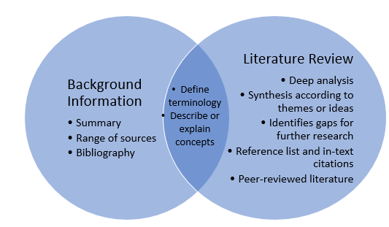
Figure 1: Background information compared to a literature review

Corresponding to the two main purposes of secondary-source research, literature reviews can be categorised as either narrative or systematic.
A narrative review provides a summary of relevant ideas in a topic area and is most useful for communicating a broad understanding of the field.
A systematic review provides evidence for the development of scientific hypotheses. It presents the key ideas in the topic area, gaps in understanding or conflicting theories, and how that information leads to the development of their research question and hypothesis. It also includes a discussion of specific data and methodologies which lay the foundation for designing valid investigations and performing validation or replication studies.

How do I conduct secondary-source research?
The most important thing when using secondary sources for data collection is that they are valid. The validity of secondary data relies on the sources coming from educational, government or scientific institutions where a panel of scientists evaluates the data before it is published (peer review). This ensures that the data and information are accurate and reliable.
Valid sources are:
- Educational textbooks (being mindful of the date of publication)
- Educational and government institution web pages
- Scientific journals and articles
- Encyclopaedias
Valid sources are not:
- General fiction books
- Non-educational web pages
- Articles in popular magazines
- Discussion blogs in social media
An excellent method for evaluating sources is the CRAAP method as described by QUT library, which is widely used at many universities. It is also the best-practice approach used in Science Extension.

C
- Is it Current?
- When was it published?
- Are their references current?
- Is currency important for your topic?
R
- Is it Relevant?
- Does the information relate to my topic?
- Which audience is it written for?
- Is it at an appropriate level for my needs?
A
- Is it Authoritative?
- Who is the author and/or organisation? Are they qualified?
- Is it edited or peer-reviewed?
- If it is a website, does the URL tell you anything?
A
- Is it Accurate?
- Where does the information come from?
- Are there references?
- Are there errors, broken links?
P
- What is its Purpose?
- What is the purpose of the information? Is it an advertisement?
- Scholarly work? Opinion?
- Is there bias?
Tips for conducting secondary-source research:
Read widely on your topic using the internet, books and scientific journals.
Check potential resources for currency, relevance, authority, accuracy and purpose. Keep a note of any references you find useful.
Add to your bibliography as you go. Do not leave your bibliography until the end or you may have trouble finding the resource again, especially if it is an online resource.
Use an appropriate referencing style (for example APA or Harvard).

How do I correctly reference an information source?
Once the sources are selected, and information is gathered, they must be referenced correctly in alphabetical order (by surname) in a reference list (or bibliography). It is good practice to add them to your list of sources as soon as they are used to avoid misplacing information and data. Creating and maintaining a reference section in your workbook or digital document is a handy idea.
Bibliography or Reference List – Which should I use?
A bibliography is a list of all the secondary-sources you looked at for obtaining and writing background information. A bibliography is used when you do NOT need to include in-text citations.
If you are writing a literature review that requires you to synthesise (combine) ideas from different sources, then you must use in-text citations and a reference list. In-text citations are ‘pointers’ that tell the reader where the information, quote or ideas came from; they ‘point’ to the correct source in the reference list. Every in-text citation must have a corresponding entry in the reference list, and the reference list must only include sources with in-text citations.

Formatting
When writing a bibliography or reference list (with in-text citations), there are formatting rules to follow. Three common referencing systems used in Science are APA, Harvard and MLA. These are called parenthetical systems because parenthesis (brackets) are used for in-text citations. Individual faculties/schools at tertiary institutions will generally prescribe which reference system to use. The librarian at your school will be able to show you websites or apps that can cite information for you in the required format (e.g. the double quotation (”) icon in Google Scholar). There are also referencing tools in Microsoft Word that generate bibliographies.
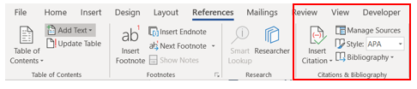
Figure 2: Screen clipping of the Microsoft Word ribbon that shows the referencing tool

Scaffolds: Secondary-source research

Sample (exemplar) of summarising information
Table 1: Scaffold: secondary-source research sample
Scaffold Prompt
Inquiry Question (IQ): | Why do seasons occur?
Source title (T): | What causes the seasons?
Bibliography (B): | Erickson, K. (2018). What causes the seasons? Retrieved June 12, 2018, from spaceplace.nasa.gov/seasons/en/  (Note: underline the title for handwritten references because it cannot be italicised)
Valid (V)? | The source is an official government website for NASA, so it is probably trustworthy.
Reliable (R)? | It has the same information as other valid websites: (http://www.abc.net.au/news/science/2017-09-01/seasons-and-their- changes-explained/8858776) and (weather.gov/lmk/seasons).
Summary (S) of the information relevant to the inquiry question. | Our seasons do not depend on how far away Earth is from the sun. In fact, in the Northern Hemisphere, the Earth is actually closest to the Sun during winter, and furthest away during summer.  We have seasons because of the tilt of Earth’s axis. Earth’s axis is the imaginary line through the centre of the planet around which it spins. The axis is the imaginary line drawn through the north and south poles. When we compare the orientation of Earth to the Sun, Earth’s axis is tilted (leans over). The angle of this tilt is always in the same the direction. As the Earth orbits around the Sun, sometimes the north pole is tilted towards the Sun, and sometimes the south pole is tilted towards the Sun. The image below shows this relationship between the seasons and Earth’s tilt. (Include any labelled or annotated diagrams that will assist you to explain.)  Which season you are in depends on whether your hemisphere is pointing towards the Sun or away from it. During summer, your hemisphere is pointing towards to Sun, so your hemisphere receives more of the direct rays from the Sun. With more of the direct rays from the sun hitting your hemisphere in summer, it gets hotter.

Secondary-source investigation scaffold
Scaffold Prompt
Inquiry Question (IQ):
Source title (T):
Bibliography (B):
Valid (V)?
Reliable (R)?
Summary (S) of the information relevant to the inquiry question.
Use mnemonics to help develop summaries, including
SUM (Shorter than the text, Use your own words, Main ideas only) or
PEEL (Point, Explain, Evidence, Link)
Labelled diagrams can be included.
Table 2: Scaffold: secondary-source investigation

Evaluating Accuracy, Precision, Reliability and Validity
These terms are talked about a lot in science, but what do they mean? While accuracy, precision, and reliability are all elements of validity, it is important to understand the distinction between these terms. The following information provides a brief overview of these terms. For more information, refer to Evaluating Data from the NSW Department of Education curriculum pages.

Figure 3: Validity, reliability and accuracy

Accuracy: emphasis on exactness
Accuracy is how close a measurement is to its true value. Error is the difference between the measured quantity and its true value, and so the higher the level of accuracy, the lower the amount of error.
Errors can be:
Random – an error that is present in every measurement. Repeating measurements and calculating an average for analysis improves accuracy.
Systematic – an error that is due to a problem in the system. Repeating measurements will not improve the accuracy of the data, but the error itself is predictable once it has been identified. For example, measuring a length from the end of a 30 cm ruler (instead of from zero) will result in measurements that are all out by the same amount.

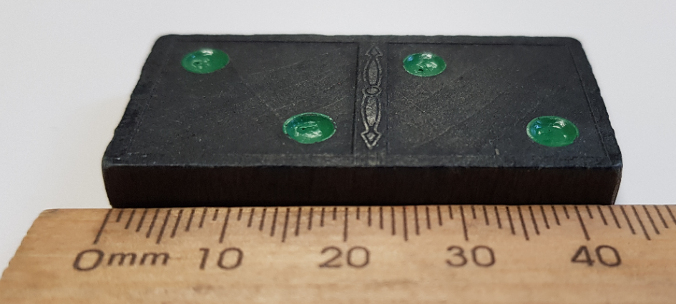
Figure 4: Random error when measuring a domino with a ruler – is it 43 or 44 mm? Image credit: © State of New South Wales (Department of Education), 2020
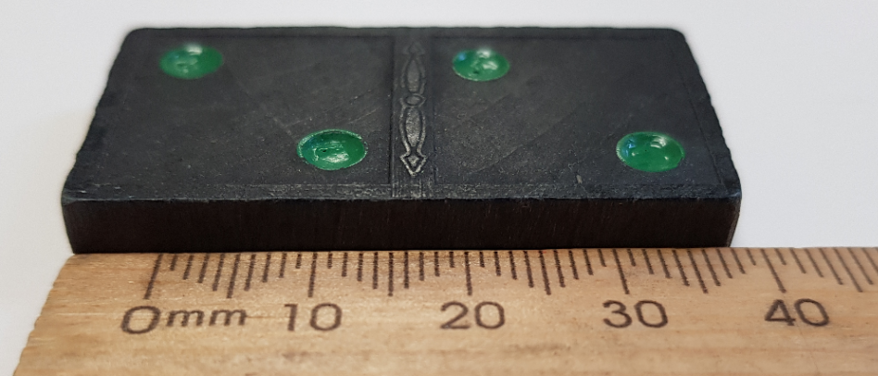
Figure 5: Systematic error caused by measuring a domino from the end of the ruler instead of from 0 mm. Image credit: © State of New South Wales (Department of Education), 2020

Precision: emphasis on agreement
Precision is internal reliability, but it is important to understand that reliability encompasses more than just precision.
- Measurement precision – the extent to which repeated measurements, made under identical conditions, agree with each other. Conducting repeat trials and comparing measurements for consistency is an evaluation of measurement precision.
- Instrument precision – refers to the error associated with the instrument itself. It is important to note that digital instruments do not always have greater precision / lower error than analogue instruments.

Reliability - emphasis on stability
Reliable measurements are similar in value over multiple experiments.
To improve reliability,
- repeat an experiment and compare the results (internal reliability, precision)
- compare results with a group that carried out the same method (external reliability).

Uncertainty: a measure of accuracy and reliability
The measurand is the quantity being measured, and uncertainty represents the range of values that we are confident our measurand lies in. When estimating uncertainty, we need to take both accuracy and reliability into account.
Measurand = best estimate ± uncertainty
Analogue measurements:
- start with a minimum uncertainty is $±$½ smallest unit minimum
- increase the level of uncertainty according to the design of the experiment
Digital measurements:
- use the error / precision reported in the manual (for example, $2\% at 10℃, 5\% at 90℃$)
- if precision is unknown, account for unknown rounding in electronics (may only round down or round up):
  - for a stable reading: measurand = reading $±$smallest unit
  - for an unstable reading: measurand = average reading $± ½$ range
Uncertainty is not just about the instrument and the methodology. Even the measurand itself may vary. Take the height of a bottle rocket, for example – how consistent will the measurements be?
Repeat trials allow you to estimate the size of the variation of the measurand:
- best estimate = mean value
- uncertainty* = maximum difference from the mean (for a very small number of trials)
*Alternate method: uncertainty = ½ range (maximum-minimum)

Validity: emphasis on meaning
Validity relates to the meaning of the results.
Validity of method: Did the experiment accurately measure what was intended to be measured?
Validity of conclusions: Are the results interpreted and generalised to other situations appropriately? Accuracy and reliability are essential for valid scientific findings.
To ensure your method is valid, you can:
- check that your hypothesis is directly relevant to your aim
- check that your method tests your hypothesis
- check that your sampling method represents the wider population
- control your variables so that the test is fair and the chance of sneaky (lurking) variables affecting your results is minimised
To ensure your conclusions are valid, you can:
- check the accuracy and reliability of your measurements
- identify the limitations of your data so that you can check if/how your findings can be generalised or extrapolated to other situations
- examine your underlying assumptions to check for possible bias
check data representations for potential bias (such as axis scales can distort ‘impression’ of data)
Figure 6: The relationship between validity, reliability and accuracy
Validity
Validity of method: aim, hypothesis, and method match; sampling method; controlled variables; experimental control
Validity of conclusions: limitations, assumptions, possible bias, accuracy and reliability
Reliability
- Internal reliability (precision)
- External reliability

- Closeness of measurement to the true value
- Depends on the technology

Accuracy
Take an average from repeat trials to reduce uncertainty

Scaffolds: Conducting first-hand investigations
Table 3: Planning scaffold for investigations
Scaffold Prompt
Title
Aim (A): | To (observe, investigate, study, measure or another verb).
Background information (BI): | (Relevant and scientific)
Variables (V):  IV: X  DV: Y  CV: same | Independent (IV)…  Dependent (DV)…  Controlled (CV)…
Control or standard (C/S): | Control: Additional experiment with the independent variable removed (e.g. when investigating different fertilisers, the control would be no fertiliser).  Standard: The value of the independent variable used to obtain baseline observations to which all other observations are compared.
Hypothesis (H):  PT- IV & DV | A statement of the predicted trend/pattern. It must include the independent variable, dependent variable, and their relationship.
Materials and equipment (ME):
Safety (S):
Control measures
Method (M): | Sequential, steps start with a verb, clear, quantifiable, reproducible, may include a diagram.
Results(R): | Observations, tables, graphs, identify trends.
Discussion (D):  Analysis and discussion of what the results show | Describe the variation in the results and identify any outliers.  Identify any trends or patterns in the data.  Discuss any problems that occurred and how they were (or could be) addressed. Explain any changes that should be made if the experiment was repeated.  Evaluate your method and results for validity, reliability & accuracy.
Conclusion (C): | A summary of the findings and how they relate to the aim.  Do not include specific results, but trends may be described.  Do the observations/results support or disprove the hypothesis?

Planning scaffold for first-hand investigations
Scaffold Prompt
Title
A:
BI:
V:
(IV, DV, CV)
C/S:
H:
(PT- IV & DV)
ME:
S:
(CM)
M:
R:
D:
C:
Table 4 Scaffold: First-hand investigation blank
The scaffold can be pasted into an online logbook or journal, and each section can be as long as required. If drafts are used for the teacher to provide feedback, copy and paste draft (1) into a new page called draft (2) and modify it. Teacher feedback can be provided in an additional column on the right.

Working Scientifically self-evaluation checklist
Name: Activity: Date:
Skill content | Evident | Developing | Not evident | N/A
While planning investigations, students:
Develop a question and/or hypothesis
Identify the independent and dependent variable
Identify and explain the controlled variables
Source appropriate materials/technology
Ensure all risks are assessed
Ensure a valid procedure will allow for the reliable collection of data
Develop strategies ensuring controlled variables are kept constant
Justify the selection of equipment, resources and design of an investigation
Use an experimental control when appropriate
While conducting investigations, students:
- Select appropriate equipment
- Employ safe work practices
- Ensure the risk assessments are conducted and followed
- Use appropriate technologies
- Methodically collect valid and reliable data
- Apply correct waste disposal procedures
- Correctly reference any secondary-sources information
While processing data and information, students:
- Use the most appropriate and meaningful methods and media to organise and analyse data and information
- Use digital technologies & a variety of appropriate visual representation
- Process data from primary and secondary-sources, including qualitative/quantitative data and information
While analysing data and information, students:
- Identify trends, patterns and relationships
- Recognise error, uncertainty and limitations in data
- Recognise error, uncertainty and limitations in data
- Interpret scientific and media texts
- Evaluate the relevance, accuracy, validity and reliability of primary or secondary-sourced data
- Evaluate processes, claims and conclusions by considering the quality of the evidence
- Use reasoning to construct scientific arguments
- Use mathematical models to demonstrate trends and relationships that occur in data where appropriate
While problem-solving, students:
- Use critical thinking skills and creativity to demonstrate an understanding of scientific principles related to the inquiry questions and questions posed in investigations
- Use models to qualitatively and quantitatively explain and predict cause and effect relationships
- Synthesise and use evidence to construct & justify conclusions
- Interpret scientific and media texts
- Evaluate processes, claims and conclusions
- Consider the quality of evidence available
While communicating, students:
- Focus on clarity and accuracy
- Use qualitative and quantitative information gained from investigations using primary and secondary data
- Use digital, visual, written & verbal forms of appropriate communication
- Apply appropriate scientific notations and nomenclature
- Apply & use scientific language for specific audiences/contexts
Table 5 Self-evaluation checklist for WS skills

Report checklist for first-hand investigations
Name: Report title: Date:
Research report includes, where appropriate: | Evident | Developing | Not evident | N/A
Title
Aim: To (verb) OR
Abstract: (Stage 6, 1 paragraph, overall summary)
Background Information (relevant, scientific) OR
Literature Review (Stage 6, in-text citations)
Variables (IV, DV and CV) OR
Experimental control (IV removed)
Hypothesis (predict trend, IV & DV clear/specific)
Materials and Equipment
Safety (risk assessment, control measures & explanation)
Method (clear, sequential, reproducible, quantifiable, steps usually start with a verb, labelled diagram or photograph as appropriate) OR
Methodology (Stage 6, essay style, reproducible by an expert reader)
Results (observations, tables, graphs, identify trends)
Discussion
Describe trends/patterns and use background information to explain them
Describe the variation in the results, identify outliers and how they were handled in analysis
Describe problems/sources of error
Explain what changes you would make to improve the quality of the data collected
Discussion (Stage 6)
In-text citations
Evaluate validity by determining
if the tests measured what they were intended to measure
if the data, analysis and actions are accurate
Evaluate reliability by determining
The consistency of the results obtained
Measures are taken to reduce error
Discussion SciX, InvSci, Phys
Assess accuracy (uncertainty) including random and systematic error
Discussion SciX, InvSci:
Describe the potential real-world consequences (beneficial and harmful)
Conclusion (overall findings and how they relate to the aim, judgement of whether results support or disprove the hypothesis, include trends but do not mention specific results)
Bibliography (Stage 4/5 list of secondary-sources) OR
Reference List (Stage 6, list of all cited sources in an appropriate format, e.g. Harvard or APA)
Table 6: checklist for the scientific research report

Guide to controlling risks
Controlling risks is included in this guide, as an integral part of the process of planning and conducting investigations, although it is not addressed in the accompanying presentation.
The purpose of risk management is to make first-hand investigations as safe as possible. Risk assessments are used during planning to identify hazards, assess risks, and eliminate or control risks. When conducting risk assessments, you need to consider
- the chemicals and equipment that will be used
- the volume and concentration of chemicals
- the handling and storage of chemicals
- the proposed method
- the experience and knowledge of the people involved
It is not enough just to consider the type of chemicals involved. The volume, concentration, handling and storage of chemicals are all important considerations. For example:
- Pouring 5mL of strong acid into a test tube directly from a 1L bottle is much more likely to result in spills and splashes then using 40 mL dropper bottles.
- Acids in high concentrations can cause severe tissue damage, whereas weak acids are very unlikely to cause an injury if it is rinsed off with water quickly.
- Spilling acid over the entire forearm will cause greater injury than if a single drop of the acid touches the skin.
- Using a retort stand to hold a test tube being heated over a Bunsen burner eliminates (removes) the risk of burning your hand if you were holding the test tube instead.
IMPORTANT: Risk assessments should be done in consultation with other people and preferably with an expert who has experience using the materials, equipment or procedures involved.
The following sections describe how to carry out a risk assessment. The Risk Analysis Table template can be downloaded from the General Resources section on the Department of Education’s Investigating Science webpage.

Risk control measures: hierarchy of controls
The hierarchy of controls is standard practice for managing risks in the workplace; it lists the options for controlling hazards in order from the most effective to the least effective. As shown below, the most effective control method is to remove the hazard altogether (elimination).

Order of effectiveness | Control | Example
1 | Elimination | Remove the hazard, such as taking a hazardous piece of equipment out of service.
2 | Substitution | Replace a hazardous substance or process with a less hazardous one, such as replacing a strong acid with a weak acid.
3 | Engineering controls | Isolate people from the hazard. For example, redesign an experiment, piece of equipment or process to make it less hazardous, install a guard or barrier, or use a fume hood.
4 | Administrative controls | Make changes to the way people work:  - adopt safe work practices  - provide appropriate training, instruction or information  For example, use a retort stand or test tube holder instead of a person holding equipment and have a teacher demonstrate safe use of the materials and equipment.
5 | Personal protective equipment (PPE) | Use of lab-coat, gloves, safety glasses, safety footwear, dust masks, face shields or goggles
Table 7: Hierarchy of controls. The controls are listed in Health and safety management procedure

Sample risk assessment
Risk analysis for dissolving calcium carbonate in different concentrations of HCl:
Risk | Consequence  1-5 | Likelihood  1-5 | Risk rating (See matrix) | Precaution | Control
skin damage due to spills/splashes | 3 | 2 | M | HCl in dropper bottles  Wear gloves | Substitution  PPE
Eye damage due to chemical splash | 4 | 2 | M | Safety glasses | PPE
Cut hand due to broken glassware | 2 | 3 | M | Do not use damaged test tubes.  Train user | Elimination  Administrative controls
Table 8: Risk analysis for dissolving calcium carbonate in HCl

Template for risk analysis

Consequence and likelihood template
Risk | Consequence1-5 | Likelihood  1-5 | Risk rating (See below) | Precaution | New consequence 1-5 | New likelihood 1-5 | New risk rating
Table 9: Template for risk analysis from Risk analysis table document

Acknowledgements:
Auburn Girls High School: Dr Lisa Wallis
The scientific literature review, Science Extension (NSW Department of Education, 2019)
Evaluating Data (NSW Department of Education, 2019)
Risk Analysis Table (NSW Department of Education, 2019)
Health and Safety management procedure , NSW department of Education

