Organic spectroscopy problem set

Teacher guide
This document is intended to provide opportunities for students to apply their understanding of the spectroscopic techniques in Module 8 Inquiry Question 2 to a wide range of compounds from Module 7 Inquiry Question 1. The question stem is adapted from the HSC 2019 Chemistry examination Question 26a with the attached selection of spectra provided to adapt this question to new structures for students. This resource can be used in several ways:
- Practice HSC style exam question for Module 8 Inquiry Question 2
- Internal assessment stimulus material
- Teaching resource for the comparison of each spectrum across the range of techniques covered in Module 8 Inquiry Question 2
Each spectrum provided for use as an unknown is identified in the table below along with a link to the original source (National Institute of Advanced Industrial Science and Technology, Japan, 2018). A complete worked example for propanoic acid is provided to guide students extracting data from each spectrum to identify the unknown compound.
Each unknown may be printed on a single double-sided sheet and allocated to students. An answer key is provided on page 5.

Contents
Organic spectroscopy problem set 1
Teacher guide 1
Syllabus reference 3
HSC Chemistry Module 7 3
HSC Chemistry Module 8 4
Answer key 5
Student activity: example 6
Marking scheme 7
Example data analysis 8
Observations and inferences 10
Chemical tests 10
Infrared spectroscopy 10
Mass spectrometry 10
Carbon-13 NMR 12
Proton NMR 12
Student activity: unknowns 12
Sample A 13
Sample B 15
Sample C 17
Sample D 19
Sample E 21
Sample F 23
Sample G 25
Sample H 27
Sample I 29
Sample J 31
Sample K 33
Sample L 35
Sample M 37
Sample N 39
Sample O 41
Sample P 43
Sample Q 45
Sample R 47
Sample S 49
Sample T 51
Sample U 53
Sample V 55
Sample W 57
Sample X 59
Sample Y 61
Sample Z 63
References 65

Syllabus reference

HSC Chemistry Module 7
Outcomes referenced in this document are from Chemistry Stage 6 Syllabus, © 2017 NSW Education Standards Authority (NESA) for and on behalf of the Crown in right of the State of New South Wales.

Outcomes
- CH11/12-5 - analyses and evaluates primary and secondary data and information
- CH11/12-6 - solves scientific problems using primary and secondary data, critical thinking skills and scientific processes
- CH11/12-7 - communicates scientific understanding using suitable language and terminology for a specific audience or purpose
- CH12-14 - analyses the structure of, and predicts reactions involving, carbon compounds

Content
Inquiry question - How do we systematically name organic chemical compounds?
Investigate the nomenclature of organic chemicals, up to C8, using IUPAC conventions, including simple methyl and ethyl branched chains, including: (ACSCH127)
- alkanes
- alkenes
- alkynes
- alcohols (primary, secondary and tertiary)
- aldehydes and ketones
- carboxylic acids
- amines and amides
- halogenated organic compounds
Explore and distinguish the different types of structural isomers, including saturated and unsaturated hydrocarbons, including: (ACSCH035)
- chain isomers
- position isomers
- functional group isomers

HSC Chemistry Module 8

Outcomes
- CH11/12-1 - develops and evaluates questions and hypotheses for scientific investigation
- CH11/12-2 - designs and evaluates investigations in order to obtain primary and secondary data and information
- CH11/12-3 - conducts investigations to collect valid and reliable primary and secondary data and information
- CH11/12-4 - selects and processes appropriate qualitative and quantitative data and information using a range of appropriate media
- CH11/12-7 - communicates scientific understanding using suitable language and terminology for a specific audience or purpose
- CH12-15 - describes and evaluates chemical systems used to design and analyse chemical processes

Content
Inquiry question: How is information about the reactivity and structure of organic compounds obtained?
Conduct qualitative investigations to test for the presence in organic molecules of the following functional groups:
- carbon–carbon double bonds
- hydroxyl groups
- carboxylic acids (ACSCH130)
Investigate the processes used to analyse the structure of simple organic compounds addressed in the course, including but not limited to:
- proton and carbon-13 NMR
- mass spectrometry
- infrared spectroscopy (ACSCH130)

Answer key
Table 1: Answer key for sample compounds A-Z
Sample spectra | Compound
A | Pentane
B | Hexane
C | Pent-1-ene
D | Hex-1-ene
E | Methanol
F | Ethanol
G | Ethanoic acid
H | Propan-1-ol
I | Propanal
J | Propan-2-ol
K | Propan-2-one
L | Butan-1-ol
M | Butan-2-ol
N | 2-methylpropan-1-ol
O | 2-methylpropan-2-ol
P | Pentan-1-ol
Q | Pentanal
R | Pentanoic acid
S | Pentan-2-ol
T | Pentan-2-one
U | Propan-1-amine
V | Butan-1-amine
W | Butanamide
X | Pentanamide
Y | 2-chloropropane
Z | 1-bromopropane

Student activity: example
What is the structural formula of this compound? Justify your answer with reference to the information given on its reactivity and to at least three of the provided spectra. (5 marks)
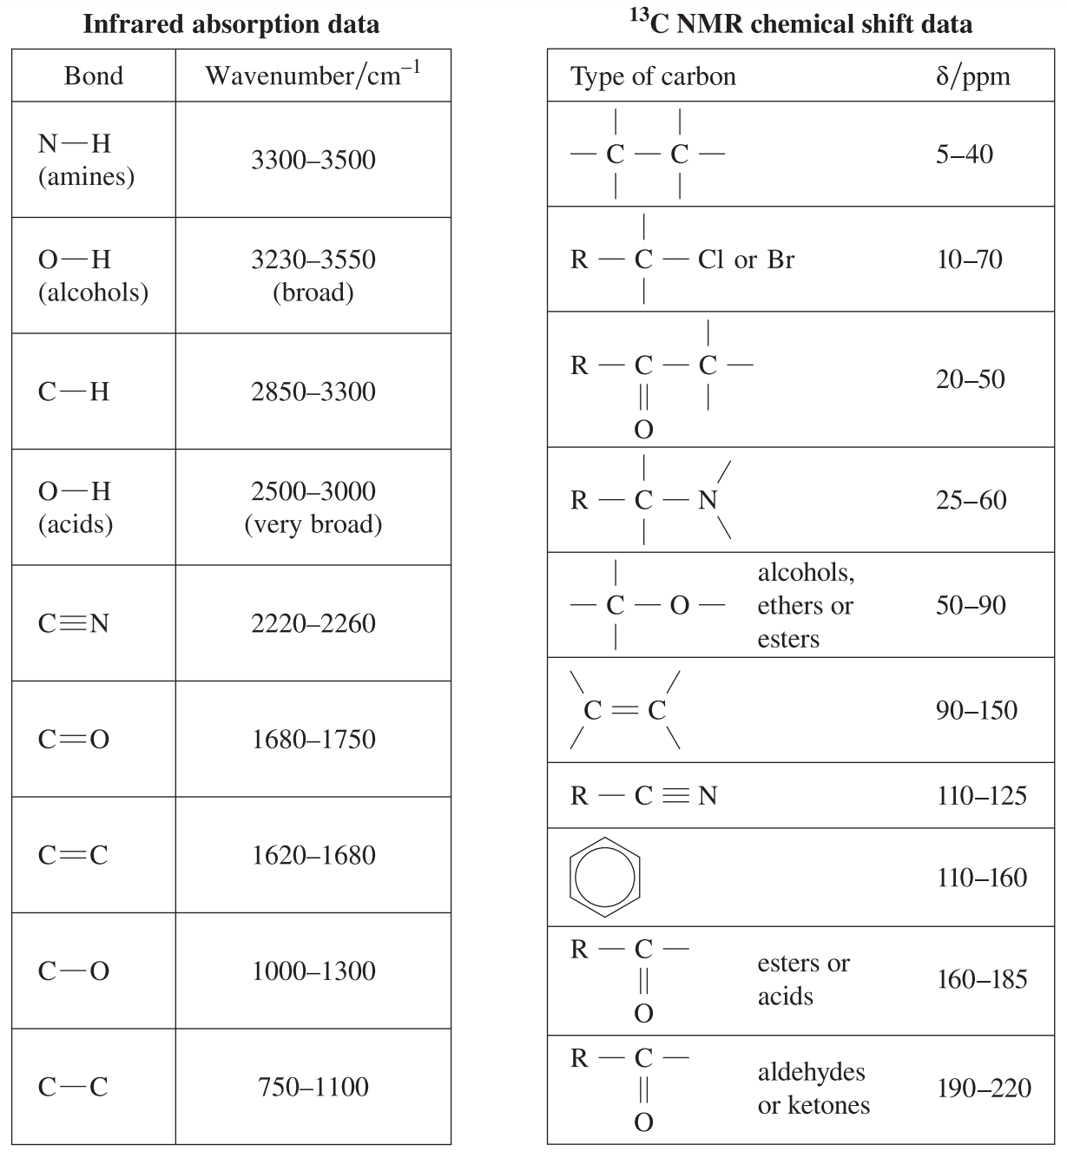
Figure 1: extract from Chemistry HSC Data Sheet © 2019 NSW Education Standards Authority (NESA) for and behalf of the Crown in right of the State of New South Wales

Marking scheme
Table 2: Marking scheme from the 2019 HSC Chemistry examination pack Question 26a
© 2019 NSW Education Standards Authority (NESA) for and behalf of the Crown in right of the State of New South Wales
Criteria | Marks
- Gives correct structure and justifies using reactivity and at least three spectra | 5
- Gives substantially correct structure and justifies using reactivity and at least two spectra  or  - Gives a correct structure and justifies using at least three spectra | 4
- Gives substantially correct structure and some correct analyses  or  - Gives substantially correct analyses with incorrect structure | 2-3
- Provides some relevant information | 1

Example data analysis
Test | Result
Unsaturation test using bromine water | Orange colour remains
Oxidation test using acidified potassium dichromate | Orange colour remains
Carboxylic acid test using sodium carbonate | Bubbles of carbon dioxide
Infrared spectroscopy | 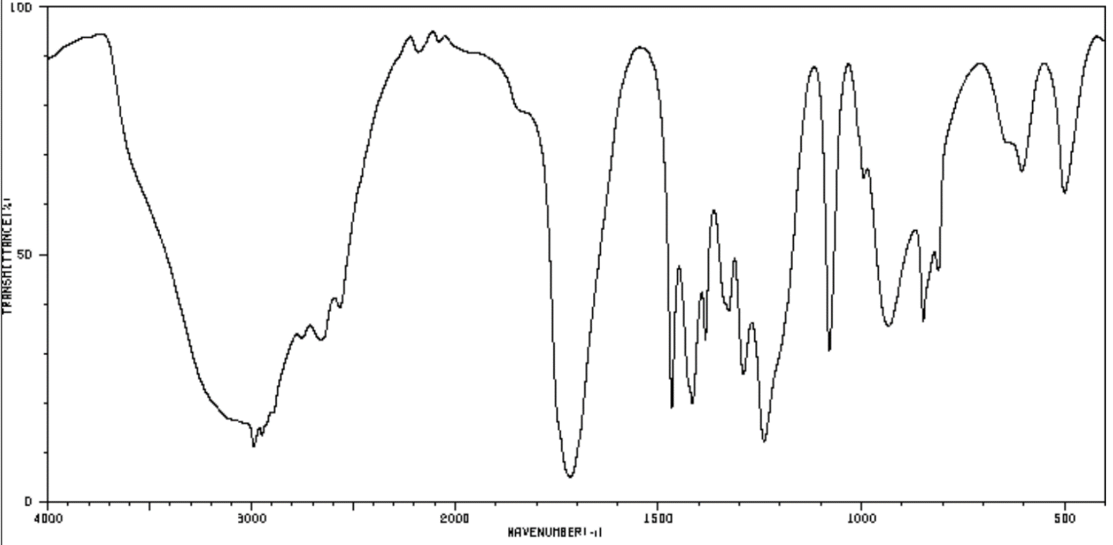
Mass spectrometry  Mass of molecular ion:  m/z = 74 | 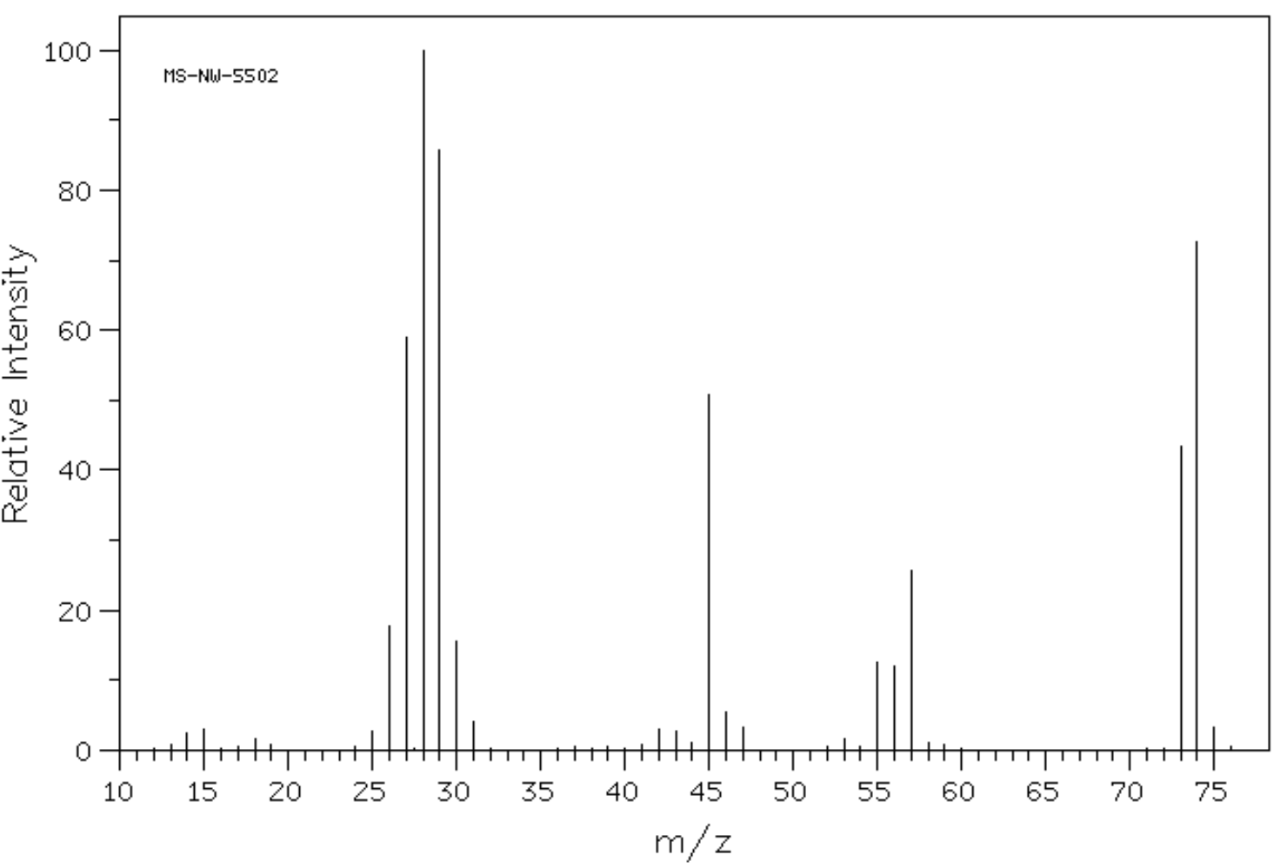
Carbon-13 NMR | 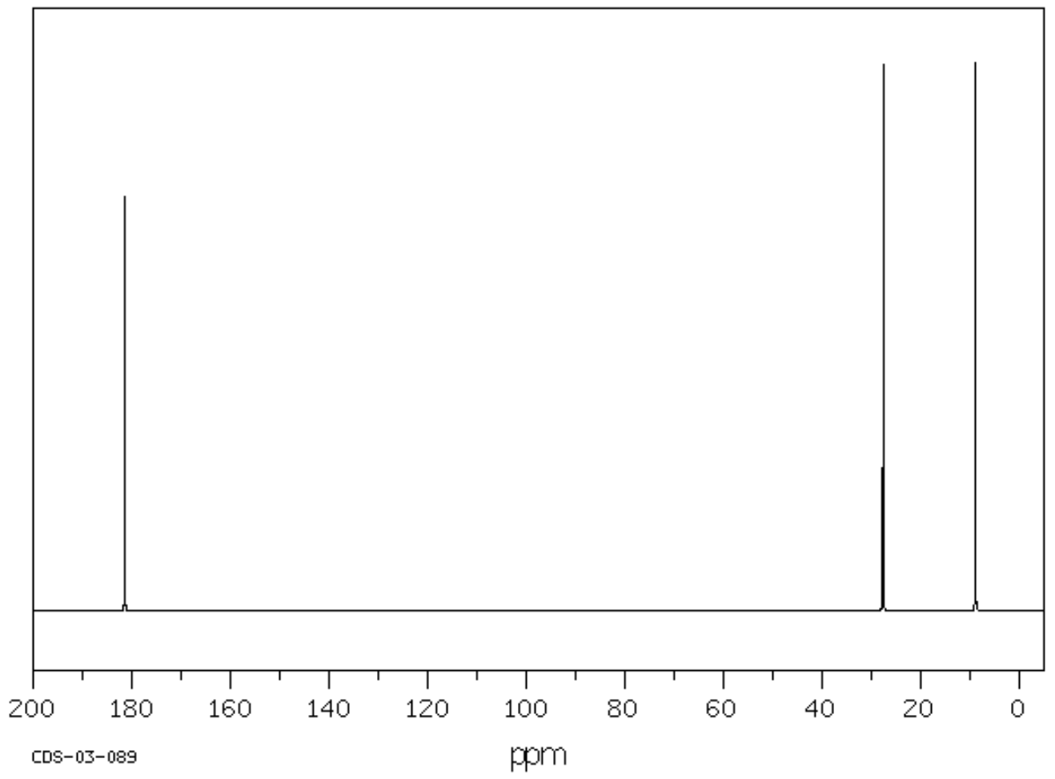
Proton NMR | 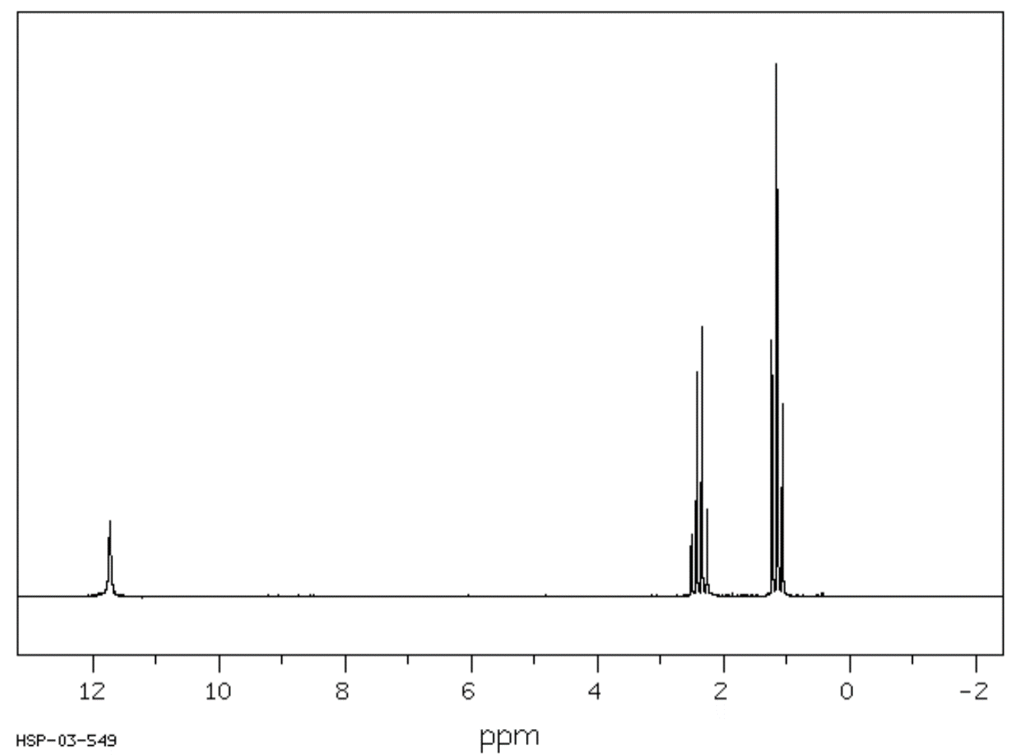
Proton NMR peak data
Shift (ppm) | Number of peaks | Peak area ratio
11.73 | 1 | 1
2.38 | 4 | 2
1.16 | 3 | 3

Observations and inferences
This question requires the use of a minimum of three (all four are discussed here) of these spectra and the other chemical reactivity information given in the table to propose the identity of this unknown organic compound. It is important to have a structure which agrees with all the information obtained to justify the compound you have proposed. The solution provided here is highly detailed and intended to fully explain the justification above the requirement of the justification needed in the marking scheme.

Chemical tests
- The orange colour remaining in the unsaturation test is a negative result indicating this compound does not contain a double or triple carbon-carbon bonds.
- The orange colour remaining in the oxidation test is a negative result indicating this compound does not contain a primary/secondary alcohol or aldehyde functional group which are oxidisable.
- The bubbles of carbon dioxide in the sodium carbonate test is a positive result indicating a carboxylic acid functional group is present. This result also eliminates the possibility of any other functional group.

Infrared spectroscopy
Major observations from the IR spectrum are a broad peak at ~3000cm⁻¹ which indicates the presence of a hydroxyl (OH) group and a narrow peak at ~1700cm⁻¹ which indicates the presence of a carbonyl (C=O) bond. This combination is only possible with a carboxylic acid functional group being present on the structure.
Using the reference table provided, several of the peaks can be identified as the bonds in propanoic acid but does not allow confirmation of the compound’s identity. The absence of peaks corresponding to the other functional groups listed in the data sheet also helps to eliminate alternative possible functional groups in this compound. Due to the common nature of C-C and C-H bonds in organic compounds, these peaks are observed in the IR spectrum of all organic compounds and are not particularly useful for determining the unknown structure.

Mass spectrometry
The mass spectrum gives the molecular ion (m+) peak at m/z = 74 (a very small m+1 peak at m/z = 75 is also present) so it can be determined that the compound has a molecular weight of 74gmol⁻¹. It is at this point we can first propose a structure, the only carboxylic acid which has a molecular weight of 74gmol⁻¹ is propanoic acid, C₃H₆O₂:
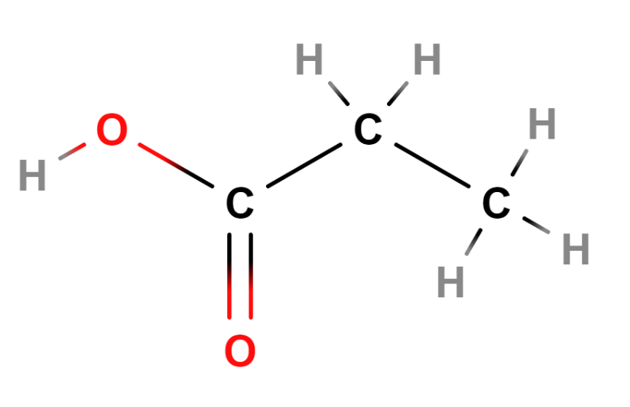
Figure 3: A molecular structure for propanoic acid (Bergwerf, 2015)
Using the proposed structure of propanoic acid the molecular weights of fragments can be more easily matched to the peaks present. When the other spectra (IR/NMR) are available, there is little benefit from analysing the fragmentation pattern in MS. For the completeness of this analysis, other prominent fragment ion peaks are:
Fragment A mass (m/z) | Fragment A | Fragment B | Fragment B mass (m/z)
1 |  | 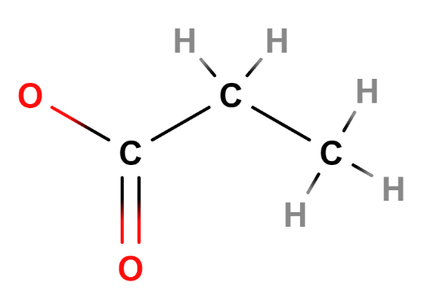 | 73
17 | 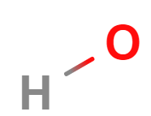 | 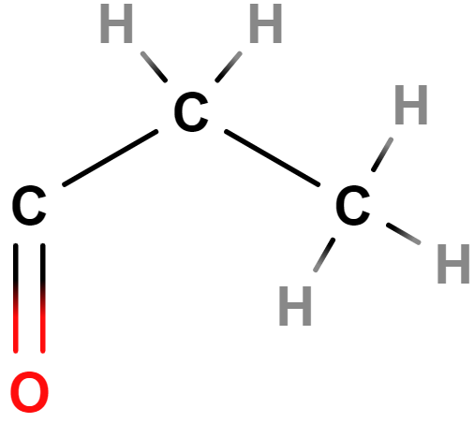 | 57
45 | 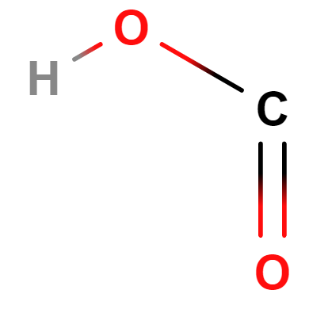 | 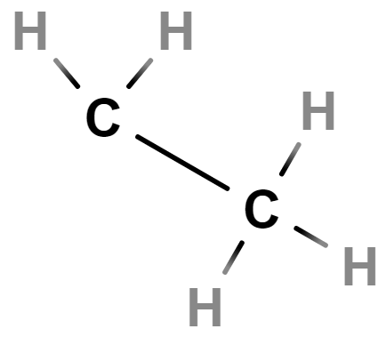 | 29
Table 4: Fragments for spectrometry of propanoic acid

Carbon-13 NMR
The carbon-13 NMR contains three peaks, this requires a minimum of three carbons in the compound. This excludes methanoic acid (only 1 carbon) and ethanoic acid (only 2 carbons). Continuing with the hypothesis this compound is propanoic acid allows the use of the reference table provided, these peaks can be identified as specific carbon environments:
- The peak at ~10ppm corresponds to a hydrocarbon chain and is normally a very low shift for a terminal CH₃ group
- The peak at ~27ppm corresponds to a hydrocarbon chain also and the slightly higher shift gives the indication this carbon is non-terminal as a CH₂ group
- The peak at ~180ppm corresponds to a carbonyl (C=O) group as a component of a carboxylic acid.

Proton NMR
The Proton NMR contains three peaks which indicates the existence of three unique hydrogen environments where each are split according to the arrangement of adjacent hydrogen nuclei. Using the carbon-13 NMR and IR peaks it can be observed the presence of a CH₃, CH₂ and OH groups which create the hydrogen environments in propanoic acid. Continuing with the hypothesis this compound is propanoic acid allows the peaks to be identified as specific hydrogen environments:
- The peak at ~1ppm is split into a triplet (3 peaks), indicating this hydrogen environment is adjacent to two hydrogens, the terminal CH₃ group is adjacent to the CH₂ group capable of this triplet peak and is normally a very low shift for a terminal hydrogen environment
- The peak at ~2.2ppm is split into a quartet (4 peaks), indicating this hydrogen environment is adjacent to three hydrogens, the CH₂ group is adjacent to the terminal CH₃ group capable of this quartet peak and the slightly higher shift gives the indication this is a non-terminal hydrogen environment
- The peak at ~11.7ppm is a singlet (not split), indicating this hydrogen environment is not adjacent to any other hydrogens, only the hydroxyl (OH) hydrogen is capable of this peak due to the separation of this hydrogen environment from the others by the oxygen.

Student activity: unknowns
What is the structural formula of the allocated compound (A-Z)? Justify your answer with reference to the information given on its reactivity and to at least three of the provided spectra for the allocated unknown (A-Z). (5 marks – using the marking scheme from 2019 Chemistry HSC question 26a)

Sample A
Test | Result
Unsaturation test using bromine water | Orange colour remains
Oxidation test using acidified potassium dichromate | Orange colour remains
Carboxylic acid test using sodium carbonate | No bubbles
Infrared spectroscopy | 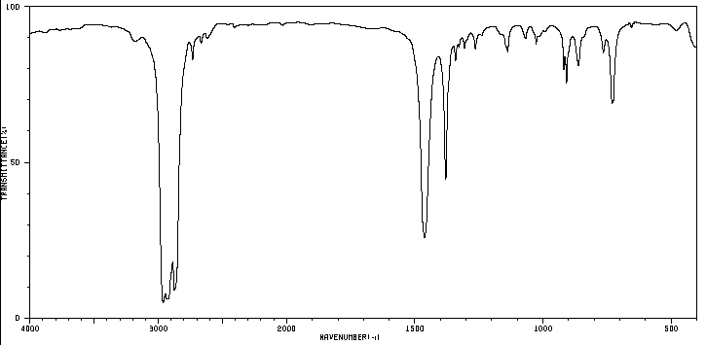
Mass spectrometry  Mass of molecular ion:  m/z = 72 | 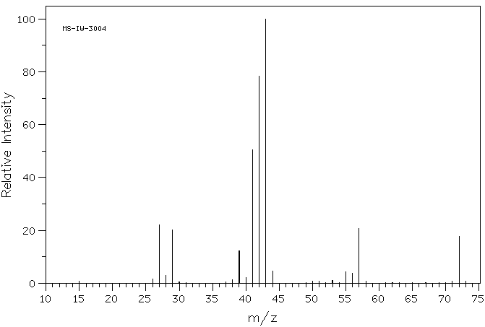
Carbon-13 NMR | 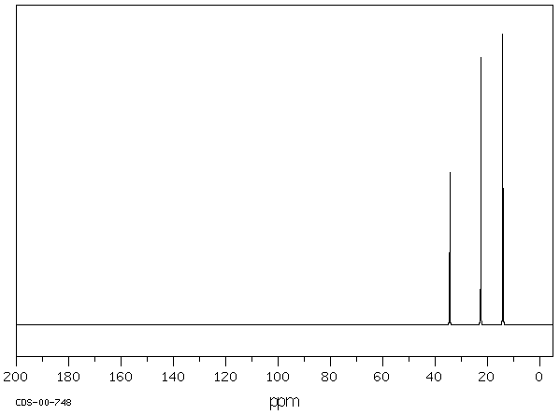
Proton NMR | 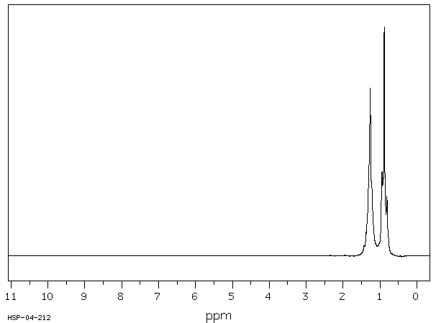
Proton NMR peak data
Shift (ppm) | Number of peaks | Peak area ratio
1.30 | 6 | 4
1.26 | 5 | 2
0.884 | 3 | 6

Sample B
Test | Result
Unsaturation test using bromine water | Orange colour remains
Oxidation test using acidified potassium dichromate | Orange colour remains
Carboxylic acid test using sodium carbonate | No bubbles
Infrared spectroscopy | 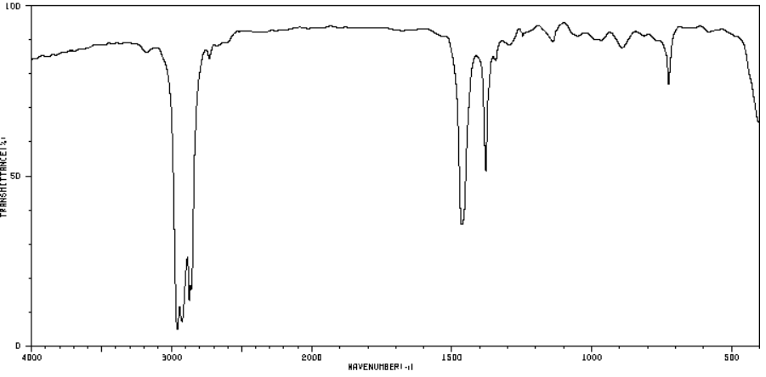
Mass spectrometry  Mass of molecular ion:  m/z = 86 | 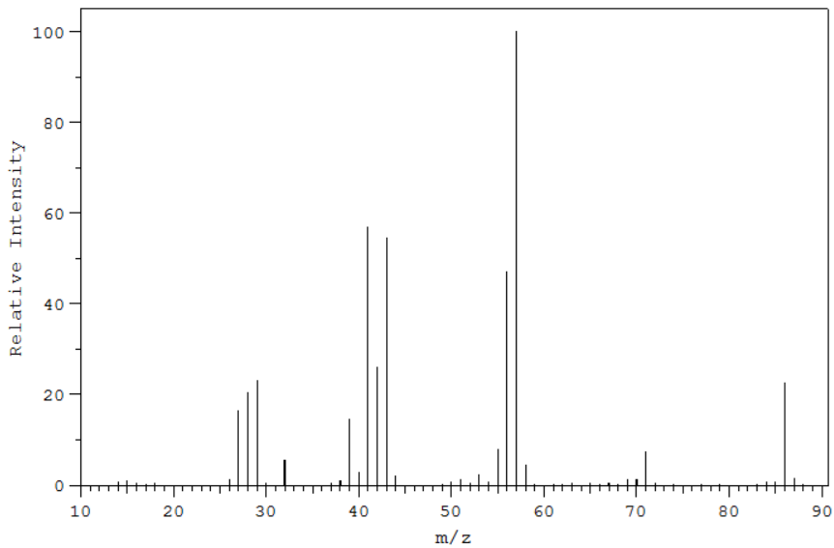
Carbon-13 NMR | 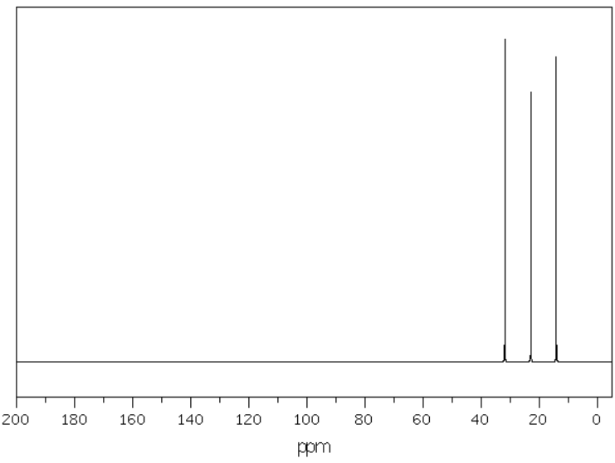
Proton NMR | 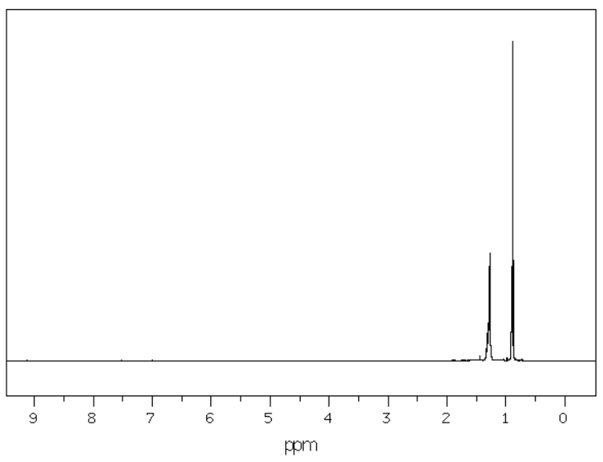
Proton NMR peak data
Shift (ppm) | Number of peaks | Peak area ratio
1.30 | 6 | 4
1.28 | 5 | 4
0.90 | 3 | 6

Sample C
Test | Result
Unsaturation test using bromine water | Solution turns colourless
Oxidation test using acidified potassium dichromate | Orange colour remains
Carboxylic acid test using sodium carbonate | No bubbles
Infrared spectroscopy | 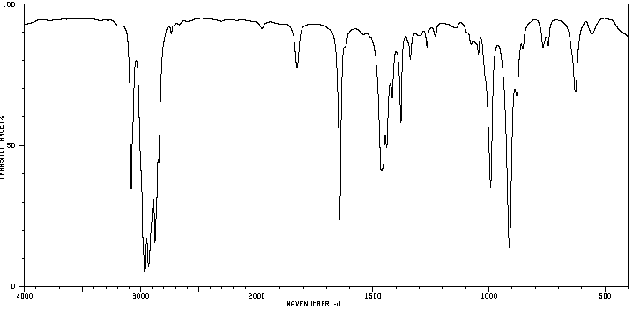
Mass spectrometry  Mass of molecular ion:  m/z = 70 | 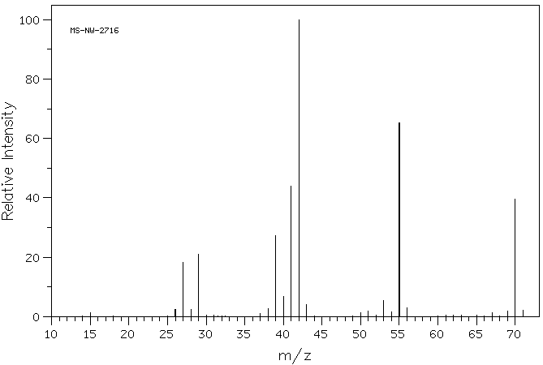
Carbon-13 NMR | 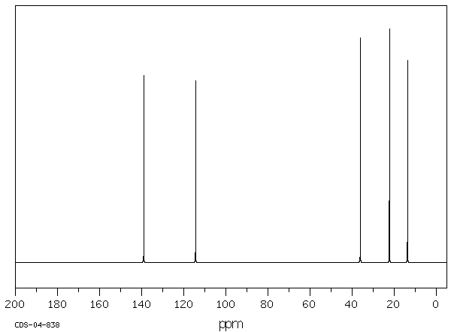
Proton NMR | 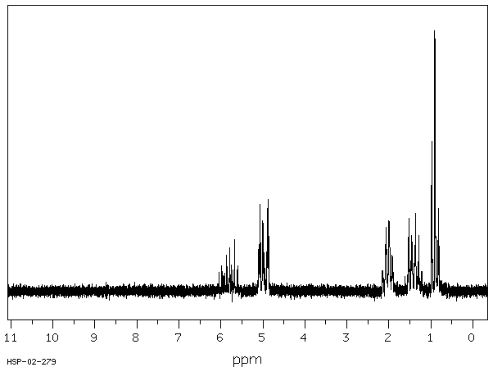
Proton NMR peak data
Shift (ppm) Number of peaks Peak area ratio  5.81 5 1  4.97 3 1  4.93 3 1 | Shift (ppm) Number of peaks Peak area ratio  2.02 4 2  1.43 6 2  0.91 3 3

Sample D
Test | Result
Unsaturation test using bromine water | Solution turns colourless
Oxidation test using acidified potassium dichromate | Orange colour remains
Carboxylic acid test using sodium carbonate | No bubbles
Infrared spectroscopy | 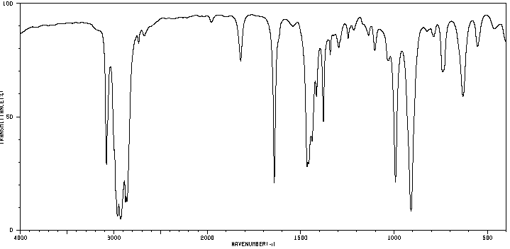
Mass spectrometry  Mass of molecular ion:  m/z = 84 | 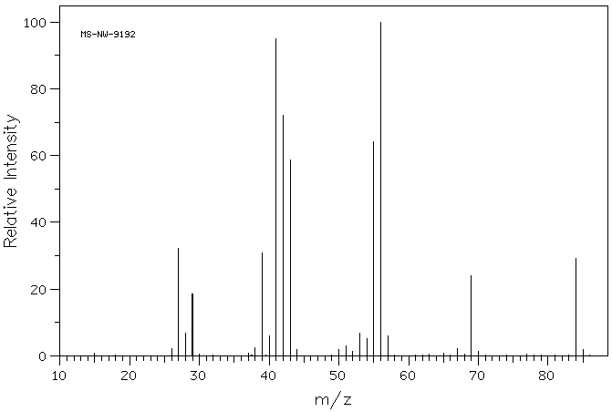
Carbon-13 NMR | 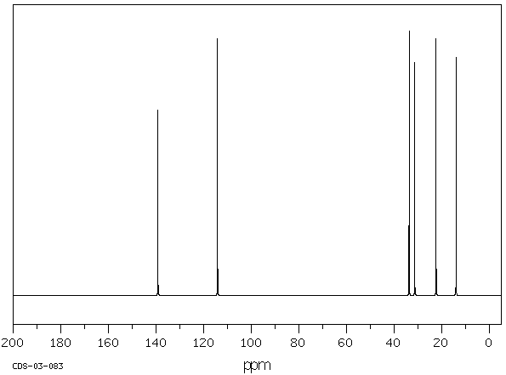
Proton NMR | 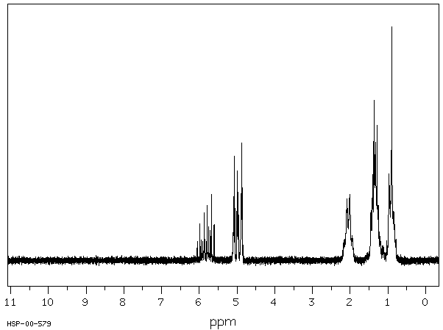
Proton NMR peak data
Shift (ppm) Number of peaks Peak area ratio  5.80 5 1  4.96 3 1  4.92 3 1  2.06 4 2 | Shift (ppm) Number of peaks Peak area ratio  1.40 5 2  1.10 6 2  0.90 3 3

Sample E
Test | Result
Unsaturation test using bromine water | Orange colour remains
Oxidation test using acidified potassium dichromate | Solution turns green
Carboxylic acid test using sodium carbonate | No bubbles
Infrared spectroscopy | 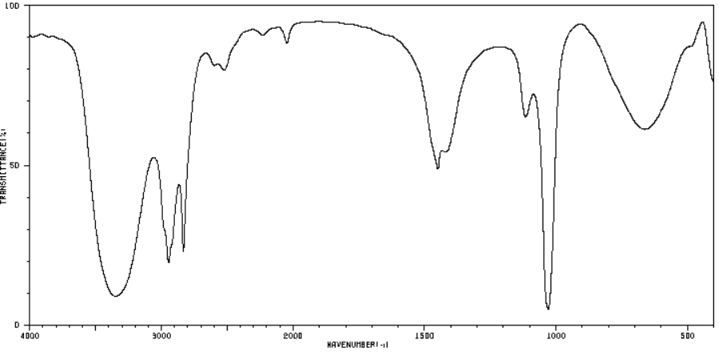
Mass spectrometry  Mass of molecular ion:  m/z = 32 | 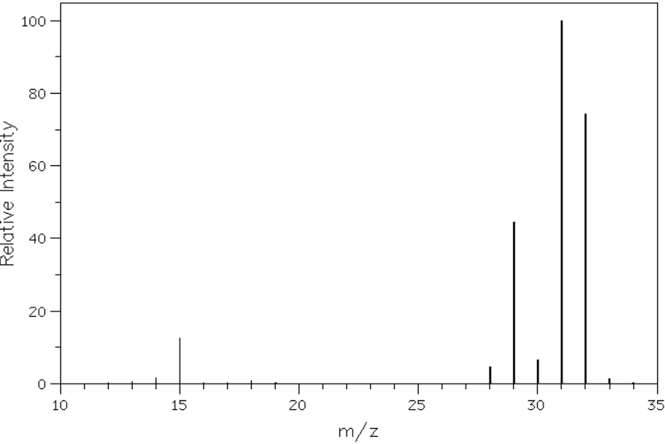
Carbon-13 NMR | 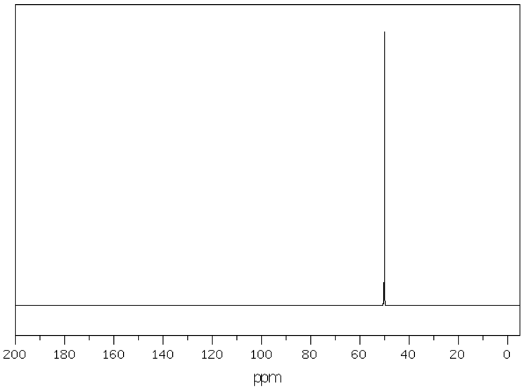
Proton NMR | 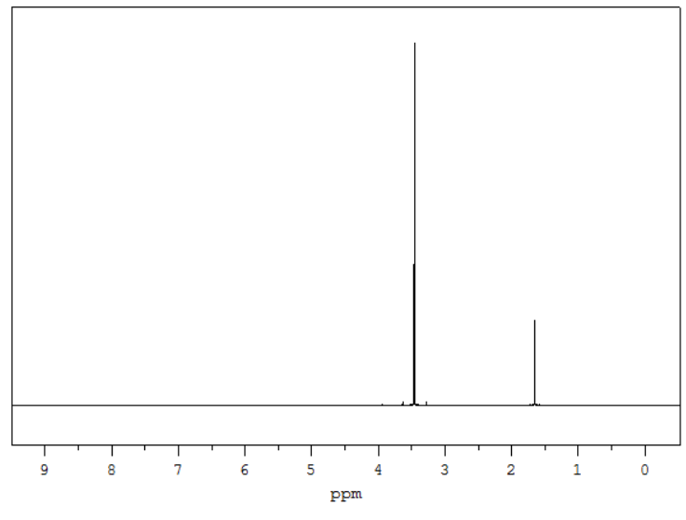
Proton NMR peak data
Shift (ppm) | Number of peaks | Peak area ratio
3.47 | 1 | 3
1.67 | 1 | 1

Sample F
Test | Result
Unsaturation test using bromine water | Orange colour remains
Oxidation test using acidified potassium dichromate | Solution turns green
Carboxylic acid test using sodium carbonate | No bubbles
Infrared spectroscopy | 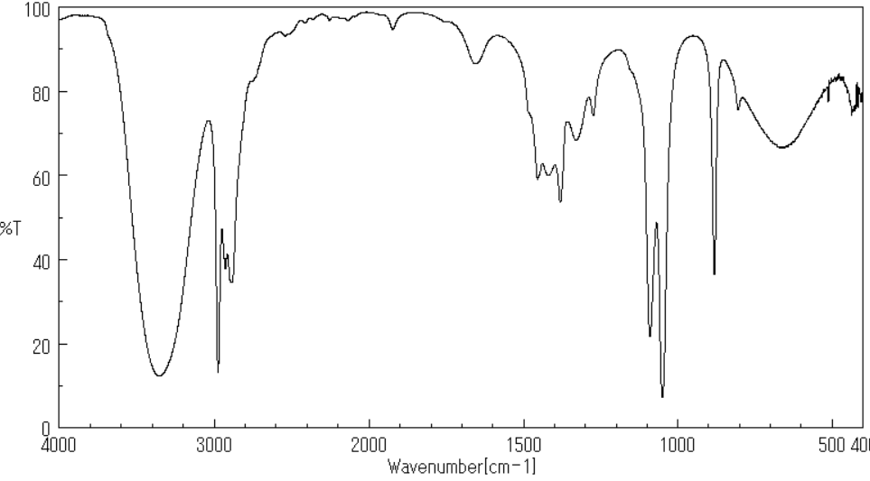
Mass spectrometry  Mass of molecular ion:  m/z = 46 | 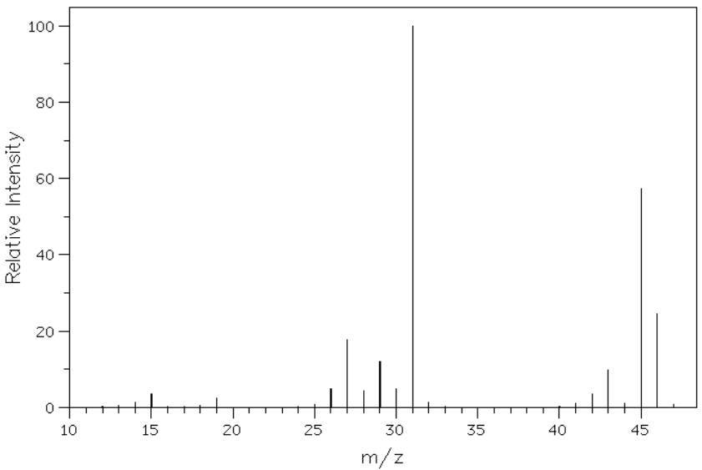
Carbon-13 NMR | 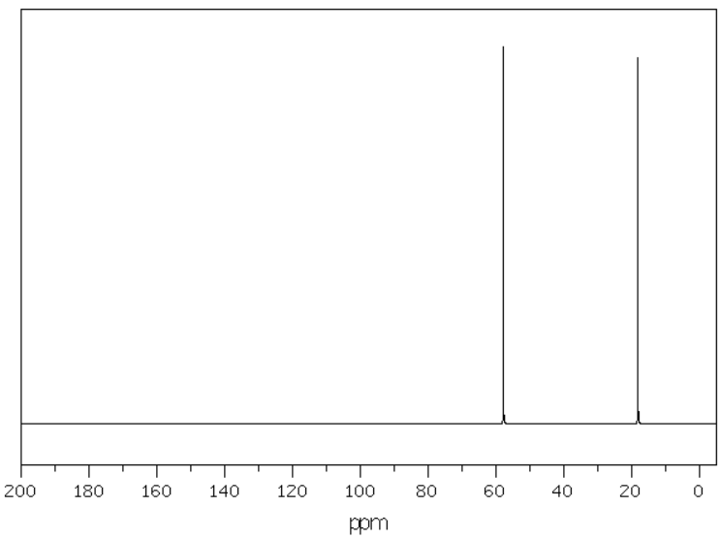
Proton NMR | 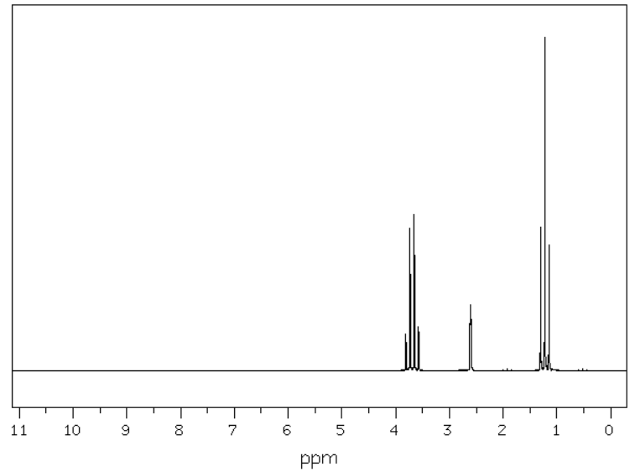
Proton NMR peak data
Shift (ppm) | Number of peaks | Peak area ratio
3.69 | 4 | 2
2.61 | 1 | 1
1.23 | 3 | 3

Sample G
Test | Result
Unsaturation test using bromine water | Orange colour remains
Oxidation test using acidified potassium dichromate | Orange colour remains
Carboxylic acid test using sodium carbonate | Bubbles of carbon dioxide
Infrared spectroscopy | 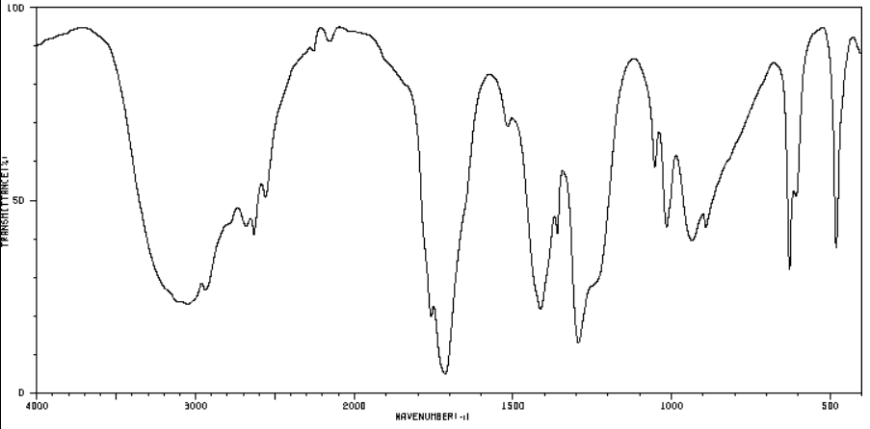
Mass spectrometry  Mass of molecular ion:  m/z = 60 | 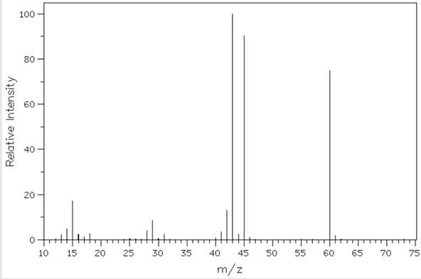
Carbon-13 NMR | 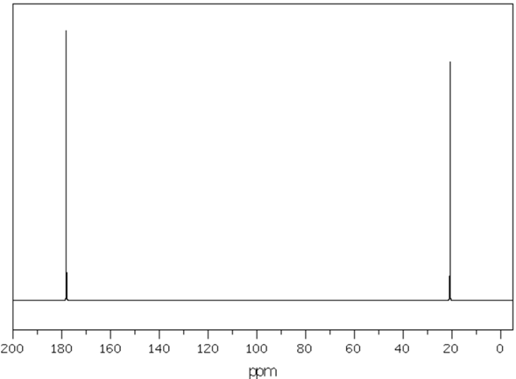
Proton NMR | 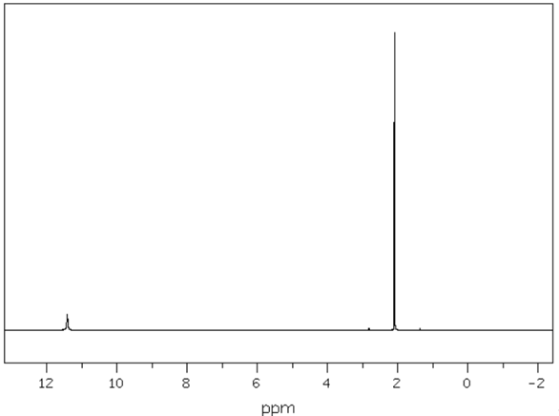
Proton NMR peak data
Shift (ppm) | Number of peaks | Peak area ratio
11.42 | 1 | 1
2.10 | 1 | 3

Sample H
Test | Result
Unsaturation test using bromine water | Orange colour remains
Oxidation test using acidified potassium dichromate | Solution turns green
Carboxylic acid test using sodium carbonate | No bubbles
Infrared spectroscopy | 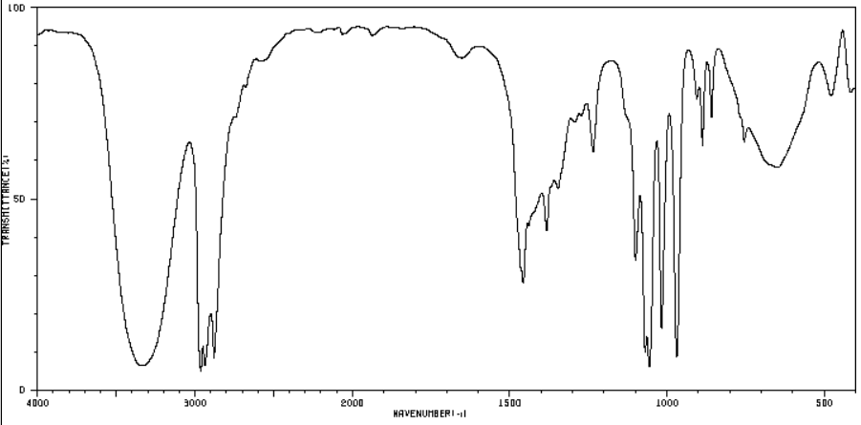
Mass spectrometry  Mass of molecular ion:  m/z = 60 | 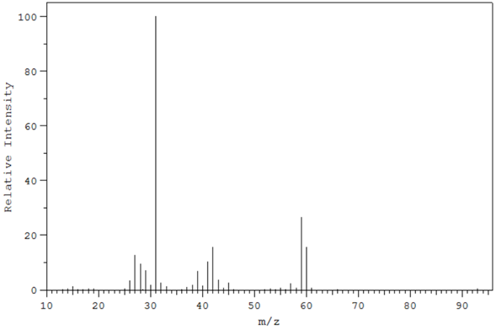
Carbon-13 NMR | 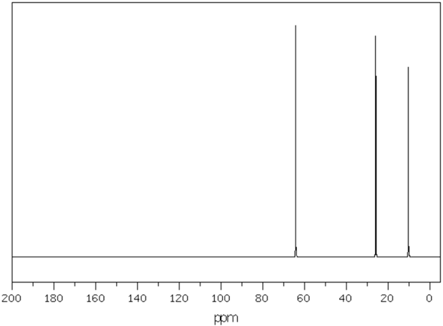
Proton NMR | 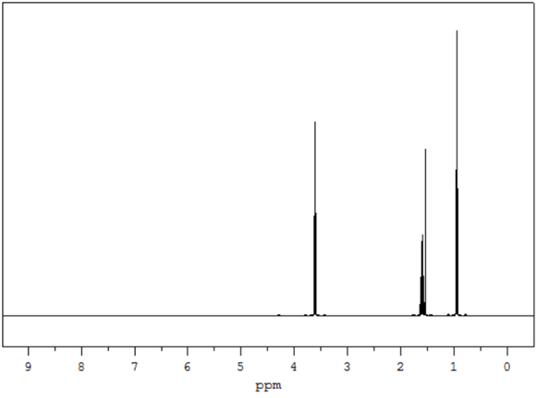
Proton NMR peak data
Shift (ppm) | Number of peaks | Peak area ratio
3.60 | 3 | 2
1.60 | 6 | 2
1.53 | 1 | 1
0.94 | 3 | 3

Sample I
Test | Result
Unsaturation test using bromine water | Orange colour remains
Oxidation test using acidified potassium dichromate | Solution turns green
Carboxylic acid test using sodium carbonate | No bubbles
Infrared spectroscopy | 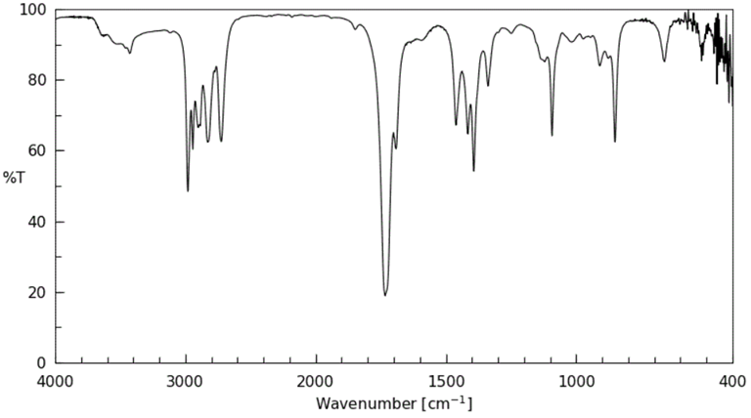
Mass spectrometry  Mass of molecular ion:  m/z = 58 | 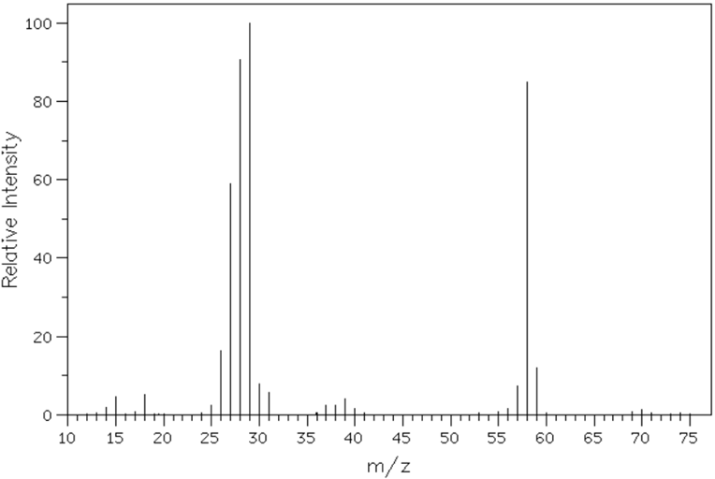
Carbon-13 NMR | 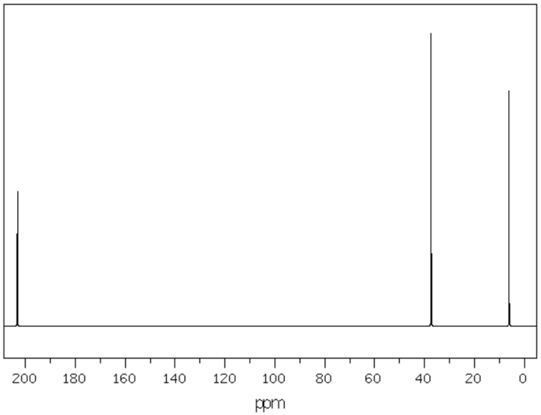
Proton NMR | 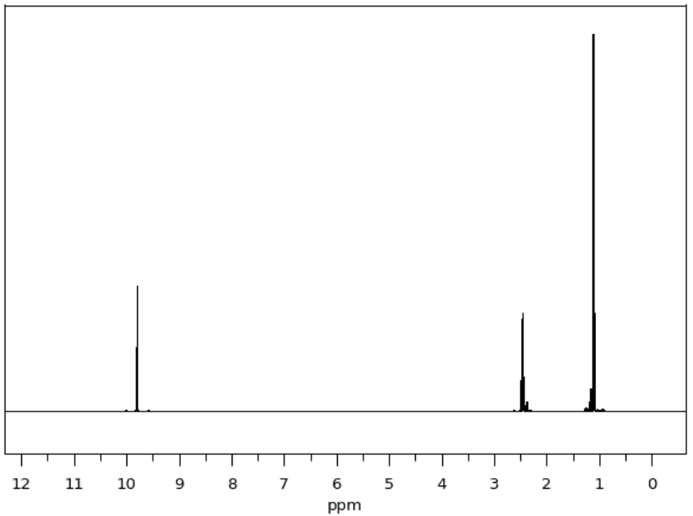
Proton NMR peak data
Shift (ppm) | Number of peaks | Peak area ratio
9.80 | 3 | 1
2.47 | 5 | 2
1.11 | 3 | 3

Sample J
Test | Result
Unsaturation test using bromine water | Orange colour remains
Oxidation test using acidified potassium dichromate | Solution turns green
Carboxylic acid test using sodium carbonate | No bubbles
Infrared spectroscopy | 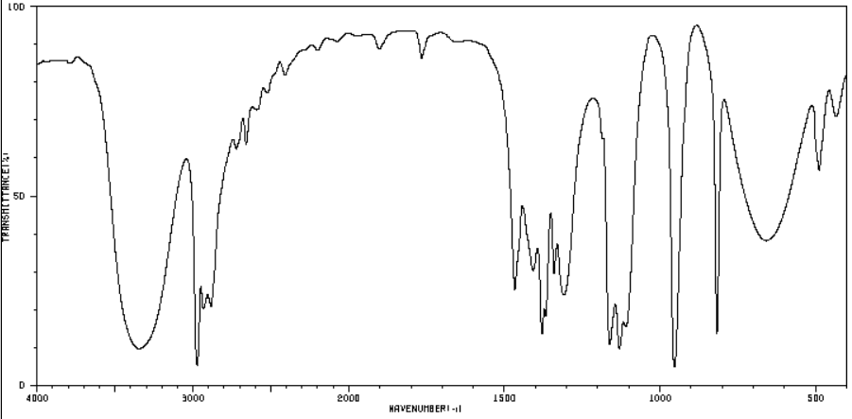
Mass spectrometry  Mass of molecular ion:  m/z = 60 | 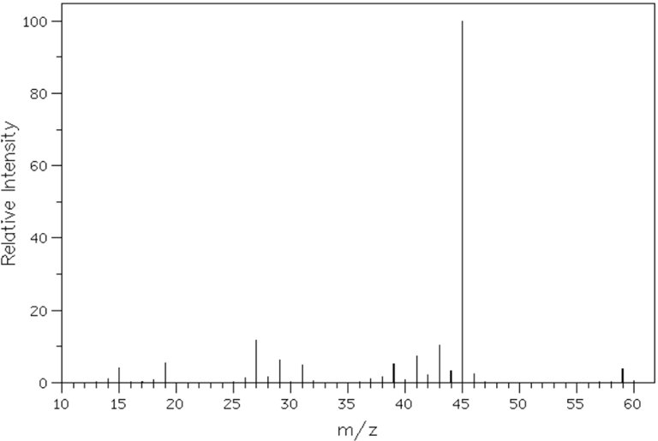
Carbon-13 NMR | 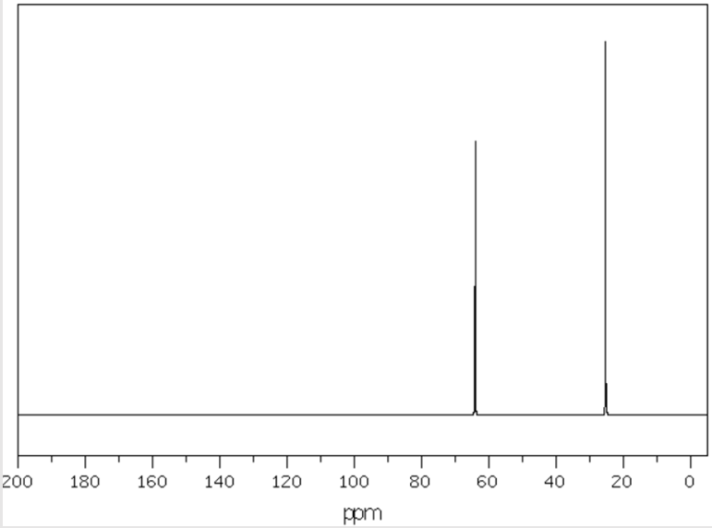
Proton NMR | 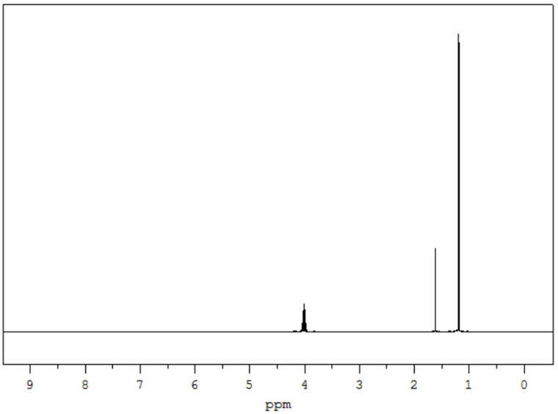
Proton NMR peak data
Shift (ppm) | Number of peaks | Peak area ratio
4.02 | 7 | 1
1.63 | 1 | 1
1.21 | 2 | 6

Sample K
Test | Result
Unsaturation test using bromine water | Orange colour remains
Oxidation test using acidified potassium dichromate | Orange colour remains
Carboxylic acid test using sodium carbonate | No bubbles
Infrared spectroscopy | 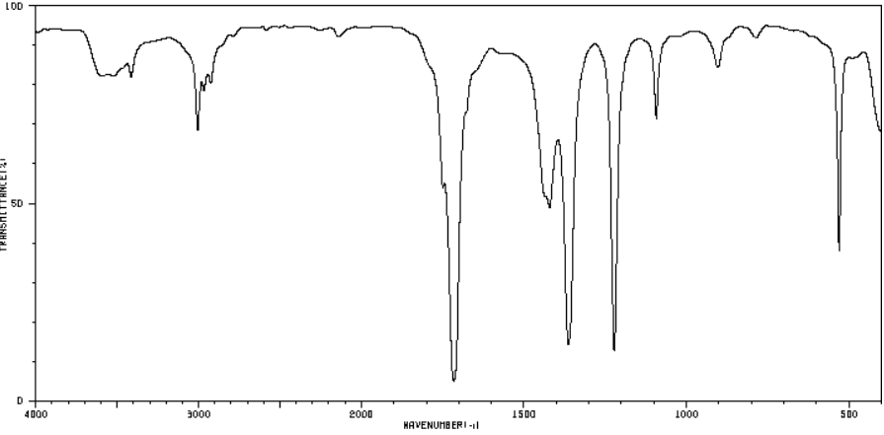
Mass spectrometry  Mass of molecular ion:  m/z = 58 | 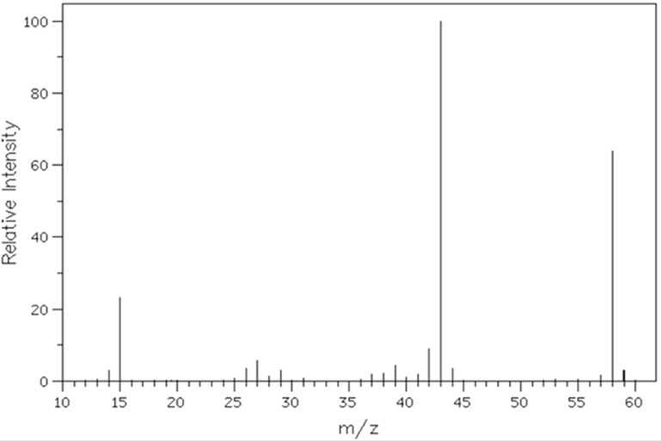
Carbon-13 NMR | 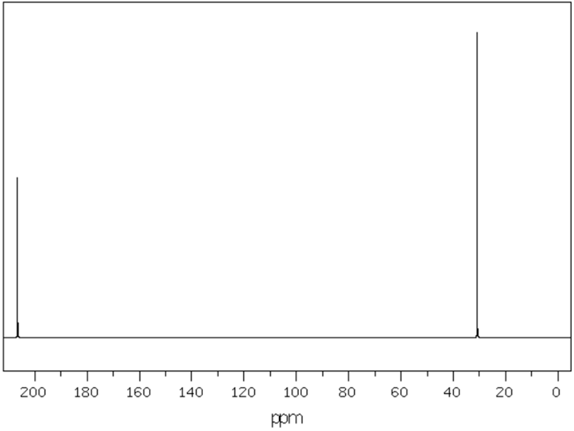
Proton NMR | 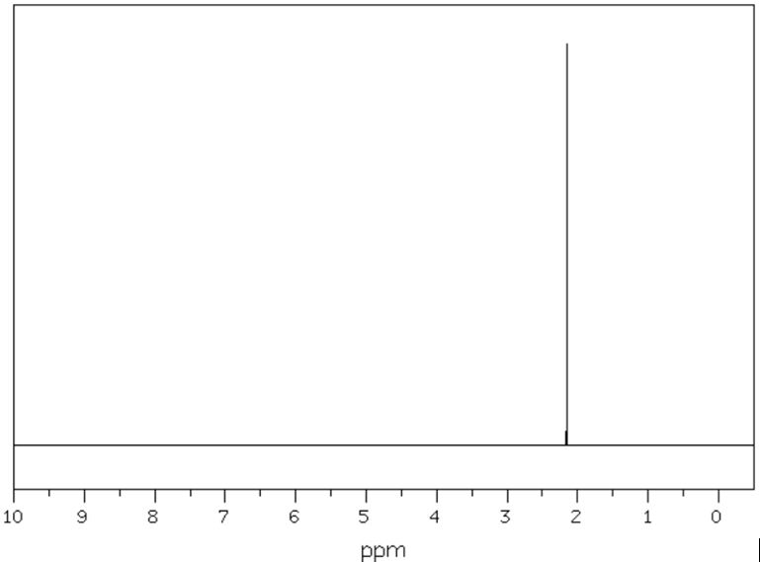
Proton NMR peak data
Shift (ppm) | Number of peaks | Peak area ratio
2.16 | 1 | 6

Sample L
Test | Result
Unsaturation test using bromine water | Orange colour remains
Oxidation test using acidified potassium dichromate | Solution turns green
Carboxylic acid test using sodium carbonate | No bubbles
Infrared spectroscopy | 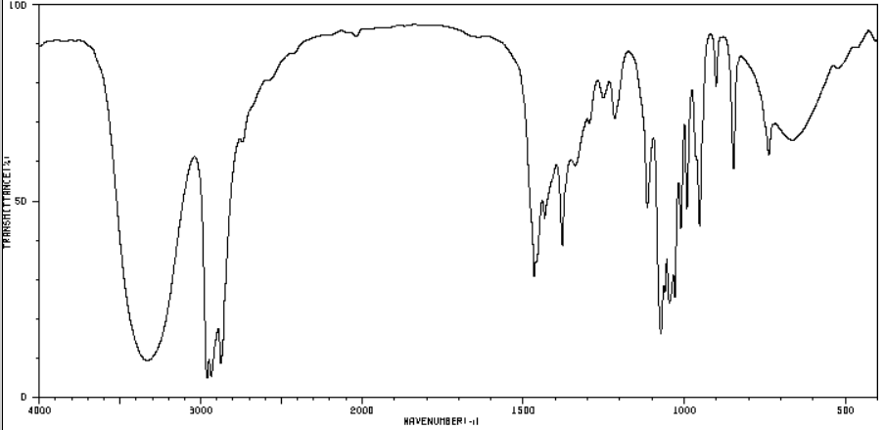
Mass spectrometry  Mass of molecular ion:  m/z = 74 | 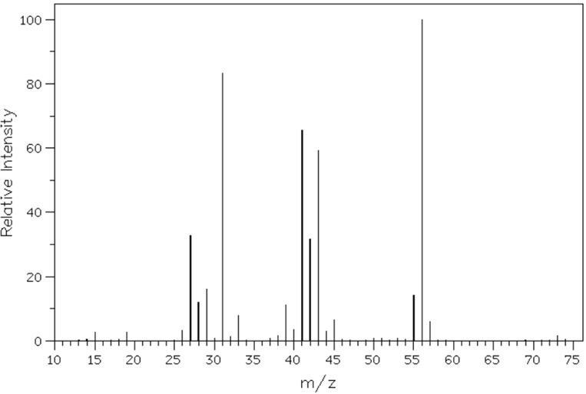
Carbon-13 NMR | 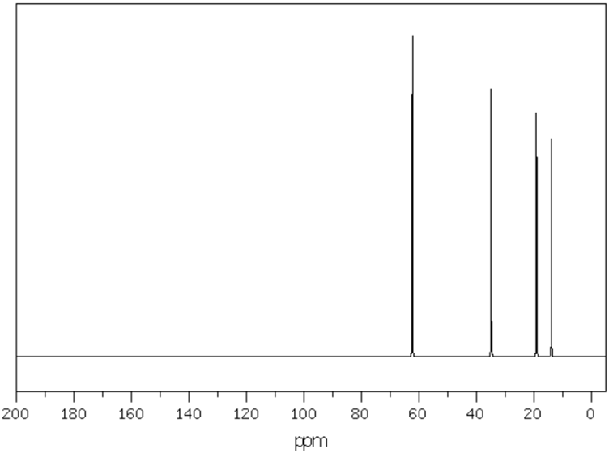
Proton NMR | 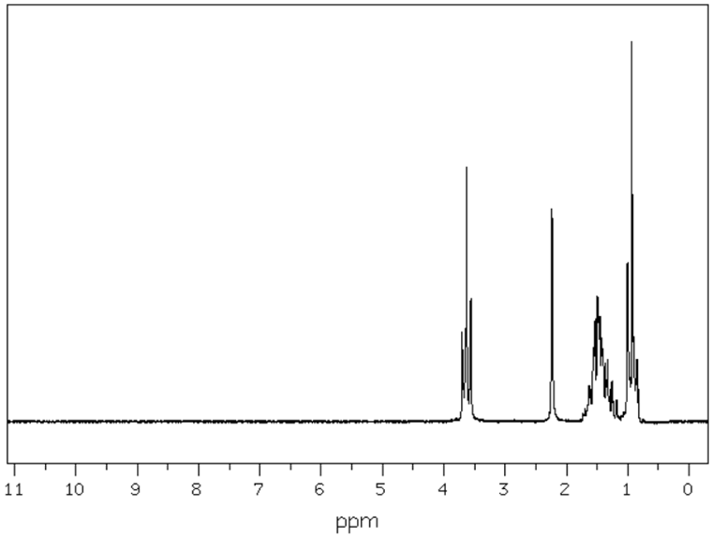
Proton NMR peak data
Shift (ppm) Number of peaks Peak area ratio  3.63 3 2  2.24 1 1  1.53 5 2 | Shift (ppm) Number of peaks Peak area ratio  1.39 6 2  0.94 3 3

Sample M
Test | Result
Unsaturation test using bromine water | Orange colour remains
Oxidation test using acidified potassium dichromate | Solution turns green
Carboxylic acid test using sodium carbonate | No bubbles
Infrared spectroscopy | 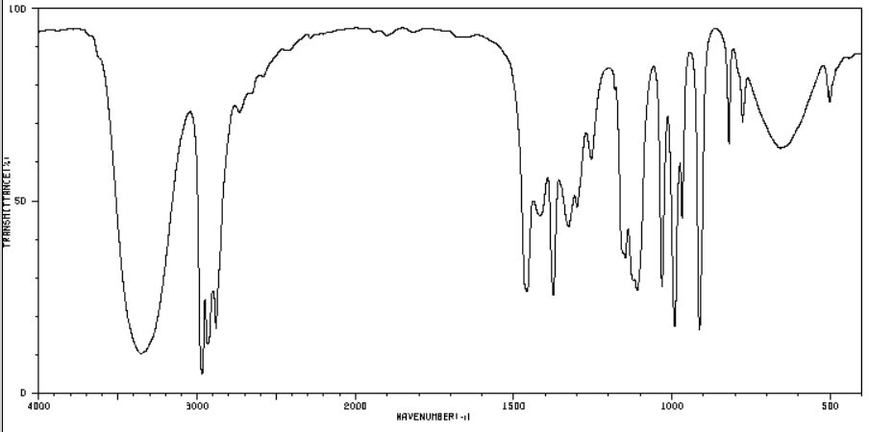
Mass spectrometry  Mass of molecular ion:  m/z = 74 | 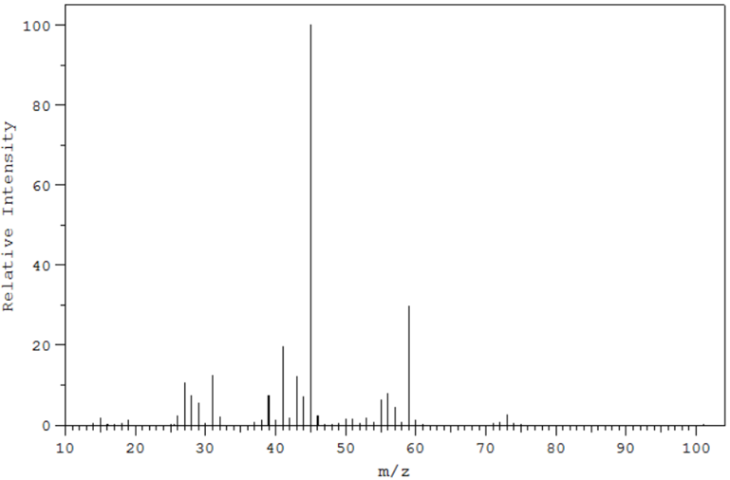
Carbon-13 NMR | 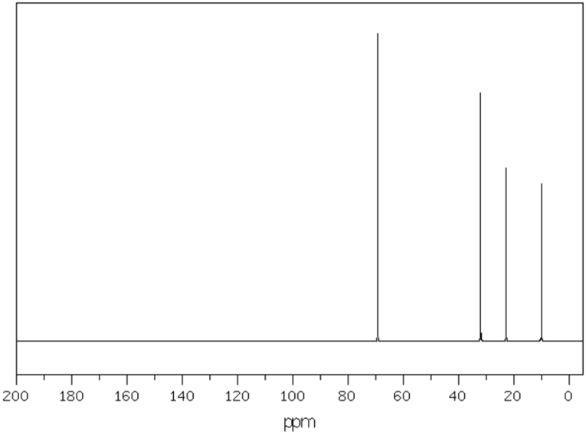
Proton NMR | 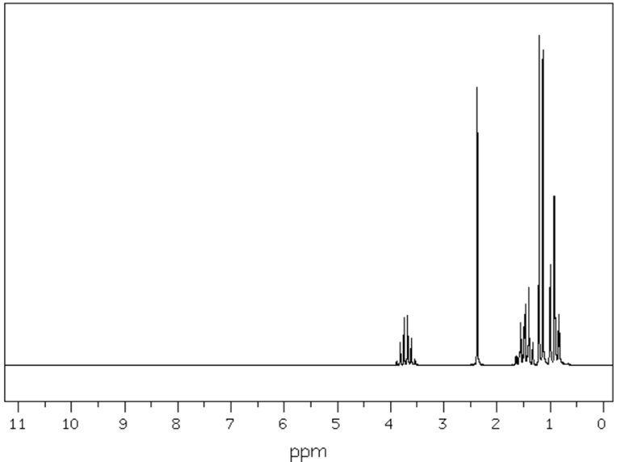
Proton NMR peak data
Shift (ppm) Number of peaks Peak area ratio  3.71 6 1  2.37 1 1  1.46 5 2 | Shift (ppm) Number of peaks Peak area ratio  1.17 2 3  0.93 3 3

Sample N
Test | Result
Unsaturation test using bromine water | Orange colour remains
Oxidation test using acidified potassium dichromate | Solution turns green
Carboxylic acid test using sodium carbonate | No bubbles
Infrared spectroscopy | 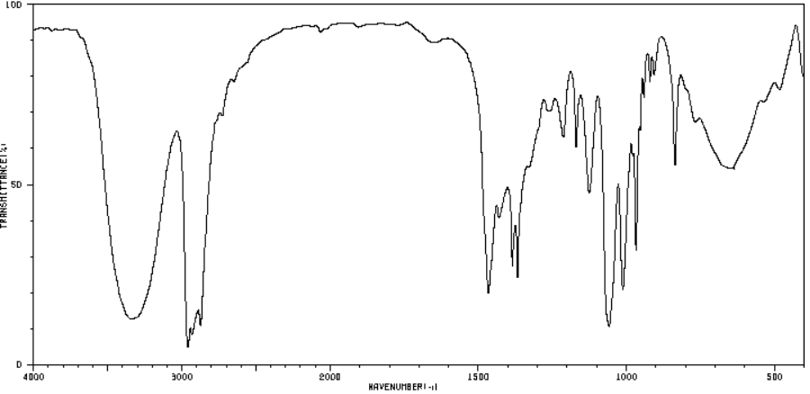
Mass spectrometry  Mass of molecular ion:  m/z = 74 | 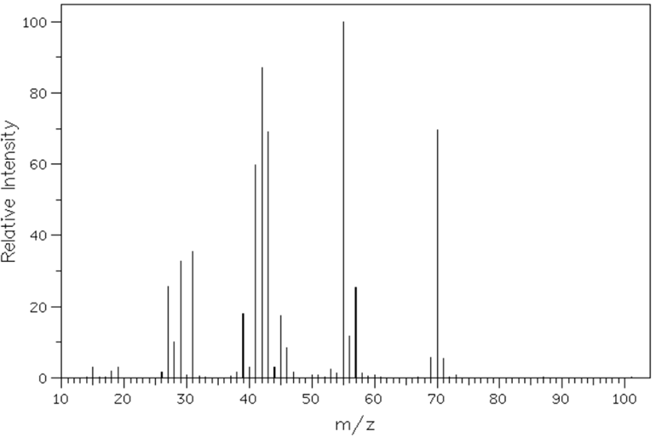
Carbon-13 NMR | 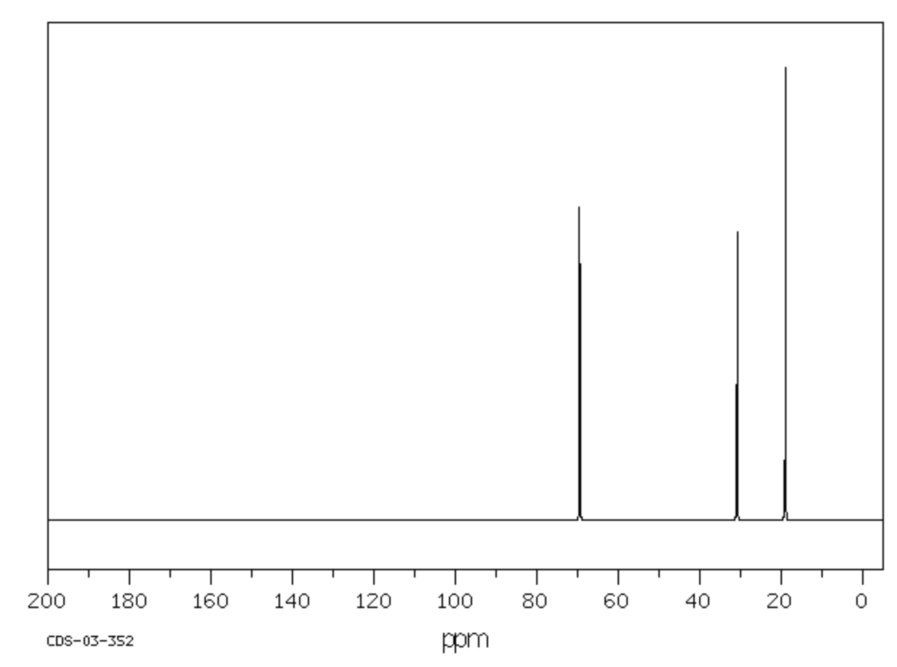
Proton NMR | 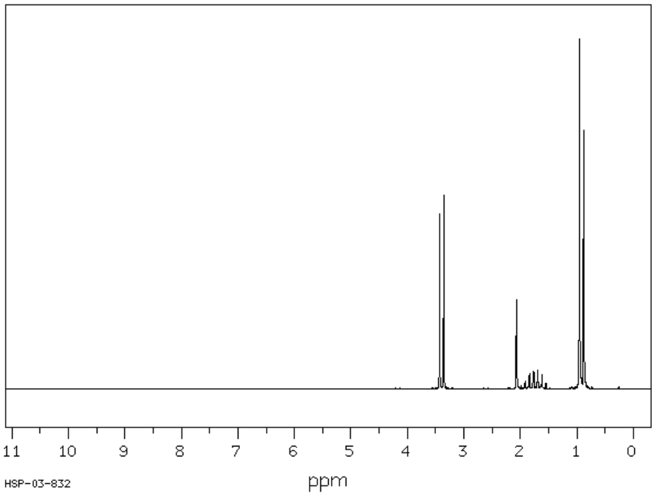
Proton NMR peak data
Shift (ppm) | Number of peaks | Peak area ratio
3.40 | 2 | 2
2.07 | 1 | 1
1.75 | 9 | 1
0.92 | 2 | 6

Sample O
Test | Result
Unsaturation test using bromine water | Orange colour remains
Oxidation test using acidified potassium dichromate | Orange colour remains
Carboxylic acid test using sodium carbonate | No bubbles
Infrared spectroscopy | 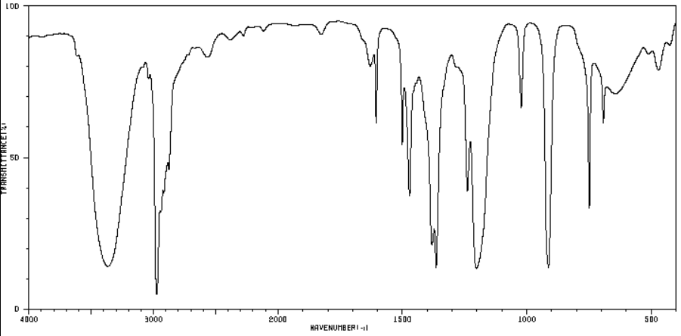
Mass spectrometry  Mass of molecular ion:  m/z = 74 | 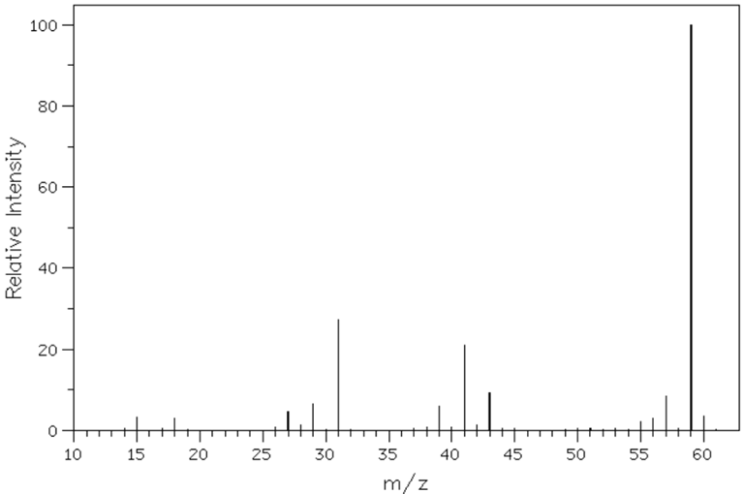
Carbon-13 NMR | 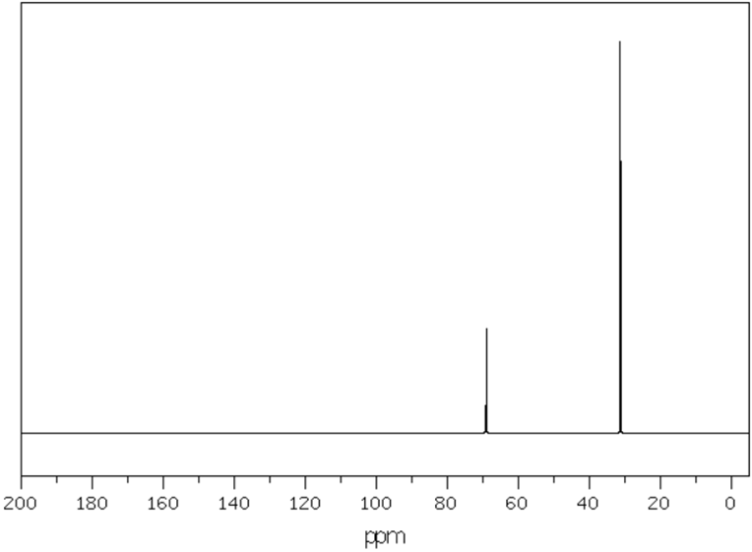
Proton NMR | 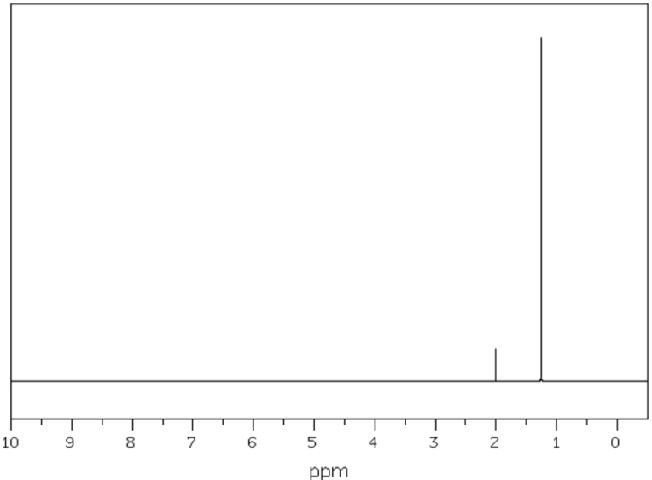
Proton NMR peak data
Shift (ppm) | Number of peaks | Peak area ratio
2.01 | 1 | 1
1.26 | 1 | 9

Sample P
Test | Result
Unsaturation test using bromine water | Orange colour remains
Oxidation test using acidified potassium dichromate | Solution turns green
Carboxylic acid test using sodium carbonate | No bubbles
Infrared spectroscopy | 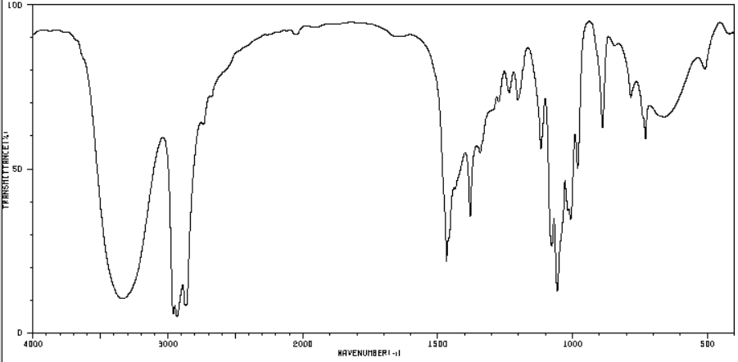
Mass spectrometry  Mass of molecular ion:  m/z = 88 | 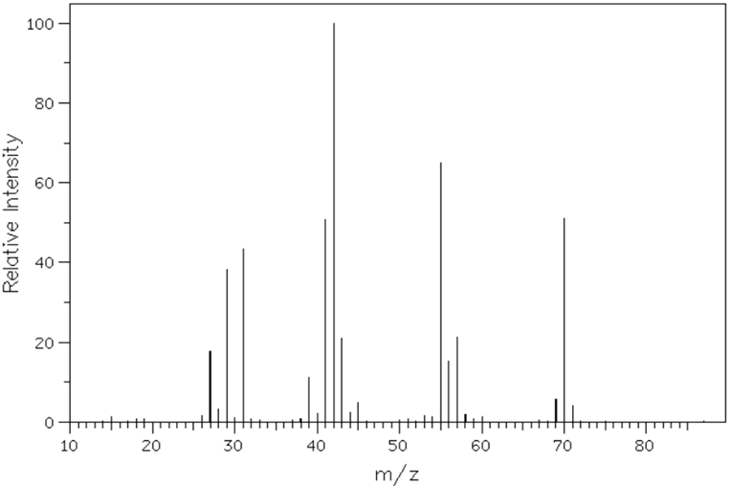
Carbon-13 NMR | 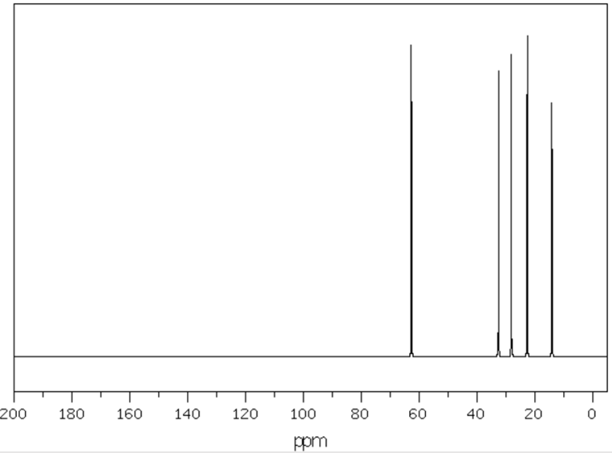
Proton NMR | 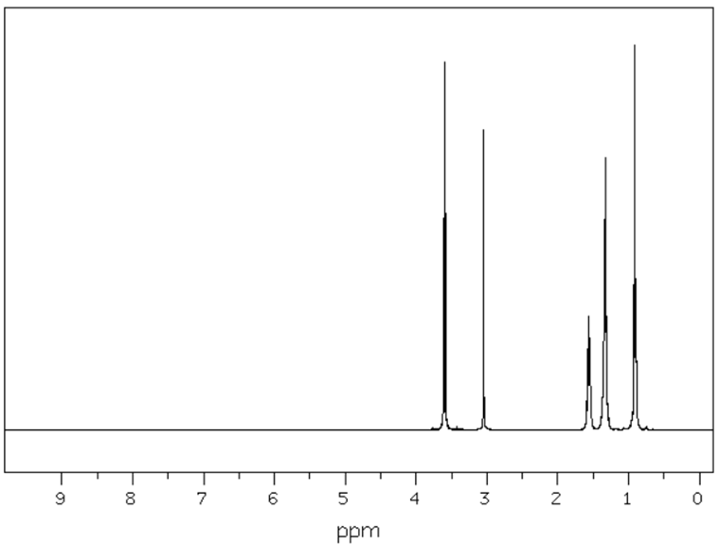
Proton NMR peak data
Shift (ppm) Number of peaks Peak area ratio  3.60 3 2  3.05 1 1  1.56 5 2 | Shift (ppm) Number of peaks Peak area ratio  1.34 5 2  1.32 6 2  0.91 3 3

Sample Q
Test | Result
Unsaturation test using bromine water | Orange colour remains
Oxidation test using acidified potassium dichromate | Solution turns green
Carboxylic acid test using sodium carbonate | No bubbles
Infrared spectroscopy | 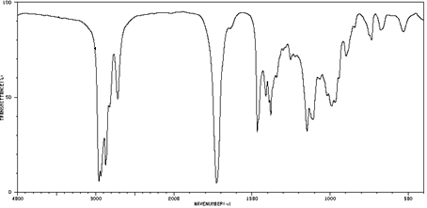
Mass spectrometry  Mass of molecular ion:  m/z = 86 | 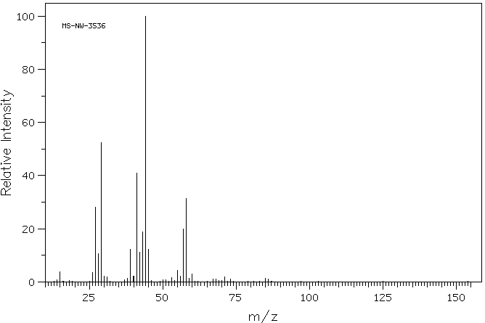
Carbon-13 NMR | 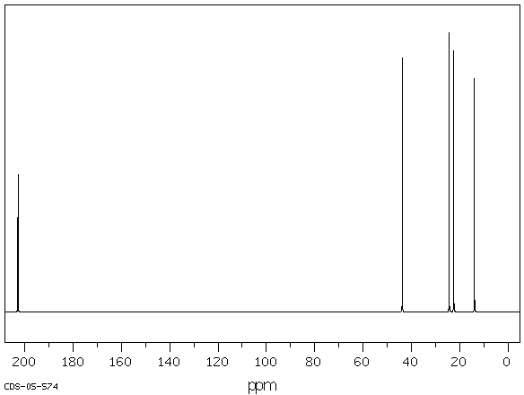
Proton NMR | 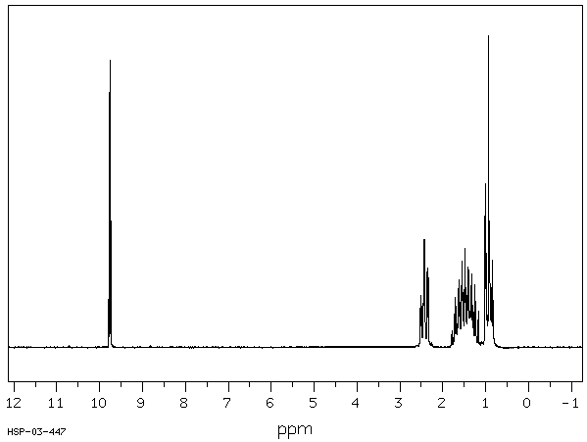
Proton NMR peak data
Shift (ppm) Number of peaks Peak area ratio  9.76 3 1  2.42 4 2  1.59 5 2 | Shift (ppm) Number of peaks Peak area ratio  1.35 6 2  0.93 3 3

Sample R
Test | Result
Unsaturation test using bromine water | Orange colour remains
Oxidation test using acidified potassium dichromate | Orange colour remains
Carboxylic acid test using sodium carbonate | Bubbles of carbon dioxide
Infrared spectroscopy | 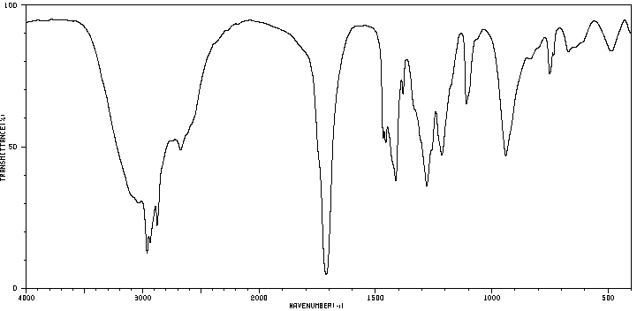
Mass spectrometry  Mass of molecular ion:  m/z = 102 | 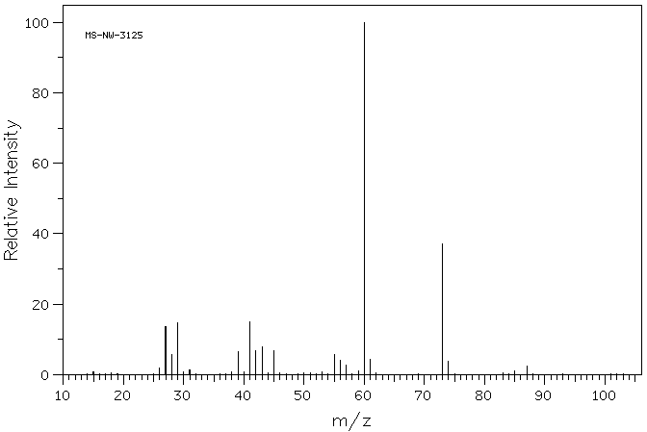
Carbon-13 NMR | 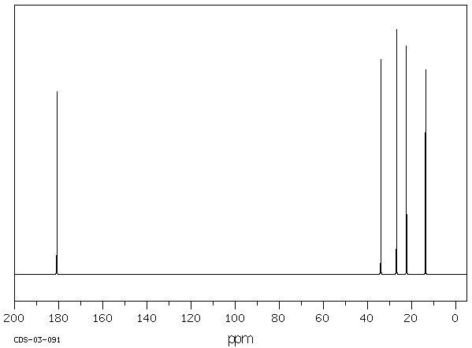
Proton NMR | 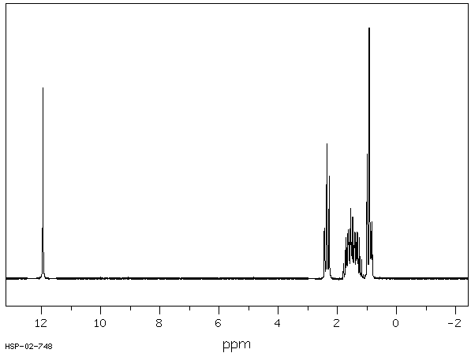
Proton NMR peak data
Shift (ppm) Number of peaks Peak area ratio  11.96 1 1  2.35 3 2  1.62 5 2 | Shift (ppm) Number of peaks Peak area ratio  1.39 6 2  0.93 3 3

Sample S
Test | Result
Unsaturation test using bromine water | Orange colour remains
Oxidation test using acidified potassium dichromate | Solution turns green
Carboxylic acid test using sodium carbonate | No bubbles
Infrared spectroscopy | 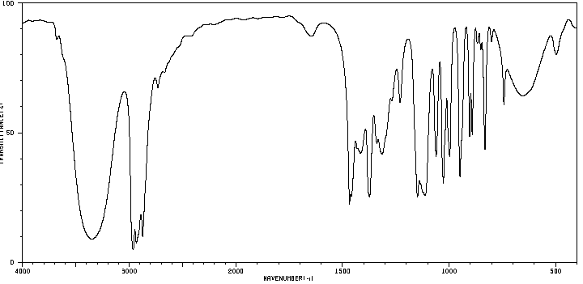
Mass spectrometry  Mass of molecular ion:  m/z = 88 | 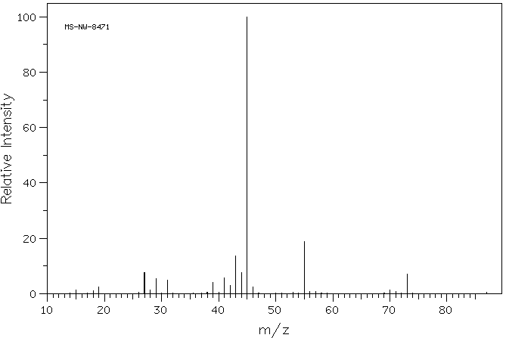
Carbon-13 NMR | 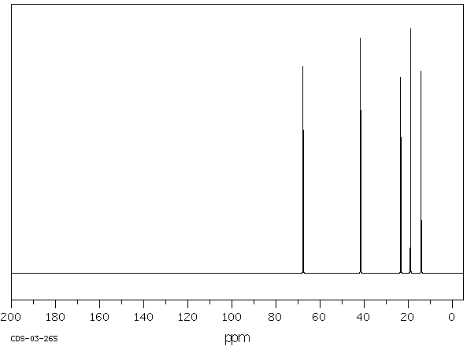
Proton NMR | 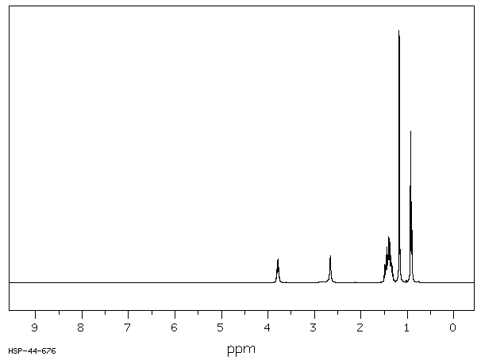
Proton NMR peak data
Shift (ppm) Number of peaks Peak area ratio  3.79 6 1  2.66 1 1  1.44 4 2 | Shift (ppm) Number of peaks Peak area ratio  1.36 6 2  1.17 2 3  0.92 3 3

Sample T
Test | Result
Unsaturation test using bromine water | Orange colour remains
Oxidation test using acidified potassium dichromate | Orange colour remains
Carboxylic acid test using sodium carbonate | No bubbles
Infrared spectroscopy | 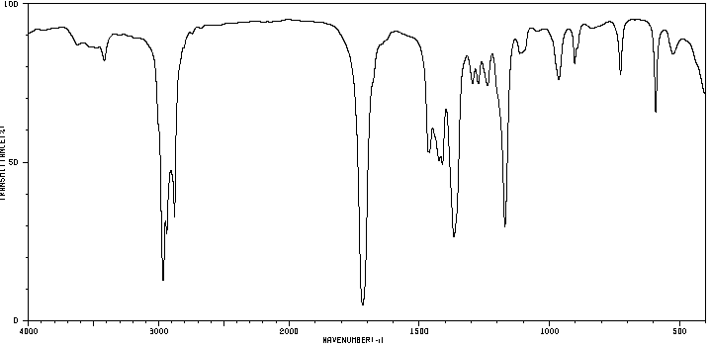
Mass spectrometry  Mass of molecular ion:  m/z = 86 | 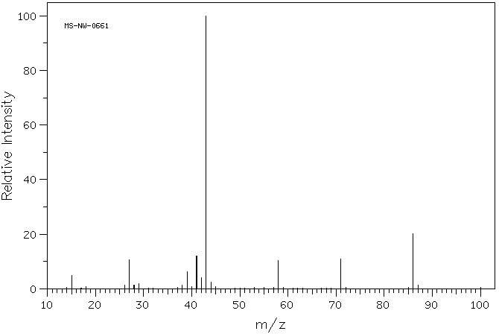
Carbon-13 NMR | 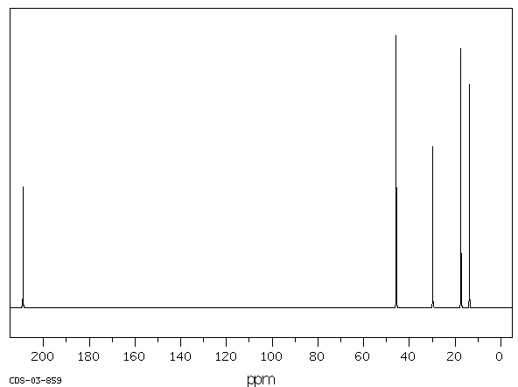
Proton NMR | 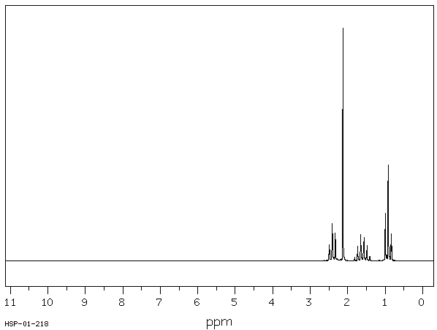
Proton NMR peak data
Shift (ppm) | Number of peaks | Peak area ratio
2.40 | 3 | 2
2.13 | 1 | 3
1.60 | 6 | 2
0.93 | 3 | 3

Sample U
Test | Result
Unsaturation test using bromine water | Orange colour remains
Oxidation test using acidified potassium dichromate | Orange colour remains
Carboxylic acid test using sodium carbonate | No bubbles
Infrared spectroscopy | 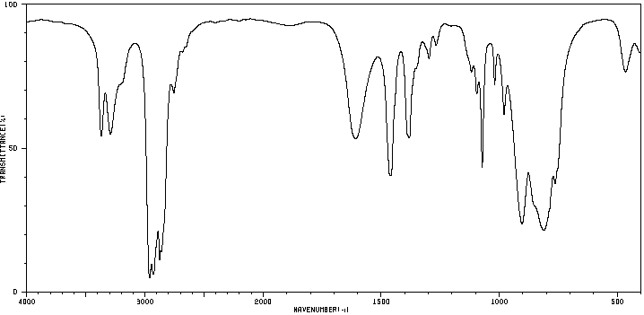
Mass spectrometry  Mass of molecular ion:  m/z = 59 | 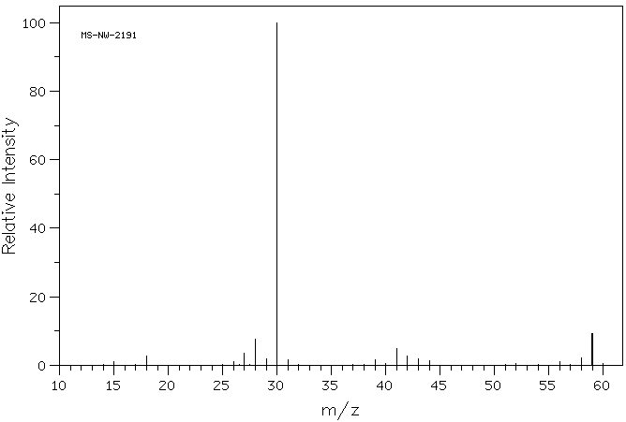
Carbon-13 NMR | 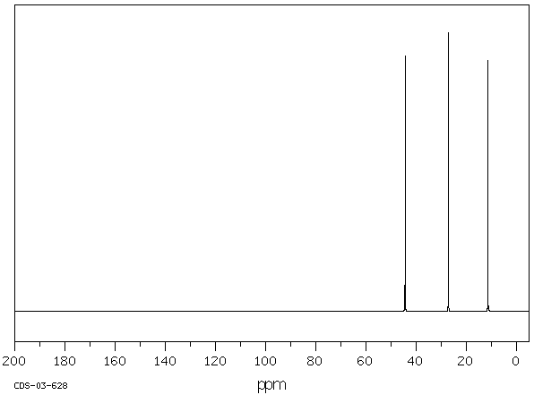
Proton NMR | 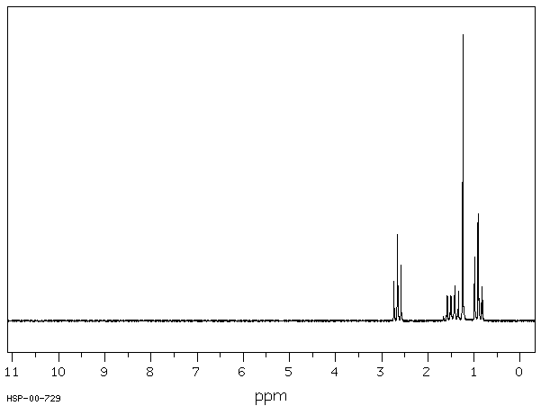
Proton NMR peak data
Shift (ppm) | Number of peaks | Peak area ratio
2.65 | 3 | 2
1.45 | 6 | 2
1.24 | 1 | 2
0.92 | 3 | 3

Sample V
Test | Result
Unsaturation test using bromine water | Orange colour remains
Oxidation test using acidified potassium dichromate | Orange colour remains
Carboxylic acid test using sodium carbonate | No bubbles
Infrared spectroscopy | 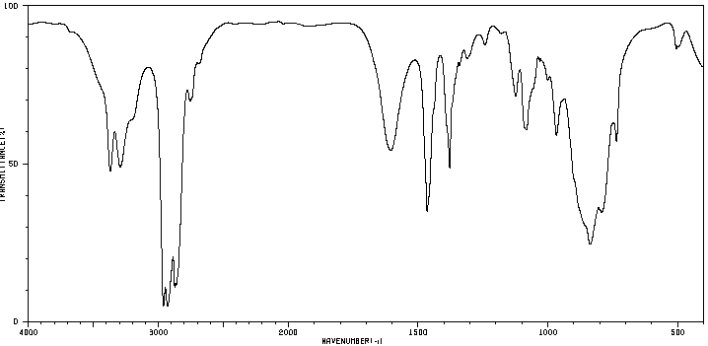
Mass spectrometry  Mass of molecular ion:  m/z = 73 | 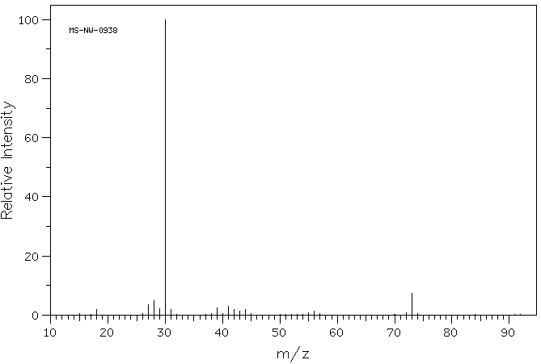
Carbon-13 NMR | 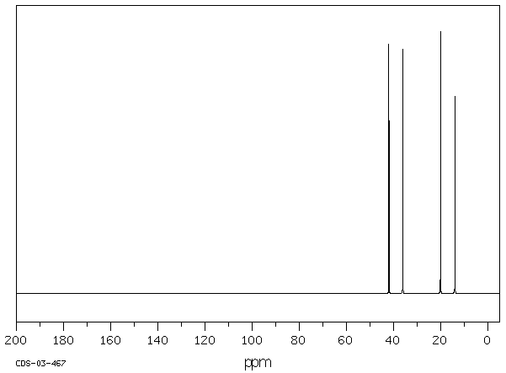
Proton NMR | 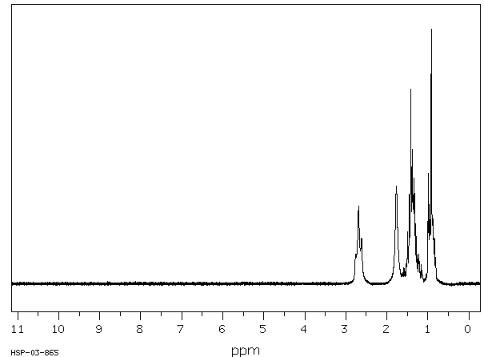
Proton NMR peak data
Shift (ppm) Number of peaks Peak area ratio  2.68 3 2  1.77 1 2  1.43 5 2 | Shift (ppm) Number of peaks Peak area ratio  1.33 6 2  0.92 3 3

Sample W
Test | Result
Unsaturation test using bromine water | Orange colour remains
Oxidation test using acidified potassium dichromate | Orange colour remains
Carboxylic acid test using sodium carbonate | No bubbles
Infrared spectroscopy | 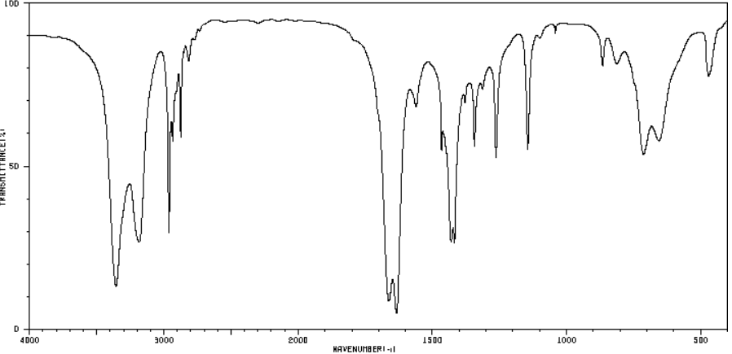
Mass spectrometry  Mass of molecular ion:  m/z = 87 | 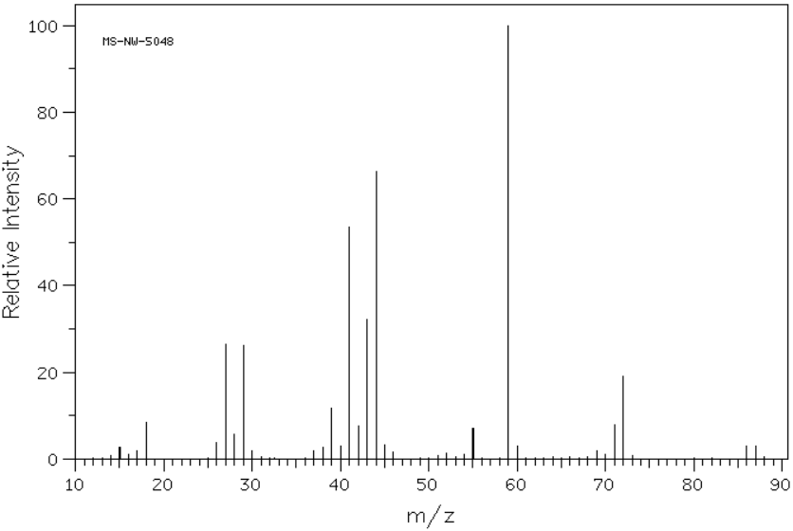
Carbon-13 NMR | 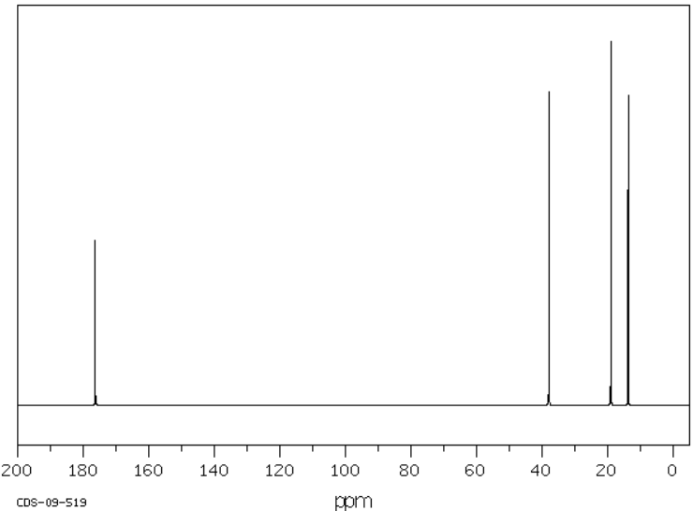
Proton NMR | 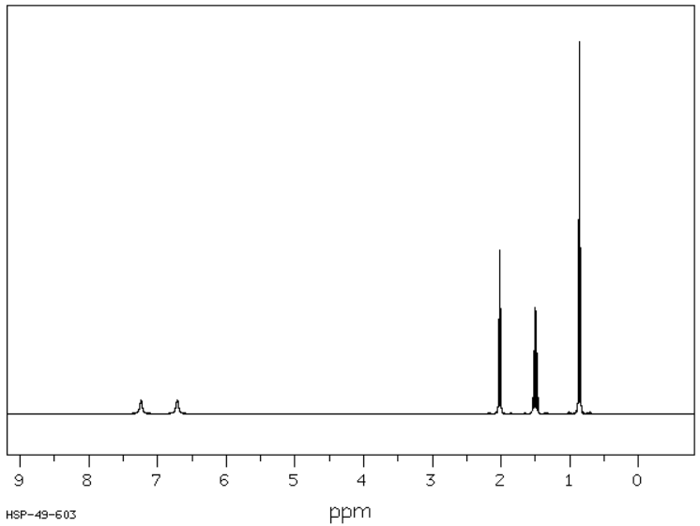
Proton NMR peak data
Shift (ppm) Number of peaks Peak area ratio  7.24 1 1  6.71 1 1  2.02 3 2 | Shift (ppm) Number of peaks Peak area ratio  1.50 6 2  0.86 3 3

Sample X
Test | Result
Unsaturation test using bromine water | Orange colour remains
Oxidation test using acidified potassium dichromate | Orange colour remains
Carboxylic acid test using sodium carbonate | No bubbles
Infrared spectroscopy | 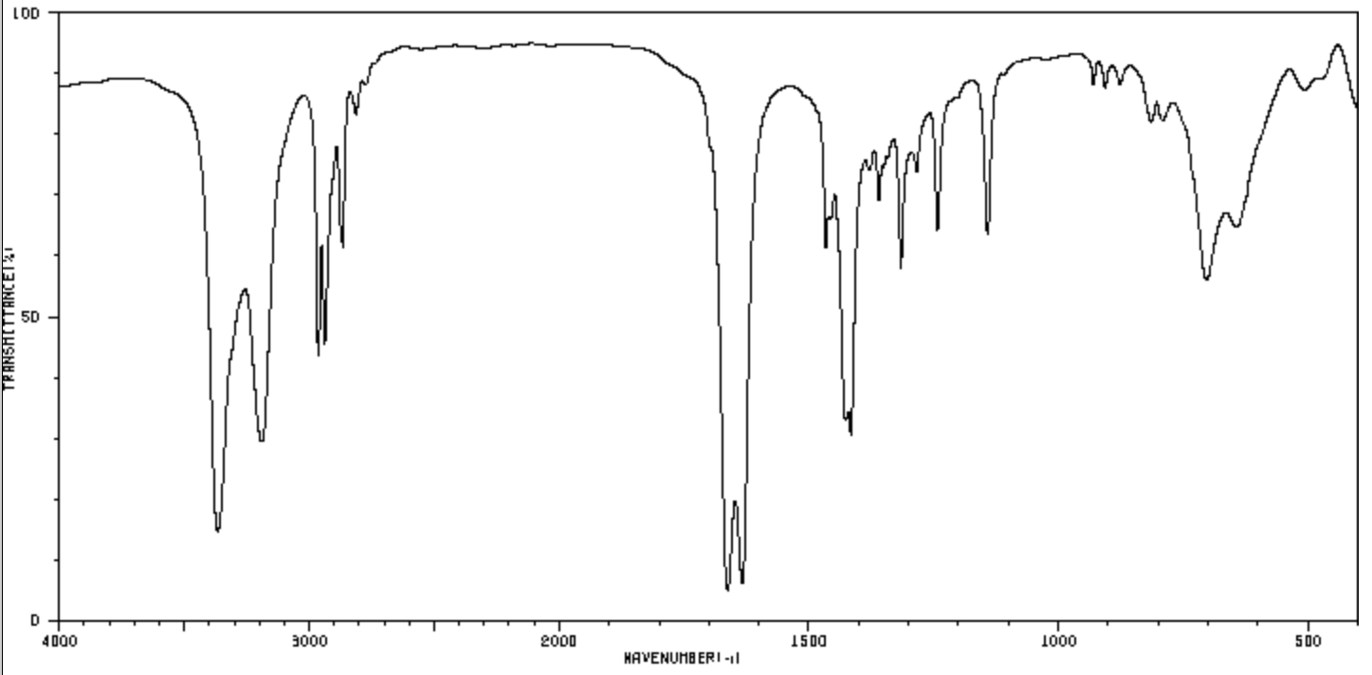
Mass spectrometry  Mass of molecular ion:  m/z = 101 | 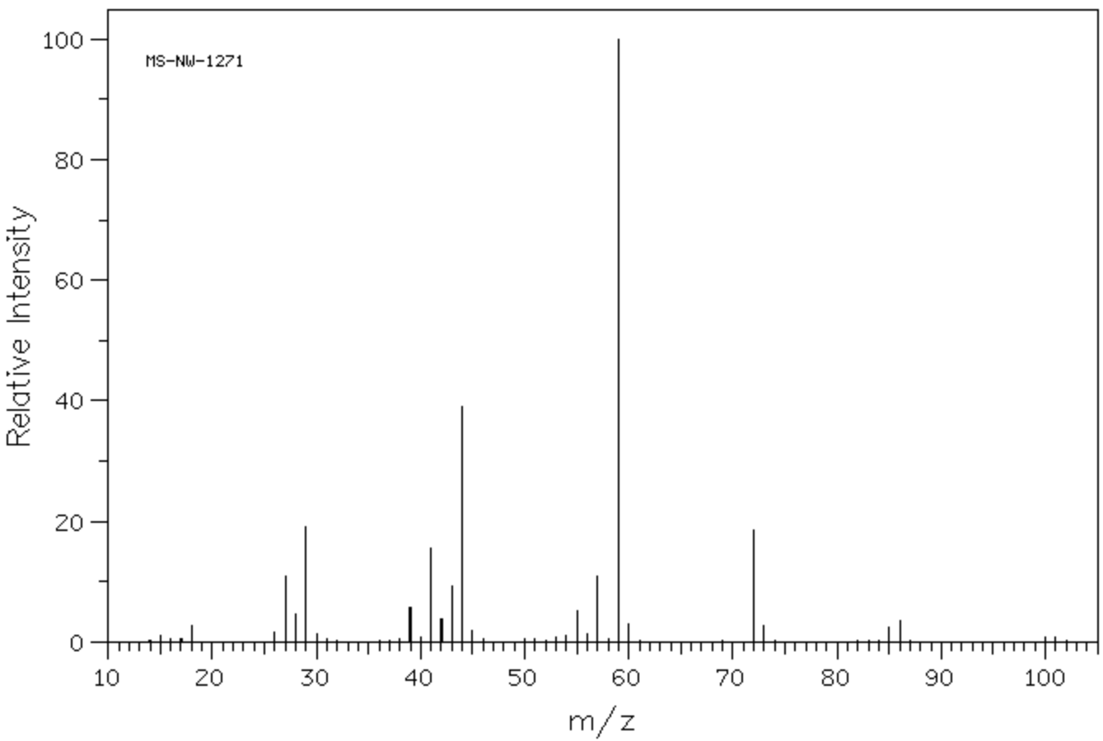
Carbon-13 NMR | 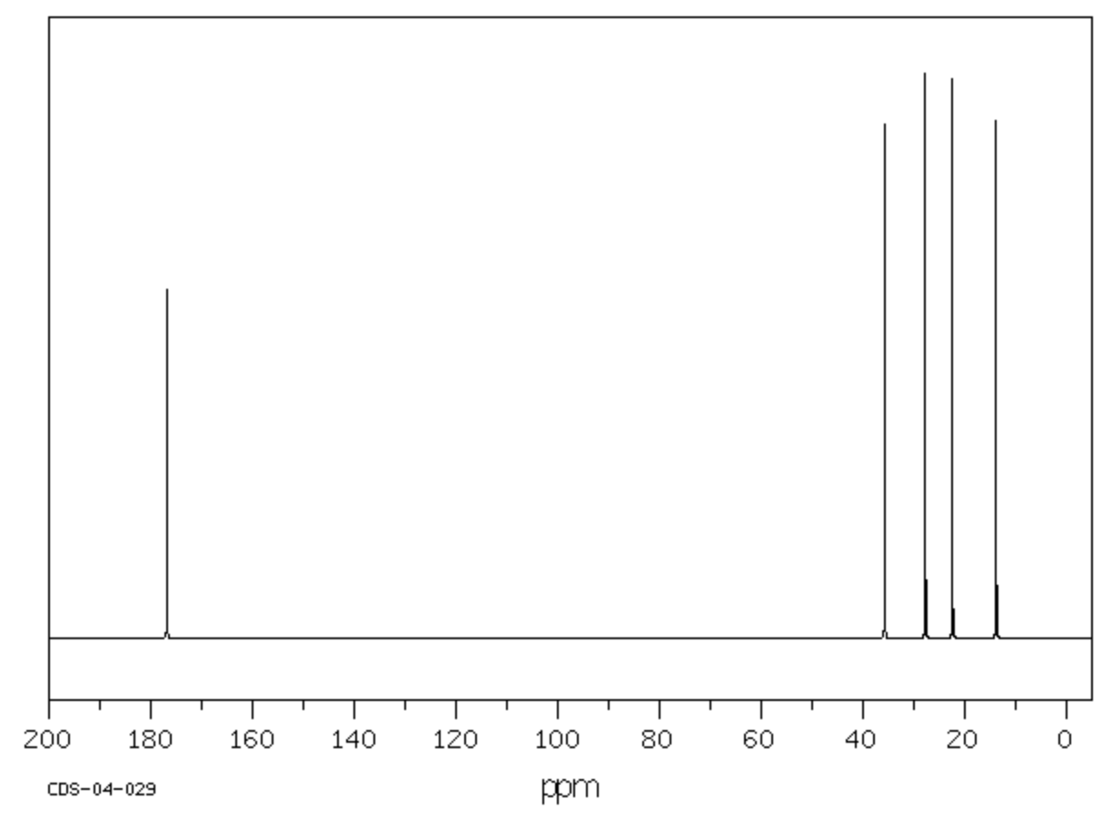
Proton NMR | 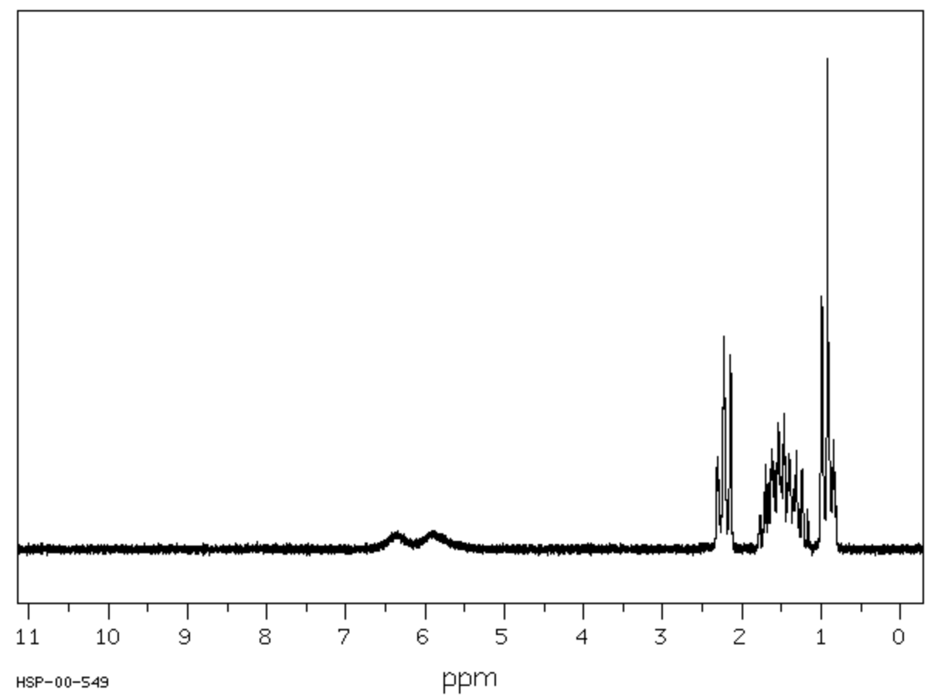
Proton NMR peak data
Shift (ppm) Number of peaks Peak area ratio  6.40 1 1  5.90 1 1  2.22 3 2 | Shift (ppm) Number of peaks Peak area ratio  1.60 5 2  1.37 6 2  0.93 3 3

Sample Y
Test | Result
Unsaturation test using bromine water | Orange colour remains
Oxidation test using acidified potassium dichromate | Orange colour remains
Carboxylic acid test using sodium carbonate | No bubbles
Infrared spectroscopy | 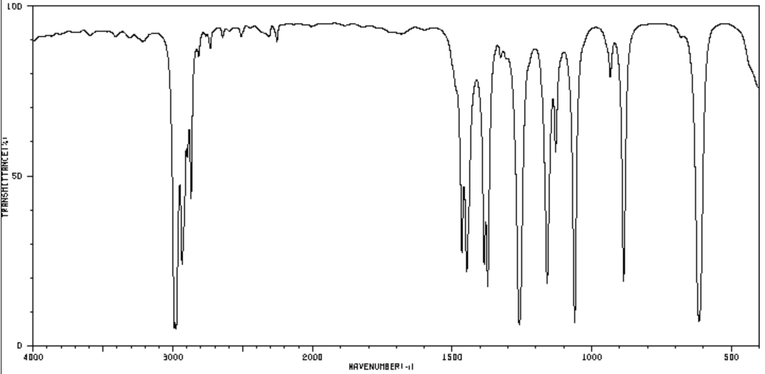
Mass spectrometry  Mass of molecular ion:  m/z = 78 | 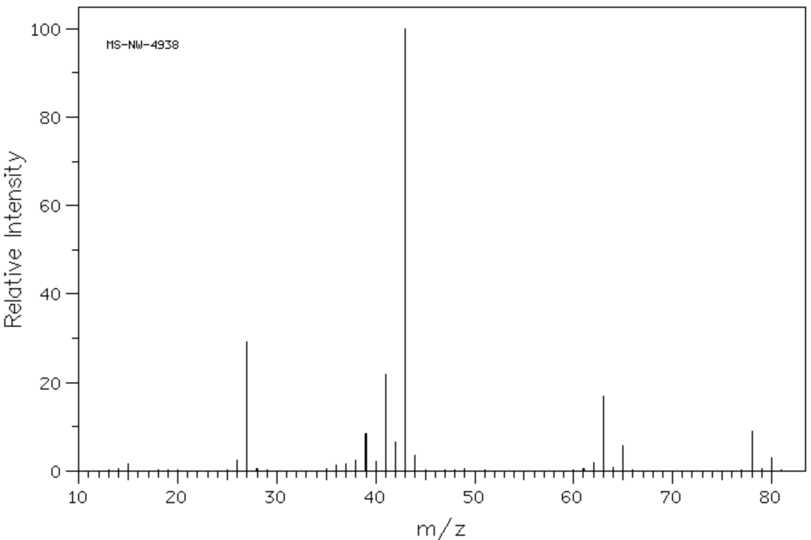
Carbon-13 NMR | 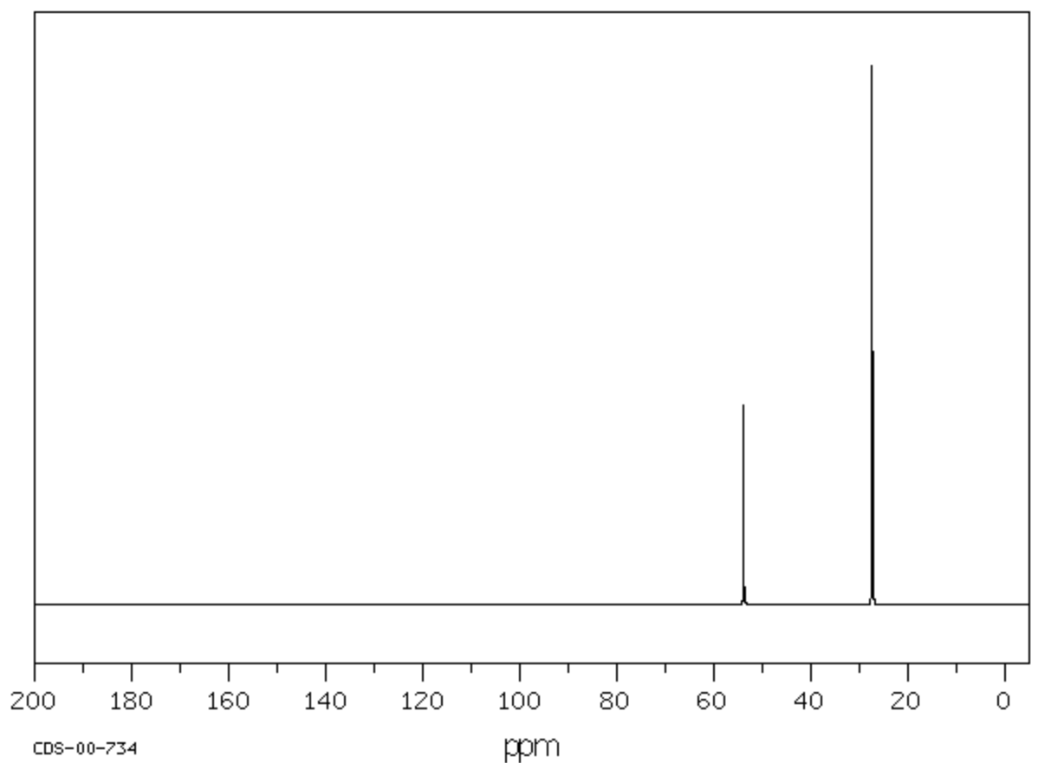
Proton NMR | 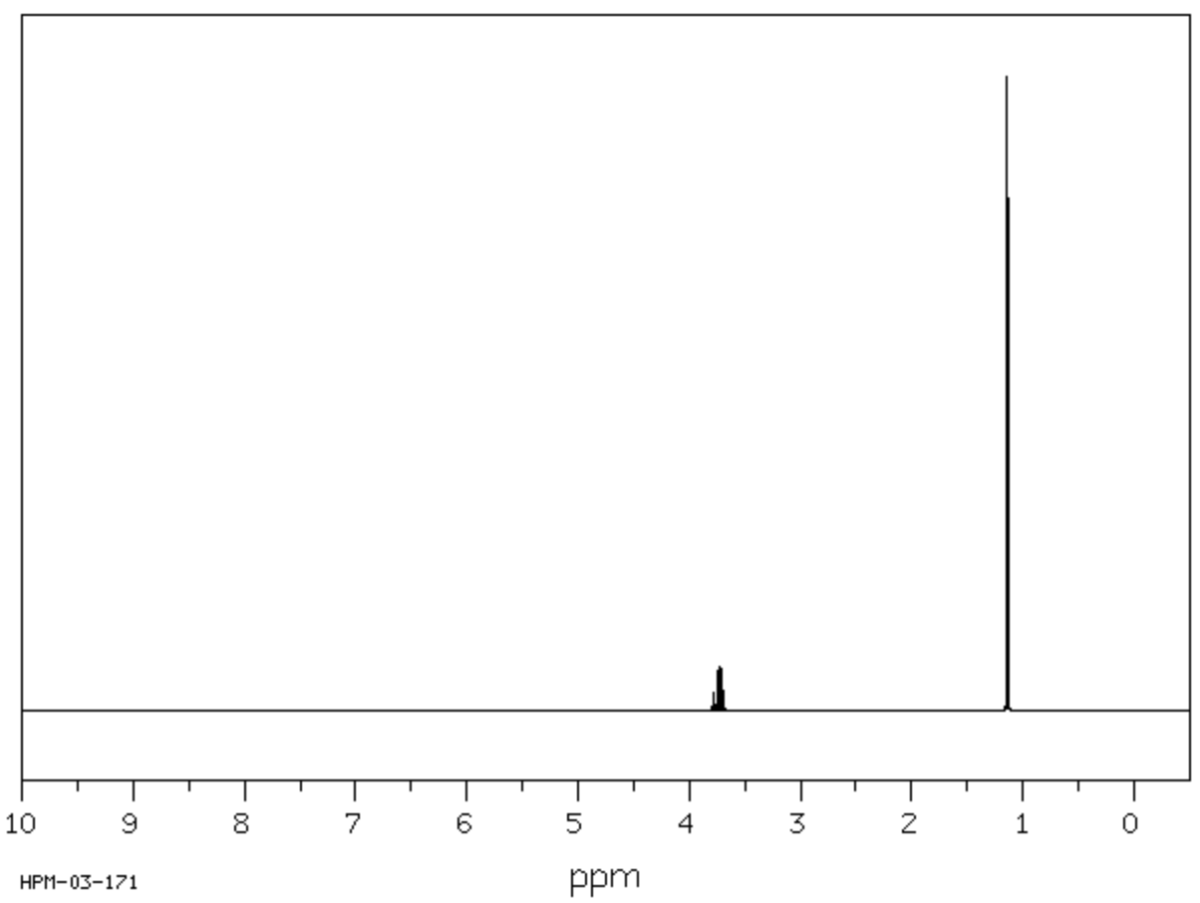
Proton NMR peak data
Shift (ppm) | Number of peaks | Peak area ratio
3.73 | 7 | 1
1.14 | 2 | 6

Sample Z
Test | Result
Unsaturation test using bromine water | Orange colour remains
Oxidation test using acidified potassium dichromate | Orange colour remains
Carboxylic acid test using sodium carbonate | No bubbles
Infrared spectroscopy | 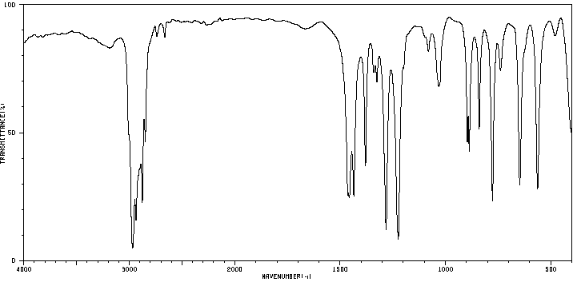
Mass spectrometry  Mass of molecular ion:  m/z = 122 | 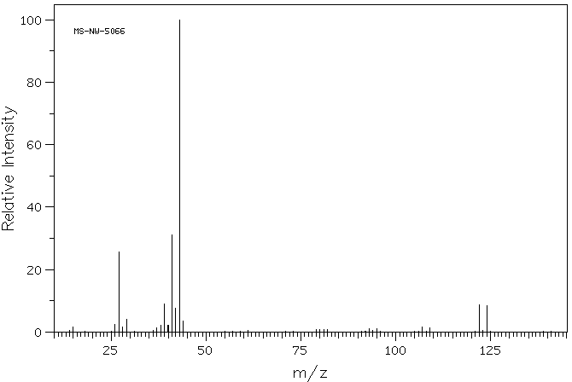
Carbon-13 NMR | 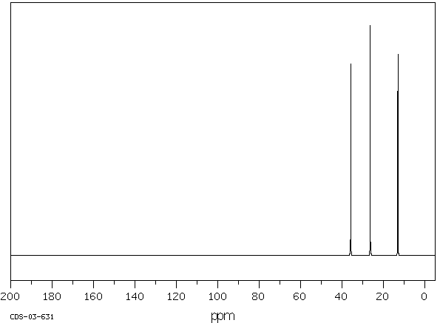
Proton NMR | 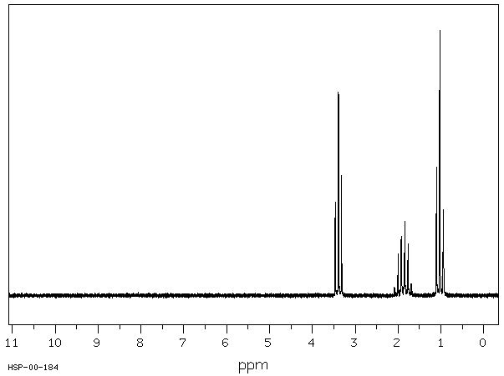
Proton NMR peak data
Shift (ppm) | Number of peaks | Peak area ratio
3.39 | 3 | 2
1.87 | 6 | 2
1.03 | 3 | 3

References
Bergwerf, H., 2015. Molview. [Online]
Available at: http://molview.org/
[Accessed 29 06 2020].
National Institute of Advanced Industrial Science and Technology, Japan, 2018. Spectral Database for Organic Compounds. [Online]
Available at: https://sdbs.db.aist.go.jp/sdbs/cgi-bin/cre_index.cgi
[Accessed 06 29 2020].
NSW Education Standards Authority, 2017. Chemistry HSC Data Sheet. [Online]
Available at: https://educationstandards.nsw.edu.au/wps/wcm/connect/98664936-221f-4c49-88e1-d002ec69285c/chemistry-data-sheet-2017-02.pdf?MOD=AJPERES&CVID=
[Accessed 30 6 2020].
NSW Education Standards Authority, 2017. Chemistry Stage 6 Syllabus. [Online]
Available at: https://educationstandards.nsw.edu.au/wps/portal/nesa/11-12/stage-6-learning-areas/stage-6-science/chemistry-2017
[Accessed 6 29 2020].
NSW Education Standards Authority, 2019. Chemistry 2019 HSC Exam Pack. [Online]
Available at: https://educationstandards.nsw.edu.au/wps/portal/nesa/resource-finder/hsc-exam-papers/2019/chemistry-2019-hsc-exam-pack
[Accessed 6 29 2020].

