Earth and Environmental Science Module 7 – climate science

Table of contents
Earth and Environmental Science Module 7 – climate science 1
Table of contents 2
Course overview 3
Module summary 4
Big ideas 4
Relationship to other modules 5
Core concepts 5
Opportunities for extending concepts 6
Alternative conceptions and misconceptions 7
Suggested teaching strategies 8
Appendix 1: Ocean acidification investigations 9
Task 1: 9
Task 2: 10
Task 3: 11
Resources 12

Course overview
During the teaching of the Year 11 course, it is expected that students have been provided opportunities to develop all seven of the Working Scientifically skills. Ideally, these would be embedded into the teaching of the Knowledge and Understanding components of the course. In preparation for the Year 12 course, students in Year 11 could benefit from work that engages them in the following areas:
- Propose hypotheses and design and conduct valid and reliable practical investigations that enable the collection and analysis of data. Teachers should look for opportunities to engage students in these beyond where the syllabus explicitly states the need to conduct a practical investigation.
- Construct and analyse graphical data (particularly line graphs) for both primary and secondary sources. This will be essential for an understanding of a changing Earth over time, including geological events and climate changes.
- Assess the uses, benefits and limitations of various types of scientific models. Many of the processes that occur on the Earth are invisible (for example, convection currents beneath the surface) or happen very slowly (for example, movement of tectonic plates, the process of evolution over geological time). Models help people to better understand these types of processes.
- Determine the impacts of various technologies in improving the understanding of various concepts, including events that have occurred in the ancient past and potentially those that will occur in the future.
- Collect relevant information from secondary sources and determine the accuracy, reliability and validity. Many of the investigations will require students to obtain information from the Internet or other sources. Students will benefit from learning how to access the correct sort of information and appreciate how new evidence can change prevailing views about aspects of Earth and Environmental Science.
- Understand the major features of the Earth’s spheres and the relationships between each one. This is an underlying theme the spans both the Year 11 and Year 12 courses. It is essential that students understand the components of each one and can appreciate how changes in one can impact on the others.
- Develop skills in numerical scaling, with particular reference to periods of geological time. It is expected that students have developed a good understanding of the divisions of the geological timescale.
- Develop an understanding of relative and absolute dating of rocks and fossils. Using and constructing stratigraphic diagrams where appropriate and numeracy activities to build skills in applying radiometric dating principles.
- Construct simple diagrams of various processes, including tectonic boundary relationships and the geological and/or volcanic features associated with them, the formation of earthquakes at fault zones and the movement of warm and cool water in ocean currents across the Earth.
- Develop a deep understanding of the impacts of humans on the Earth and an appreciation of the importance of sustainability in its various forms. This includes understanding the roles of Aboriginal and Torres Strait Islander Peoples in caring for Country and Place.

Module summary
This module explores the following inquiry questions:
- IQ7-1: How long does it take for the climate to change naturally and what causes these changes?
- IQ7-2: What scientific evidence is there of climate variations in the past?
- IQ7-3: Is there scientific evidence to show that human activity has led to a variation in the Earth’s climate since the Industrial Revolution?
- IQ7-4: Is there scientific evidence that demonstrates how humans could minimise and respond to the effects of increased global temperatures?
This module investigates the causes, bodies of evidence and potential impacts of natural and anthropogenic climate changes throughout Earth’s history. There is considerable investigation into the greenhouse effect and its links to global warming, and discussion around strategies to mitigate the potential impacts on the biosphere and on human populations. It allows for student to develop evidence-based opinions about the effects of climate variation into the future.

Big ideas
- The Earth’s climate is dynamic; evidence suggests it has varied considerably throughout its history.
- Atmospheric composition plays an important role in influencing the global temperatures in the atmosphere and hydrosphere.
- The variations to Earth’s climate have both natural and anthropogenic (human-influenced) causes.
- Evidence for atmospheric climate variations come from many different sources, including from the geosphere and biosphere.
- The variations can happen over very different time scales; it has changed extremely rapidly since the Industrial Revolution.
- Human activities can drastically alter the composition of the atmosphere. The likely impact on climate could have wide scale impacts on natural ecosystems, sea levels and human communities.
- Humans have a shared responsibility in responding to the effects of anthropogenic climate change.
- Aboriginal and Torres Strait Islander Peoples have played an important role in scientists understanding climate changes in the past and in planning for mitigation strategies into the future.

Relationship to other modules
While there is quite a lot of new content that appears in the module, there are some concepts that rely on assumed knowledge from the Year 11 course and of Stage 5 Science. Some suggested areas of focus to activate prior knowledge could include:
- How ocean currents are related to atmospheric temperatures (Module 3).
- Formation and properties of different types of volcanic eruptions (Module 3).
- Human impacts on the environment and failure to address these properly (Module 4).
- Absolute dating methods using radioisotopes (Module 1). This will be especially significant when investigating evidence of past climates using isotopes.
- Human extraction and use of fossil fuels and their impacts (Stage 5). Students should have a background in understanding the different ways that humans contribute to atmospheric pollution since the Industrial Revolution, including the enhanced greenhouse effect.
Some potential links to other Modules in the Year 12 course could include:
- The concept of the Earth changing through time is an ongoing theme that is particularly apparent in Module 5: Earth’s Processes
- The causes of natural climate variations links to both Module 5: Earth’s Processes (plate tectonic supercycle) and Module 6: Hazards (massive volcanic eruptions).
- The processes involved in dating past climates using ice cores, dendrochronology for example, can link with dating major geological events in Module 5.
- Human influences on climate can link with the concept of management of Earth’s natural resources in Module 8: Resource Management.
- Methods to mitigate effects of increased global temperatures by Aboriginal and Torres Strait Islander Peoples links to similar concepts of sustainability practiced by these groups in Module 8.

Core concepts
When exploring the inquiry questions within each module, the most important concepts that students need to develop a deep understanding of can be broken down. These include:
- Climate has varied naturally throughout geological time and there are many causes for these variations, including volcanic emissions, oceanic circulation and changes in Earth’s orbit around the Sun.
- There are large bodies of evidence that suggest global temperatures have varied over time, including analyses from geological, chemical and biological sources. Some of these are much older than others.
- Climate has varied across many different time scales, but the most rapid changes have happened since the industrial revolution. This suggests humans have had a very significant impact, largely due to the release of excess greenhouse gases.
- The greenhouse effect is a natural phenomenon that has been linked to global warming. This can also be enhanced by human activities that release excess greenhouse gases.
- Humans have the capacity to minimise and respond to the effects of increases in global temperatures. This includes adapting to the changes or trying to reduce the human contribution to the issue.

Opportunities for extending concepts
These are some suggested pathways students could investigate to allow for a deeper appreciation of the inquiry questions within this module:
- Investigate the evidence for changes in the Australian environment witnessed by Aboriginal and Torres Strait Islander Peoples over the past 65 000 years and present in oral histories, including sea level rise, climatic variation and ecological change. Many of these changes are noted in cultural artefacts including rock art and archaeological evidence.
- Assess the extent to which solar activity (for example, solar flares) influences climatic patterns on the Earth (not to be confused with the Earth’s orbit around the Sun).
- Investigate the Milankovitch cycles, assessing the extent to which they have played a role in regulating past climates.
- Examine the additional flow-on effects of changes to climate, including general survival of species, their altitudinal and latitudinal range shifts, changing frequency of extreme weather events (for example, bushfires, storms) or the social impacts of low-lying areas inhabited by humans.
- Examine how climate change is reported about in the media. Determine how it is perceived by different groups in society, for example, scientists, farmers, indigenous communities, etc.
- Examine evidence from around Australia of various Aboriginal rock art sites showing the existence of now extinct species of megafauna. Assess the contribution of various factors to their extinction.
- Make predictions about future climates based on a number of potential scenarios, for example, what would the climate on Earth be like when another supercontinent forms? What if the Yellowstone volcano were to erupt?
- Analyse climate change projection data for Australia, or other localities around the world.
- Evaluate the worldwide success of the Kyoto Protocol.
- Examine projects undertaken by Aboriginal and Torres Strait Islander Peoples that aim to respond to the effects of climate change.

Alternative conceptions and misconceptions
The terms “global warming”, “climate change” and “greenhouse effect” are interchangeable. Scientific explanations for these should be encouraged, and students need to be aware that sometimes these terms are not explained accurately in the popular media.
- The greenhouse effect is only something brought about by human activities and that climate variations are only a recent phenomenon that have only occurred since the Industrial Revolution.
- Ozone depletion is synonymous with global warming. It may be necessary to distance the students from the concept of ozone depletion when teaching the greenhouse effect concept. However, CFCs and some other ozone depleting substances are also recognised as greenhouse gases.
- Confusion between the terms “climate” and “weather” and the thought that these only include temperature shifts, not taking into account other aspects like rainfall. Teachers may need to explain that, in science, the term climate refers to the general weather conditions (including temperature, rainfall, humidity, etc.) prevailing in an area in general or over a long period (this may need to be defined).
- The different timescales on which global climate change is operating. When the evidence of past climates is investigated, the terms “ancient” and “more recent” are used, and yet these refer to only very recent periods in comparison to the scales of time referred to in previous modules. Some may not fully understand that it is the extreme rapidity of the change to climate since the Industrial Revolution that makes anthropogenic climate change so significant. As such, it may be useful for the teacher to keep revisiting these concepts throughout the module.
- One strategy that could be useful to overcome these issues relating to time scales is to use a series of scaling or graphing activities that allows students to visually interpret time periods in reference to the geological timescale. They can then be linked to content areas covered in Module 5 that investigate events over longer periods of time.
- The practices utilised by Aboriginal and Torres Strait Islander Peoples to mitigate the effects of climate changes doesn’t primarily focus on Western perspectives as the driving factor. It is important that students are taught that this is part of a broader concept of cultural concepts, such as Cleaning up Country and Healthy Country.

Suggested teaching strategies
Ideally, this module would be taught after Modules 5 and 6. Both these modules contain some potentially useful prior knowledge for Module 7. The inquiry questions could be taught effectively in the order presented in the syllabus. However, it may be more suitable for some teachers to move the first content descriptor of IQ7-4 and teach it alongside IQ7-3.
Some inquiry-based learning activities that could prompt investigations and address Working Scientifically skills could include:
- Manipulate and analyse climate data. There are numerous opportunities for students to engage with climate datasets throughout this module. Students can formulate questions or hypotheses about climate data using the datasets from reliable sources. These hypotheses/questions can be tested by manipulating and analysing the data.
- Assess articles from the popular media, such as newspapers and online blogs, relating to “climate change” in terms of their scientific accuracy and reliability.
- Construct and/or analyse graphical (or other) data that compares the contribution of greenhouse gas emissions by country/industry/etc. Research the involvement of different countries on international agreements on dealing with the issue, such as the Kyoto Protocol.
- Research to potential impacts of ocean acidification on the survival of shelled invertebrates.
- Apply principles of dendrochronology to determine climate changes in the recent past. This could be done as a primary investigation with actual samples, or secondary investigation with images and data sets.
- Conduct an audit on household or school contribution to greenhouse gas emissions. Use the data to make suggestions on potential areas to improve with regards to energy usage.
- Analyse species distribution data. Students can propose inquiry questions around the change in distribution of species over time and whether these shifts are in association with climate change.
- Use secondary sources to gather evidence from around Australia of various rock art sites showing extinct species (for example, megafauna), researching how they are dated and provide an annotated bibliography of the competing theories to explain their extinction.
These are some practical investigations that may help to encourage more use of the Working Scientifically skills:
- Investigate the effect of carbon dioxide concentration on the pH of water. In relation to ocean acidification, an investigation of the relationship between dissolved carbon dioxide concentration and the pH of water could be undertaken.
- Investigate the effect of water pH on the structure of shelled animals to model ocean acidification. Students can design their own experiment to show that decreasing water pH has a negative effect on the structure of shelled animals (see appendix).
- Investigate the effect of carbon dioxide concentration on the temperature of air in a greenhouse. The enhanced greenhouse effect can be modelled using a closed system, such as a large drink bottle with Alka-Seltzer tablets acting as the carbon dioxide source. A second bottle without the addition of a tablet can be used as a control, or as a reflection of the natural greenhouse effect. When both bottles have a thermometer inserted into them and placed in sunlight, changes in the temperature of each can be recorded incrementally over a pre-determined time period. Students could also vary the number of Alka-Seltzer tablets added to the bottles as an indicator of carbon dioxide concentration.
- Model the effect of combustion on carbon dioxide emissions. To demonstrate that carbon dioxide is a product of the combustion of fossil fuels, a small amount of hydrocarbon could be combusted, the gas collected and bubbled through limewater.
- Investigate one aspect for the consequences of temperature rise on the biosphere by conducting a first-hand experiment. For example, students could measure rate of growth in plants as temperature rises.

Appendix 1: Ocean acidification investigations
Task outline: the purpose of this series of activities is to make it clear how the various Working Scientifically skills can be explicitly taught through a content area (ocean acidification). Each of the seven skills are targeted in the first two activities and in the third activity students would be required to incorporate them all in a summative task via a first-hand investigation.

Task 1:
The following information was obtained from the Great Barrier Reef Marine Park Authority (GBRMPA), accessed in July 2019.
Ocean acidification is a significant impact of a changing climate on the Great Barrier Reef ecosystem.
Acidification occurs because the ocean acts as a carbon sink, absorbing carbon dioxide from the atmosphere. This is changing the ocean’s chemistry by reducing the ocean’s pH — which measures acidity or alkalinity — over an extended period time.
When seawater absorbs carbon dioxide, chemical reactions occur, resulting in a greater concentration of hydrogen ions. This causes the seawater to become more acidic and for carbonate ions to be relatively less abundant.
Carbonate ions are the building blocks for many marine animals such as corals, oysters, clams, sea urchins, molluscs, crustaceans and echinoderms, helping them to produce shells and skeletons.
Students can use the information above and other secondary sources to answer the following questions.
- Explain how human activity could be responsible for the ocean acidification problem.
- Justify whether the information in the article should be regarded as accurate.
- How could you determine the relevance, reliability and validity of the information gathered from the other secondary sources researched?
- Construct a flow chart that outlines the cause, process and effects of ocean acidification on marine animals such as those found on the Great Barrier Reef. Use information from the article above and from other sources.
- Make a prediction related to the survival of shelled animals in an acidic ocean. Justify your reasoning.

Task 2:
Below are 2 graphs that were obtained from a website when researching ocean acidification:
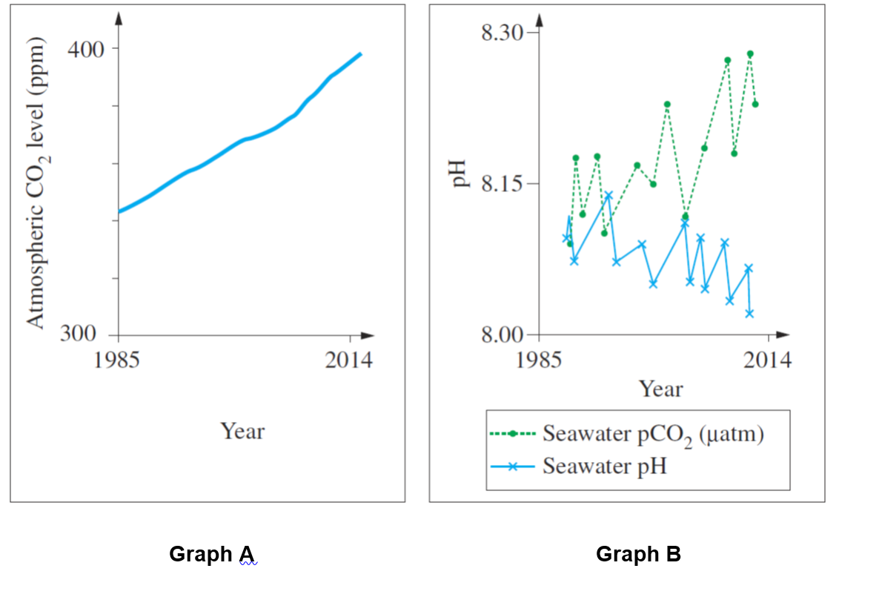
Image credit: NESA EES additional sample hsc questions 2019. Mod7, Q3.
Students could investigate the following:
- Identify the independent and dependent variables in Graph A.
- Explain the trend found in Graph A.
- Identify one problem with the presentation of data in Graph B
- Explain the overall relationship between Year and Seawater pH in Graph B.
- Identify two possible sources of error for the data shown.
- Propose two different inquiry questions that could be derived from the data shown in Graph B.
- Write a hypothesis for one of the inquiry questions and design a valid, accurate and reliable investigation that could scientifically investigate the hypothesis in a laboratory setting.

Task 3:
Design and conduct a first-hand investigation into the effects of ocean acidification on marine animal shells. This could be directly with shells if available, or the process could be modelled. You may use secondary research to guide your design. You will need to consider:
- An appropriate hypothesis.
- Independent and dependent variables.
- Safety measures.
- Methods of obtain accurate and reliable data, using digital technologies where available.
- Measures to ensure the investigation is valid.
- How to record and present both quantitative and qualitative data.
- Analysis of the data to devise trends, assess any potential errors or limitations, suggest improvements.
- Your experiment should be presented in the form of a scientific report.

Resources
- Cleugh, H., Smith, M. S., Battaglia, M. and Graham, P. (2011). Climate Change: Science and Solutions For Australia. CSIRO Publishing: Collingwood.
  - This is a free resource, available online as an e-book download. An accompanying Teacher Resource is also available but is targeted more at Stage 4 and 5 Science. Depending on the ability of the students, the activities in the Teacher Resource may be used as they are or could act as a starting point and adapted for a more capable class. The e-book itself contains information that is applicable to many of the Module 7 inquiry questions, particularly those dealing with anthropogenic climate change and mitigation/adaptation strategies.
- Tompkins, D. E. and Watkins, J. M. (2016). Exploring Earth and Environmental Science Year 12 (2nd ed.). Earth Science Western Australia.
  - This textbook offers two chapters on climate change. Chapter 7 focuses on the geological record of climate change, while chapter 8 focuses on modern climate change. Many of the concepts covered in this book are relevant to the NSW syllabus, however, it does not cover mitigation and adaptation strategies. As this book has been written with the Western Australian syllabus in mind, some of the impacts of climate change are specific to Western Australia but are still applicable in the wider Australian context.
- Rock art paints a different prehistory - article on analysis of Aboriginal rock art by Sydney Morning Herald-this investigates use of rock art as evidence to help understand the past. There is focus on co-existence with megafauna and climate changes.
- ABC News article New evidence suggests megafauna no match for humans - this is one of several recent articles that point to climate change, rather than human intervention, being the major factor in extinction.
- UNSW Journal article - Indigenous Australians’ knowledge of weather and climate gives an excellent and comprehensive overview of Australia’s efforts to utilise Aboriginal and Torres Strait Islander Peoples’ knowledge of past climate patterns and recent observations of change to provide a greater understanding for wider Australia.
- Exploring Palaeo-climate Data by the National Centre for Atmospheric Research (NCAR)-this allows students to explore and interpret historical ice core data and relate it to past climates.
- Climate change - how do we know? by NASA-this website provides excellent reasoning behind the evidence for human-induced climate changes.
- Charctic Interactive Sea Ice Graph by the National Snow and Ice Data Centre-this allows students to produce and analyse a visual comparison of sea ice extent ranging from 1979 to the present. This resource is very easy to use and covers both the Arctic and Antarctic. See appendix for graph of screenshot of monthly data.
- Online training module by Bureau of Meteorology-this website provides a series of training modules on climate science. While the concepts start out at a basic level (for example, examining greenhouse gases, looking at trends in data and defining climate variability vs. climate change), they quickly become more advanced (such as evaluating uncertainty of climate projections). Therefore, this website is best used as a teacher resource, as a source of information rather than as an activity undertaken by students.
- Data sets by ANSTO-this provides real data sets (for example, ice core and historical atmospheric data) that can be used to form inquiry-based lessons or prepare examination style questions.
- Data sets on species distribution in response to climate by The Atlas of Living Australia-Species distribution shifts to examine include: The range of the Pied Butcherbird in 1980s vs 2010s: Atlas of Living Australia-Pied Butcherbird; the range of the Pacific Baza in 1980s vs. 2010s: Atlas of Living Australia-Pacific Baza.
- Here's How Scarily Accurate NASA's Long-Term Climate Predictions Have Been So Far - information on the accuracy of NASA predictions into climate change by Science Alert-this provides detailed information on how accurate past predictions into current temperature shifts due to human-induced climate change have been.
- Aboriginal art as evidence of changing climate
- Geoscience Australia TimeWalk booklet can be used as a standalone guide on geological time or as part of a field trip, excursion or virtual activity with Geoscience Australia. Each section in this publication discusses a single geological time interval, and outlines the major geological, climatic and biological events which occurred in that interval. Climatic events include changes in the content of the atmosphere and the occurrence of ice ages.

