Problem sets: Year 12 Biology

Introduction
This document contains questions to probe students’ understanding of various concepts in the Year 12 course of the Stage 6 Biology syllabus0F. The questions in this problem set have been designed by NSW Biology teachers who attended the ‘Teaching the Year 12 modules in Stage 6 Science’ workshops in 2019, as well as the science curriculum support officers at the Learning and Teaching Directorate. The problem set may be used as classroom activities or in assessments to evaluate student understanding. Teachers are free to adapt or modify the questions in this problem set to suit the learning needs of their students.

Acknowledgements
The Learning and Teaching Directorate at the NSW Department of Education developed this resource for science teachers. The Department acknowledges the efforts of the Biology teachers at the ‘Teaching the Year 12 modules in Stage 6 science’ workshops for contributing to this resource.

Multiple-choice questions
Questions 1-3 relate to the following information about fur coat colour alleles in dogs1F.
The most common coat colour in wild dogs is wolf grey. The pigment that produces this colour is due to the agouti gene. After centuries of domestication and selective breeding of dogs, several mutations have arisen in this gene. There are now five recognised alleles of this coat colour gene. These multiple alleles are listed below in order of dominance. There are no incompletely dominant alleles in this series.
Solid black A^{B} is dominant to Yellow A^{Y}
Yellow A^{Y} is dominant to Agouti A
Agouti A is dominant to Saddle pattern a^{ba}
Saddle pattern a^{ba} is dominant to Tan pattern a^{t}
Tan pattern a^{t} is recessive to all other alleles

Question 1 (Module 5)
What is the maximum number of different alleles for coat colour you could find in an individual dog?
  - Two
  - Three
  - Four
  - Five

Sample answer
A

Question 2 (Module 5)
Which of the following genotypes will NOT give rise to a yellow dog?
  - A^{Y}a^{ba}
  - A^{Y}A
  - A^{Y}A^{B}
  - A^{Y}a^{t}

Sample Answer
C

Question 3 (Module 5)
A breeder crossed two black dogs and produced a litter in which there were four black pups and two yellow pups. Later the same breeder crossed the two yellow pups. They produced a litter with four yellow pups and two tan pattern pups. Given this information, the genotypes of two black dogs mated in the first cross were
  - A^{Y}A^{B} and A^{B}a^{t}
  - A^{B}A^{Y} and a^{t}a^{t}
  - A^{B}a^{t} and A^{B}a^{t}
  - A^{B}a^{t} and A^{Y}a^{t}

Sample answer
A

Question 4 (Module 6)
Which of the following could NOT be a cause of evolutionary change?
  - genetic drift
  - mutation
  - asexual reproduction
  - non-random mating

Sample answer
C
Questions 5 and 6 relate to the following information about allele frequencies.
A gene which determines the presence of blood cell antigens has two alleles, M and N. The following table shows the frequency of the M allele in various human populations.

Population | Frequency of M allele
Inuit | 0.91
Indigenous Australian | 0.18
Egyptian | 0.52
German | 0.55
Chinese | 0.58
Nigerian | 0.55

Question 5 (Module 5)
The frequency of the N allele in the Egyptian population is:
  - 0.52
  - 5.20
  - 0.48
  - 1.48

Sample answer
C

Question 6 (Module 5/6)
The frequency of the M alleles in the Australian population is approximately 0.5. The difference between this frequency and the frequency for the Indigenous Australians is most likely due to:
  - genetic drift
  - non-random mating
  - natural selection
  - migrations

Sample answer
C

Extended response questions

Question 7 (Module 6)
The frequency for an allele in a large breeding population of a mammal on the mainland of a continent is at 50%. Twenty individuals from this population have suddenly become isolated on an island.
  - Plot a graph that predicts the expected allele frequency for both the mainland and island populations over the next 140 generations. You may assume that there is no change to the environment where the small mammals are living (3 marks).
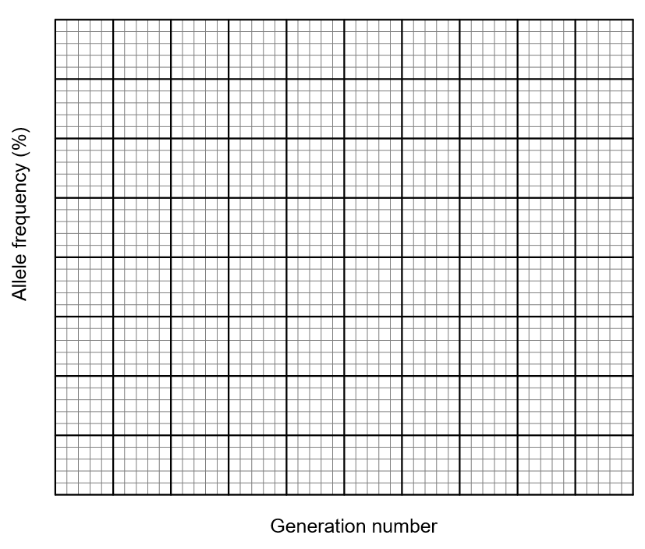
  - Justify the difference between the two populations shown on your graph (3 marks).

Marking criteria (a)
Criteria | Marks
- Provides a key to indicate the difference between large and small populations  - Large population line shows relatively stable allele frequency  - Small population line shows allele frequency becoming either reduced, lost or fixed in the population over time | 3
- Provides a key to indicate the difference between large and small populations  - Large population line shows relatively stable allele frequency  OR  - Small population line shows how allele frequency becoming either reduced/lost or fixed in the population over time | 2
- Any relevant information | 1

Sample answer

Marking criteria (b)
Criteria | Marks
- Difference between populations is explained in terms of genetic drift | 3
- Shows some understanding of genetic drift  - Describes one of the population changes over time | 2
- Any relevant information | 1

Sample answer
Genetic drift refers to the random changes in allele frequency that occur in all populations due to chance, rather than selective pressures. On the mainland, the large population buffers against random loss of alleles. This is reflected in the consistent line for the large population (i.e., the relative frequency of the allele remains stable). In the small breeding population, relative frequencies of the allele may fluctuate to such an extent that allele may become reduced or lost (frequency 0%) from the gene pool altogether, as suggested by the graph which shows the removal of the allele after 140 generations. Alternatively, the allele may become fixed in the population (100%).

Question 8 (Module 8)
The internal body temperature of two desert animals was recorded at different environmental temperatures, as shown in the table below.
Environmental temperature (ºC) | Desert goanna body temperature (ºC) | Spinifex hopping mouse body temperature (ºC)
10 | 9 | 34.6
15 | 12 | 34.3
20 | 18 | 35
25 | 24 | 34.9
30 | 27 | 35.5
35 | 32 | 35.6
40 | 38 | 34.9
45 | 43 | 34.6
50 | 47 | 34.6

  - Plot these values on the same set of axes. Use a key to identify each animal on the graph (3 marks).
  - Use your graph to justify which animal is endothermic (3 marks).
  - Explain two mechanisms the spinifex hopping mouse animal may use to maintain its body temperature when the environmental temperature falls below 35ºC (3 marks).

Marking criteria (a)
Criteria | Marks
- Axes correctly allocated, labelled, scaled. Points placed correctly, and the line graph is drawn. Key to identify lines or lines labelled | 3
- Axes correctly allocated, labelled, scaled. Points placed correctly, and the line graph is drawn with minimal errors | 2
- Axes correctly placed, labelled and scaled. Errors in plotting points and/or line graph not drawn | 1

Sample answer
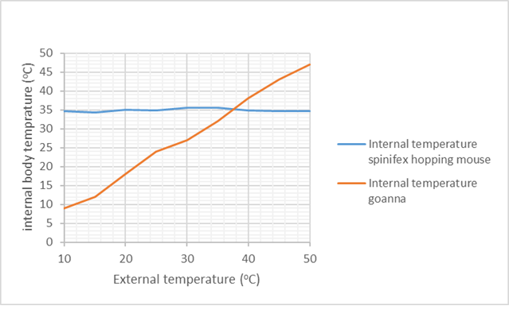

Marking criteria (b)
Criteria | Marks
- Correctly identifies the spinifex hopping mouse as the endotherm AND  - Refers to the graph to justify the statement | 2
- Correctly identifies the spinifex hopping mouse as the endotherm | 1

Sample answer
The spinifex hopping mouse is an endothermic animal as the graph show that its internal body temperature remains constant despite fluctuations in ambient environmental temperature.

Marking criteria (c)
Criteria | Marks
- Identifies and explains two mechanisms that maintain constant body temperature | 3
- Identifies two mechanisms that maintain constant body temperature  OR  - Explains one mechanism for maintaining constant body temperature | 2
- Identifies one mechanism for maintaining constant body temperature | 1

Sample answer
- Constriction of arterioles near the skin reduces blood flow to the surface and therefore, heat loss.
- Burrowing underground where the temperature is less variable could reduce heat loss to the environment.

Question 9 (Module 7)
Read the text about the development of hygiene practices and answer the question that follows.
In the mid-1800s, physicians in Europe observed that women were dying of childbed fever after delivering their babies. Several hypotheses for its cause were proposed, including bad air, a lack of personal hygiene by doctors and the use of contaminated equipment.
The cross-infection of patients by the contaminated hands of healthcare workers is a major method of spreading infectious agents. Hand hygiene is noted to be the most important factor for infection control. Even today, hand washing is not performed as often as it should be.
Design a safe, valid and reliable practical investigation that could test the effectiveness of one hygiene practice to reduce the transmission of microorganisms. (5 marks)

Marking criteria
Criteria | Marks
- All steps are outlined succinctly, logically, and consistently using correct scientific terms  - Independent and dependent variables are clearly stated  - Clear measures are taken to ensure the experiment is valid and reliable  - A potential hazard associated with the investigation and relevant safety measures to minimise harm are indicated. | 5
- Steps are outlined in a logical sequence  - Independent and dependent variables are clearly stated or inferred  - An attempt is made to ensure the validity or reliability of the experiment  - One safety precaution is stated and is relevant to the investigation | 3-4
- Some steps are outlined in a logical sequence  - Independent or dependent variables are clearly stated or inferred  - One feature of validity or reliability is included  - A safety precaution is stated | 1-2

Sample answer
This investigation will determine the effectiveness of using soap (independent variable) in preventing the transmission of microbes, which will be measured by the number of colonies that grow (dependent variable).
- Gather 4-5 participants for this study
- Obtain a set of 10x sterile nutrient agar plates for each participant.
- Thoroughly wash one hand of each participant with soap, while leaving the other hand, unwashed (this is the experimental control which is necessary for a valid test).
- With the washed hand, gently press fingers into the surface of one agar plate, then quickly seal and label as “treated”. Do this for 4x more agar plates to increase the possibility of obtaining reliable data.
- Repeat the same procedure with the unwashed hand and label as “untreated”.
- Repeat steps 3-5 for each participant
- Incubate the agar plates at 30°C for 3 days – keeping them at a controlled temperature improved the validity and lessened the likelihood of pathogenic organisms growing.
- Being sure never to open the plates to prevent the chance of infection, count the number of microbe colonies that grow on the 5 treated and 5 untreated plates. Analyse and compare data to determine if there is an effect of using soap on the growth of microbe colonies.

Question 10 (Module 7)
A group of students wished to examine if microorganisms could be found in river water. To do this, they followed the method below:
- Collect 1L sample from the Murray River by filling an empty water bottle.
- Spread one drop of water from the bottle onto an agar plate.
- Tape the plate closed and label it as MR.
- Tape another nutrient agar plate closed without adding anything to it. Label this plate as C for control.
- Place both nutrient agar plates into an incubator for 2-3 days at 30°C.
Explain one positive feature and one negative feature of the experimental design (3 marks).

Marking criteria
Criteria | Marks
- Identifies and explains one positive of the experimental design  - Identifies and explains one negative of the experimental design | 3
- Identifies one positive of the experimental design  - Identifies one negative of the experimental design | 2
- Provides some relevant information | 1

Sample answer
A positive feature of the experimental design is that it includes a control nutrient agar plate with no water on it. This will allow for a comparison with the Murray River sample and show that any difference between the two is due to the Murray River water.
A negative aspect of the experimental design is that it only uses two nutrient agar plates. This means the reliability is low. This will make it difficult to know if microorganisms can consistently be found in river water or if it was a ‘one-off’ result.

Question 11 (Module 8)
Examine the graph below and answer the questions that follow
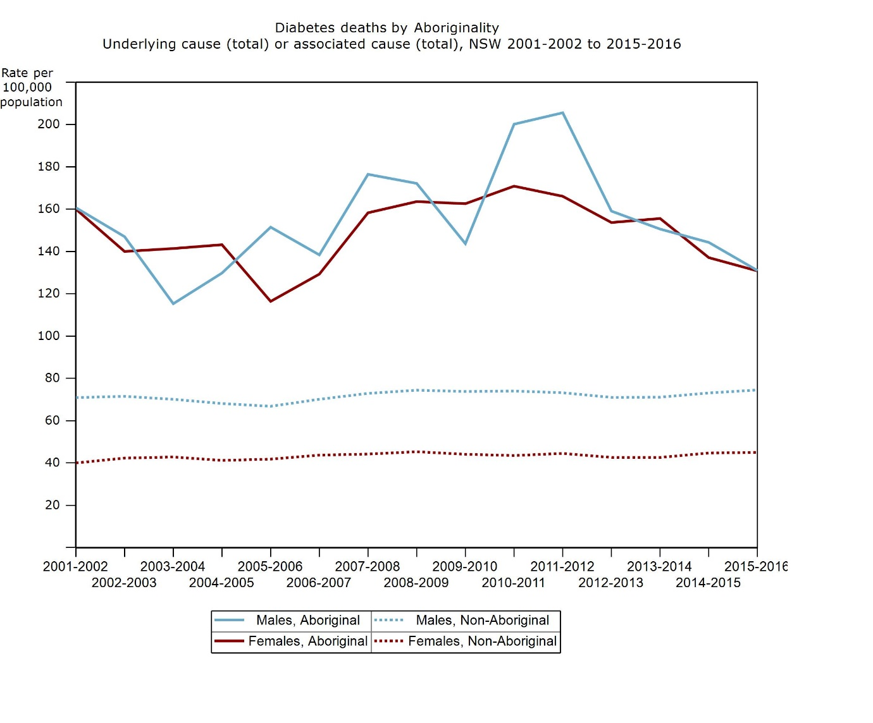
Image credit: Health NSW
  - Describe the trends shown in the graph for the incidence of diabetes-related deaths in all populations (3 marks).
  - Identify one future direction for further research into the reasons for the data recorded (1mark).
  - Describe and evaluate the effectiveness of an educational program or campaign that has helped to prevent a non-infectious disease in Australia (3 marks).

Marking criteria (a)
Criteria | Marks
- Describes the trends for all four sets of data on the graph | 3
- Describes the trends for some sets of data  OR  - Outlines the trends for all sets of data | 2
- Outlines trends for some sets of data | 1

Sample answer
From 2001-2002 to 2015-2016, the number of deaths related to diabetes per hundred thousand of the population of Non – Aboriginal males and females have remained relatively constant at 70 and 40 deaths per 100,000, respectively.
Between 2001 and 2016, the incidence of diabetes-related deaths in Aboriginal populations was consistently higher than that for the non-Aboriginal populations.
From 2001-2002 to 2011-2012, the rate for Aboriginal males fluctuated, but there has been an upward trend from 160 diabetes-related deaths per hundred thousand to 200 per hundred thousand. The rate then decreased to 130 per hundred thousand in 2015-2016.
The rate for Aboriginal females showed some decrease from 160 per hundred thousand in 2001-2002 to 120 per hundred thousand in 2005-2006. From then until to 2010-2011, the rate increased to around 170 deaths per hundred thousand. Since then there has been a decline in the deaths to be the same as the males, 130 per hundred thousand in 2015-2016.

Marking criteria (b)
Criteria | Marks
- Identifies any feasible further study | 1

Sample answer
Answers could include the study of diet, alcohol consumption, age of onset of diabetes, age at death.

Marking criteria (c)
Criteria | Marks
- Describes and evaluates an educational program or campaign | 3
- Describes an educational program or campaign OR  - Names and evaluates an educational program or campaign | 2
- Names an educational program or campaign | 1

Sample answer
Tobacco control measures became prevalent in the late 1980s and 1990s. This included a ban on tobacco advertising in 1993. Tobacco health warnings on cigarette packets were introduced in 1995, along with an advertising campaign warning of the link between smoking and lung cancer. Dining areas were designated as smoke-free dining, and later in 2013, plain packaging for cigarettes was introduced.
This campaign has been successful in reducing the number of smokers aged over 14 in Australia from 25% of the population in 1990 to 14% in 2018. Additionally, the proportion of the population who has never smoked has increased from 49.5% in 2007-2008 to 55.7% in 2017-2018. Consequently, it could be said that the campaign has been successful (nearly halving the number of smokers in the population), but there is still room for a further reduction in smokers.

Question 12 (Module 5/7)
Cavendish bananas are the most widely grown banana variety in the world. They are propagated, as shown below.
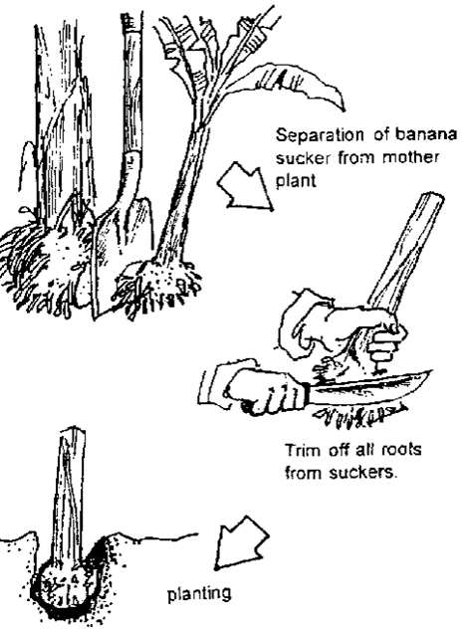
Image credit: Slideshare
A recently identified disease of Cavendish bananas is Panama Disease. It is caused by a fungus that originated from South East Asia and is present in South East Asia, the Middle East, southern Africa and small areas of the Northern Territory and North Queensland. The fungus attacks the banana’s vascular system causing wilting and death of the infected plant. It can be transmitted via infected plants, equipment, soil and clothing. There is no known cure for the disease. 80% of global production is under threat from Tropical race 4. If the disease were to spread beyond its current distribution in Australia, it would devastate Australia’s banana industry.
Source: Australian Government, Department of Agriculture and Water Resources
  - Identify this type of reproduction and describe one advantage of this type of reproduction (2 marks).
  - Propose why the world’s bananas are at such a great risk (2 marks).
  - Describe measures could the Australian government and farmers take to prevent the spread of the disease in Australia (3 marks).
  - A banana plant in Coffs Harbour is showing is signs of Panama Disease. Design an investigation that could be used to demonstrate that the fungus is the cause of the disease (3 marks).

Marking criteria (a)
Criteria | Marks
- Identifies that this is a type of asexual reproduction AND describes one advantage | 3
- Identifies that this is a type of asexual reproduction AND identifies one advantage | 2
- Identifies that this is a type of asexual reproduction OR identifies one advantage | 1

Sample answer
This is a type of asexual reproduction. Because there is only one parent, the offspring is genetically identical to the parent plant. This provides the advantage to banana growers that they can be assured of consistency of production.

Marking criteria (b)
Criteria | Marks
- Links lack the genetic diversity with reduced disease resistance in banana population | 2
- States that bananas have no resistance to disease | 1
Because the Cavendish banana population reproduces asexually, there will be limited genetic diversity, so there will be very few bananas with resistance to this new disease. Consequently, there will be a large proportion of bananas affected by the disease.

Sample answer
Criteria | Marks
- Describes two appropriate measures to prevent the spread of the disease | 3
- Describes one appropriate measure to prevent the spread of the disease OR names two appropriate measures to prevent the spread of disease | 2
- Provides some relevant information | 1

- To prevent this disease from spreading beyond the limited area where it currently exists, bananas and banana plants should not be allowed to leave the area.
- Australia should have strict quarantine regulations so that banana plants from overseas cannot enter the country without approval.
- Approved imports should be quarantined, so that infected/diseased bananas or the fungus can be isolated and destroyed and not permitted to enter the country.
- Equipment used on affected plants should be sterilised before being used on other plants.
- Boots and clothes should be cleaned before being used on other properties so that the pathogen cannot be transmitted in soil or clothing.

Marking criteria (d)
Criteria | Marks
- Applies all four steps of Koch’s postulates concerning the disease fungus | 3
- Applies 2 or 3 steps of Koch’s postulates | 2
- Provides some relevant information | 1

Sample answer
- Take a sample from the affected plant,
- Inoculate an agar plate and grow a pure culture.
- Inoculate the pathogen into a healthy banana plant
- Reisolate the pathogen from the new host. It must be shown to be the same as the originally inoculated pathogen and stored samples of the Panama Disease fungus.

Question 13 (Module 6)
Using THREE specific examples, evaluate the effect of using biotechnology on biodiversity in agriculture (6 marks)

Marking criteria
Criteria | Marks
- Provides three specific examples of biotechnological applications in agriculture  - Evaluates the impact of these examples on biodiversity | 5-6
- Provides TWO or more examples of biotechnological applications in agriculture  - Explains how the technologies impact on biodiversity | 3-4
- Provides an example of biotechnology in agriculture  OR  - Describes how this impacts on biodiversity | 1-2

Sample answers
Biotechnology in agriculture has its greatest effect on genetic diversity. In artificial insemination, semen from a quality sire (ram, bull, stallion) is introduced into a female animal’s reproductive tract to produce a high-quality offspring. This can reduce the gene pool in the population as only the genetic material from a limited set of high performing sires are used. It does, however, provide opportunities for gene mixing between geographically isolated populations. For example, a bull that has been bred in the USA can be used in Australia.
Artificial pollination can be used to cross-breed different varieties of crops to incorporate favourable traits from parental varieties into offspring. For example, using artificial pollination, the high yielding traits of one variety of wheat can be combined with the disease-resistant traits of another. There may be a small increase in genetic diversity, as plant varieties that are geographically isolated can be cross-pollinated. This initially increases genetic variation because there will be a wide variety of genetic combinations possible. However, because only the most successful cross will be commercially produced, the gene pool will be reduced as this newly produced favourable variety will be widely grown at the expense of other varieties.
Genetically modified organisms are produced when the genes of one species are inserted into the genome of another species. For example, genes from salmon can be inserted into the genomes of strawberries to produce frost-resistant strawberries. Another example is that of genetically-modified cotton. Here, a gene from the bacterium Bacillus thuringiensis is transferred into the genome of the cotton. The protein product of this gene is toxic to the cotton boll weevil – a serious insect pest of the cotton plant. As a result, the genetically-modified cotton is resistant to the insect pest. This increases the biodiversity of these genetically-modified organisms, as completely new genes have been introduced to the cotton plants and strawberry plants. If, however, the new variety becomes the only variety of cotton/strawberry grown, then the biodiversity will eventually be reduced.

Question 14 (Module 6)
A small population of loop worms were studied over some time. The tables below show the phenotype and genotype of generations 1 and 6.
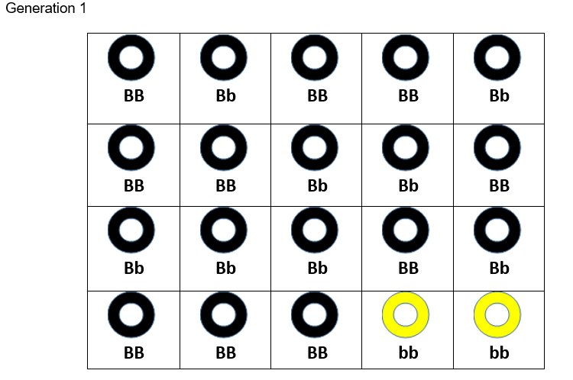
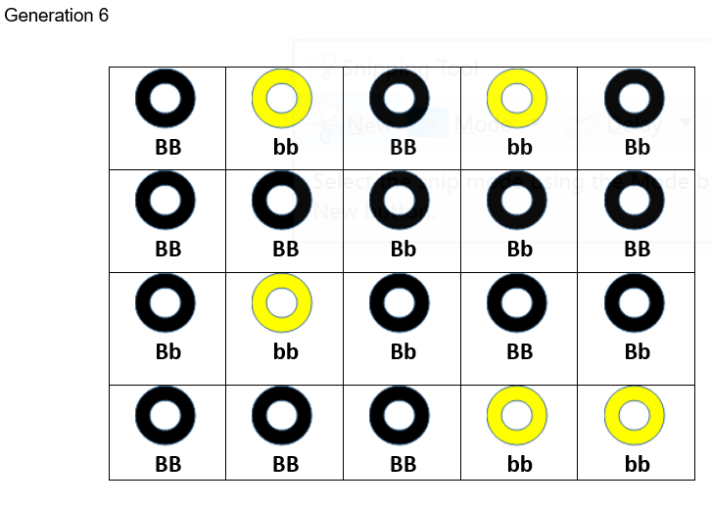
  - Calculate the allele frequencies for both generations 1 and 6.
  - Propose TWO possible reasons for the changes in the observed allele frequencies (2 marks).

Marking criteria (a)
Criteria | Marks
- Calculates the allele frequencies of both generations accurately | 2
- Calculates the allele frequency of one generation accurately | 1

Sample answer
Generation 1
- Allele frequency (B) = 28/40 = 0.70
- Allele frequency (b) = 12/40 = 0.30
Generation 6
- Allele frequency (B) = 24/40 = 0.60
- Allele frequency (b) = 16/40 = 0.40

Marking criteria (b)
Criteria | Marks
- Proposes 2 possible reasons for the change in gene frequencies | 2
- Proposes 1 possible reason for the change in gene frequencies | 1

Sample answer
Two of the possible reasons could include:
- The yellow allele could become more common by chance due to genetic drift acting on a small population
- The yellow allele could provide a survival advantage over the black one, e.g. through camouflage

Question 15 (Module 5/6)
Huntington’s disease is an inherited disorder that is characterised by progressive degeneration of neurological function. Symptoms include clumsy involuntary movements, difficulty in swallowing and speaking, hallucinations, and a decrease in mental capabilities. Eventually, the patient is completely dependent on carers. The onset of the disease usually occurs in the 30s or 40s, and death generally occurs between 10 and 25 years after onset. The mode of inheritance for Huntington’s disease is autosomal dominant.
Carl, a 25-year-old man, is planning a family with his partner. His mother is suffering from Huntington’s disease. Carl has concerns about the possibility of passing on Huntington’s disease to his children. He understands that the disease is inherited, but has shown no signs of the disease himself. He attends a genetic clinic where the results of genetic testing show that Carl does have the gene for Huntington’s disease. His younger brother was also tested and found not to have the affected gene, but his younger sister did. Carl’s partner has no history of Huntington’s in her family, and her results show that she does not have the affected gene.
  - Construct a pedigree showing the occurrence of the Huntington’s disease gene in Carl’s family, including his parents, siblings and his partner (3 marks).
  - Carl and his partner are planning to have a family. Predict the likelihood of any of their children having this disease. Use a Punnett square to explain your answer (3 marks).
  - Explain some the possible social and ethical implications for Carl and his partner that result from the biotechnology used when planning to have a family (4 marks)

Marking criteria (a)
Criteria | Marks
- Draws pedigree that shows correct relationships  - Identifies all affected individuals | 3
- Draws pedigree with most relationships shown  - Identifies only Carl as affected | 2
- Draws diagram or pedigree that shows ONE correct relationship | 1

Sample answer
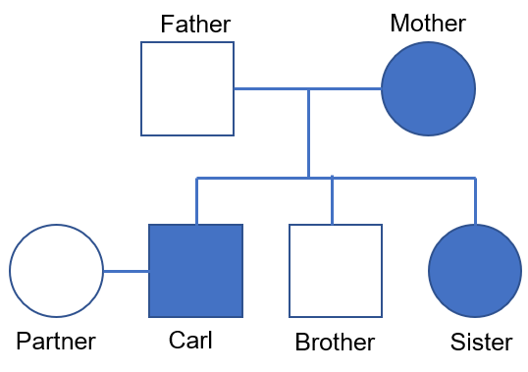

Marking criteria (b)
Criteria | Marks
- Constructs a correct Punnett square  - States correct phenotypic ratio/probability | 2
- Construct a correct Punnett square  OR  - Identifies the correct phenotypic ratio/probability | 1
The information suggests that Carl is heterozygous for Huntington’s disease (Hh), as his father is unaffected (hh), meaning Carl has inherited the Huntington’s disease allele from his mother. Carl’s partner is unaffected, meaning her genotype is hh. The outcome of the Punnett square shows a 50% chance of a child having Huntington’s disease.

Sample answer
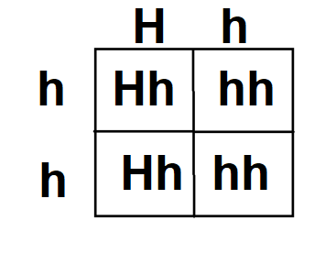

Marking criteria (c)
Criteria | Marks
- Explains points relating to BOTH social and ethical implications of genetic testing of parents or genetic screening of embryos | 3-4
- Provides some points relating to the social or ethical implication of genetic testing of parents or genetic screening of embryos | 1-2

Sample answer
By being screened, Carl has been able to determine that at some point in his mid-life, he will develop Huntington’s disease. This will enable him to prepare his family financially for the care that he will need. He may be able to set and achieve life goals for the period before he becomes sick. A disadvantage of genetic screening and knowing that he will get sick is the stress and anxiety it may cause him. If his employer has access to this information, it might affect Carl’s employment prospects.
Carl and his partner can also have their baby by in-vitro fertilisation. This will allow them to have the embryo genetically tested pre-implantation to determine if it has the Huntington’s disease allele. They can then choose to implant an embryo that does not have the dominant allele. While this means that they can be sure that their child will not develop Huntington’s disease, nor pass it onto their child, there is a significant amount of trauma/distress in deciding to reject an embryo. Also, while the embryo may not have HD, it could potentially have an array of other inherited diseases that are not tested for.

Question 16 (Module 6)
A group of scientists were investigating the genetic modification of microbes. Two strains of yeast were compared in their ability to produce ethanol from sugar in a process called fermentation. Strain A is an unmodified version of the yeast, while Strain B has been modified using recombinant DNA technology.
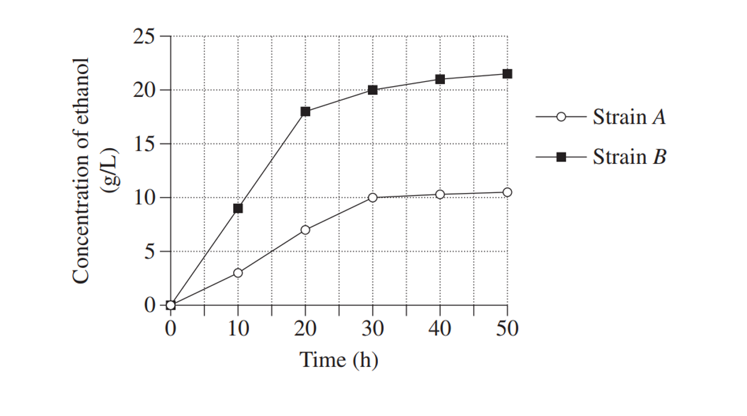
Image credit: NESA
  - Identify the dependent variable in this investigation (1 mark).
  - Using your knowledge of recombinant DNA technology, account for the differences shown in the graph (3 marks).
  - Describe two benefits of using genetic technologies in agriculture (2 marks).

Marking criteria (a)
Criteria | Marks
- Identifies the concentration of ethanol as the dependent variable | 1

Sample answer
The dependent variable is the concentration of ethanol

Marking criteria (b)
Criteria | Marks
- Identifies and describes how the curves for 2 strains differ  - Relates difference to genetic modification of strain B, showing a sound understanding of recombinant DNA technology | 3
- Identifies the difference between 2 curves  - Shows basic understanding of recombinant DNA technology | 2
- Some relevant information | 1

Sample answer
Strain B has produced a far higher concentration of ethanol and a faster rate of production than Strain A, indicating a greater ability to ferment the sugar. This is because Strain B has been genetically modified to do so. The yeast microbes could have been given a gene from a different species of organism that allow it to ferment the sugar at a faster rate than what it could do naturally.

Marking criteria (c)
Criteria | Marks
- Can accurately describe two benefits of genetic technologies in agriculture | 2
- Can accurately describe one benefit of genetic technologies in agriculture | 1

Sample answer
- Can produce a greater yield of crop to feed people.
- Can produce disease- and pest-resistant crops that reduce the need for pesticides or other expensive treatments.

Question 17 (Module 6)
In the diagram below, scientists were investigating the effects of irradiating bread mould (exposing it to X-rays) on the ability of it to grow. Arginine is an amino acid that is naturally produced by the bread mould, enabling it to grow.
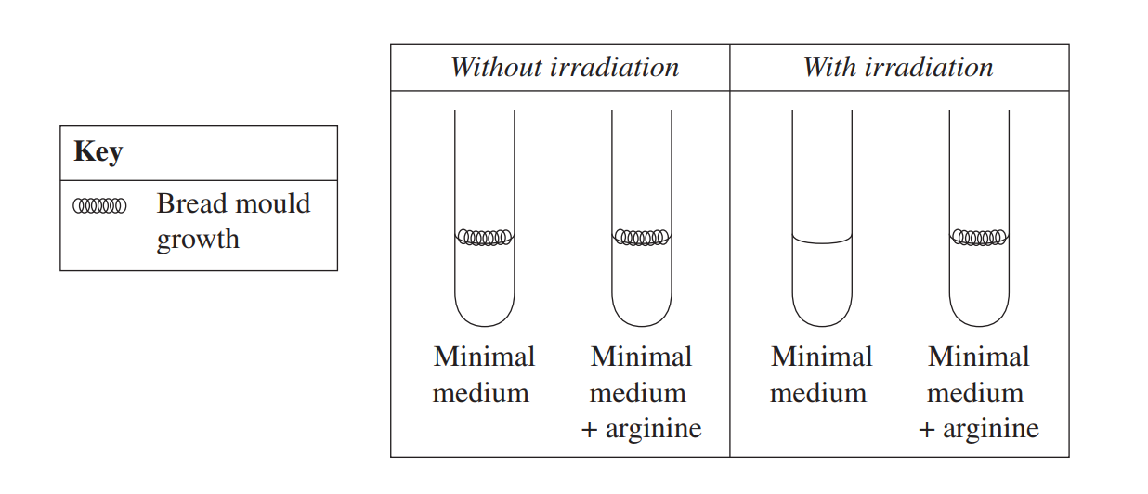
Source: NESA

  - Explain the results shown (4 marks).
  - Explain one safety precaution that would be necessary when working with bread mould (2 marks).

Marking criteria (a)
Criteria | Marks
- Shows a thorough understanding of the link between exposure to X-rays, mutation and amino acid production  - Accurately uses information in the tables to the response | 3-4
- Shows some understanding of the link between exposure to X-rays, mutation and amino acid production  - Attempts to use information in the tables to the response | 2-3
- Any relevant information | 1

Sample answer
X-rays are mutagenic forms of electromagnetic radiation. This means that after the bread mould is exposed to the x-rays, its DNA is mutated (damaged). In this example, the mutated DNA in the irradiated mould prevents the organism from producing the amino acid arginine. This is clearly shown as the bread mould hasn’t grown; it’s only after arginine is added after irradiation that it can still grow.

Marking criteria (b)
Criteria | Marks
- Relevant safety precaution stated  - Precaution is linked to the potential risk of harm | 2
- Relevant safety precaution stated | 1

Sample answer
Face masks would need to be worn in case mould spores are inhaled, leading to possible infection.

Question 18 (Module 5/6)
The table shows the base triplets in mRNA and how they code for amino acids. For example, the amino acid Serine (Ser) can be coded for by the base triplet UCG.
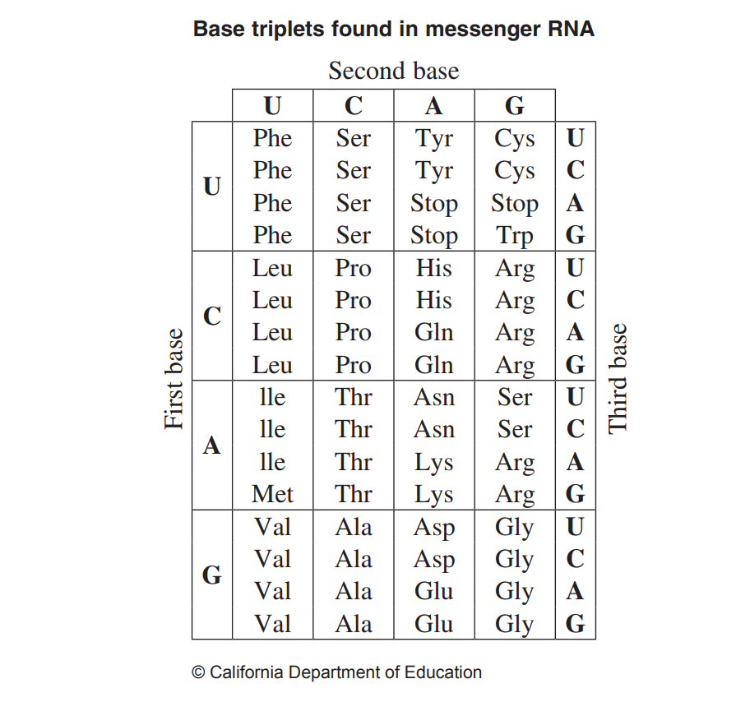
Image credit: NESA
Create a flowchart to show how a point mutation could result in a new allele. Use data from the table in your response (3 marks).

Marking criteria
Criteria | Marks
- Shows sound understanding of the process of mutation resulting in a new allele  - Uses information from the data table in response  - Includes at least 3 steps separated by arrows | 3
- Shows some understanding of the process of mutation resulting in a new allele  - Includes at least 3 steps separated by arrows | 2
- Any of the above | 1

Sample answer

-T-A-G-C-T-
This codon, on the coding strand of a DNA molecule, codes for the amino acid serine (ser)
Cell is exposed to ionising radiation during mitosis
Point mutation results in the G in the codon being substituted with an A
-T-A-A-C-T-
Subsequent mRNA instead of being UCG is now
-A-U-U-G-A
This codon now codes for a different amino acid, tryptophan (trp)
This will result in a different polypeptide.
The original and new polypeptide represent different alleles of the same gene

Question 19 (Module 5)
Some species of mammals can be affected by a recessive genetic disease that limits the growth of young individuals. In an experiment to test the effectiveness of a new drug for this condition, 50 mice with the genetic condition were divided randomly into two groups of 25. Mice in Group X were given the drug in their food, and those in Group Y were given only food with no drug. Each mouse was weighed regularly, and the average weights of mice in each group over six weeks are shown below.
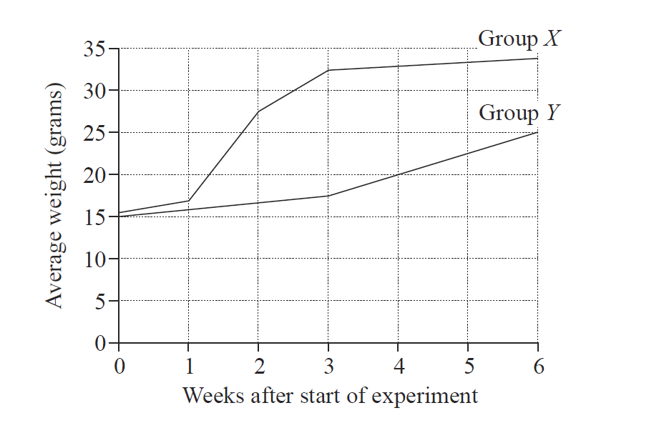
Source: NESA
  - State when the greatest difference between the average weights of mice in both groups occurs (1 mark).
  - Justify the need for Group Y in the experiment (2 marks).
  - Two mice from the experiment were bred together to produce four offspring. Using Punnett squares, show the probability of their offspring also have the disease (2 marks).

Marking criteria (a)
Criteria | Marks
- Identifies that the greatest difference in the average weights of the two groups occurs at 3 weeks | 1

Sample answer
The greatest difference in the average weights of the two groups of mice occurs at 3 weeks

Marking criteria (b)
Criteria | Marks
- Identifies that Group Y acts as the experimental control  - Links the use of a control to improving the validity | 2
- Any of the above | 1

Sample answer
Group Y is needed as the experimental control. This allows for comparison with the changed variable and therefore adds to the validity of the investigation.

Marking criteria (c)
Criteria | Marks
- Uses Punnett square to show parent and offspring genotypes, which are all homozygous recessive | 2
- Indicates correct genotype without working OR uses Punnett square correctly but wrong genotypes provided | 1

Sample answer
Since it is stated in the question that all mice in the experiment have the disease and that it is recessive, both parents must be homozygous recessive. Therefore 100% of offspring will also be homozygous recessive.
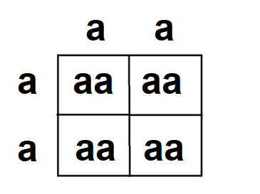

This document references the Stage 6 Biology syllabus © 2019 NSW Education Standards Authority (NESA) for and on behalf of the Crown in right of the State of New South Wales.
This question has been modified from Canavan, D (1994). Biol Notes: A summary of VCE Biology Unit 4. South Melbourne: Thomson Nelson.

