Module 8: Waste management options

War on waste
Watch the War on Waste – Turning the Tide (duration 59:48) series 1, episode 4 from the ABC.
- Select two waste management options explored in the video. Categorise each of the two options as one the following categories and justify your reason.
  - energy used to produce or recycle the waste
  - environmental impact of waste disposal
  - space for disposal or storage of waste
  - local waste management facilities
  - demand for reused or recycled waste
- Evaluate the two waste management options selected in the activity above using the evaluate scaffold below.
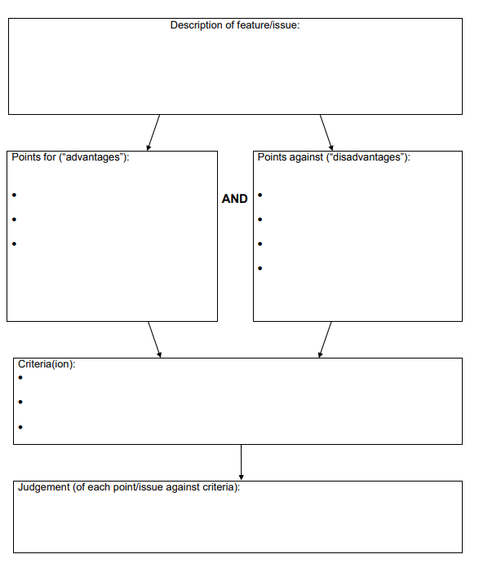
NSW Department of Education 2002

Comparing councils
Research, evaluate and compare two council waste management strategies.
These can be found on the council websites for example, Sydney’s Inner West Council provides its waste management strategies at:
Live > Environment and sustainability > At council.

