Material world
Science and technology Stage 2 student workbook
Name:
Class:

Overview
You will investigate how different properties of materials affect the use of materials in products. You will learn to understand that the choice of materials is important when designing successful products. You will design and make an entertaining game for you, your friends and family to play.

Resources
- You may need help from an adult to read all the information in this workbook, discuss your ideas, or find information online through a device for more understanding.
- Pencil, rubber, coloured pencils, scissors
- Recycled materials (the resources needed will depend on the game you choose to create) – such as paper, cardboard, aluminium foil, bottle tops, art supplies, craft supplies, glue, sticky tape – an adult may be able to help you find what you need.

Activity 1 – Which material to use?
During this activity you will investigate materials, their properties and uses.

Activity 1.1 – investigating materials
During this activity you will explore materials in the world around you.
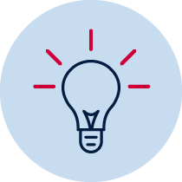Have you ever wondered about the world around you and what objects are made from? What is the same and what is different about objects in the world?
What is a material? Discuss your ideas with an adult.
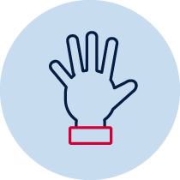You are going on a material world scavenger hunt. Here is your challenge!
You have 5 minutes to find one different object for each letter of the words, ‘material world’. For example, M – marble, A – adapter and so on.
If you find one for each letter in 5 minutes – Amazing! Try to find 2 for each letter. Have an adult time you and have some fun. If you have trouble finding the objects in 5 minutes, keep going until you get them all.
Here is one collection. Can you tell which letter each object represents?
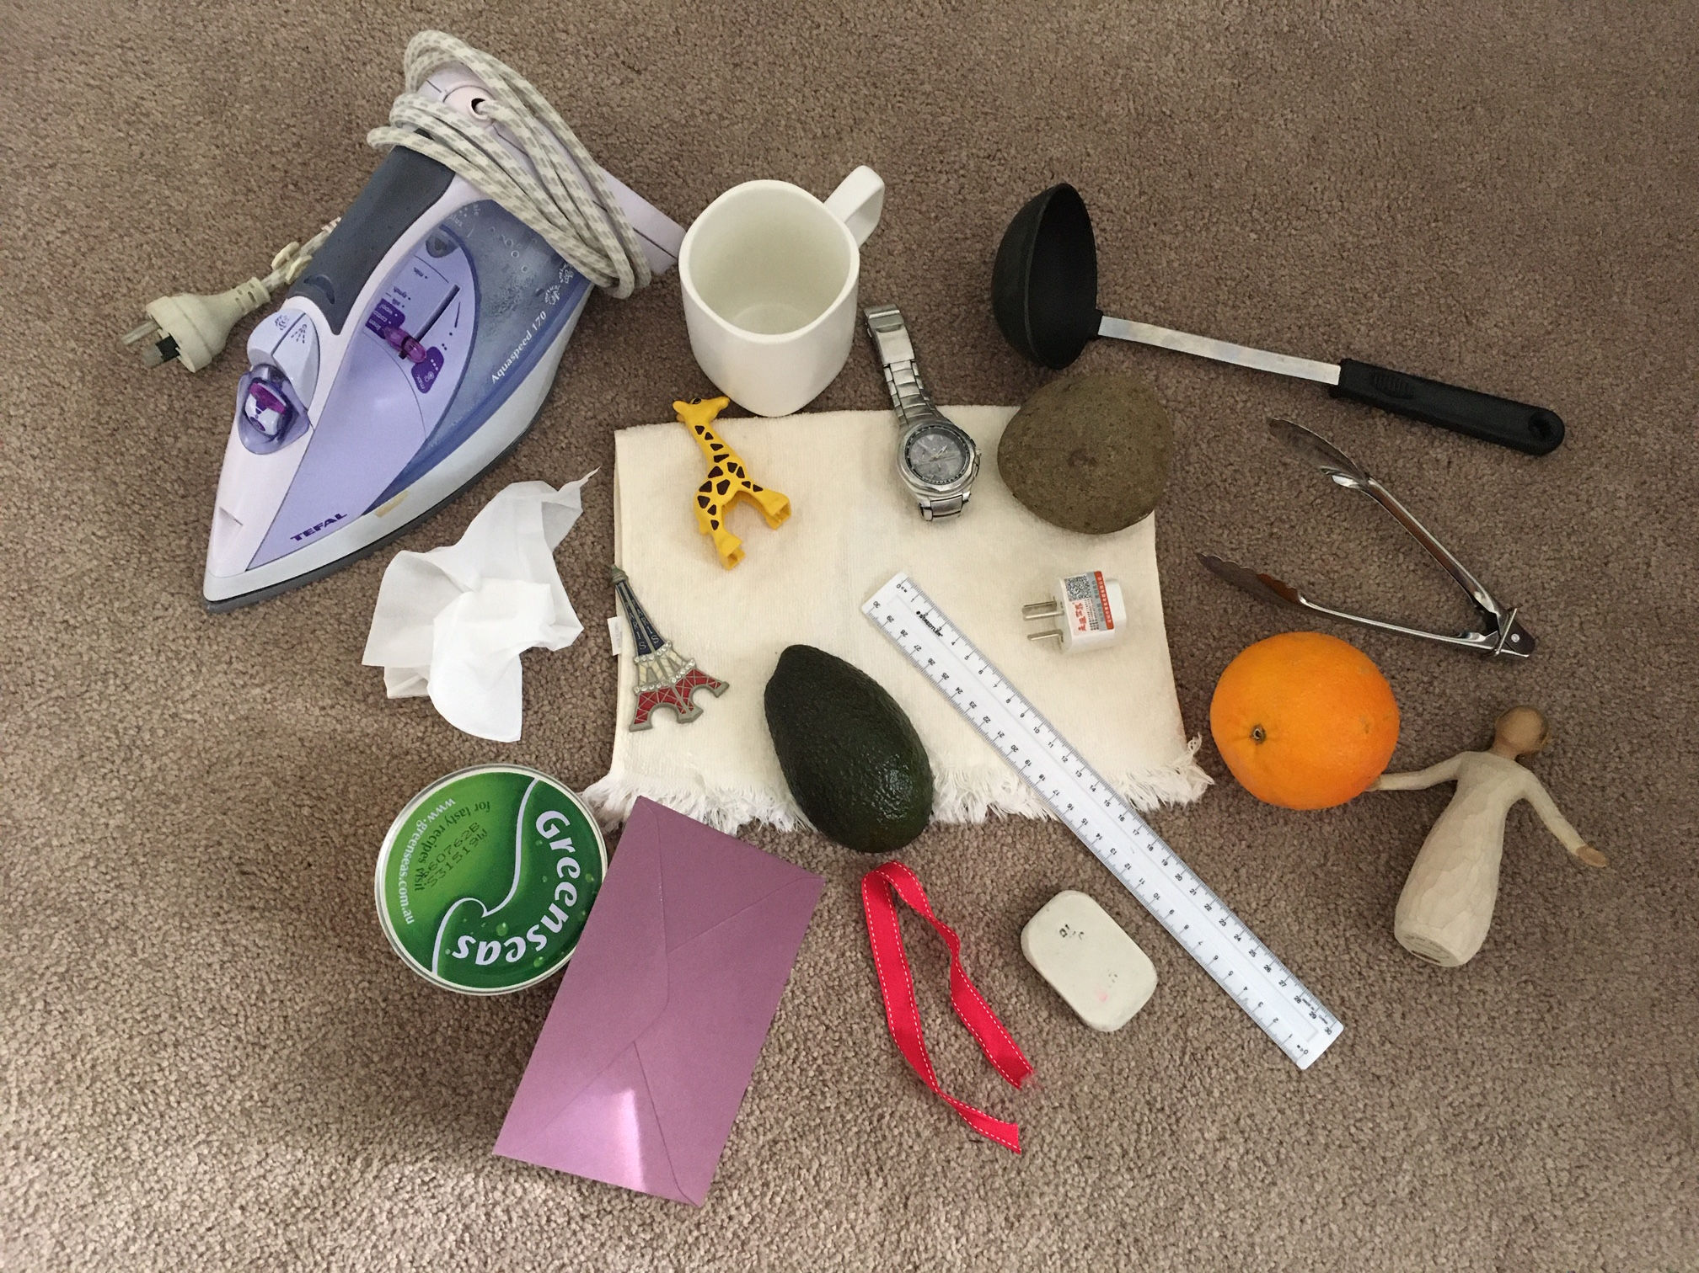
After you have finished collecting your objects, have a good look at your selection. Pick them up and move them, squeeze them softly, feel how heavy they are, what they feel like and with an adult, discuss what they are used for.
- Materials are the substance things are made from. Make sure you distinguish between an object and the material(s) from which the object is made. For example, a window (object) is made from glass (material); a door (object) is made from wood (material).
- A property of a material represents the characteristics that can be identified. For example, bendy (flexible), stretchy (flexible), stiff (rigid), brittle (breaks easily), durable (doesn’t break easily) smooth, rough, waterproof, absorbent, transparent, opaque, shiny, dull.
- Some materials are found naturally in the environment, some materials are processed by humans to change their properties to make them more suitable for a particular purpose. See if you can tell if the material is natural or processed.
Write the name of each object. Identify the material(s). Decide if the material is natural (N) or processed (P). List the observable properties you can identify for each material.
Use your collection to complete this table.
Object | Material | N or P | smooth or rough | rigid or flexible | transparent or opaque
m

a

t

e

r

i

a

l

w

o

r

l

d

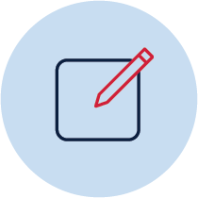 Choose two of your objects. Think about the material(s) they are made from and the properties of these natural and/or processed materials.
Can you observe any other properties of the material(s). Write your observations.
Can you think of another product or purpose these materials could be used for. Write your ideas.
Object 1 name:______________________
properties:_______________________________________________________________
_______________________________________________________________________
uses:___________________________________________________________________
_______________________________________________________________________
Object 2 name:_______________________
properties:_______________________________________________________________
_______________________________________________________________________
uses:___________________________________________________________________
_______________________________________________________________________

Activity 1.2 – uses of materials
During this activity you will explore why materials are used for particular purposes.
The properties of different materials make them suitable for specific purposes. Answer these questions.
Question | Answer
What if bed sheets were made of aluminium foil?

What if pillows were made of gold?

Why are windows made of glass?

Why are bricks used to make houses?

What if plastic had never been invented?

Activity 1.3 – importance of materials
During this activity you will explore how important materials are in your daily life.
From the moment you get up (woken by an alarm) to the time you go to bed (snoozing soundly on a pillow and sheets), every single activity you do involves materials of one kind or another.
Could we survive without materials? No!
When you remember that materials provide everything from the clothes we wear and the food we eat to the shelter that keeps us safe, it's obvious that modern human life is impossible without them.
Discuss with an adult ways that you use materials each day. List or draw some of these ideas. For example, drying yourself with a towel (towel is made from fabric) or eating breakfast (spoon is made from metal).

Activity 2 – Design and produce a game
During this activity you will design and produce a game to entertain family and/or friends.
Recycling is the process of turning waste materials into new materials and objects. Some materials can be recycled through waste management systems such as cardboard, glass, paper, metal cans and some plastics. Some materials cannot be recycled using the recycling bin. For example, some plastics and packaging materials such as Gladwrap and Styrofoam.
Look around your home and/or school. Identify 10 objects made from materials that can be recycled.
Objects | Material(s)

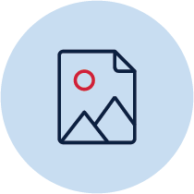Why do you think it is important to recycle materials? What do you think will happen if we don’t recycle materials? Write and draw your ideas.
Can you think of new products that could use recycled materials? Draw your ideas.

Activity 2.2 – games, games, games
During this activity you will begin designing your own game.
What are some games you, your friends and family like to play? Think about the materials you need for these games. They can be inside or outside games (that don’t need an electronic device). Here are some ideas to help you think of your own.
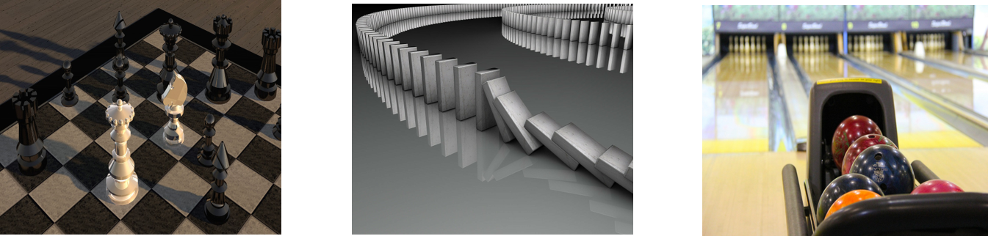
List and/or draw some games you like to play with your friends and family.
Using what you know about games, choose one game, or create a brand-new game, that you could make from recycled materials. You may like to use a game you know well and change it slightly to suit your purpose. It could be a board game, throwing game such as, ring toss, maze run, ten pin bowling or a carnival game like mystery fishing game, water squirt, guess how many, stilt racer or milk bottle pyramid throw game. You may also like to create an arcade game like mouse hole roll, marble race, target golf or frisbee challenge.
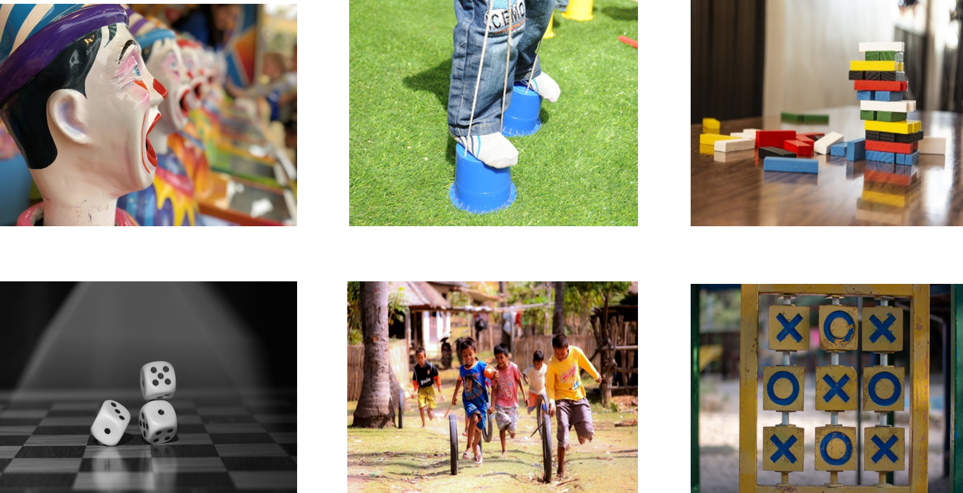
Choose the game you would like to create. Decide who the game is for. For example your younger sibling or friend. You could research information about your idea. Planning is a very important part of the design process. Plan the materials and steps you will have to follow to make your game.

Activity 2.3 – planning
During this activity you will plan your game design.
Draw an annotated, labelled drawing of your idea to explain how it will work. This will help you visualise your design. Write a list of the materials you will need to collect to make your game. Circle the recycled materials you will use.
Annotated drawing | Materials

Activity 2.4 – create and make
During this activity you will produce a sample model of your design idea.
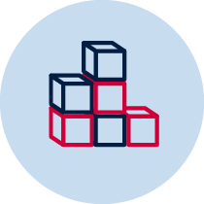 It is important to make a sample model of your design before building the final product. This is called a prototype. You can test the prototype and make improvements, or modifications, before you make the final version of your game.
Collect the materials you will need to make your sample model.
Build a prototype (using suitable materials).
Remember when you make your game there are many ways to join pieces of cardboard without using sticky tape. Before you build the prototype, gather some bits of cardboard and practise different ways of joining them together such as cutting slots in the cardboard and sliding two pieces together, using fasteners (split pins), using a hole punch and string to tie cardboard pieces together or glue a stand to the back of a shape.
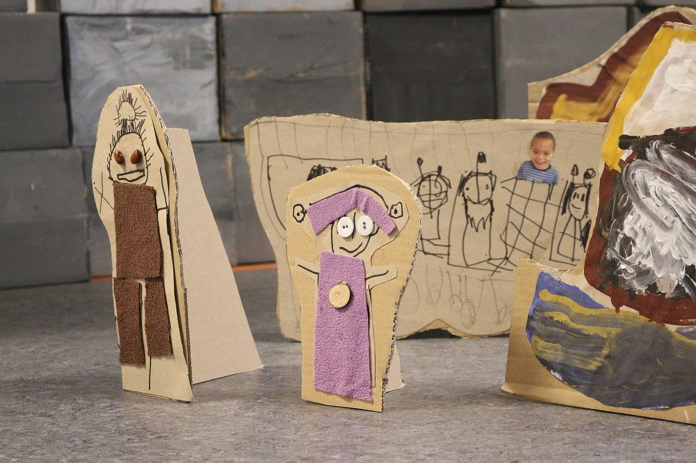
Test the prototype to see if it works the way you think it should. Make changes to improve your design if you need to.
Draw your prototype or take photos of the model and add them to this student workbook.

Reflection
Think about your prototype. Were you happy with how it turned out? Did you enjoy the design process in Activity 2? Write your reflections using the two stars and a wish format.
Star  Something that went well! | Star  Something that went well! | Wish  A goal for next time…

Activity 3 – optional
During this activity you will make the final product of your design idea and reflect on the design process.

Activity 3.1 – Play your game
During this activity you will make a final model of your game.
Make a final version of your game. It will take some time. You may need help from an adult.
Spend time thinking of new ways to use your recycled materials. Test and check that it works as you are designing and building.
Play your game and gain feedback from others to make your game the best it can be. Take photos of your game or you could bring it to school to share with others. It would be wonderful if your game could come into school on a games day and each class member has a go at playing each other’s games.
You will be asked to present your game to the class and tell them:
- Which materials you chose and why.
- How your game works.
- What other people think of your game. Did they have fun playing it? How? Why?
- Did you make changes from the feedback you received?
- What changes did you make?
- What did you learn from your mistakes?
- What would you do differently if you could make another game?
- Could you use other materials to make your game last longer? What would they be?
- Could you adjust this game to create a new game?
Have lots of fun!

Reflection
Once you have completed your project reflect on the process and record your responses to these sentence starters.
I really enjoyed____________________________________________________________
________________________________________________________________________
________________________________________________________________________
I learned a lot about________________________________________________________
________________________________________________________________________
________________________________________________________________________
I could improve___________________________________________________________
________________________________________________________________________
I’m still wondering about____________________________________________________
________________________________________________________________________
________________________________________________________________________
________________________________________________________________________
________________________________________________________________________
________________________________________________________________________
All images from pixabay

