Science workbook Stage 2
Name:
Class:

Overview
You will learn about how weathering and erosion change the surface of the Earth over time and design a solution that helps reduce or prevent erosion.

Resources

Activity 1
- pencil
- coloured pencils

Activity 2
- help from an adult
- tools to build a design prototype, such as sticky tape, glue, scissors

Activity 1
During this activity you will explore weathering and erosion.
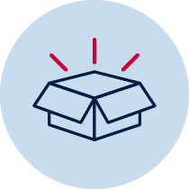 Resources – lead pencil, colour pencils, ruler
Read
Weathering and erosion are processes of the rock cycle. The rock is worn away over time by rain, ocean waves, snow, ice and human activity like walking, driving and construction. The pictures below show examples of weathering and erosion. For each picture, identify whether erosion has been caused by rain, ocean waves, snow, ice and human activity like walking, driving or construction. Write your answers in the space below each picture.
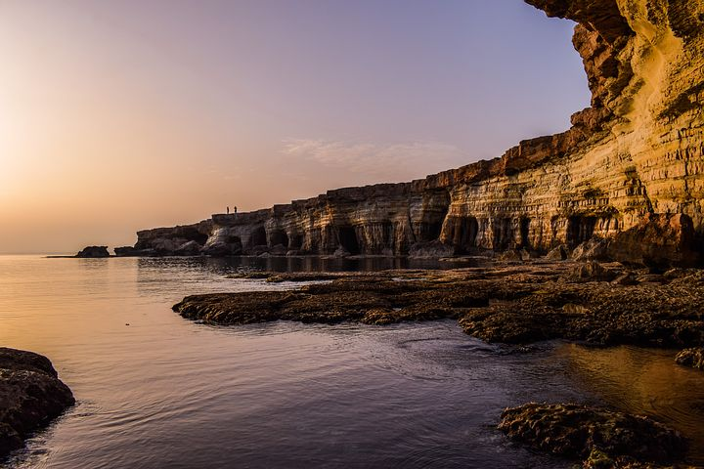 | 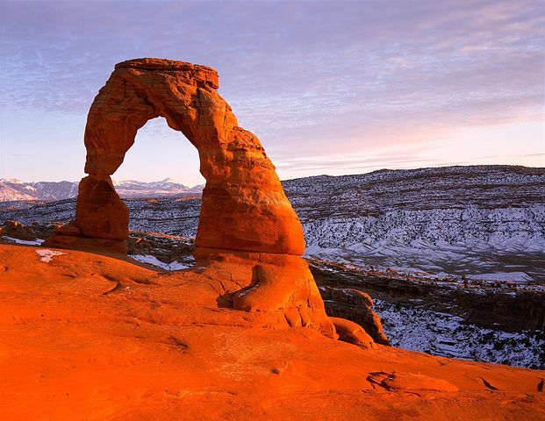
1. | 2.
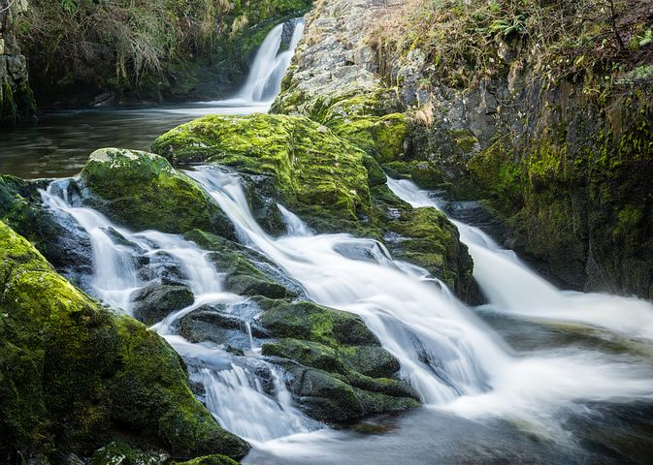 | 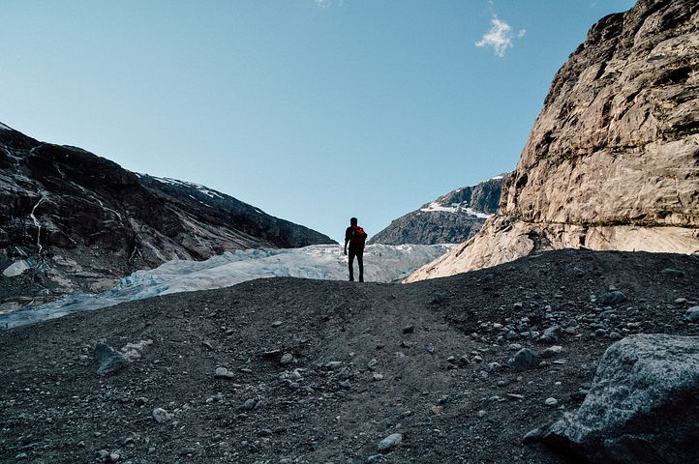
3. | 4.
Write
Think about where you have seen or heard of erosion happening. This could have been while you were on holidays somewhere. Write a list of these places or events.
Read
Scientists conduct field studies and surveys to collect information and data from selected places. Field studies tell scientists what happens in real places. Scientists often record their observations through scientific diagrams.
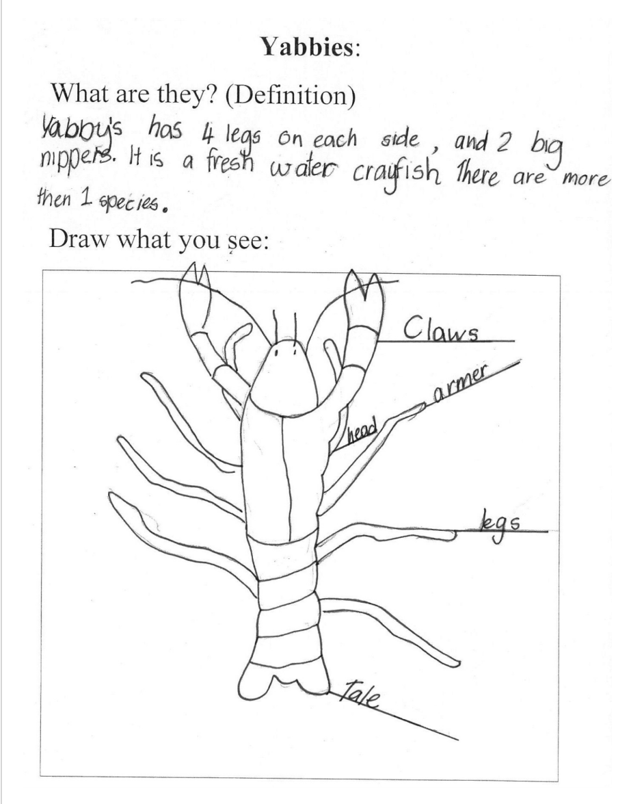
A scientific diagram is a simple line drawing with labels pointing to the corresponding part on the drawing. Look at the example of a scientific diagram of a Yabbie by a year 4 student.
Image credit: Australian Curriculum, Assessment and Reporting Authority

Observe/find
Go on a field study! Take a walk around your home or local neighbourhood (make sure you go with a parent or caregiver). Observe where erosion has occurred. Choose one place where erosion has occurred and draw a scientific diagram to record your observation.
Draw
Draw a scientific diagram in the space below.
Hands on
Waves can erode the sand on a beach and people can erode the sand dunes at a beach by walking carelessly over them. Conduct an investigation to demonstrate beach erosion.
Before you carry out your investigation, you need to write down a prediction about what you think will happen to the sand and pebbles on the beach. Will they be eroded? How much?
Prediction: I think that...

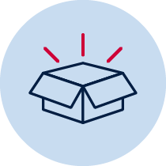 Collect resources
Next you will need to collect the following materials:
- water tray
- sand
- pebbles
- blue food colour (optional)
- empty plastic bottle or a cup.
Step 1. Add some sand to cover half of the bottom of the container – this will be your beach. Leave half of the bottom of the container uncovered – this will be where the ocean goes.
Step 2. Add a few pebbles to the beach.
Step 3. Add 3 drops of blue food colour to the empty plastic bottle.
Step 4. Carefully fill the plastic bottle with water and shake gently to mix in the colour.
Step 5. Carefully pour the water from the bottle into the container with the sand and pebbles. Make sure that you don’t disturb the sand.
Step 6. Add 4 or 5 more cups of water to the container to create your ocean.
Step 7. Use the empty plastic bottle to make waves and observe that happens to the sand and pebbles.
Observe/find
Think about what happened in your investigation and write down an observation.
Think
Thinking about your prediction and what you observed in your investigation, write down one sentence to say if your prediction was right and why you think your prediction was right. If something unexpected happened in your investigation, write down one sentence to say why you think this happened.

Activity 2
During this activity you will identify a place at home where erosion has happened. You will design and produce a solution that reduces or prevents the erosion from happening.
Resources – help from an adult
Think Create/make
Thinking about the observations and findings from your field study, follow a design process below to find a possible solution to help reduce or prevent the erosion from happening.
Identify the problem by describing the erosion issue happening at home.
Think
Think and discuss with an adult about how the images below show erosion prevention.
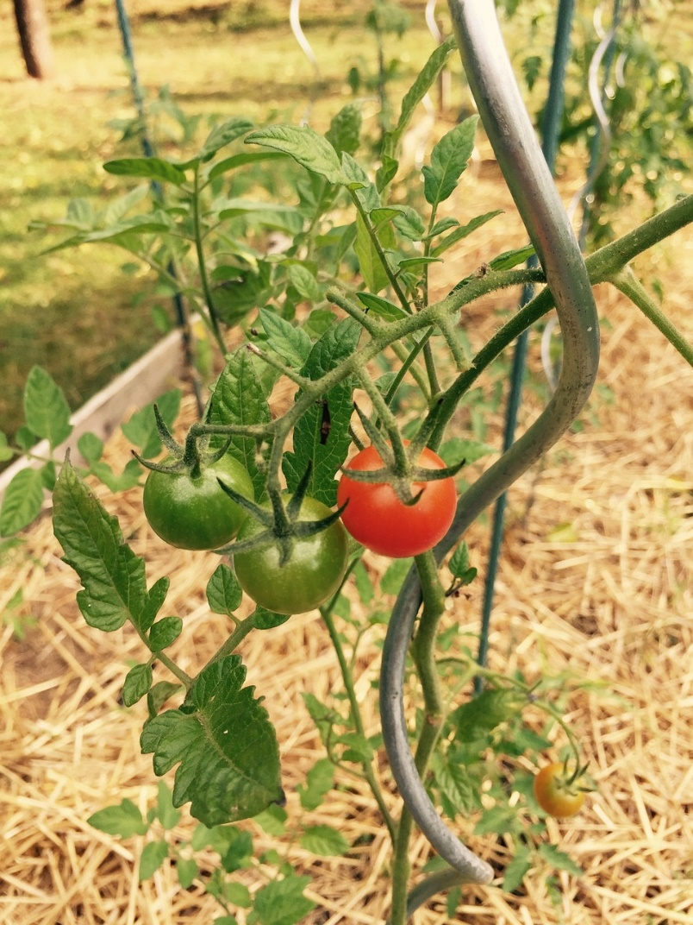 | 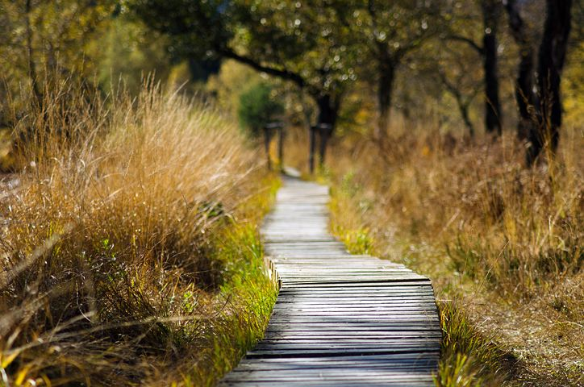
Straw mulch on vegetable garden | Boardwalk at beach

Brainstorm/think
Brainstorm ideas for how you could reduce of prevent erosion happening at home.
Draw
Draw a scientific diagram to show how your idea could work.
Write
Make a list of the materials that you will need to construct a prototype of your design solutions.
Create/make
Construct a prototype or model of your design solution then test it.
Observe/find
Write down some observations about how well your design solution works.
Reflection
Can you think of any improvements that might make your design solution work better? Write them down.

