Design and production investigation – Solar oven
Science and technology Stage 2 – Physical world

Focus question
How can we use forces and energy in a product or system?

Task
Students will complete a design and production investigative task to implement the skills and knowledge associated with understanding how the effects of light and heat energy can be used in a product to perform a function.
Students work in pairs to explore how light energy from the sun is converted to heat energy to cook food using a solar oven. They will investigate types of solar oven designs while exploring materials that are the most efficient in achieving heat absorption and insulation. Students will collect, analyse and evaluate data on the melting effects of this heat energy on a cheese pizza.
Task duration – estimated to be 4-5 hours, which can be delivered over a sequence of lessons.

Assessment
Formative assessment opportunities, where teachers gather evidence about the impact of their teaching to move students forward with their learning, are referenced throughout the learning experiences. These opportunities are elaborated upon in the Formative assessment section at the end of this document, where they are also connected to the Quality Teaching and Learning Framework elements.

Resources
Light concentration resources:
- aluminium foil
- car reflective shade
Light absorption resources:
- black, white, yellow, red and blue paper
- 6 clear glasses
- black cardboard
- black metal cake/loaf tin (1 per student from home)
Heat retention resources:
- plastic kitchen wrap
- newspaper
- selection of cardboard boxes- pizza, shoe, packing
- clear tape
- black duct tape
- bubble wrap
- oven roast bags
Cooking resources:
- thermometers (infrared, food and digital)
- digital timers
- tongs
- oven mitts
- English muffins (approx. 2 packs)
- pizza base tomato paste
- mixed shredded pizza cheese
Miscellaneous:
- scissors
- ruler
- pencils/pens
- glue
- hot glue gun
- clips
- spoons

Student safety – if a box cutting tool is necessary for the cardboard boxes, the teacher must do this for the students.
Student safety – if a hot glue gun is necessary, instruct students on its safe use and only with adult supervision.
Student safety – check all food allergies before making and cooking the pizza. Be mindful of cross contamination if tongs are being shared and how food thermometers are used. Students to make and touch only their pizza half in a hygienic manner i.e. washed hands, clean cooking surfaces.
Student safety – make sure students do not touch the solar oven while the food is cooking as it will be very hot. Teachers to open lids and oven bags using mitts and tongs while being mindful of the trapped heat.
Online support resources:
- School-gen How to make a solar oven (using a pizza box (2:57 minutes)
- Here comes the sun: Crash Course Kids #5.1 (3:03mins)
- Kazoo How-To: DIY Solar Oven (2:40mins)
- Stop Heat from Escaping: Testing Insulation Materials (1:57mins)
- What Material Conducts Heat Best Science Experiment (3:15mins)
- Home-made solar oven projects website

Syllabus outcomes and content
ST2-8PW-ST describes the characteristics and effects of common forms of energy, such as light and heat
- investigates the behaviour of light
- describes the effects of heat energy
- explores ways heat can be transferred due to conduction
- investigates how we use energy and forces in a solar oven to perform a function.
ST2-2DP-T uses materials, tools and equipment to develop solutions for a need or opportunity
- critique needs or opportunities for designing solutions through evaluating products and processes
- define a need or opportunity according to functional and aesthetic criteria
- consider potential resources in defining design needs and opportunities
- investigate and research materials, components, tools and techniques to produce design solutions
- define simple problems by determining and defining a process
- develop a sequence of steps and decisions (algorithms) to solve a problem
- develop a set of criteria for success with guidance, based on defined needs and opportunities
- develop criteria to evaluate the environmental impact of a design with guidance
- devise a fair process to test a designed solution with guidance
- evaluate design ideas, processes and solutions, based on criteria for success.
ST2-3DP-T describes follows and represents algorithms to solve problems
- follow and represent sequences of steps and decisions (algorithms) to solve problems
- test and evaluate the effectiveness of steps and decisions (algorithms) in solving a problem.
Science and Technology K-6 © 2017 NSW Education Standards Authority (NESA) for and on behalf of the Crown in right of the State of New South Wales.

Prior content knowledge and skills
Students understand:
- energy can exist in different forms such as sound, light, heat and movement (Stage 1 outcome)
- the Sun is a natural source of light energy
- different types of every day thermal conduction. For example:
  - the hood on a car will become warm as heat is conducted from the engine to the hood
  - anything placed on the heater, like an article of clothing, will become warm
  - you can warm your back muscles with a heating pad
  - trying to cross the street barefoot in the summer may result in heat being conducted from the asphalt to your feet
  - the heat from a hot liquid makes the cup itself hot
  - an ice cube will soon melt if you hold it in your hand. The heat is being conducted from your hand into the ice cube.

Addressing student misconceptions
For greater student success and engagement, it may be helpful to clarify understanding of the following concepts before engaging in planned activities.
- Conduction is the transfer of heat between solid matters through direct touch, such as a metal spoon in a cup of hot tea.
- Convection is the transfer of heat between moving liquid or gas particles as they expand, become lighter and rise, such as hot air rising inside a hot air balloon.
- Radiation is the transfer of heat felt directly from a source, such as a fire.
- Heat is a type of energy and temperature is a measurement of that energy.
- Heat energy is often referred to as thermal energy.
- An algorithm is a sequential series of steps.

Investigation – solar oven
Students are learning to:
- recognise that the Sun is a source of light energy that can be converted to heat
- identify surfaces that will absorb or reflect light
- compare heat absorption and heat retention properties of a range of materials
- investigate how conduction transfers heat between solid objects
- simulate tests to apply the results to realistic, problem-based scenarios
- design and make a solar oven based on their investigations and test the melting point of cheese pizzas
- gather, analyse and evaluate the data generated from the investigations.

Design and production learning experiences

Identifying and defining
- The teacher introduces the investigation by telling a narrative about a class of Stage 2 students on a whale watching excursion who find themselves shipwrecked on a deserted island. All that has been washed up with them is a crate that was being delivered to a local office supply store by the shipping company. A rescue ship is on its way but will not be able get to the island for another 3 days. The Stage 2 students and their teacher have caught fish while they are waiting to be rescued but are a bit tired of raw seafood for breakfast. They have no matches or a lighter but think they might be able to use the sun to cook their fish using the office materials that have been washed up on the island. They do not have enough data signal on a phone but can listen to instructions on a call. Can you help them?
- Explain to students that they will be designing, making and testing a solar oven in pairs. Firstly, they need to understand how energy from sunlight can make food cook at high temperatures, as well as the materials and design that would work successfully to engineer and construct a solar oven.
- Define that a solar oven is a box that traps some of the Sun’s energy to make the air inside the box hotter than the air outside the box. Consolidate students’ understanding that conduction is when heat moves from one hotter object to another cooler object through direct touch.
- Introduce the topic of light energy from the sun and ask students to contribute to a KWLH chart about what they already know about the sun, light, heat and solar energy and what they want to find out.
Formative assessment opportunity 1 – teacher observes student background knowledge and understanding of the Sun’s energy through student contributions to the KWLH chart. Teachers are looking for students connecting everyday life experiences to the conceptual topic of light and heat energy as well as demonstrate curiosity to define and set learning goals. Teachers are also using this opportunity to inform the direction of their teaching. Learning should be started without re-teaching consolidated knowledge.

- Students view this Here comes the sun: Crash Course Kids #5.1 (3:03mins) video about the Sun’s heat and light energies on Earth. Discuss how light energy travels through space and the importance of the Sun’s energy to life on Earth. Students write down 3 facts about the Sun’s light and heat energy in an exit ticket.
- As a class examine the word ‘sol’ from the video, meaning sun in Latin. Relate this word to the definition of ‘Solar System’ and briefly discuss. Challenge students to find more words that begin with ‘sol’, which relate to the sun, in a ‘Think, Pair, Share’ and analyse the words they have found as a class. Add these words to student weekly spelling lists.
Formative assessment opportunity 2 – teachers use the exit tickets to establish their understanding of their students’ early conceptual knowledge about light and heat energy from the Sun. This understanding will inform teachers which students might need further consolidation on this concept.

Research and planning

Concept 1: Light absorption
- Hypothesise with students what colour they think would absorb the Sun’s energy the best, based on their experiences, such as the clothes/hats they wear, the colour cars their parents drive or the coloured playground equipment they have used.
  - Each student writes down one colour anonymously on a piece of paper, from a choice of red, black, yellow, white or blue, which they think will absorb the most heat from the sun’s light energy.
  - Tally and represent the class data.
  - Analyse and discuss the results.
- Conduct a teacher led investigation into colours, and their light absorption capabilities, to discover which colours convert light to heat energy most effectively.
  - Wrap black, red, yellow, blue and white colour paper around 5 clear glasses. Add another clear glass with no paper for the control.
  - Fill each glass with the same amount of room temperature water and record the base line temperature with a thermometer for each glass.
  - Place the glasses in full sun for 2 hours.
  - Retest the temperatures and discuss the results by numbering the colours hottest (1) to coolest (6).
  - Discuss the colours which have best reflected the sunlight and remained cooler compared to the colours that have absorbed the sunlight and become hotter.
  - Discuss which of these colours would be best used inside a solar oven to absorb the light energy of the sun to then convert it to heat energy.
Recommended colour for heat absorption: black

Concept 2: Heat conduction
- Ask students how they could make their solar oven more effective through heat conduction. Watch What Material Conducts Heat Best Science Experiment (3:15mins) video about heat transfer that uses a variety of different materials which conduct heat. What material would be best used inside their solar oven to conduct higher temperatures? Discuss.
Recommended material for heat conduction: metal cake/loaf tin

Concept 3: Heat retention
- After the light energy has been converted to heat energy, what materials do students think will keep this heat trapped inside a solar oven, so the temperature stays hot enough to cook food? The heat will escape into the cooler air outside the solar oven if it is not blocked. Watch Stop Heat from Escaping: Testing Insulation Materials (1:57mins) video about heat insulation and discuss with students how these ideas could be used in their solar oven.
- As a class, students brainstorm a list of materials they, or their adult carers, have used in their kitchen that would trap (retain) heat in their food after cooking and explain why. Responses could include alfoil, plastic wrap, oven roast bags, glass lids and metal baking dishes.
  - Cross out the resources that are not transparent as the Sun’s light needs to enter through the top of the oven without being blocked.
Recommended materials for heat retention: plastic kitchen wrap, oven bag

Concept 4: Concentration of light
- Ask students how their solar oven could attract more sunlight to make the temperature in their oven hotter.
  - Discuss what materials reflect light the most so the Sun’s light energy can be directed towards the black materials in the centre of the solar oven, where they will be trapped as heat by the insulation. Responses could include alfoil, mirrors, sheets of metal, car reflector shades, cooler bag material, reflective paint and reflective tape.
  - Explain that some types of solar power farms use mirrors (or heliostats) to reflect the light towards towers that process that light energy into stored energy for electricity. Examine some pictures from a search website - solar farms that use mirrors and discuss how the design of the solar farm encircles the tower and concentrates the light into the centre.
  - Examine the word ‘heliostats’ (helio = sun in Greek) and compare the meaning and etymology to the word ‘sol’.
  - Students choose which reflective resources would work best in their solar oven and explain why.
Recommended materials for light concentration: alfoil, car reflector shade.
- Remind students that they identified metal to be a good conductor of heat that could be used in their solar oven. However, this shiny surface would be reflecting light back out, and away from, the centre of the solar oven. Ask students to think of a way metal could still be used inside their solar oven to conduct the heat, but not reflect the light back out of the oven.
Recommended material for conduction without light reflection: black metal cake/loaf tins.

Solar oven quality criteria
To be successful as a system, solar ovens need to demonstrate these 4 criteria elements:
- The concentration of sunlight – a reflective surface that directs sunlight into the centre of the solar oven
- The absorption of sunlight – a dark colour material in the centre of the solar oven to absorb light to make heat
- The conduction of heat – a material that can transfer heat to the food
- The retention of heat – a way to trap the heat energy inside the solar oven.
Students complete a concept map, either digitally using a website like Popplet or on paper, to demonstrate their understanding of the relationships between the elements of light concentration, light absorption, heat conduction and heat retention.
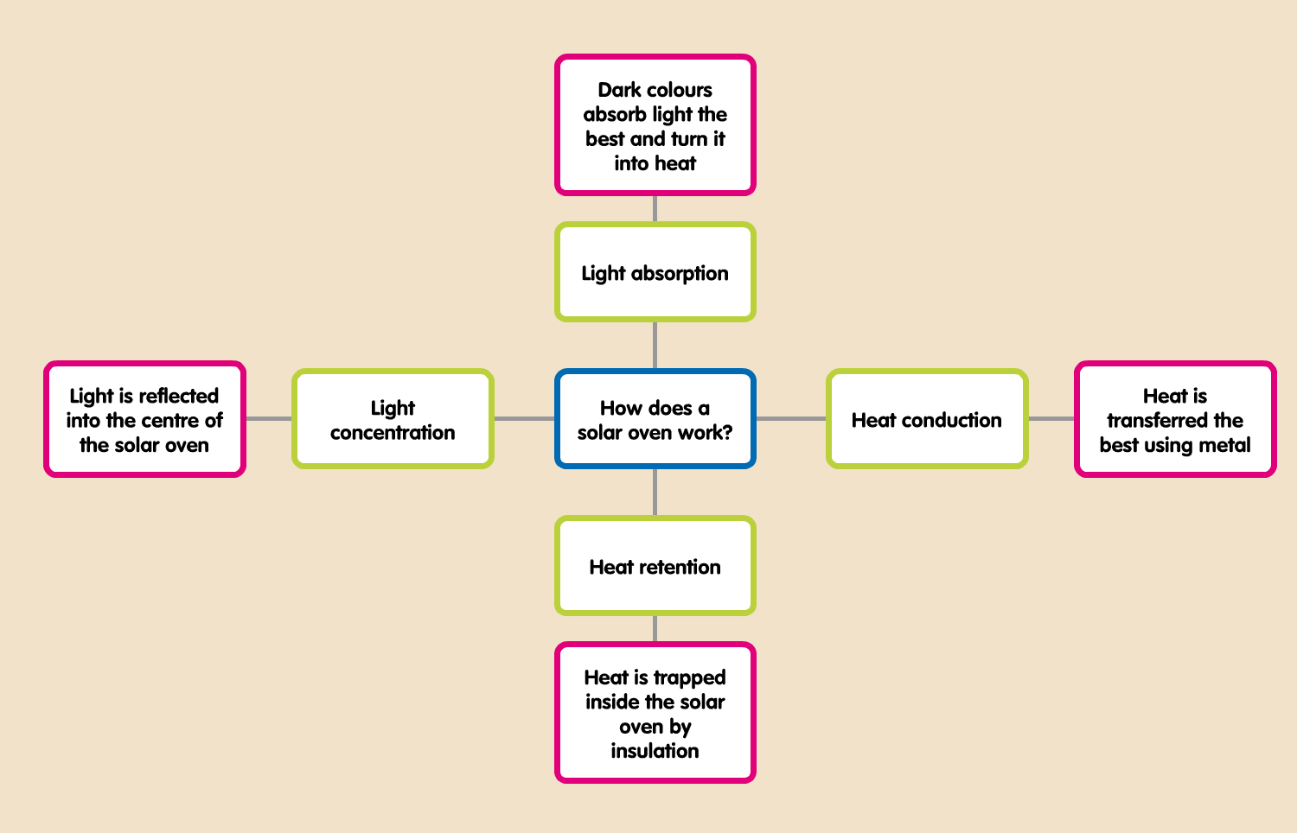
Formative assessment opportunity 3 –Teachers examine students’ concept maps looking for clear definitions and examples/elaborations of each criteria concept that demonstrate student understanding of light and heat energy.

Solar oven planning
- As a class, begin to brainstorm a list of resources students believe they might need to complete a solar oven based on their knowledge to date.
- Students research ideas for their own solar oven in pairs. Using the home-made solar oven projects website, and other online resources (see online support resources), students investigate different ways solar ovens can be designed and made to meet the 4 criteria elements needed for their solar oven.
- Give students time to review the videos from the links and to draw a labelled diagram of their solar oven design.
- Students add a comprehensive list of resources that would be available at an office supply store.
- Students design an algorithm (a chronological series of steps) to complete the solar oven, which reflects their labelled drawing and resource list.
- Student groups meet with their teacher to conference about their solar oven diagram, resource list and algorithm.
Formative assessment opportunity 4 – teachers use the algorithm as a conferencing reference to discuss the solar oven with students to help define their planning. The algorithm needs to be clear, detailed and sequential and describe the use of all resources with clarity while reflecting the labelled diagram.

Producing and implementing
- Teacher reviews safety considerations with students before solar oven production begins (see Student safety above)
- Students collect their resources and begin constructing their solar oven working in pairs.
Formative assessment 5 – teachers observe students constructing their solar ovens while they use the process of trial and error to engineer their resources to achieve the 4 functional criteria elements.
- Students need to document any changes to their design on their plan and algorithm while they are in production.
- Students implement a simulated trial test of their solar ovens in full sunlight (between the hours of 10am and 2pm) by leaving a thermometer inside the oven for 2 hours. Students record the temperature after 2 hours and analyse if the oven has generated enough heat to hypothetically cook seafood, between 70-80 degrees Celsius, to help the Stage 2 shipwrecked class from the narrative.
- As a class, analyse if the temperature results from each solar oven design have met the temperature criteria of the simulated seafood test. Students recommend which design would be best shared over the phone as an algorithm with the shipwrecked students, and their teacher, to help them.

Testing and evaluating
- Teacher introduces the final investigation where students will test their solar ovens to cook a pizza. Students will now discover how quickly the solar ovens can reach temperatures that will achieve the melting point of cheese, by timing how long it takes to effect this change through solar heat energy. The cheese will need to be confirmed to have reached at least 65 degrees Celsius to stop the timer.
- Students make their pizza following the student safety considerations. They take the solar oven outside into full sun and place their first pizza in the cold solar oven.
- Students start their timer as soon as they open their solar ovens.
- Students observe their pizza through the clear cover and call their teacher over to test their pizza with a food thermometer when they think the cheese has reached its melting point. The timer is then either stopped if the cheese has reached 65 degrees Celsius or continues if it is less than this temperature.
- Back in the classroom, after the pizzas have been cooked and eaten, represent the time data from the investigation in a table to show how fast the solar ovens affected the melting point of the cheese at 65 degrees Celsius. Compare this data with the previous simulated test data. Do some solar ovens reach higher temperatures than others? Do some solar ovens get hotter more quickly than others? What could it be about their designs that affects the speed and temperature differences?
- Invite students to present their solar ovens to the class and explain their design ideas in terms of concentration, absorption, conduction and retention. The audience, and teacher, write down two stars and a wish (2 positive feedback points and 1 helpful suggestion or alternative solution) which are collected by the teacher and given to each presenting group for their feedback.
Formative assessment 6 – teacher analyses the student feedback responses from the presentations. Consistently analytical, detailed and criteria focused feedback and suggestions given in response to presentations would indicate students who have a strong understanding of light to heat concepts. Feedback that is shallow or confusing could indicate students who require some extra support to consolidate concepts.

- Students use this information to reflect on their solar oven plan, labelled diagram and algorithm. Students can make a list of changes and improvements before their teacher conference.
- Teacher and students engage in a conference to discuss their original plan, demonstrate their solar oven features and explain why they were selected for each of the 4 criteria areas of absorption, conduction, retention and concentration. Discussion about their reflections from the peer feedback is also an important point of discussion.
- Students complete the KWLH chart from the start of the investigation. Add what they have ‘Learnt’ and ‘How’ more learning can occur on this topic.

Formative assessment opportunities with Quality Teaching Framework elements
Formative assessment opportunity | Purpose | Quality Teaching Framework assessment element | Digital Learning Selector
1 – identifying and defining | Teachers are looking for students connecting everyday life experiences to the conceptual knowledge of light and heat energy. Teachers use this information to direct their teaching to where learning should start without re-visiting learnt information. | Background knowledge | KWLH  Learning intentions
2 – identifying and defining | Exit tickets inform teachers which students might need further consolidation on the concept of light and heat energy. | Substantive communication  Metalanguage | Exit ticket
3 – research and planning | Teachers examine students’ concept maps looking for clear definitions and examples of each concept that demonstrate student understanding of transferring light to heat energy. | Deep knowledge  Substantive communication | Concept map
4 – research and planning | The algorithm demonstrates if a student’s thinking is clear, detailed and sequential that reflects their deep understanding of how their solar oven functions. | Higher order thinking  Deep understanding
5 – producing and implementing | Teachers observe students constructing their solar ovens while they use the process of trial and error to engineer their resources to achieve the 4 functional criteria elements. | Explicit quality criteria
6 – testing and evaluating | Students who can consistently analyse and suggest alternate solutions in response to their peers’ presentations, while using the quality criteria, would indicate they have a strong understanding of light to heat concepts. Surface level feedback could indicate students who require extra support to consolidate concepts. | Explicit quality criteria  Problematic knowledge | Peer feedback

