Student workbook – Material world
Name:
Class:

Overview
You will learn about how materials are described by their properties while investigating the natural materials used by Aboriginal and Torres Strait Islander Peoples. You will design and plan a shelter for your favourite toy and make it from natural materials with help of an adult.

Resources

Activity 1
- Lead pencil
- Glue
- Scissors

Activity 2
- Lead pencil
- Coloured pencils and markers
- Natural materials

Activity 3
- Lead pencil
- Coloured pencils and markers
- Natural materials
Optional: printer, digital camera

Activity 1.1
During this activity you will explore the differences between man-made and natural materials.

Man-made or natural?
Man-made materials are formed by human technology, tools and resources. Natural materials are formed by nature and have not been changed in anyway.
Cut out the man-made and natural materials on the next page. Sort and paste them into the T-chart under the correct heading.
Natural materials | Man-made materials

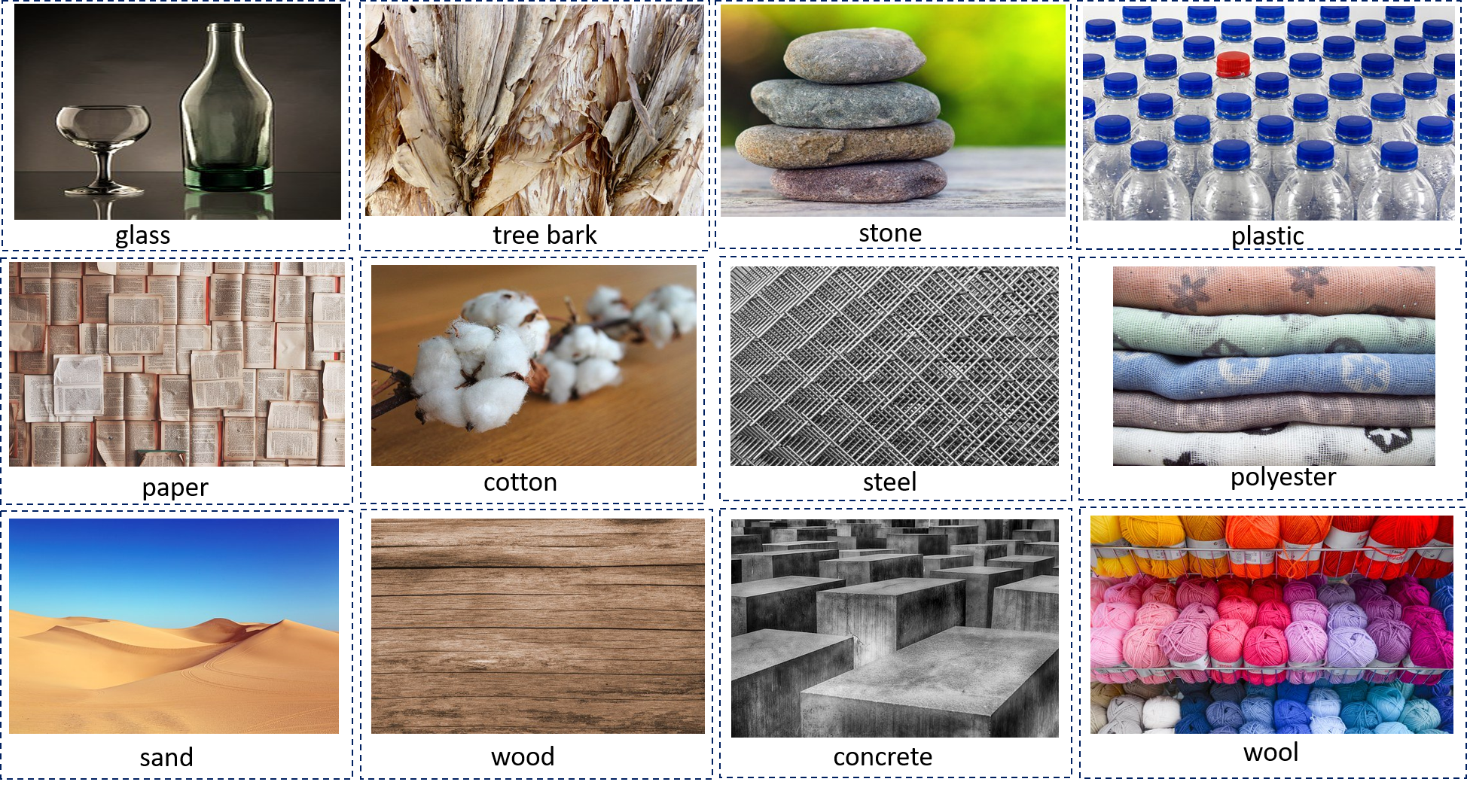
Natural and man-made materials. Cut, sort and paste them into the table above.

Activity 1.2
During this activity you will use properties to describe a natural material’s characteristics.

Natural material properties
Properties of materials can describe how that material looks and feels.
For example, the properties of natural chalk could be white, dry, crumbly and light. We use the senses of touch and sight to describe the material.
Choose 4 natural materials from activity 1.1 and add them to the headings below. Find and write 4 properties that describe each material.
Properties of natural materials
Material 1: | Material 2:
Material 3: | Material 4:

Activity 1.3
During this activity you will use Venn diagrams to compare the properties of natural materials.

Compare the properties
Properties of materials can be both similar and different to each other. We can use Venn diagrams to compare what material properties are the same as each other and which ones are different.
For example, the Venn diagram below is comparing the materials of wool and cotton. The circles show the differences while the space in the centre shows the similarities.
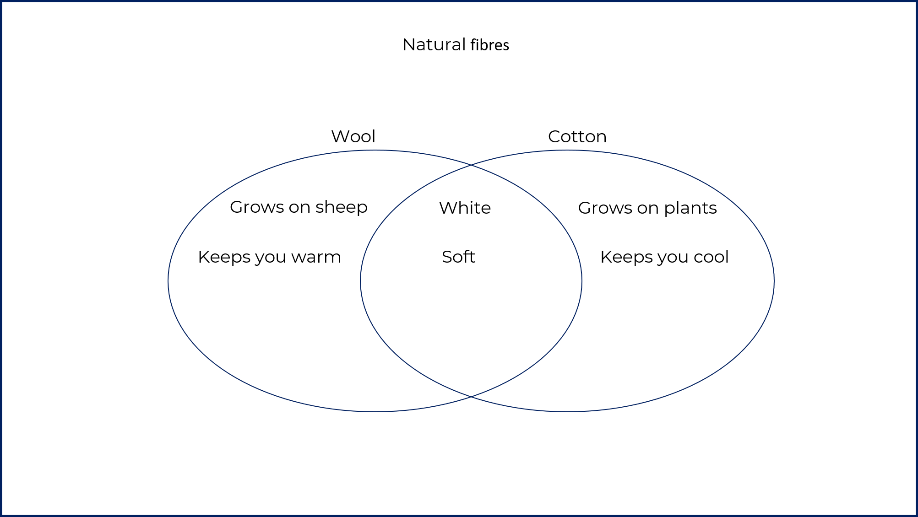
It’s your turn now to compare the properties of rock and wood. Put the properties that are the same as each other in the centre space. Put the properties that are unique into each side as appropriate.

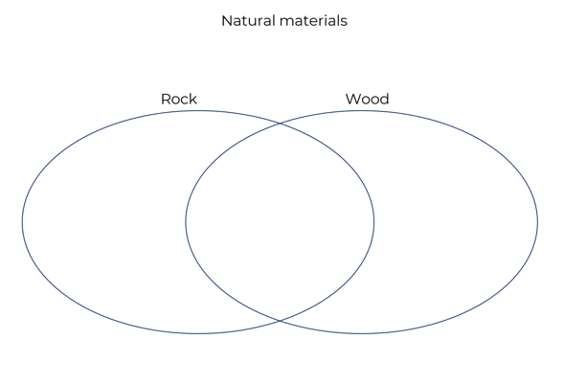

Activity 1.4
During this activity you will explore why Aboriginal and Torres Strait Islander Peoples chose certain natural materials to help solve a problem.

What’s the reason why?
Aboriginal and Torres Strait Islander Peoples used a range of natural materials to make objects that had a purpose. There were reasons why some materials were chosen instead of others to do a certain job. For example, Aboriginal People used emu oil to make grass fibres softer and easier to twist to make something from them.
Object | Material | Why? Cut and paste the correct reason
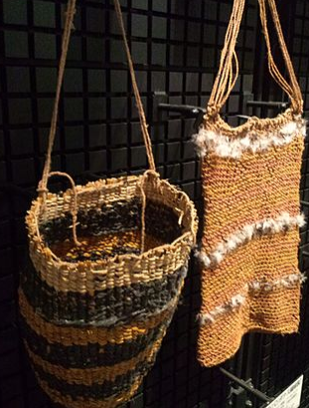  Yanajin33 / CC BY-SA (https://creativecommons.org/licenses/by-sa/3.0) | grass fibre  bag
Port Jackson Painter, fl. 1788-1792.Previously attributed to John Hunter; see discussion p.208-210 of: The art of the First Fleet / ed. by Bernard Smith and Alwyne Wheeler. [NLA notes] / Public domain | bamboo wood  spear
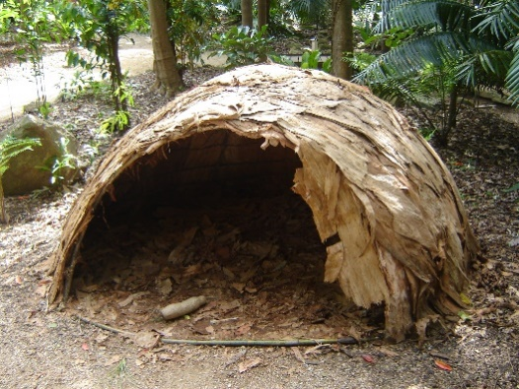  Creative Commons Attribution-ShareAlike 3.0 licence | paper bark hut
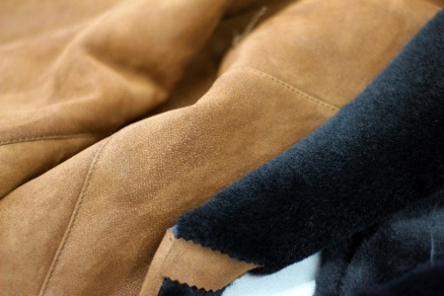  Creative Commons CC0 licence | animal hide clothing
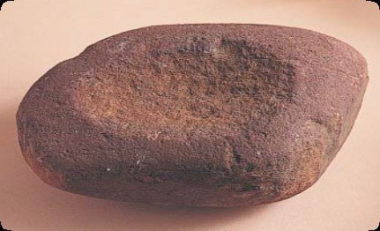  State government of Victoria use under Creative Commons Attribution 4.0 International licence | quartzite  grinding stone
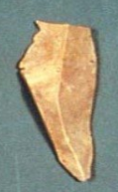  State government of Victoria use under Creative Commons Attribution 4.0 International licence | flint  cutting tool
Reason why? Cut and paste
It can crack to make a sharp edge
It keeps us warm and is soft
Strong and used for food preparation
It is light, strong and floats
It can bend and be woven
It can be heated and shaped into many objects

Activity 1.5
During this activity you will investigate and research some different shelters traditionally made by Aboriginal Peoples. Using Google images for Aboriginal shelters would be a great place to start.

Materials for shelter
Aboriginal people used different types of shelter depending on the season, weather and what natural materials were around them in the environment. Research 4 different types of shelter that Aboriginal Peoples made with the natural materials from the land around them. Draw a sketch of what each shelter looks like, describe how it looks and the natural materials used.

Types of natural shelter
Sketch of shelter 1 | What does it look like and the materials used?
Sketch of shelter 2 | What does it look like and the materials used?
Sketch of shelter 3 | What does it look like and the materials used?
Sketch of shelter 4 | What does it look like and the materials used?

Activity 2.1
You are going to design a shelter made from natural materials for your favourite teddy bear
Make sure:
1. The shelter is big enough to fit your chosen teddy or doll.
2. The shelter must be made only from natural materials.
3. The shelter must be free standing (without leaning on something else).
4. The shelter must keep its shape.

Materials for my toy’s shelter
Before you make this shelter, you need to investigate what natural materials you can use. Ask for an adult’s permission first and ask them to help you find as many materials as possible from the list below. Make sure you wear gloves in gardens and try to use materials that have fallen from trees already.
Tick off the materials when you and your adult helper find them. Don’t worry if you can’t find all of them. You can also add materials that aren’t on the list.

Natural materials | Do I have it?
sticks or small twigs
different types of leaves
long grasses
bark from trees
stones
clay
dirt and mud

Activity 2.2
Now you have found all the materials you think you might use, it's time to plan your shelter. Make sure you have your favourite teddy or doll next to you so you can imagine them sitting under the shelter you are designing.

Time to plan
In the centre box, draw your shelter with your toy sitting under it. Use the space around it to label your drawing with the materials you will be using.

My shelter plan
Use labels, arrows and words to show the natural materials and parts of the shelter in the drawing. Also label how the parts of the shelter will hold together.

The shelter with my teddy or doll sitting under it

Activity 2.3
Do you think your shelter will work?

Questioning and predicting
Before you start building your toy’s shelter, think about the natural materials you have chosen and your plan. Talk about it with an adult.
Ask yourself and answer these yes/no questions:

Question? | Yes or no
Will the shelter be big enough for my toy to sit under?
Are the materials strong enough for my shelter to keep its shape and from falling down?
Do I know how all the materials of the shelter will hold together?
Can my shelter stand by itself without leaning on something else?
Do I have an adult to help me make the shelter?

If you answered NO to any of those questions, you might like to use some more planning time before you start making your toy’s shelter.

Activity 3.1 – optional
Time to start making your toy’s natural shelter.

Maker hour
You have an hour to make your shelter for your teddy bear or doll. Using the natural materials you have found, as well as your shelter plan, begin to make your toy’s shelter.
Make sure:
1. The shelter is big enough to fit your chosen teddy or doll.
2. The shelter must be made only from natural materials.
3. The shelter must be free standing (without leaning on something else).
4. The shelter must keep its shape.

Activity 3.2 – optional
Test and think about your shelter – did it work?

Testing and evaluating
Answer the following questions.
Question? | Yes or no
Can my favourite toy fit under the shelter?
Is the shelter made only from natural materials?
Is the shelter staying together in the right shape?
Can my shelter stand up by itself?

Did you answer NO to any of the questions?
In the box below write a few sentences about what needs to be fixed or changed to help your shelter do its job better. What were some problems you had using only natural materials? Did you have to change your plan?

What could I do to make the shelter better?
____________________________________________________________________________ ____________________________________________________________________________________________________________________________________________________________________________________________________________________________________________________________________________________________________________________________________________________________________________________________________________________________________________________________________________________________________________________________________________________

Activity 3.3 – optional
Time to show and tell your teacher and classmates about how you made the shelter for your toy. Share the great things about your shelter as well as the things you think you could fix.

Communicating and sharing
You can share what you have made with your teacher and classmates. You might like to have a chat with just your teacher, perhaps share in a small group of your classmates or present a special news item in front of your class.
After you have spoken with your teacher about your shelter, they will give you some written feedback about your work which they can write in the boxes below.

This was great! | This was interesting | Have you thought about…?

Your teacher will also take a picture of you, with your favourite toy under the shelter you have made. Glue the picture in the box below.

Me, my favourite toy and its new shelter
Image credits. Unless otherwise indicated, all Pixabay images are used under the Creative Commons CC0 licence.

