Student workbook – Living world
Name:
Class:

Overview
You will learn about features of living things and their environment. You will follow and represent sequences of steps and decisions to solve problems. You may like to ask your parent or carer for help with some of the activities.

Resources

All activities
- lead pencil

Activity 2
- coloured pencils

Activity 3
- camera (optional)

Activity 5
- scissors and glue

Activity 7
- coloured pencils
- cardboard, recycled materials, string, sticky tape, glue, material, glitter and paint.
- camera (optional)

Activity 1 – Living and non-living things
During this activity you will explore the differences between living and non-living things.
Living things can grow, move and change.
Find 4 living things around your house, back yard or school. Write the name of each living. and explain why you chose it.
Living thing 1 | Living thing 2 | Living thing 3 | Living thing 4
Non-living things don’t grow, move without help or change unless they are damaged or made that way. Non-living things are often made by people.
Find 4 non-living things around your house, backyard or school. Write the name and explain why you chose them.
Non-living thing 1 | Non-living thing 2 | Non-living thing 3 | Non-living thing 4

Activity 2 – Animal features colour code
During this activity you will explore the features of living things.
Identify all the photos of living things. Colour their boxes using this colour key:
- feathers = green
- fur = red
- fins = blue
- shell = orange
- scales = pink (* not fish)
- skin = purple
Living things? | Living things? | Living things? | Living things?
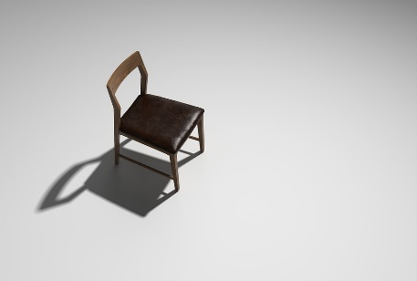 | 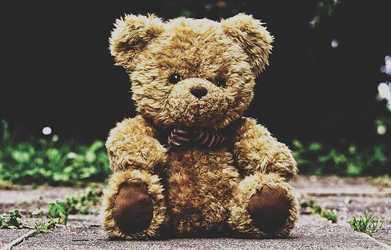 | 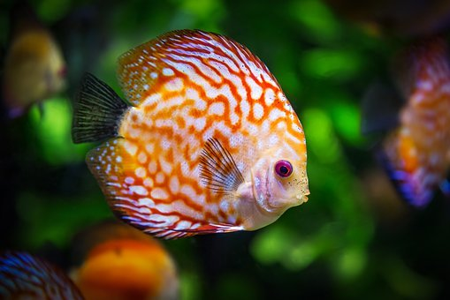 | 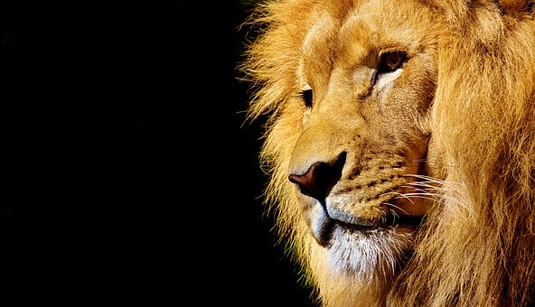
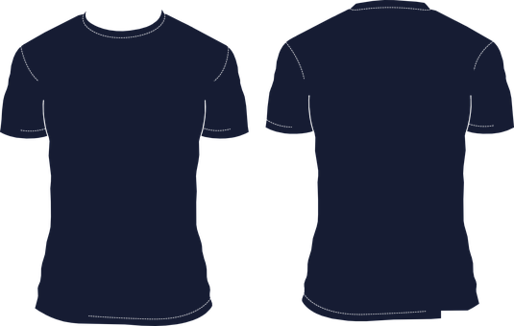 | 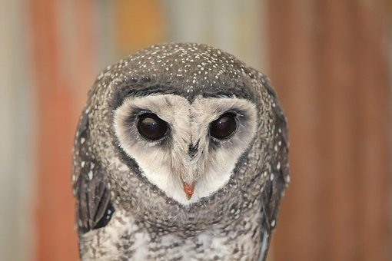 | 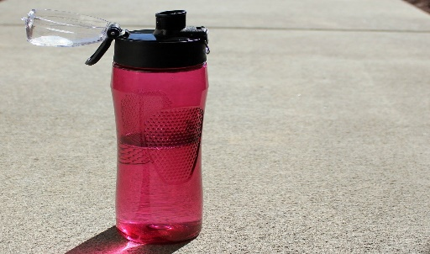 | 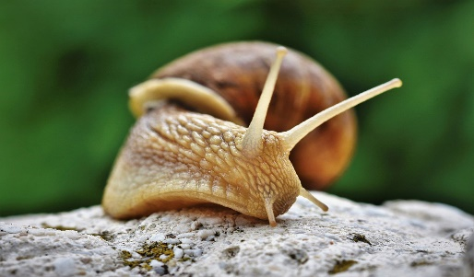
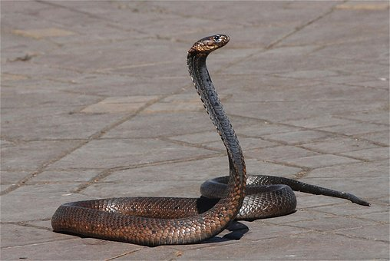 |  | 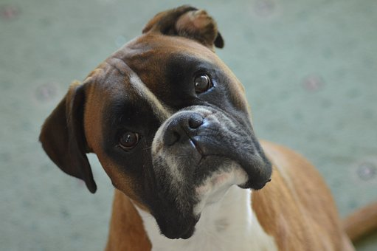 | 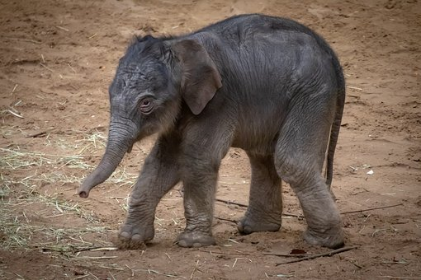
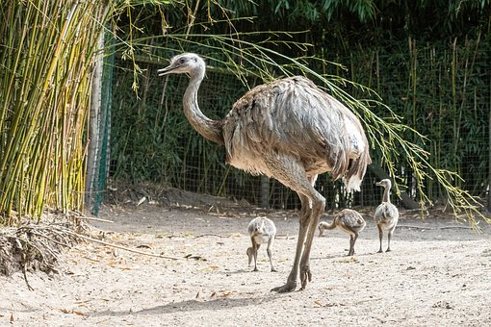 | 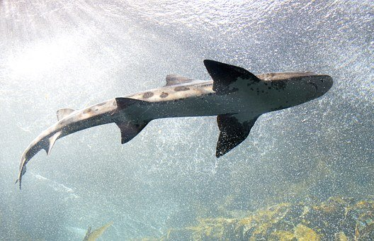 | 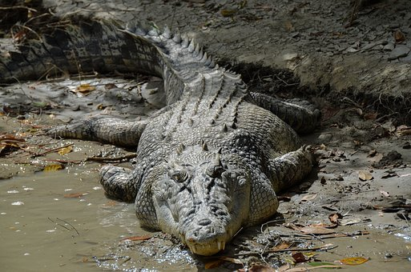 | 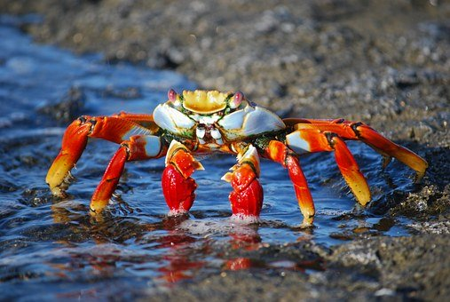
All images from pixabay.com

Activity 3 – Local native plant research
During this activity you will explore native plants in your local area.
Go for a walk with your parent or carer. Find 2 native plants in your area. Draw, or take a photo of the plants and write a brief description. You might find native plants in your garden, your neighbour’s garden or even at the local park.
Native plant 1:_________________________________
Description:_______________________________________________________________________________________________________________________________________________________________________________________________________.

Native plant 2:__________________________________
Description:_______________________________________________________________________________________________________________________________________________________________________________________________________.

Activity 4 – Bush tucker cloze
During this activity you will explore examples of bush tucker.
Complete the cloze passage using the words in the box below.
Bush tucker can be found from ______________ plants in the Australian bush by Aboriginal and Torres Strait Islander people. They have been finding food like this for _________________ of years.
Bush food can include _________________, herbs and vegetables. Some examples of bush tucker include a fruit that is called the Blue ___________________, a herb that is called Bush ______________ and a vegetable called a ‘Youlk’, which tastes a bit like a _________________.
Maybe you could add some bush tucker to your school’s _________________ garden with the help of your ___________________.
Cloze words | Cloze words | Cloze words | Cloze words
Lilly Pilly | vegetable | carrot | Basil
teacher | thousands | native | fruits

Activity 5 – Animal movement sort
During this activity you will explore how different animals move.
Look at the photos. Identify how each animal moves.

How do they move? | How do they move? | How do they move? | How do they move?
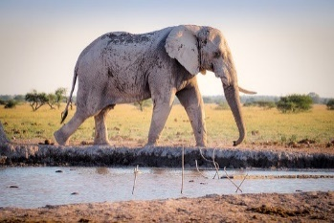 | 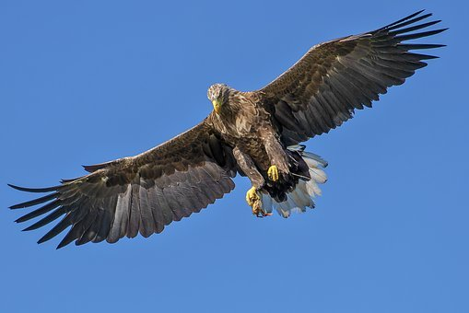 | 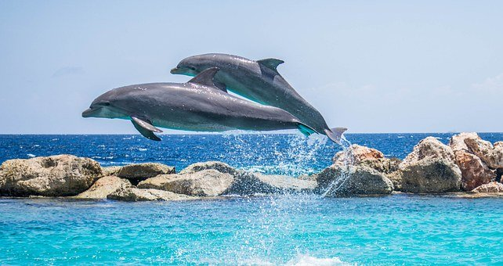 | 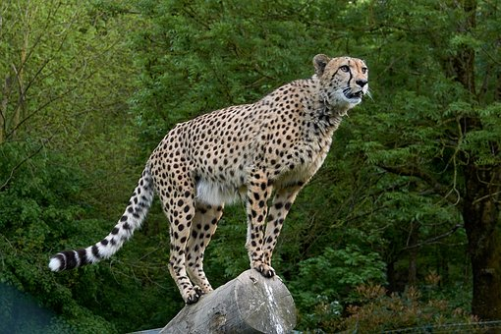
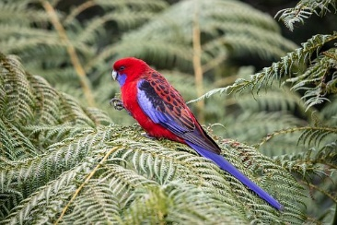 | 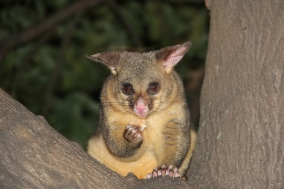 |  | 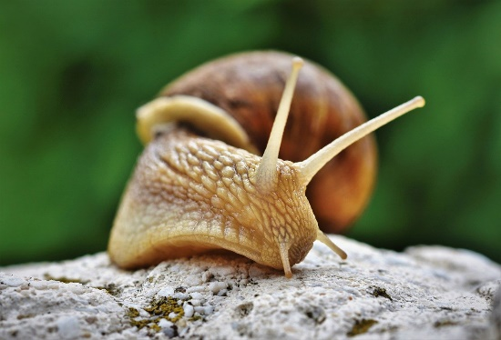
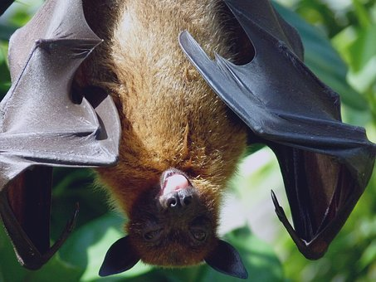 | 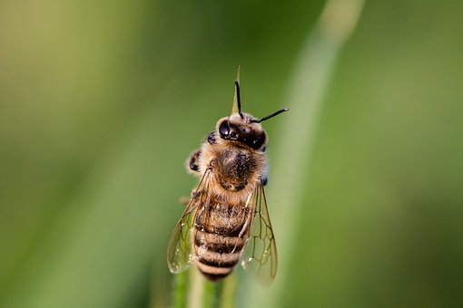 | 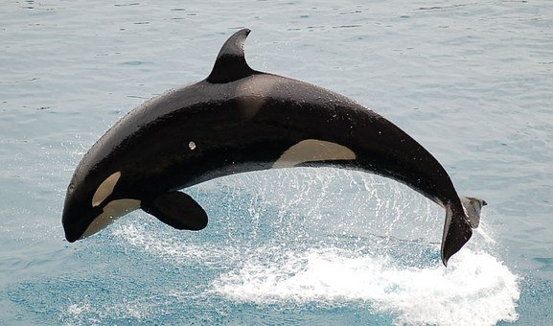 | 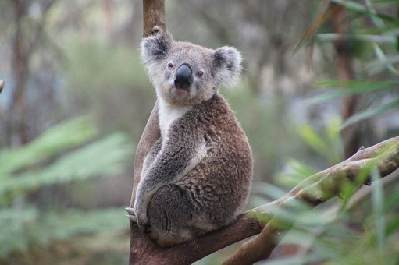

Complete the animal movement sort. Cut and paste the photos into the correct boxes. Write the name of the animal underneath the photo.
How do they move? | How do they move?
Walk | Slither
Swim | Fly

Activity 6 - Imaginary animal fact sheet
During this activity you will design your own imaginary creature.
Create your own imaginary animal by completing the fact sheet below.
Picture
Animal name:
How does it move?
Habitat (where does it live?):
____________________________________________________________________________________________________________________________________________________________

Life span (how long it lives):

What it eats for food:
__________________________________________________________________________________________
Body description:
________________________________________________________________________________________________________________________
It loves when:
____________________________________________________________________________________________________________
It hates when:
______________________________________________________________________________________________________________

Activity 7 - Imaginary animal algorithm
During this activity you will make and evaluate a model of your imaginary creature.
Make a model of your imaginary animal. List the materials you used to make your model. Describe the series of steps in order (algorithm) you used to make your model.
Materials

Description of how I made my animal | Photos or drawings
Step 1.

Step 2.

Step 3.

Step 4.

Step 5

Evaluate your design. Think about how you could have improved your model.
What could I change or add to make my model better?

