Science and technology workbook S1 Earth and space
Name:
Class:

Overview

To investigate how the Sun, Moon and the 4 seasons change the sky and the land.

Resources

Activity 1
- pencil
- coloured pencils and markers
- 1a T-chart worksheet
- 1b sun tracker worksheet (camera is optional)
- 1c moon journal worksheet

Activity 2
- 4 boxes worksheet
- Coloured pencils and markers for colouring

Activity 1a
Write Observe Record
T-chart
Record what objects change and what objects stay the same. Look inside your house as well as go for a walk in your backyard (ask a parent first). Look up, down and side to side.
Objects that CHANGE | Objects that stay the SAME

Highlight or circle the natural objects (the ones that are living or not made by a person).
What makes the natural objects change?
Choose one or more of these words to describe why the natural objects change:
rain, heat, dry, cold, wind, day, night, seasons
Write the words you chose next to the objects you have highlighted or circled as being changing things.

Activity 1b
Observe Record 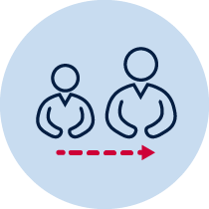 Adult help
Plot the sun’s position across the sky.
Look at the sun’s place in the sky each hour between 9am- 5pm. Make sure you stand in the same spot every time you look. Take a picture each hour or add a new sun to your drawing.
Add something else in your picture frame, such as trees or buildings, to show how the sun’s place in the sky is changing but other objects are not.
Don’t forget to put the time next to each sun you draw or when you take a picture.
Don’t look at the sun directly because it may hurt your eyes.
Complete the activity in the blank space on the next page if you would like to draw the suns. Make it landscape (turn it sideways)
Your picture may look a bit like this.
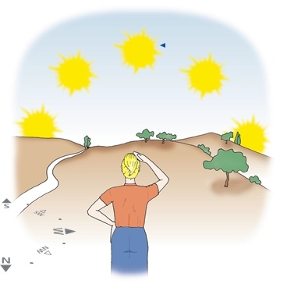
Image: http://www.space-awareness.org/en/

Activity 1c
Observe Record Reflect
Use the moon journal to track how the moon looks each night.
Sunday | Monday | Tuesday | Wednesday | Thursday | Friday | Saturday
Date: | Date: | Date: | Date: | Date: | Date: | Date:
Date: | Date: | Date: | Date: | Date: | Date: | Date:
Date: | Date: | Date: | Date: | Date: | Date: | Date:
Date: | Date: | Date: | Date: | Date: | Date: | Date:
Do you think the sun and moon change their shape and position in the sky, or does it just look that way from Earth? Can you see some patterns in the moon’s shapes? Ask an adult or an older brother or sister what they think. Write it down.
________________________________________________________________________________________________________________________________________________

Activity 2
Reflect Draw
Draw a picture of yourself in each box dressed in what you might wear for each season. Label each box with the season name and add any words that might give more information about your pictures. Add anything else around you in the environment, which you might notice that changes for each season, in each box. Some examples could be trees, weather or activities that may change or be different for each season

