Stage1 Design and production investigation - Physical world

Shadow puppet theatre

Focus question – How are forces and energy used for a purpose?

Design and production task description:
Students complete a design and production investigative task to demonstrate their understanding of how light and movement energies can be used to create change for specific purposes in a product.
Students work in groups of 2 to demonstrate how light energy sources are used for shadow theatre design and how forces are used to create movement in shadow puppets for entertainment and storytelling. Students investigate how forces and light energy create changes by students making, testing and presenting a model shadow theatre while using Indonesian shadow puppets.
Task duration is estimated to be approximately 3-4 hours, which can be delivered over a sequence of lessons.

Assessment
Formative assessment opportunities, where teachers gather evidence about the impact of their teaching to move students forward with their learning, are referenced throughout the learning experiences. These opportunities are elaborated upon in the Formative assessment section at the end of this document, where they are also connected to the Quality Teaching and Learning Framework elements.
Resources:
Puppet templates on heavy card - arjuna warrior (Scribd page 11)
Scissors, pencils, coloured markers
Student safety - if a box cutting tool is necessary, it may only be used by the teacher.
Split pins (approximately 4-5 per student)
Hole punch 0.3cm
Bamboo skewer sticks with the pointed end cut flat (3 per student)
Student safety - remove any sharp points on bamboo skewers before use
Masking tape
Recycled medium to large sized cardboard box for each group of 3 students (60cm+ length/ 45cm+ width)
A selection of translucent materials e.g. white paper, tissue paper, translucent plastic bags
Desk lamp or battery torch
Online resource links:
- Center for Southeast Asian Studies, University of Hawai'i-Manoa (2019-2020) Teacher Resource Guide Balinese Performing Arts for Your Students Fall 2019 - Spring 2020, Scribd, accessed 25 June 2020
- WCPO-9 (15 January 2014) ' The color in shadows: Madcap takes age-old form of puppetry to layered levels [video] ',WCPO-9, YouTube, accessed 25 June 2020
- State of New South Wales (Department of Education) (n.d.) Simple graphic organisers PowerPoint - Venn diagrams , Digital Learning Selector, education.nsw.gov.au, accessed 25 June 2020
- Rajshri Entertainment Private Limited (8 April 2015)' Shadow The Dr. Binocs Show Educational Videos For Kids [video]', Peekaboo Kidz, YouTube, accessed 25 June 2020
- Rajshri Entertainment Private Limited (3 September 2016) ' Light The Dr. Binocs Show Learn Videos For Kids [video]', Peekaboo Kidz, YouTube, accessed 25 June 2020
- State of New South Wales (Department of Education) (n.d.) Exit tickets , Digital Learning Selector, education.nsw.gov.au, accessed 25 June 2020
- Kidspot (4 November 2013) ' How to make your own shadow puppet theatre [video]',Kidspot, YouTube, accessed 25 June 2020
- State of New South Wales (Department of Education) (n.d.) 'Effective teacher questioning' , Teacher quality and accreditation, education.nsw.gov.au, accessed 19 June 2020
- State of New South Wales (Department of Education) (2016) 'Assessment elements of the Quality Teaching model ', Quality Teaching Online, education.nsw.gov.au, accessed 19 June 2020

Syllabus outcomes and content
ST1-8PW-S describes common forms of energy and explores some characteristics of sound energy
- identifies sound, light, heat electricity and movement as forms of energy

ST1-9PW-ST investigates how forces and energy are used in products
- explore how technologies use forces to create movement in products
- design and develop a product that uses one or more forms of energy to create change
ST1-2DP-T uses materials, tools and equipment to develop solutions for a need or opportunity
- generate ideas for design solutions for a defined purpose
- consider sustainable use of resources in planning design solutions
- record design ideas using labelled and annotated drawings including simple digital graphic representations
- effectively managing a variety of tools
- manipulate a range of materials for a purpose
- consider safety, sustainability and time constraints when producing solutions
- segment and sequence steps for making designed solutions
- collaborate to develop designed solutions
- perform strategic roles within a group to solve a problem

Science and Technology K-6 © 2017 NSW Education Standards Authority (NESA) for and on behalf of the Crown in right of the State of New South Wales.

Prior content knowledge and skills
Students have:
- identified sound, light, heat, electricity and movement as forms of energy
- explored sound, light and heat from various sources, using their senses.

Addressing student misconceptions
For greater student success and engagement, it may be helpful to clarify understanding of the following concepts before engaging in planned activities.
- ‘Technology’ is science or knowledge put into practical use to solve problems or invent useful tools. These tools may include digital or computer technologies but are not a necessity.
- Push pull force from ES1 outcomes
  - A push is the force that moves an object away from something.
  - Push and pull are opposite forces, meaning they move objects in different directions.
  - Therefore, a pull is the force of bringing an object closer
- The moon is not a true source of light due to it simply reflecting the light of the sun. The moon is a rock that generates no sound, light, heat or electricity. However, in Stage 2 outcomes, concepts will include the moon’s gravitational pull.
- Clarify that the sun and stars are balls of energy (light and heat) made from gas. A sun is a medium to large star that has planets circling it.

Investigation – shadow puppet theatre

Students are learning to:
- explore how forces create movement in shadow puppets
- investigate sources of light that are suitable for model theatres
- explore how objects that block light create shadows
- investigate and test how light can pass through some objects but not others
- investigate and test how changes in light can affect the size and shape of puppet shadows
- design and develop a puppet and theatre that utilise both movement and light energy.

Design and production learning experiences

Identifying and defining
- Students explore how shadow puppets move by examining a variety of online shadow puppet theatre videos. They discuss how forces create movement in the puppets by examining the split pin joints and the attached sticks the puppeteer pushes and pulls to create motion and change. In addition to the puppet’s movement, the teacher draws attention to the theatre design, the screen material and light source while stopping at significant points in the video for discussion.
Formative assessment opportunity 1 – Teachers observe how students explain the puppets’ movements using scientific language of push, pull, motion, movement and force. They discuss the pin and rod design features of shadow puppets that allow movement energy to be generated by the puppeteer.

- Students identify that light energy is one of the main components needed for the theatre design, as it is the light that creates the shadow of the puppet. Brainstorm a list of light sources together as a class. Student answers could include the sun, stars, fire, light bulb (torch, lamp, ceiling light), neon light signs, fluorescent light tubes, fireworks, lightning and animals (jellyfish, firefly, glow worm, Angler fish).
- Students sort these light sources into a Venn diagram to show what light sources are natural, man-made or both. Note that fire can be both natural and man-made e.g. a bushfire from a lightning strike vs a spark from an electrical machine.

Formative assessment opportunity 2 – Teachers assess students’ understanding of light energy sources through Venn diagrams. Teachers observe how students organise this information visually to demonstrate their understanding of relationships between light sources as well as their similarities and differences.

- Discuss that fire was traditionally used for light in puppet theatres, though was not the safest of options. Together, analyse the light Venn diagram and identify a safe and convenient light source for a classroom puppet show (i.e. a torch or reading lamp).
- Watch the Shadow The Dr Binocs Show video on light energy to examine how shadows are created by objects stopping light from passing through them. Discuss how the size of shadows can be changed depending on the direction of the light source and how some objects let light pass through them, so they don’t create a shadow. For an optional deeper investigation into light, view and discuss this Light The Dr Binocs Show video about transparent, opaque and translucent objects.
- Optional experience: explore how shadows from the sun change depending on the sun’s position in the sky. Perform an experiment by placing a small chalk cross on a concrete area. A student stands on this cross at the times 10am, 12pm and 2pm with their shadow silhouette drawn in chalk for each of these times. Discuss the change in size, shape and position of the shadow outline as the sun’s position changed throughout the day.
- Students share three of their understandings about the concept of light energy on an exit ticket given to the teacher.

Formative assessment 3 – Students complete an exit ticket to demonstrate their knowledge of light energy and how shadows are formed. Teachers use these exit tickets to strategically support students needing further consolidation and clarification of light energy concepts.

Research and planning
- Students select their puppet template (one different puppet for each student in a group of 3 – see links in the resource list) and construct them using the split pins and bamboo sticks that will facilitate the puppet’s movement through the push pull forces generated by the puppeteer. Students practise and experiment with how their puppet can move when forces are exerted on the bamboo sticks. Students might need to further adjust their puppets to allow them to move smoothly.
- Students watch this video about how to make your own shadow puppet theatre . Discussion should focus on the method and materials, screen choice and light source.
- As a class, design a set of quality criteria for students to follow as they begin construction of their shadow puppets and theatre. Considerations could include aspects of:
  - puppet quality and construction
  - theatre screen choice
  - theatre construction method and requirements
  - light source choice
  - performance elements required for the 2-minute play
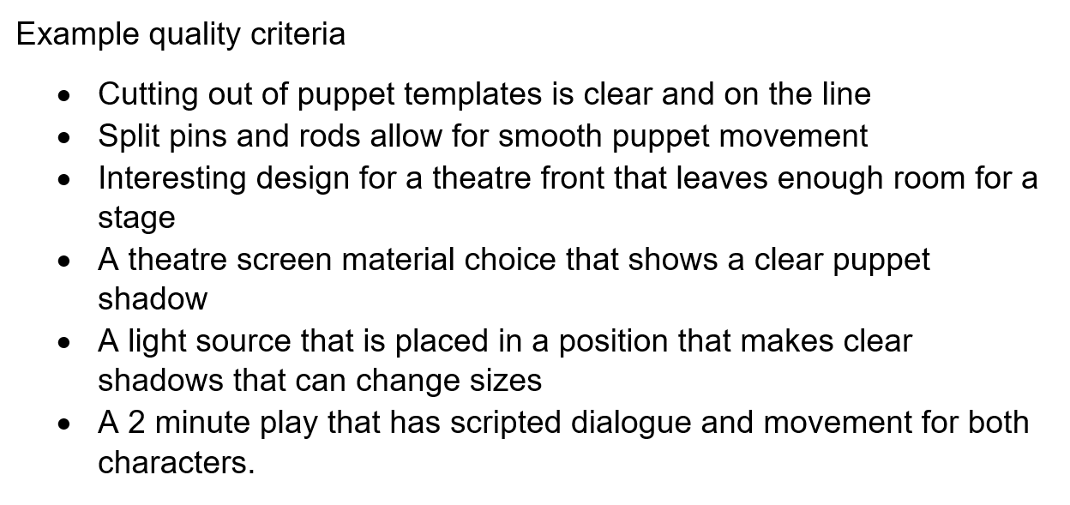

- In their groups of 2, students discuss and plan the methods and resources needed to make their puppet theatre out of the cardboard box and materials available. The most important features that need to be planned for the theatre are:
  - the shadow theatre box design
  - the type of screen material students think works most effectively to create shadows
  - how the position of the light source and puppets will work to create shadows suitable for their theatre stage size.
- Students complete a labelled theatre design diagram on paper to demonstrate all their planning details and then conference with the teacher.

Formative assessment opportunity 4 – students conference with the teacher in their groups to gather some initial feedback on their shadow theatre design plan based on the quality task criteria that have contributed to setting. Teacher elicits student responses through effective questioning techniques to ascertain if students need additional support or can be further challenged. Open questions are used such as:
  - “What problems did you have with your puppet construction and movement? Did you solve them? How?”
  - “Why did you choose your screen material? If this one doesn’t work, what material could you try instead? Why?”
  - “How did you choose your theatre box design?
  - “What light positions have you thought about? What do you think will work?”

Producing and implementing
- Using the materials they have selected, and the teacher feedback, students safely construct their shadow theatre box that meets the quality criteria.
- Students develop a short 2-minute play with a script that includes 2 shadow puppet characters, with movement and dialogue, to showcase the use of light and movement energies.
- After the students have planned and made their puppet show’s theatre box, script and puppets, they use this time to practise producing and implementing their play while merging the concepts of movement and light energy to create an entertaining show.
- Students need to identify and acknowledge problems with their shadow puppet theatre and collaborate as a group to rectify these issues. Using the task criteria that has been developed, students target the areas needing improvements.

Testing and evaluating
- Before students present their play to their audience, they will need to explain their production to the class using the following criteria:
  - describe their challenges and successes when making and moving the shadow puppets
  - describe the process on how their theatre has been constructed
  - explain the selection of the theatre screen material and why it was chosen
  - explain how the light position generates shadows
  - discuss an aspect of the design process they would change to improve their product
  - introduce their play and the characters and set the scene
- Students perform their play for their teacher and classmates. Peer and teacher feedback can be gathered in the form of ‘two stars and a wish’ based on the presentation criteria (two positive comments about the use of light and movement energies and one suggestion for further improvement).
Formative assessment opportunity 5 – teacher analyses what task criteria students have engaged with to demonstrate their understanding of light and movement energies performing a function in a historical and artistic product. This teacher feedback will form part of the students’ reflections.
- Students use the feedback from their peers and teacher to improve and amend their original design plan, and diagram, to more successfully demonstrate the task criteria.
Formative assessment opportunity 6 – teachers observe students using peer/teacher feedback to assist forming their own reflections to amend and improve how their shadow puppet theatre meets the task criteria.

Formative assessment opportunities with Quality Teaching Framework elements
Formative assessment opportunity | Purpose | Quality Teaching Framework assessment element | Digital Learning Selector
1- identifying and defining | Students demonstrate their understanding of how push pull forces create movement. Teachers observe students using scientific language to explain how the pin joints and bamboo sticks facilitate an Indonesian shadow puppet’s change in movement energy. | Deep Knowledge  Substantive Communication  Cultural knowledge
2- identifying and defining | Students complete the Venn diagram to demonstrate how they organise information to demonstrate the relationships, similarities and differences in light energy. |  | Venn diagram
3- identifying and defining | Students synthesise their knowledge of light energy and how shadows are formed through high quality written communication. | Substantive Communication | Exit ticket
4- research and planning | Students contribute to setting, and demonstrate meeting, the task criteria that will demonstrate their knowledge of how light and movement energies are used in a product. | Explicit quality criteria  Student Direction
5- testing and evaluating | Students describe, articulate and demonstrate what task criteria they have engaged with and how a meaningful connection has been made between scientific, artistic and historical elements. | Knowledge Integration  Substantive Communication
6- testing and evaluating | Students receive feedback on their puppet show based on the presentation criteria. Students use peer/teacher feedback to assist forming their own reflections to amend and improve how their shadow puppet theatre meets the task criteria. |  | Two stars and a wish

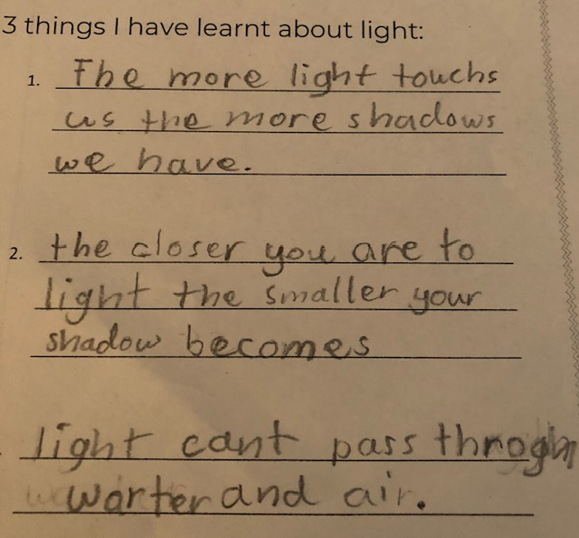 | 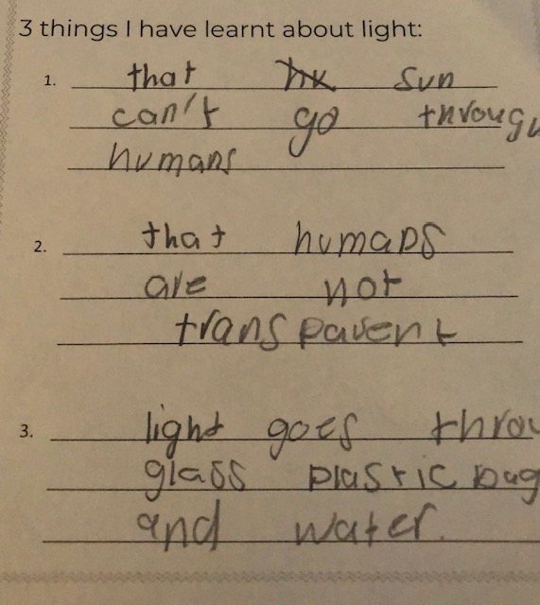
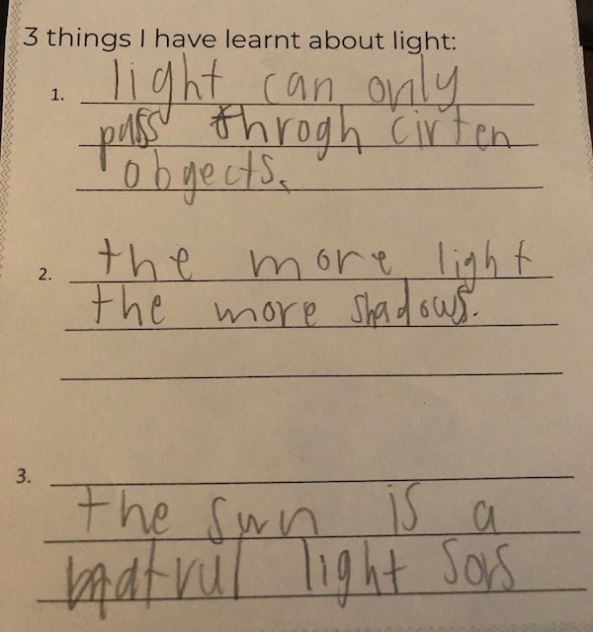 | 