How do the properties of materials affect their use?
Science and technology Early Stage 1 student workbook material world
Name:
Class:

Overview
You will learn about how materials are described by their properties and investigate why objects are made from different materials for different uses. You will design and plan a chair for your favourite toy and make it from household items with the help of an adult.

Resources

Activity 1
- Lead pencil
- Glue
- Scissors
- Coloured pencils and markers
Optional: printer, digital camera

Activity 2
- Lead pencil
- Coloured pencils and markers
- Household craft items

Activity 3
- Lead pencil
- Coloured pencils and markers
- Household craft items
Optional: printer, digital camera

Activity 1.1
During this activity you will explore how different materials feel when you touch them.

How do materials feel on our fingertips?
When we touch a material with our fingertips, we can feel if it is bumpy, smooth, rough, soft or hard. These are called the properties of materials.
Cut out the hand shape below. On each of the fingertips find something in your house or classroom that feels the way it is described. For example, something soft could be cotton wool. Glue a small piece of that material on the fingertip that describes how that material feels.
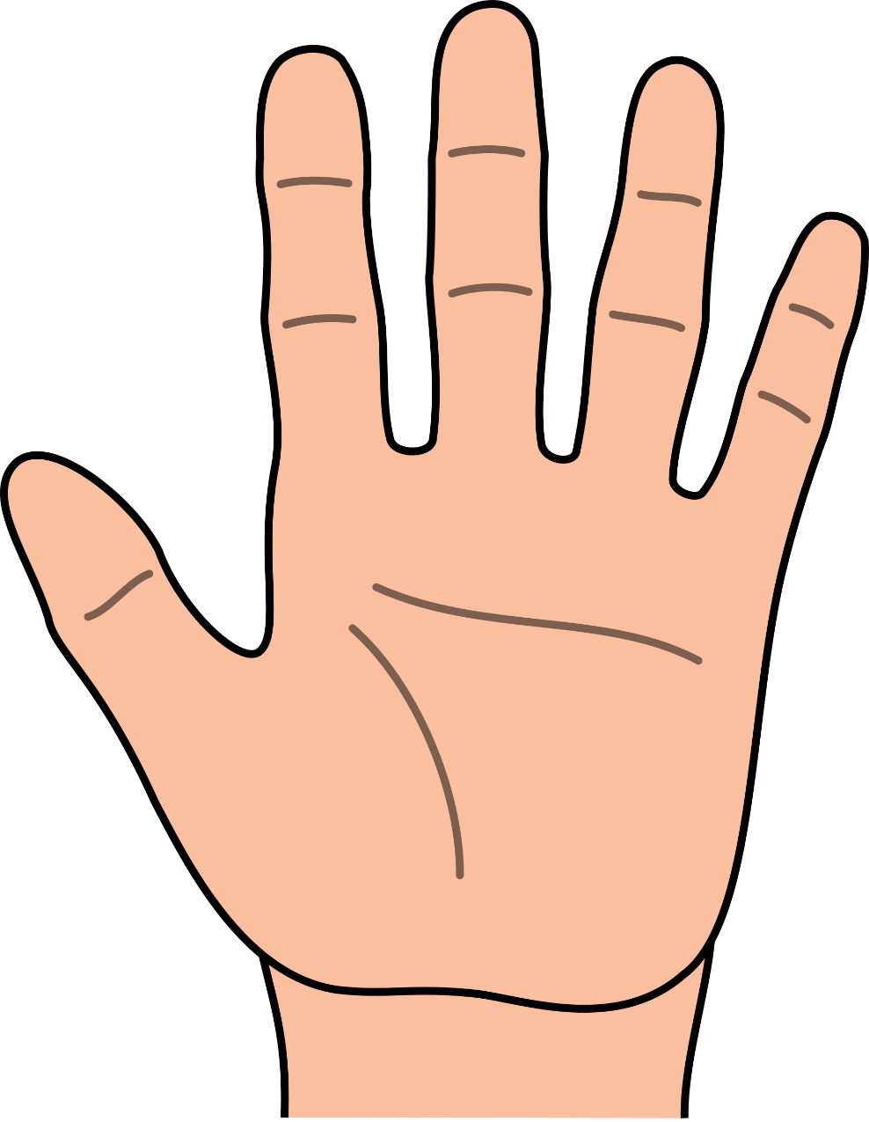
Smooth
Rough
Bumpy
Hard
Soft
openclipart

Activity 1.2
During this activity you will investigate what kinds of objects are made from different materials.

Material scavenger hunt
Different things, or objects, are made from different materials. Some objects need to be strong while others are soft or smooth.
Find objects around your house or classroom that are made from plastic, metal, wool and fabric. You can choose to:
- draw and label them or
- take a picture, print, glue and label them
Objects and materials
Metal | Wool
Fabric | Plastic

Activity 1.3
During this activity you will investigate why objects are made from different materials

Match the reason why
Would you use paper to make your shoes? Would you use spaghetti for a belt? Why not?
In the activity below you need to match the object to the reason why it has been made from that material. Some materials don’t let in water, some materials stretch, some come from nature and other materials keep you warm.
Cut and paste the reasons why that material was chosen next to the object.
Object | Material | Why? Cut and paste the correct reason
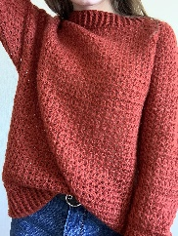  pixabay | wool  jumper
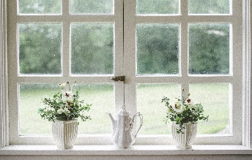  pixabay | glass  window
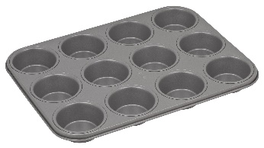  pixabay | metal  cupcake tin
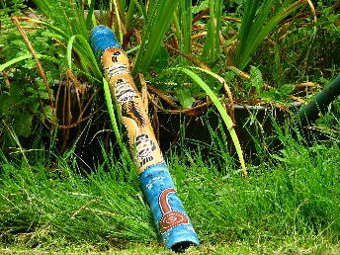  pixabay | wood didgeridoo
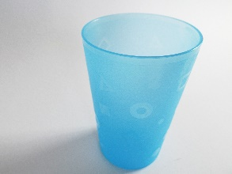  pixabay | plastic  cup
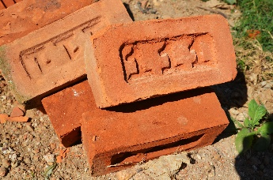  pixabay | brick
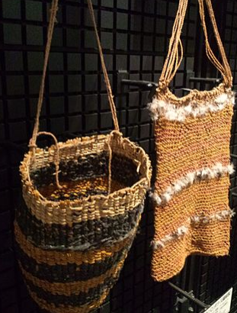  wikimedia | grass  dillybag
pixabay | paper  book

Reason why? Cut and paste
It doesn’t melt when it gets hot
It keeps us warm and is soft
It doesn’t break when we drop it
It is heavy and strong
It can bend and be woven
We can write on, cut and fold it
We can see through it
It can be shaped with tools

Activity 1.4
During this activity you will investigate how different chairs are made and the materials used to make them.

Chairs in my house
Chairs are very useful. Without them we would have to stand up all day or sit on the ground! Chairs, just like in ‘Goldilocks and the three bears’, come in all shapes and sizes.
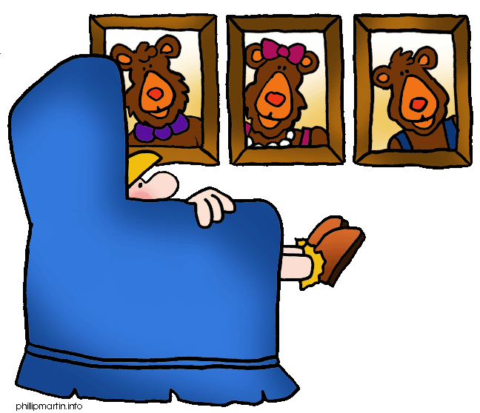
blogspot
After reading ‘Goldilocks and the three bears’, look around your house and find as many types of chairs, seats, stools, lounges and sofas you can.
Choose 5 of them to take pictures or draw.
Describe what the chair is used for and when it is used. Is it for relaxing, working, watching TV, eating breakfast or reading? There are many different reasons we sit down on different chairs.
See if you can find out what materials the chair is made from.

Chairs in my house | Why do I use it? | What is it made from?

Activity 1.5
During this activity you will investigate some wonderful and unusual chairs and seats.

Magnificent chairs and seats
There are some beautiful and very interesting chairs around the world used for different reasons. Use a magazine, furniture store catalogue from the mail or the internet to find some magnificent chairs and make a collage. They could be made from gold and jewels, maybe they are a strange shape, are huge or have wheels!

Magnificent chairs
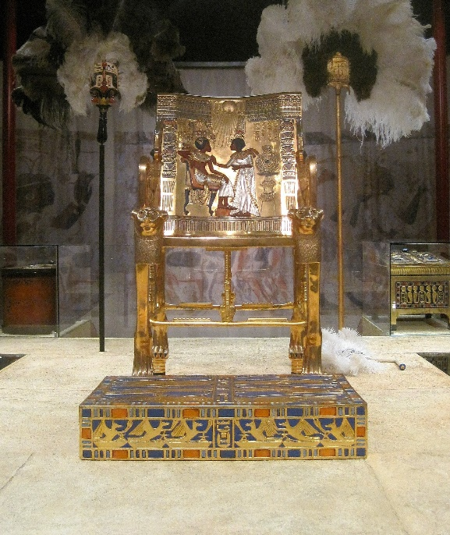  pixabay | 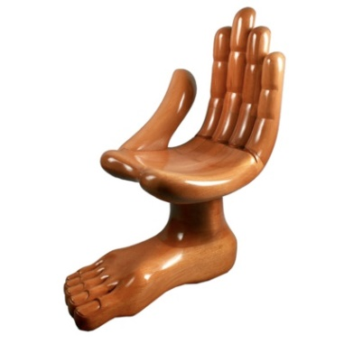  boingboing images | 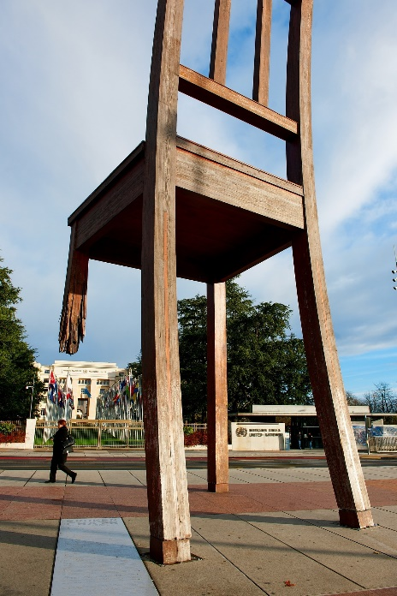  pixabay

My chair collage

Activity 2.1
You are going to design a chair for your favourite teddy bear or doll to sit in on your desk while you do your school work at home.
Make sure:
- the chair is big enough for your toy to fit
- your toy cannot touch the desk when it is sitting in the chair
- the chair looks magnificent, different or unusual.

Materials for my toy’s chair
Before you make this chair, you need to investigate what household materials you can use. Ask for an adult’s permission first and ask them to help you find as many materials as possible from the list below.
Tick off the materials when you and your helper adult find them. Don’t worry if you can’t find all of them. You can also add materials that aren’t on the list.
Materials | Do I have it?
pop sticks
fabric - like old socks
cotton thread
cardboard- like cereal boxes, egg cartons or toilet rolls
Foil
plastic bottles, plastic bag
straws
wrapping paper, newspaper, cupcake paper, A4 paper
kitchen sponge or foam
cotton wool or cotton wool buds
old shoelaces
pipe cleaners
plasticine
glue
tape
safety scissors
decorations such as feathers, sequins, ribbon

Activity 2.2
Now you have found all the materials you think you might use, its time to plan your chair. Make sure you have your favourite teddy or doll next to you so you can imagine them sitting in the chair you are designing.
In the centre box, draw your chair with your toy sitting in it. Use the space around it to label your drawing with the materials you will be using.

Time to plan
My chair plan
Use labels, arrows and words to show the materials and parts of the chair in the drawing. Also label how the parts of the chair will hold together
The chair with my teddy or doll sitting in it

Activity 2.3
Do you think your chair will work?

Questioning and predicting
Before you start building your toy’s chair, think about the materials you have chosen and your plan. Talk about it with an adult.
Ask yourself and answer these yes/no questions:
Question? | Yes or no
Will the chair be big enough for my toy to sit on?
Are the materials strong enough to keep my toy from touching the desk?
Do I know how all the materials of the chair will hold together?
Will the chair look magnificent, different or unusual?
Do I have an adult to help me make the chair?

If you answered ‘no’ to any of those questions, you might like to use some more planning time before you start making your toy’s chair.

Activity 3.1 – optional
Time to start making your toy’s chair.

Maker hour
You have an hour to make your chair for your teddy bear or doll. Using the household materials you have found, as well as your chair plan, begin to make your toy’s chair.
Make sure:
- the chair is big enough for your toy to fit
- your toy cannot touch the desk when it is sitting in the chair
- the chair must look magnificent, different or unusual.

Activity 3.2 – optional
Test and think about your chair – did it work?

Testing and evaluating
Answer the following questions.
Question? | Yes or no
Can my favourite toy fit on the chair?
Are the chair’s materials holding my toy up without the toy touching the desk?
Is the chair staying together in the right shape?
Does my chair look magnificent, different or unusual?

Did you answer ‘no’ to any of the questions?
In the box below write a few words about what needs to be fixed or changed to help your chair do its job better.

What could I do to make the chair better?
_
____________________________________________________________________________ ________________________________________________________________________________________________________________________________________________________________________________________________________________________________________________________________________________________________________________

Activity 3.3 – optional
Time to show and tell your teacher and your classmates about how you made the chair for your toy. Share the great things about your chair as well as the things you think you could fix.

Communicating and sharing
You can share what you have made with your teacher and classmates. You might like to have a chat with just your teacher, perhaps share in a small group of your classmates or maybe present a special news item in front of your class.
After you have talked with your teacher about your chair, they will give you some written feedback about your work which they can write in the boxes below.

This was great! | This was interesting | Have you thought about…?
Your teacher will take a picture of you and your favourite toy in the chair you have made for it. Glue the picture below.

Me, my favourite toy and its new chair

