Student workbook – Living world
Name:
Class:

Overview
You will learn about living things and that they have basic needs including air, food and water. You will investigate what living things need to survive by investigating the growth of a bean.

Resources

Activity 1
- coloured pencils
- help from an adult

Activity 2
- help from an adult
- zip lock bag
- dried beans (soaked overnight)
- paper towel
- tape
- camera (optional)

Activity 1 – Is it a living thing?
Look at the pictures in the table below. Think about what you know about living things. Put a tick if you think it is living or a cross if you think it is not living. Talk to your parent or carer about why you think it is living. Trace the words in the last column. Can you read some of the words?
All images from Pixabay.com.
Is it a living thing? | Tick/cross | What is it?
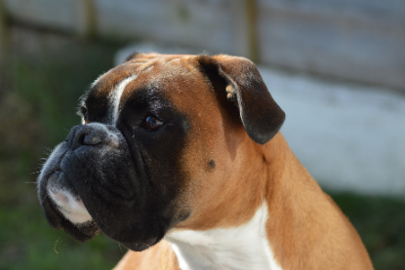 |  | dog
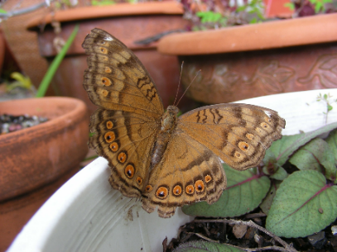 |  | butterfly
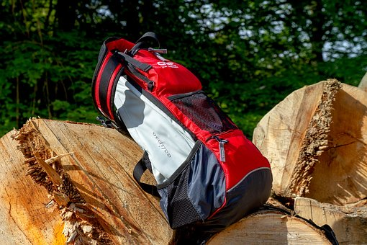 |  | bag
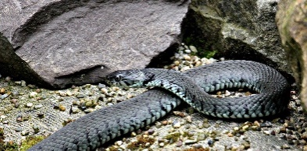 |  | snake
 |  | crayons
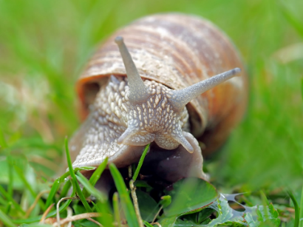 |  | snail
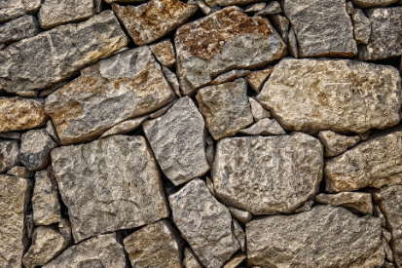 |  | rocks
Go to your backyard or for a walk to the local park with your parent or carer. What living things can you see? Do you know what they are? How do you know it is living? Talk to your parent or carer about what living things you see.
Choose one living thing. Draw a picture in the box. Add three labels to the picture. Write a sentence or talk to your parent/carer about why you think it is a living thing (What can it do?)
Living thing 1

Choose a second living thing. Draw a picture in the box. Add three labels to the picture. Write a sentence or talk to your parent/carer about why you think it is a living thing (What can it do?)
Living thing 2

Activity 2 – What do living things need to stay alive?
During this activity you will explore what living things need to stay alive. Talk to your parent/carer about what things you think living things need every day. Draw what you think living things need to stay alive.
What do living things need to stay alive?

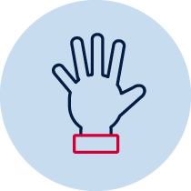Bean investigation
During this activity you will investigate what living things need by investigating the growth of a bean. Follow the steps below with a parent or carer.
- Wet the paper towel slightly. If it’s too wet, carefully squeeze the paper towel so that the excess water comes out.
- Open the zip lock bag.
- Fold the paper towel and put it in the zip lock bag.
- Put the beans inside the zip lock bag. Make sure the beans are next to the paper towel inside the zip lock bag.
- Close the zip lock bag and tape it to a window.

Observations
After you have set up your bean investigation, talk to your parent or carer about what you think might happen with the bean seeds. Record your answer in the space below.
My prediction (guess)

Over the next couple of days you will be recording what is happening to your bean. You can either draw what you see or take pictures with a digital device such as, a camera or mobile phone.
Day | Draw what you see is happening in the zip lock bag.
1
2
3
4
5

Bush Tucker
Aboriginal Australians find most of their food in the bush. Bush tucker are food from plants and animals that are from the Australian outback. Here are some pictures of bush tucker. Draw foods that you eat that might be similar to bush tucker. You may need help from your parent or carer to read the sentences below the pictures.
Bush Tucker | My food
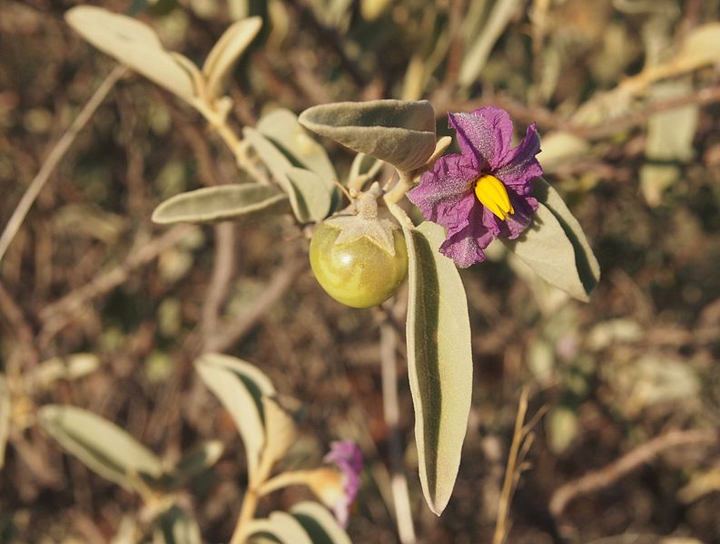
This is a bush tomato.
Photo by Mark Marathon under Creative Commons Attribution-Share Alike 3.0 Unported from wikimedia
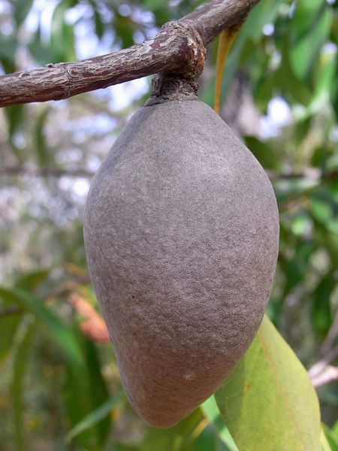
This is a woody pear.
Photo by Poyt448 Peter Woodard under Creative Commons Attribution-Share Alike 3.0 Unported from wikimedia
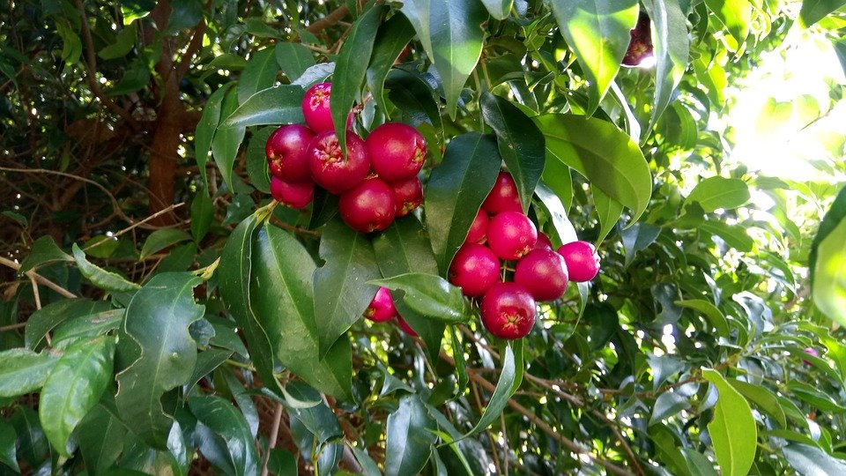
These are bush cherries.
Image from Pixabay.com.

After 5 days, do you think you can answer this question? What do you think your bean needed to grow? Talk to your parent or carer and then draw your answers in the box below.
What do think your bean needed to grow?

Reflection
Think about what you have learnt in this activity. Use the two stars and a wish structure to guide your reflection.
Star  Something that went well! | Star  Something that went well! | Wish  A goal for next time…

