Design and production investigation – Marble push challenge
Science and technology Early Stage 1 – Physical world

Inquiry question
What causes objects to move in different ways?

Task
Students complete a design and production investigative task to implement the skills and knowledge associated with forces and changes in motion. Students are introduced to the concept that the force of air (or wind) can push and pull objects causing them to move. Students investigate their surroundings, and familiar objects, and observe how these sources of air cause objects to move in different ways.
The main investigation involves small groups of students using their understanding of how rolling objects are affected by changes in forces including stopping, starting, rolling faster and slower and in different directions. Students will explore the effects of force on objects by designing a marble push course. Using a straw to exhale (push) air, students manoeuvre a marble through their course design. They investigate and discuss how the force of the air (the harder they exhale) determines the speed of the marble as well as the strategies they use to change the marble’s direction and motion. Task duration is estimated to be approximately 3 hours which can be delivered over a sequence of lessons.

Assessment
Formative assessment opportunities, where teachers can gather evidence about the impact of their teaching to move students forward with their learning, are referenced throughout the learning experiences. These opportunities are elaborated upon in the Formative Assessment section at the end of this document, where they are also connected to the Quality Teaching and Learning Framework elements.

Resources
- drinking straws (one per student)
- classroom objects for a discovery box (small to medium size/light to medium weight) – for example dice, cotton wool balls, pencils, paddle pop sticks
- State of New South Wales (Department of Education) (n.d.) 'Effective teacher questioning', Teacher quality and accreditation, education.nsw.gov.au, accessed 19 June 2020
- State of New South Wales (Department of Education) (2016) Assessment elements of the Quality Teaching model’, Quality Teaching Online, education.nsw.gov.au, accessed 19 June 2020
Student safety – ensure none of these classroom objects are small enough to be accidently inhaled up through the straw.
- standard size marbles (one per student) - marbles must be larger than the opening of the straw
- obstacle course barrier materials such as base 10 materials or blocks.

Syllabus outcomes and content
STe-5PW-ST observes the way objects move and relates changes in motion to push and pull forces
- observe the effects of push and pull forces on familiar objects
- participate in guided investigations to explore how particular objects move on land, water and/or in the air, and how these objects are affected by forces
STe-2DP-T develops solutions to an identified need
- identify and describe needs or opportunities for designing
- identify the technologies needed to achieve designed solutions
- develop skills to safely manage tools
- explore and manipulate materials to discover possibilities of their uses
- produce designed solutions through iteration
- sequence steps to solve a problem with guidance
- collaborate to improve ideas and solve a problem
Science and Technology K-6 © 2017 NSW Education Standards Authority (NESA) for and on behalf of the Crown in right of the State of New South Wales.

Prior content knowledge and skills
Students have:
- observed the way a variety of familiar objects move, for example:
  - sliding
  - rolling
  - spinning
  - bouncing.
- posed questions about familiar objects and events
- responded to questions about familiar objects and events
- made observations using senses through participation in guided scientific investigations
- recorded observations using drawings, simple digital recording methods, oral descriptions and/or simple visual representations
- worked cooperatively with others to investigate ideas
- developed safe skills when using materials and equipment.

Addressing student misconceptions
Students understand:
- The definition of ‘technology’ is science or knowledge put into practical use to solve problems or invent useful tools. These tools may include digital or computer technologies but are not a necessity.

Student safety
Please reinforce to Kindergarten students the only materials pulled/inhaled through straws are air and drinks. Anything else ingested or inhaled into the mouth or lungs could be dangerous.

Investigation – Marble push challenge
Students are learning to:
- participate in guided investigations to explore how particular objects move
- investigate how objects are affected by forces
- explore and manipulate materials to discover possibilities of their uses
- identify the technologies needed to achieve designed solutions
- collaborate to improve ideas and solve a problem.

Design and production learning experiences

Identifying and defining
- Build on students’ existing knowledge of push pull forces and motion by introducing the concept of wind force affecting the movement of objects. Students observe the playground, trees and leaves on the ground, wind chimes, weathervanes or play equipment moving due to the force of the wind.
- Use examples of local wind turbines or aeroplane engines as well as demonstrations of paper pinwheels, fans, balloons, vacuum cleaners and brass/woodwind musical instruments to show how the force of wind affects the movement of objects. Consolidate student understanding of pushing forces moving an object away from the force and pulling forces moving an object closer to the force.
- Together as a class, construct a T-chart that demonstrates students’ understanding of the sources of push pull wind forces by comparing and sorting examples into push and pull categories.
Formative assessment opportunity 1 – teachers observe what objects students can identify in their surroundings that can move due to push pull forces and if the student can indicate, physically or verbally, the direction of the push pull force.

Research and planning
- Explain to students that they will be discovering how wind force directed through straws affects how objects move. Using a range of classroom objects that can slide, roll, spin and bounce in a discovery box (see resource list and pictures), students investigate and explore which objects can be moved the easiest, or furthest, with the force of wind. Discuss the objects they found moved the most and describe how they moved e.g. “the paddle pop stick spun around when I pushed the air onto the end of the stick. If I pushed it in the middle instead, the stick slid” and “the dice didn’t roll very well because of the sharp edges, but it could slide”.
Formative assessment opportunity 2 – teacher observes the language and actions students use to communicate their understanding of how their discovery box objects can slide, roll, spin or bounce with the pushing force of wind.

Producing and implementing
- Introduce and model the marble push course with students by creating a sample course or diagram together. In small groups of 2-3, students will be designing their own course using materials such as base 10 materials or blocks. They will be generating push forces with a straw to move a rolling marble through the course they create.
Task criteria includes:
  - the course must have at least one turn or corner
  - one section of the course must have obstacles the marble must go around
  - the course is at least as long as a metre ruler (or an informal unit of measurement)
  - the course must have a start and finish line
  - the course must have one bridge that the marble must go under
  - optional extension criteria – the course has one bridge the marble must go over.
Formative assessment opportunity 3 – teacher observes how students communicate with each other using questioning and answering skills to solve the problem. Teacher elicits student responses through effective questioning to ascertain if students need additional support or can be further challenged by the optional extension criteria. Questions such as:
  - “What part of your marble course will be the easiest/hardest to push your marble through? Why?”
  - “That’s a great bridge your marble goes under, what’s another way you could use a bridge in your marble course?”
  - “Tell me how you’ve helped each other to make in the marble course?”
  - “What was the best idea your partner has had?”
Formative assessment opportunity 4 – teacher observes how students demonstrate their understanding of the explicit task criteria through their marble course design. This could be in the form of a discussion with the teacher or an opportunity for small groups to share back to the class explaining how the task criteria was addressed.

Testing and evaluating
- Students take turns moving the marble through their challenge to explore, test and discuss the push pull forces making the marble roll.
Investigation options include:
  - timing each individual marble run and analysing why some runs took longer or shorter times
  - a marble run race on the same course between 2 or 3 students
  - an accuracy test while counting the obstacle/barrier collisions
  - swapping courses with other groups to experience a different challenge.
- Students discuss, test and demonstrate how they can affect their marble’s speed through the course by exploring how the force can be increased or decreased by exhaling harder or softer through their straw. Students also discuss, test and demonstrate how they can change the marble’s direction through the course by altering where the force pushes against the marble.
Formative assessment opportunity 5 – teacher observes the language students use to explain the concepts of direction and speed by how they alter the push force from the straw onto the marble.
- Students draw their marble push course, using the task criteria prompts, and add a picture of themselves completing the course with their marble and straw. Their drawing should be labelled and/or include a simple sentence about their investigation.
Formative assessment opportunity 6 – students use a learning log to reflect on their marble course design and share their understanding about the forces that cause objects to roll with different speeds and direction. Teacher records their observations from the learning log against the learning intentions. A photo is optional to add to teacher records.

Formative assessment opportunities with Quality Teaching Framework elements
Teachers may use some or all of these opportunities to gather evidence about the impact of their teaching to move students forward with their learning.

Formative assessment opportunity | Purpose | Quality Teaching Framework assessment element | Digital Learning Selector
1- identifying and defining | Students can share their understanding of how familiar objects are moved by push pull forces. | Substantive communication
2- research and planning | Students can demonstrate and explain their understanding of how push pull forces can make objects slide, roll, spin and bounce. | Substantive communication
3- producing and implementing | Students can work in a collaborative environment while using their questioning and answering skills to design solutions to appropriately challenging problems. | Problematic knowledge
4- producing and implementing | Students meet the set task criteria to produce a push marble course that implements their knowledge of forces. | Explicit quality criteria
5- testing and evaluating | Students demonstrate how their existing knowledge has been extended or refined through discussing or demonstrating the strategic use of direction and speed with their marble course. | Background knowledge
6- testing and evaluating | Students reflect upon their learning through a learning journal or log that represents their understanding about forces that cause objects to roll with different speeds and direction. | Substantive communication | Learning log  Learning Intentions

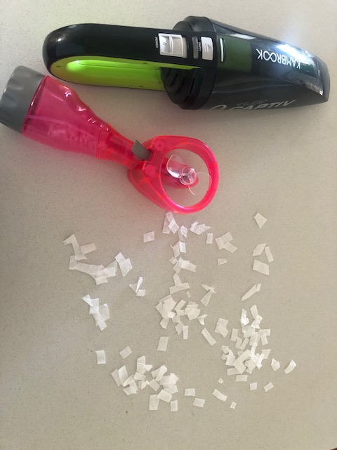
Figure 1 –How forces from wind affect motion

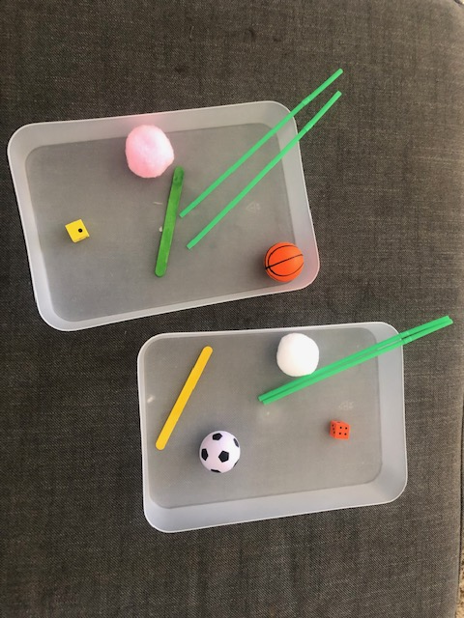
Figure 2 – Discovery box

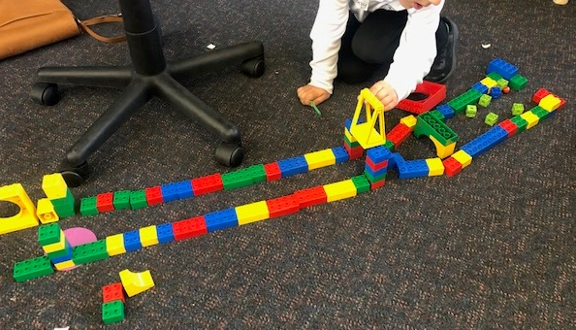
Figure 3 Marble push course design
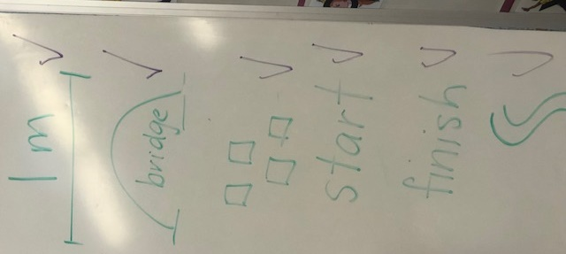
Figure 4 Explicit criteria

