Physical activity treasure hunt -personal and social attributes focus Stage 5
Duration: 2-3 lessons (50-60 minutes in length)
This lesson sequence encourages students to analyse the opportunities that exist within an environment to engage in physical activity. In this example, their home environment is used, but the home environment could be easily substituted for school, a holiday location or a recreation space. This learning sequence encourages students to engage their family in an enjoyable physical activity experience.Students are also challenged to develop their personal and social attributes by promoting safety, encouraging inclusion and developing leadership. The learning sequence highlights how the personal and social attributes aspect of the NSW Physical Literacy Continuum can be used to focus on educative purpose.

Syllabus content
Outcome PD5-8 designs, implements and evaluates personalised plans to enhance health and participation in a lifetime of physical activity
Outcome PD5-10 critiques their ability to enact interpersonal skills to build and maintain respectful and inclusive relationships in a variety of groups or contexts
All outcomes referred to in this unit come from PDHPE K-10 syllabus © NSW Education Standards Authority (NESA) for and on behalf of the Crown in right of the State of New South Wales, 2018.
Key inquiry question | Syllabus content
How can I plan and advocate for health, safety, wellbeing and participation in a lifetime of physical activity? | - design, implement and evaluate creative interventions for enhancing their own and others’ fitness levels and participation in a lifetime of physical activity  - investigate and prepare plans that promote the use of natural settings within the local community for physical activity and analyse their effectiveness in enhancing a lifetime of physical activity and/or improving fitness levels
How can I include, assist and lead others during physical activity? | - devise, implement and refine strategies demonstrating leadership and collaboration skills when working in groups or teams (ACPMP105)  - evaluate individual strengths and the contribution they make to teamwork and leadership to encourage enjoyable participation for everyone in movement activities S I M  - implement motivational strategies to influence the involvement and engagement of themselves and others in movement activities  - examine the role of physical activity in promoting health and wellbeing, for example:  - explore strategies to overcome participation in physical activity for individuals and groups, including people with disabilities

Physical literacy markers

Personal and social attributes
Includes safety, cooperation, communication and conflict resolution within physical activity settings with a focus on inclusion of others and respectful participation in physical activity and other contexts.
Continuum sub-aspect | End of Year 8  Cluster 5 | End of Year 10  Cluster 6
Safety | Assesses and adjusts the physical environment to ensure safety in physical activity for self and others | Plans and implements safe physical activity in a variety of environments for the enjoyment of others, e.g. coaching, peer mentoring and officiating
Inclusion | Selects and role models strategies that promote inclusion in physical activity  Demonstrates actions that support the rights and feelings of others | Encourages and positively influences others to demonstrate respect and inclusive behaviours  Advocates for the inclusion of others
Cooperation and communication | Interacts confidently with others in physical activities  Makes individual compromises based on the strengths of self and others to work effectively as a group  Supports and encourages the enjoyable involvement of others  Responds positively to the needs of others | Adopts a leadership role that positively influences physical activity behaviours such as volunteering, coaching and mentoring

Learning activity description

Design a physical activity treasure hunt

Learning intention
Students will develop the knowledge, understanding and skills required to incorporate their home environment in lifelong physical activity.

Success criteria
- Design a physical activity treasure hunt that successfully incorporates their home environment.
- Promote safety and inclusion in the physical activity treasure hunt.
- Evaluate and reflect on the impact of leadership skills on enjoyment and engagement.

Activity one: Your home
Students
- identify 10 key landmarks in and around their home. (e.g. lemon tree, loungeroom, letterbox, garage, trampoline)
- create a map of their home that identifies these key landmarks. Refer to appendix for an example.
  - Students may wish to create riddles, instead of a map, as clues to the landmarks. For example, go to where the fruit is yellow and sour and difficult to devour.

Activity two: Way to be active
Students:
- design 10 physical activity challenges, e.g. 20 double under skips, 20 squats, 10 successful basketball shots.
- allocate one challenge for each landmark.
Considerations
- The physical activity challenges should incorporate the environment or objects of the particular landmark they will be completed at. For example, tricep dips on the TV cabinet, kangaroo hops up the stairs.
- Opportunities and challenges of each landmark environment should be incorporated to maximise the enjoyment and excertion at each point. Examples may include a steep driveway, stairs, front step, retaining wall.
- Be creative. The more creative the activities are the more enjoyable it will be for participants.
- Incorporate the equipment available. Including balls, skipping ropes, trampoline, basketball hoop, heavy things (eg. rocks, paint tins, chairs).
- Engage the ‘whole body’ across the various activities. That includes lower body, core and upper body
Refer to the example in the appendix for more ideas.

Activity three: Safety
Students identify potential hazards and implement strategies to minimise the risk. Students complete the risk assessment proforma in the appendix to ensure the activity is performed as safe as possible. Students are encouraged to consider:
- the environment (unsafe surfaces, obstacles, weather)
- the equipment (weight, sharp or dangerous, safe, reliable)
- the participant (unsafe technique, health concerns, age).
Students are required to submit the completed proforma to their teacher.

Activity four: Get active
Students:
- challenge their family members and themselves to complete the physical activity treasure hunt in as short a time as possible.
- time the completion of the treasure hunt in its entirety or the completion of each individual landmark to maintain results for themselves and family members. Use the result recorder in the appendix to track results.
- video record their completion of the physical activity treasure hunt and share with the teacher. Students may use time-lapse recording on their phone to compress the length of the video.
- complete the physical activity treasure hunt everyday for a minimum two weeks.
Included in the appendix is a proforma for recording results.

Activity five: Adaptations
Students consider one of the following individuals;
- A 9 year old
- A 65 year old
- A person with a sore back
- A pregnant person
Respond to the following questions:
- What are the key considerations for your individual’s involvement in physical activity?
- How could you alter your physical activity treasure hunt to suit the needs of the individual?
- What other groups of individuals could benefit from the changes you have made?

Activity six: Coaching/ facilitating
Students are to facilitate the participation of one family member or friend in their physical activity treasure hunt.
Before they participate, students reflect on the following questions:
- How can the physical activity treasure hunt be altered to suit their needs. Consider:
  - fitness needs
  - medical requirements
  - level of ability
  - prior experience.
- How can you as the facilitator maximise their motivation and enjoyment?
- What can you say and/or do before, during and after their participation?
- Consider their personality and your strengths in your response. List five strategies that you will utilise to maximise motivation and enjoyment.
- During their participation, students are to encourage and motivate the participant to successfully complete the physical activity treasure hunt.

Activity seven: Reflection
At the completion of being the coach/facilitator, students respond to the following questions.
- What strengths or skills did you display that increased the enjoyment and motivation of the participant?
- What strengths or skills do you think you could continue to develop to be more successful? Devise a strategy that can develop each of those skills.
- How did your involvement enhance the experience of the participant?
- How can the lessons learnt in this activity be applied for the enjoyment of lifelong physical activity?
At the completion of two weeks, students complete a reflection identifying how effective the treasure hunt was in promoting physical activity and improving fitness levels for themselves and their family. Students respond to the following questions.
- Describe the impact the physical activity treasure hunt had on your level of physical activity and physical fitness
- Describe the impact the physical activity treasure hunt had on the physical activity and physical fitness level of your family
- Explain the greatest challenge you faced in completing the physical activity treasure hunt? Provide reasons.
- What personal strengths and strategies did you call on and use to be successful?
- What did you learn about your home environment regarding physical activity?
- Describe how you could alter the physical activity treasure hunt to continue to ensure it positively impacts your physical fitness level? Explain how each change will positively impact your physical fitness level.
- Design an infographic or a poster that highlights how people can incorporate their home environment into physical activity. This could be completed on Canva, Microsoft Publisher, Google Slides or offline in the form of a brochure or poster.

My fitness treasure hunt example
Landmark | Activity | Equipment
1.Letter box | 10 drive way ‘suicides’
2.Front step | 20 two footed jumps, 20 step ups, 20 hop ups.
3.Netball ring | 10 successful shots | netball
4.Trampoline | 10 forward rolls
5.Back steps | Carry 10kg (large rock/ 3x 3l milk bottles) up and down stairs 5 times | large rock/ 3x 3l milk bottles
6.Back grass | 20 ‘double under’ skips | Skipping rope
7.My bed | Locking feet under bed complete 30 sit ups
8.Garden retaining wall | 20 push ups
9.TV cabinet | 30 tricep dips
10.Bin | Successfully hit bin with tennis ball from 10 metres away | Tennis ball

My home
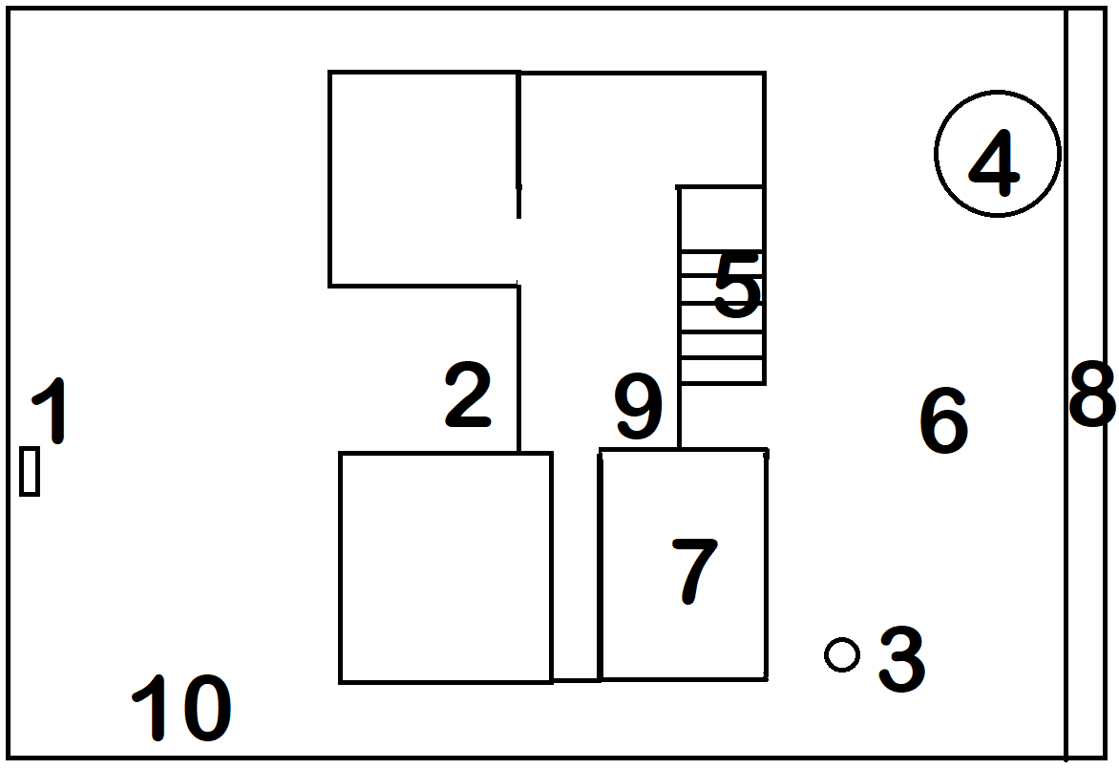

My fitness treasure hunt
Landmark | Activity | Equipment

1.

2.

3.

4.

5.

6.

7.

8.

9.

10.

My home

Draw picture here

Family physical activity treasure hunt recording sheet
Name | Att 1 | Att 2 | Att 3 | Att 4 | Att 5 | Att 6 | Att 7 | Att 8 | Att 9 | Att 10

Physical activity treasure hunt risk assessment
For each station identify potential hazards and how the risk of that hazard can be reduced.
Station | Risk | Strategies to reduce risk
1.
2.
3.
4.
5.
6.
7.
8.
9.
10.

