Physical activity treasure hunt – Movement competencies focus
Duration: 2-3 lessons (50-60 minutes in length)

Educative purpose
This lesson sequence encourages students to analyse the opportunities that exist within an environment to engage in physical activity. In this example, their home environment is used, but the home environment could be easily substituted for school, a holiday location or a recreation space. This learning sequence encourages students to engage their family in an enjoyable physical activity experience. The learning sequence highlights how the movement competencies aspect of the NSW Physical Literacy continuum can be used to focus on educative purpose.

Syllabus content
- PD5-8 designs, implements and evaluates personalised plans to enhance health and participation in a lifetime of physical activity
- PD5-11 refines and applies movement skills and concepts to compose and perform innovative movement sequences
All outcomes referred to in this unit come from PDHPE K-10 syllabus © NSW Education Standards Authority (NESA) for and on behalf of the Crown in right of the State of New South Wales, 2018.
Key inquiry question | Syllabus content
How can I plan and advocate for health, safety, wellbeing and participation in a lifetime of physical activity? | - design, implement and evaluate creative interventions for enhancing their own and others’ fitness levels and participation in a lifetime of physical activity  - investigate and prepare plans that promote the use of natural settings within the local community for physical activity and analyse their effectiveness in enhancing a lifetime of physical activity and/or improving fitness levels
How can I use feedback to create adaptations to movement skills to make them more effective in different contexts? | - provide and apply feedback to develop and refine specialised movement skills in a range of challenging movement situations (ACPMP099)  - demonstrate fundamental and specialised movement skills in a variety of increasingly complex and challenging activities

Physical literacy markers

Movement competencies
Involves developing proficiency in object control, stability and locomotor skills to sequence movement in a wide variety of physical activity settings.
Continuum sub-aspect | End of Year 8  Cluster 5 | End of Year 10  Cluster 6
Combinations | - Refines stability, locomotor and object control skills in dynamic physical activity contexts to improve the efficiency (process) and effectiveness of movement (outcome)  - Selects from a range of movement skills and applies the most appropriate skill in dynamic physical activity contexts  - Transfers similar movement skills and sequences appropriately across physical activity contexts | - Applies and refines movement skills in a range of increasingly complex dynamic physical activity contexts, e.g. at different speeds or within reduced play space  - Adapts and improvises movement skills, and combinations of skills, to perform innovative movement across a range of physical activity contexts

Learning activity description

Design a physical activity treasure hunt

Learning intention
- Students will develop the movement skills required to enhance lifelong physical activity.

Success criteria
- Design a physical activity treasure hunt that successfully incorporates their home environment.
- Perform, reflect and adapt movement skills in order to enhance performance in physical activity.

Activity 1: Your home
Students:
- identify 10 key landmarks in and around their home. For example, lemon tree, loungeroom, letterbox, garage, trampoline
- create a map of their home that identifies these key landmarks. Refer to appendix for an example.
  - Students may wish to create riddles, instead of a map, as clues to the landmarks. For example, go to where the fruit is yellow and sour and difficult to devour.

Activity 2: Way to be active
Students:
- design 10 physical activity challenges, e.g. 20 double under skips, 20 squats, 10 successful basketball shots.
- allocate one challenge for each landmark.
Considerations
- The physical activity challenges should incorporate the environment or objects of the particular landmark they will be completed at. For example, tricep dips on the TV cabinet, kangaroo hops up the stairs.
- Opportunities and challenges of each landmark environment should be incorporated to maximise the enjoyment and excertion at each point. Examples may include a steep driveway, stairs, front step, retaining wall.
- Be creative. The more creative the activities are the more enjoyable it will be for participants.
- Incorporate the equipment available. Including balls, skipping ropes, trampoline, basketball hoop, heavy things (eg. rocks, paint tins, chairs).
- Engage the ‘whole body’ across the various activities. That includes lower body, core and upper body.
- To increase the complexity of the activities, include a minimum of two activities that require accuracy to complete
- To increase the dynamic nature of the activities, include at least one activity that has a time limit to complete. This may include:
  - 10 successful throws in one minute
  - 20 double under skips in two minutes

Refer to the example in the appendix for more ideas.

Activity 3: Get active
Students:
- challenge their family members and themselves to complete the physical activity treasure hunt in as short a time as possible.
- time the completion of the treasure hunt in its entirety or the completion of each individual landmark to maintain results for themselves and family members. Use the result recorder in the appendix to track results.
- Complete the physical activity treasure hunt every day for two weeks and track results.
- Video record their completion of the physical activity treasure hunt and share with the teacher. Students may use time-lapse recording on their phone to compress the length of the video.

Activity 4: Adapt and refine
Students choose one activity.
- Record yourself completing one of the activities. Ensure it is recorded from at least two different angles so that each body movement can be clearly seen.
- Edit using a movie editor like IMovie or Microsoft photo editor to put the clips together.
- Research correct technique for the chosen activity. Highlight at least five key technique points that are vital for successful completion of the skill. Consider body position, stance, grip (if applicable) and other activity specific movements.
- Analyse the technique of the activity. Compare your research to the technique in the recording. Make at least three comparisons between your technique and correct technique. Students can embed comparison videos and/or use text, drawings or narration to describe the comparisons.
- Refine your technique. Considering the correct technique and the comparisons made, complete and record the activity again. Once you are satisfied that you are displaying the correct technique, add the clips to the movie to display the improved technique.
- Publish the movie and share with the teacher.
Note: Access the stream video by Megan Townes on the state wide staffroom who explains a range of Microsoft technologies on Windows, Mac, iPad and Office Online (therefore Chromebook) for annotating feedback onto video recordings.

Activity 5: Reflection
- Students complete a reflection to identify how effective the treasure hunt was in promoting physical activity and improving fitness levels for themselves and their family. Students respond to the following questions.
  - Describe the impact the physical activity treasure hunt had on your level of physical activity and physical fitness.
  - Describe the impact the physical activity treasure hunt had on the physical activity and physical fitness level of your family members.
  - Describe how you could alter the physical activity treasure hunt to ensure it continues to develop your movement skills. Explain how each change will positively impact your physical fitness level.
  - Design an infographic or a poster that highlights the correct technique of your chosen physical activity. Using stills (images) from your video recording highlight at least three key technique points. This could be completed on Canva, Microsoft Publisher, Google Slides or offline in the form of a brochure or poster.

My fitness treasure hunt example
Landmark | Activity | Equipment
1.Letter box | 10 drive way ‘suicides’
2.Front step | 20 two footed jumps, 20 step ups, 20 hop ups.
3.Netball ring | 10 successful shots | netball
4.Trampoline | 10 forward rolls
5.Back steps | Carry 10kg (large rock/ 3x 3l milk bottles) up and down stairs 5 times | large rock/ 3x 3l milk bottles
6.Back grass | 20 ‘double under’ skips | Skipping rope
7.My bed | Locking feet under bed complete 30 sit ups
8.Garden retaining wall | 20 push ups
9.TV cabinet | 30 tricep dips
10.Bin | Successfully hit bin with tennis ball from 10 metres away | Tennis ball

My home
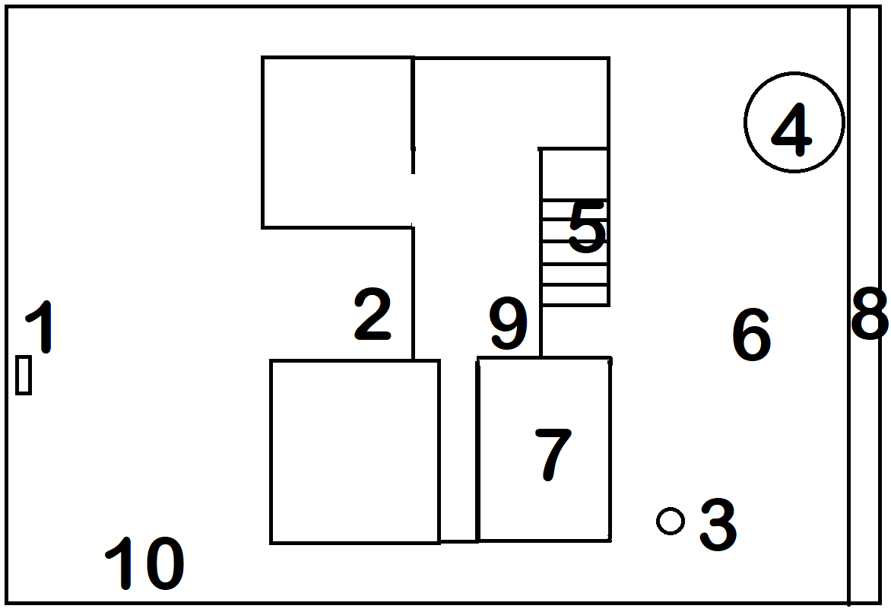

My fitness treasure hunt
Landmark | Activity | Equipment

1.

2.

3.

4.

5.

6.

7.

8.

9.

10.

My home

Draw picture here

Family physical activity treasure hunt recording sheet
Name | Att 1 | Att 2 | Att 3 | Att 4 | Att 5 | Att 6 | Att 7 | Att 8 | Att 9 | Att 10

