Physical Activity Treasure Hunt - Motivation and Behavioural Skills Focus Stage 5
Duration: 2-3 lessons (50-60 minutes in length)

Educative purpose
This lesson sequence encourages students to analyse the opportunities that exist within an environment to engage in physical activity. In this example, their home environment is used, but the home environment could be easily substituted for school, a holiday location or a recreation space. This learning sequence encourages students to engage their family in an enjoyable physical activity experience.The learning sequence highlights how the motivation and behavioural skills aspect of the NSW Physical Literacy Continuum can be used to focus educative purpose.

Syllabus content
Outcome PD5-8 designs, implements and evaluates personalised plans to enhance health and participation in a lifetime of physical activity
Outcome PD5-9 assesses and applies self-management skills to effectively manage complex situations
All outcomes referred to in this unit come from PDHPE K-10 syllabus © NSW Education Standards Authority (NESA) for and on behalf of the Crown in right of the State of New South Wales, 2018.
Key inquiry question | Syllabus content
How can I plan and advocate for health, safety, wellbeing and participation in a lifetime of physical activity? | - design, implement and evaluate creative interventions for enhancing their own and others’ fitness levels and participation in a lifetime of physical activity  - investigate and prepare plans that promote the use of natural settings within the local community for physical activity and analyse their effectiveness in enhancing a lifetime of physical activity and/or improving fitness levels
How can I create new rules, strategies and tactics to improve movement and evaluate the effect these have on performance? | - transfer understanding from previous movement experiences to create solutions to movement challenges  - demonstrate motivation, persistence, confidence and commitment when faced with difficult or unfamiliar movement tasks

Physical literacy markers

Motivation and behavioural skills
Includes persistence, initiative and working independently in physical activity settings with a focus on the values, attitudes and behavioural skills to plan for and participate in life long physical activity.
Continuum sub-aspect | End of Year 8  Cluster 5 | End of Year 10  Cluster 6
Persistence and independence | - Identifies ways that physical and social environments can be modified to promote physical activity  - Creates plans to assist in the completion of challenging activities  - Demonstrates motivation, confidence and commitment when faced with challenging and/or unfamiliar movements and physical activities  - Responds appropriately to success and challenges in physical activities  - Assesses their ability to work independently in physical activities | - Modifies the physical and social environment to increase opportunities for physical activity for self and others  - Applies problem solving skills to plan for increased physical activity in the home, school and community  - Seeks to engage in physical activities that are personally challenging regardless of previous experience or success  - Applies strategies to motivate self and others to continue to participate and improve performance in physical activities  - Critiques their effectiveness to work independently and apply initiative to achieve goals and outcomes in variety of contexts
Values and attitudes | - Evaluates the contribution of regular physical activity to wellbeing, health and fitness levels  - Recognises the benefits of participating in a range of physical activities not just ones that they enjoy | - Advocates for and positively influences the physical activity experiences of others  - Recognises their responsibility as a role model beyond participation in physical activity
Behavioural skills | - Proposes short-term and long-term goals that will assist them to maintain regular participation in physical activity in the future  - Designs plans for improving or maintaining their personal levels of physical activity and fitness  - Reflects on personal levels of physical activity, sedentary behaviour and fitness | - Applies self-monitoring strategies to contexts outside of physical activity, such as goal setting  - Evaluates and modifies personalised plans for improving or maintaining their own and others’ physical activity and fitness levels

Learning activity description

Design a physical activity treasure hunt

Learning intention
Students develop the knowledge, understanding and skills required to incorporate their home or school environment in lifelong physical activity

Success criteria
Students:
- design a physical activity treasure hunt that successfully incorporates their home environment.
- display motivation and persistence in successfully completing the physical activity treasure hunt.
- evaluate and reflect on the importance of goal setting in promoting lifelong physical activity.

Activity 1: Your home
Students:
- identify 10 key landmarks in and around their home. (e.g. lemon tree, loungeroom, letterbox, garage, trampoline)
- create a map of their home that identifies these key landmarks. Refer to appendix for an example.
  - Students may wish to create riddles, instead of a map, as clues to the landmarks. For example, go to where the fruit is yellow and sour and difficult to devour.

Activity 2: Way to be active
Students:
- design 10 physical activity challenges, e.g. 20 double under skips, 20 squats, 10 successful basketball shots.
- allocate one physical/ movement challenge for each landmark.
Considerations:
- The physical activity/ movement challenges should incorporate the environment or objects of the particular landmark they will be completed at. For example, tricep dips on the television cabinet, kangaroo hops up the stairs.
- Opportunities and challenges of each landmark environment should be incorporated to maximise the enjoyment and exertion at each point. Examples may include a steep driveway, stairs, front step, retaining wall.
- Be creative. The more creative the activities are, the more enjoyable it will be for participants.
- Incorporate the equipment available. Including balls, skipping ropes, trampoline, basketball hoop, heavy things (eg. rocks, paint tins, chairs).
- Engage the ‘whole body’ across the various activities. That includes lower body, core and upper body
Refer to the example physical activity treasure hunt in the appendix for more ideas.

Activity 3: Get active
Students:
- challenge their family members and themselves to complete the physical activity treasure hunt in as short a time as possible
- time the completion of the treasure hunt in its entirety or the completion of each individual landmark to maintain results for themselves and family members. Use the result recorder in the appendix to track results.
- record their completion of the physical activity treasure hunt and share with the teacher. Students may use time-lapse recording on their phone to compress the length of the video.

Activity 4: Goal setting
To further develop their behavioural skills, students set a goal for improvement over the next two weeks. The goal can be focused on individual activities or the entire physical activity treasure hunt. Family members are also encouraged to set a goal.
Students should consider:
- creating the goal using the SMART process and acronym
- the strategies to achieve success are clearly outlined
- the purpose behind the goal is clearly outlined
- the goal may result in improved physical fitness and improvement in ability to execute a skill or series of skills.
Students complete the physical activity treasure hunt everyday for a minimum two weeks. Included in the appendix is a proforma for recording results and setting goals.

Activity 5: Journal (literacy opportunity)
Students complete a journal entry every day for two weeks logging their participation in the physical activity treasure hunt. This can be done as an audio file, vlog, typed or written journal. Students are encouraged to:
- discuss their motivation level and consider the impact it is having on their overall daily wellbeing
- include the barriers they faced and the strategies they implemented to overcome them.
At the completion of the two weeks students analyse their journal and identify key motivating and detracting factors for their physical activity. Consider the following questions:
- What days did they feel motivated and why?
- What days did they lack motivation and why?
Examples may include time of the day, weather, previous events of that day, peers or family members, difficulty of activities, sense of wellbeing.
Using the information analysed, students then set a physical activity goal that is aimed at maximising motivation levels and minimising barriers. This goal should be achievable in 4 weeks. Students should consider the guidelines highlighted in the previous activity when setting this goal.

Activity 6: Reflection
At the completion of two weeks, students reflect on their goals and respond to the following statements:
- As a result of setting a goal and completing the treasure hunt, I have achieved:
- I will continue to improve:
Literacy opportunity: complete a reflection identifying how effective the treasure hunt was in promoting physical activity and improving fitness levels for themselves and their family. Students respond to the following questions:
- Describe the impact the physical activity treasure hunt had on your level of physical activity and physical fitness
- Describe the impact the physical activity treasure hunt had on the physical activity and physical fitness level of your family
- Explain the greatest challenge you faced in completing the physical activity treasure hunt? Provide reasons.
- What personal strengths and strategies did you call on and use to be successful?
- What did you learn about your home environment regarding physical activity?
- Describe how you could alter the physical activity treasure hunt to continue to ensure it positively impacts your physical fitness level? Explain how each change will positively impact your physical fitness level.
- Design an infographic or a poster that highlights how people can incorporate their home environment into physical activity. This could be completed on Canva, Microsoft Publisher, Google Slides or offline in the form of a brochure or poster.

My physical activity treasure hunt example
Landmark | Activity | Equipment
1.Letter box | 10 drive way ‘suicides’
2.Front step | 20 two footed jumps, 20 step ups, 20 hop ups.
3.Netball ring | 10 successful shots | netball
4.Trampoline | 10 forward rolls
5.Back steps | Carry 10kg (large rock/ 3x 3l milk bottles) up and down stairs 5 times | large rock/ 3x 3l milk bottles
6.Back grass | 20 ‘double under’ skips | Skipping rope
7.My bed | Locking feet under bed complete 30 sit ups
8.Garden retaining wall | 20 push ups
9.TV cabinet | 30 tricep dips
10.Bin | Successfully hit bin with tennis ball from 10 metres away | Tennis ball

My home
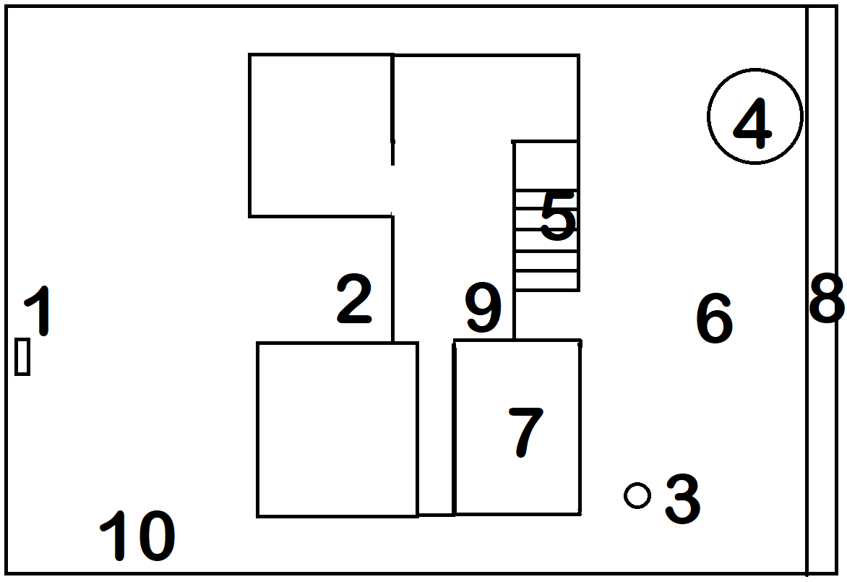

My physical activity treasure hunt
Landmark | Activity | Equipment

1.

2.

3.

4.

5.

6.

7.

8.

9

10.

My home

Draw picture here

Family physical activity treasure hunt recording sheet
Name | Att 1 | Att 2 | Att 3 | Att 4 | Att 5 | Att 6 | Att 7 | Att 8 | Att 9 | Att 10

Goal setting
This is an opportunity for all family members to set a physical activity goal. After completing the physical activity treasure hunt, over a two week period, what would you like to improve? When setting goals ensure they are SMART goals.
Name:
Goal:
I am going to achieve this by:
Name:
Goal:
I am going to achieve this by:
Name:
Goal:
I am going to achieve this by:

Name:
Goal:
I am going to achieve this by:

Review (at the completion of 2 weeks):
Name:
As a result of setting a goal and completing the treasure hunt, I have achieved:

I will continue to improve:
Name:
As a result of setting a goal and completing the treasure hunt, I have achieved:

I will continue to improve:
Name:
As a result of setting a goal and completing the treasure hunt, I have achieved:

I will continue to improve:
Name:
As a result of setting a goal and completing the treasure hunt, I have achieved:

I will continue to improve:

