PDHPE

Stage 5: Child Protection Education

Resources

The impact of power and identity on relationships

Contents
Teacher notes: Silent card shuffle activity (answers) 2
Cards: Silent card shuffle activity 3
Gender cards 7
Worksheet: They’re never happy! 10
Teacher notes: Types of power 12
Cards: Types of power 13
Worksheet: Use of power scenarios 16
Worksheet: Who? How? Where? Why? 20
Worksheet: Types of abuse scenarios 21
Worksheet: Types of abuse scenario analysis 25
Worksheet: Safety plan 26
Teacher’s notes: Infographic What do we know about family, domestic – sexual violence in Aust 2019 27
Teacher’s notes: Infographic Key facts on young women and family, domestic – sexual violence in Aust 2019 28
Teacher’s notes: Putting the prevention of violence against women into practise How to change the story 29
Worksheet: Plus 1 activity 37

Teacher notes: Silent card shuffle activity (answers)
Term | Definition
Norms | Customary rules that govern behaviour in groups and societies, eg expected ways to look and behave.
Stereotypes | A widely held but fixed and oversimplified image or idea of a particular type of person or thing.
Expectations | Strong beliefs about the proper way someone should behave or something should happen.
Identity | Individual characteristics (including thoughts, ideas, feelings and attitudes towards self-worth) and capabilities of a person, or characteristics of a social or cultural group. Refers to all things that define who we are at any given moment in our lives. It is not static and is influenced by contextual factors.
Gender | Refers to socially or culturally defined ideas about masculinity (male roles, attributes and behaviours) and femininity (female roles, attributes and behaviours).
Sex | The biological characteristics that define humans as female or male. While these sets of biological characteristics are not mutually exclusive, as there are individuals who possess both, they tend to differentiate humans as males and females.
Sexual identity | The perception a person has of themselves, their sexuality and the way they present themselves to others.

Cards: Silent card shuffle activity

Norms | Stereotypes
Expectations | Identity
Gender | Sex
Sexual identity

Customary rules that govern behaviour
in groups and societies, eg expected ways
to look and behave.
A widely held but fixed and oversimplified image
or idea of a particular type of person or thing.
Strong beliefs about the proper way someone
should behave or something should happen.
Individual characteristics (including thoughts,
ideas, feelings and attitudes towards self-worth)
and capabilities of a person, or characteristics of
a social or cultural group.

Refers to all things that define who we are
at any given moment in our lives. It is not static
and is influenced by contextual factors.
Refers to socially or culturally defined ideas about masculinity (male roles, attributes and behaviours) and femininity (female roles, attributes and behaviours).
The biological characteristics that define
humans as female or male.

While these sets of biological characteristics
are not mutually exclusive, as there are individuals
who possess both, they tend to differentiate
humans as males and females.
The perception a person has of themselves,
their sexuality and the way they present
themselves to others.

Gender cards
They need to sleep | They can have children
They like having sex | They can work
They use Facebook | They are strong
They get their hair cut | They go through puberty
They like to dance | They are emotional
They have a penis | They have a vagina
They have pubic hair | They use their legs
They need to feel valued | They have a range  of eye colours
They sometimes  fight with friends | They are protected  by their family
They do the cooking | They earn the money
They do the cleaning | They care for children
They control the money | They drive too fast
They drive too slow | They do the groceries
They do the school run | They do the laundry
Their bodies are used to  sell products | They cry
They eat | They play sport
They save their money | They can go out alone
They can wear  what they want | They like to study
They don’t cry | They like to talk
They have friends | They can garden
They like to read

Worksheet: They’re never happy!

Lucy 15
Jack and I have been going out for over a year. We really like each other and have talked a lot about whether to have sex. We have done basically everything except intercourse, and we spend a lot of time lying together kissing, cuddling and watching movies.
I’m worried that if I do have sex with Jack, he will tell people and I will get called a ‘slag’. Mum is really proud of me because I haven’t had sex. Most of my friends also say I should wait.
I had two really bad things happen this week that made me glad I hadn’t had sex with Jack. I found out that Jack has been telling other people about other things we do together. Then my friend James changed my Facebook status to say ‘Jack is going to get some sex for his birthday’. I was so embarrassed. I know some of my friends’ mums are Facebook friends and they will think I’m a real slut.
One of the worst things about the whole situation is that Jack’s sister is my best friend and she was really angry with me for being cross at Jack and his friends. A girl can’t win!

Questions
- What is Lucy most worried about? Do you think this is a common concern for girls? What does this tell us about sexuality and being a girl?
- Do you think boys have the same concerns?
- Why do you think Jack told the others about his relationship with Lucy?
- What messages is Lucy’s mum giving her about being a girl and having sex?
- What other issues in the case study make Lucy think she should be worried?
- Would you call Jack and Lucy’s relationship respectful? Why/why not?
- What would you say to Lucy to challenge some of the messages she is getting from the people around her to make her feel better about the situation?

Finn 16
I have gone out with heaps of girls. Some of them I’ve really liked, we’ve kissed and cuddled. One girl I saw for ages and we used to lie together on her bed, kissing and cuddling and other stuff. But that was all.
Dad always calls me the stud of the family and I can tell he’s proud of me because he thinks I’m doing it with all those girls. But my older brother gets heaps from Dad because at 22 he hasn’t had a girlfriend and only goes out with his mates. Dad’s always saying to Mum he’s probably gay like her brother.
I’m a virgin but I wouldn’t tell anyone that. My friends mouth off about their experiences all the time and I feel like an idiot because I haven’t done it yet. I just pretend that I have. I don’t know why I keep pretending or what the big deal about going all the way is.
I don’t think about sex all the time, there are stacks of other things in my life like football and school and basketball. I haven’t really met anyone yet that I love enough to want to have sex with.

Questions
- What does Finn’s pretending to have sex say to other people about his sexuality and what he thinks a man should be?
- If his friends knew he was a virgin, do you think it would change what they think of him?
- What does his dad think is important about Finn’s sexuality and being a man? Where else might Finn learn these kinds of messages about boys and sex?
- What if Finn was Fiona and was having sex with lots of boys? How would people see her?
- Are the expectations about sexuality the same for boys and girls?
- What if Finn was gay? Would his expectations of sexuality and gender be different? What would other people’s expectations be?
- Do you think Finn acts respectfully? Why/why not?
- What would you say to Finn to challenge some of the messages he is getting from the people around him to make him feel better about the situation?

Teacher notes: Types of power
Type | Definition | Examples
Information | Power through knowing things. | - knowing procedures to appeal against unfair practices  - withholding log in details to joint bank accounts
Charisma | Power through being attractive. | - using fame to advocate for a marginalized group  - a social media influencer promoting an unhealthy product
Expertise | Power through knowledge, understanding, skills or experience in a particular area. | - being able to use first aid in an emergency  - a tech guru not helping someone access technology
Position | Power through authority or status. | - being the Prime Minister  - being the president of the school SRC
Reward | Power through ability to reward others. | - people responsible for selecting teams or members of performances  - teachers awarding special prizes
Connection | Power through knowing someone who has another type of power. | - being best friends with a ‘gold medal’ athlete  - being family friends with someone who is an expert in an area in which you want to become involved
Strength | Power through being emotionally or physically strong | - being an older child in a family where the children are young  - being able to manage your own feelings and to seek support from others when it will help
Convention | Power through social customs. | - being an Aboriginal elder  - being on a jury and having to keep discussions confidential

Cards: Types of power
Type of power  Information | Type of power  Charisma
Type of power  Expertise | Type of power  Position
Type of power  Reward | Type of power  Connection

Definition  Power through knowing things | Definition  Power through being attractive
Definition  Power through knowledge, understanding,  skills or experience in  a particular area | Definition  Power through authority  or status
Definition  Power through ability to reward others | Definition  Power through knowing someone who has another  type of power

Examples
- knowing procedures to appeal against unfair practices
- withholding log in details to joint bank accounts
Examples
- using fame to advocate for a marginalized group
- a social media influencer promoting an unhealthy product
Examples
- being able to use first aid in an emergency
- a tech guru not helping someone access technology
Examples
- being the Prime Minister
- being the president of the school SRC
Examples
- people responsible for selecting teams or members of performances
- teachers awarding special prizes
Examples
- being best friends with a ‘gold medal’ athlete
- being family friends with someone who is an expert in an area in which you want to become involved

Worksheet: Use of power scenarios

Scenario 1
Bill is in year 10 at school. He is well liked at the school and is a key player on the Senior basketball team, even though he is younger than the rest of the guys.
Bill ‘came out’ to his family and friends last year and is comfortable with people knowing he is gay and he mostly feels safe and supported at school.
Recently there has been a group of guys in Year 12 who have started to hassle Bill. It first began during basketball games when he would hear them shouting out things from the crowd like “Shit aim you fag!”, “Watch out number 10, the poof might try to hit on you!” and worse!
It has become worse as things have now become physical. Bill has been shouldered and tripped by the group when they see him by himself at school. He is worried and not sure what might happen next.

Questions
- What is the type of power being abused in the scenario? Where has the abuse occurred?
- How has power been abused in the scenario?
- What aspect of the person’s identity has made them vulnerable?
- How has the abuse of power prevented the person from feeling included, equal and/or respected?

Scenario 2
Mia is 15 and goes to an all-girls school. She is very self-conscious about the way she looks and lacks confidence.
From afar, Mia admires the group of “hotties” and wishes her parents would let her colour her hair like theirs, she even hears them talking about their beauty therapist in class!! She is linked up with them on socials and sees the flood of amazing looking selfies they post all the time.
A few weeks ago, Mia and her family went to a wedding. She had her hair done especially and picked out a new dress which she loved. Mia took a selfie and posted it on her socials. One of the girls from the from the group wrote a mean comment about the way Mia looked, tagged her friends and shared the picture.
Mia sat and read through all of the terrible comments people wrote about her and because the girls had so many connections on socials there were loads of them! She feels so embarrassed and doesn’t know how she will face them at school.

Questions
- What is the type of power being abused in the scenario? Where has the abuse occurred?
- How has power been abused in the scenario?
- What aspect of the person’s identity has made them vulnerable?
- How has the abuse of power prevented the person from feeling included, equal and/or respected?

Scenario 3
Nell is 17 years old and comes from a large family of six children. She has four older brothers and one younger sister.
Her father is quite sick and not well enough to work so her Mum has two jobs. She works full time and four nights a week just to make ends meet. Nell is expected to cook dinner every night and make lunches for all her siblings every day.
She also needs to make sure the house is tidy as her father is very well respected in the community and has many visitors come to check on him and keep him company.
Nell’s eldest brother has taken on the role of father figure in the family and is very hard on her. He constantly criticizes her cooking and house-keeping skills. Recently he has started to slap her if she is not doing as he asks. She is constantly worried and fearful of him.

Questions
- What is the type of power being abused in the scenario? Where has the abuse occurred?
- How has power been abused in the scenario?
- What aspect of the person’s identity has made them vulnerable?
- How has the abuse of power prevented the person from feeling included, equal and/or respected?

Scenario 4
Raj is 19 and a Sikh. He proudly wears a turban. He has been working at a variety store for over a year and has always worked on the back dock, unloading pallets and organising stock.
It is very tiring and dirty work and Raj has asked his boss on a number of occasions if he could work on the checkout to gain more experience and practise his customer service skills. The boss keeps saying he’ll think about it.
Raj finds out that one of the checkout operators is leaving and thinks he will finally have his chance. He asks his boss again who says, “you don’t have the look we need in the shop”. At the start of his next shift Raj finds out that the boss’ girlfriend is the new person on the checkout.
Raj needs this job but does not feel happy about the way he has been treated by his boss.

Questions
- What is the type of power being abused in the scenario? Where has the abuse occurred?
- How has power been abused in the scenario?
- What aspect of the person’s identity has made them vulnerable?
- How has the abuse of power prevented the person from feeling included, equal and/or respected?

Worksheet: Who? How? Where? Why?
Who? | How?
Where? | Why?

Worksheet: Types of abuse scenarios

Scenario 1: Ayesha
Ayesha is 17 years old and she is still learning to speak English. Her family are refugees and maintaining their culture and religion is very important to them. Ayesha’s teacher notices that she seems depressed and has taken a lot of time off school. Her teacher also observes that Ayesha’s family seem to be very strict and controlling. Ayesha always has someone with her outside school hours and the teacher has heard from Ayesha’s classmates that she isn’t allowed to go out with friends without a family member going with her. She has a part time job but the money she earns goes into her Dad’s bank account.
When the teacher asks Ayesha if she is okay, Ayesha says that her parents took her to visit relatives. Her parents told Ayesha that she would only be able to go back to school if she agreed to marry a man her parents had chosen for her, whom she had never met. Ayesha married this man so that she could return to school. Her parents told her that when she turns 18, she will have to sign migration papers for him so that he could get a permanent visa and live with her in Australia.
Ayesha tells her teacher that she feels like a slave, and never wanted to marry him. Ayesha says that she feels trapped and is scared about what might happen if she tries to leave her family as her parents threaten her regularly when she tries to tell them that she isn’t happy. Her 18th birthday is coming up soon and she feels she needs to act before they force her to sign the papers.

Scenario 2: Kira
Kira has been with her husband for a long time and they have two young children. Things were great when they first got together but she standard to notice some negative changes in his behaviour soon after their wedding. He has a very bad temper and yells at her all the time over little things. Kira is put down regularly and constantly told that what she does isn’t good enough, so she has lost all confidence in herself. What upsets her the most is that the children see how he treats her.
No one sees the physical violence. Kira is in constant fear of her husband as he hits her quite often but not where anyone will notice the marks he leaves on her. She would love to talk to her friends and family about what is going on, but he checks her phone all the time so she is worried someone might send a message he would read. He won’t let her get a job because they don’t “need” the money, so he knows exactly where and how she spends money.
Things have been getting worse lately and she is getting worried about the children as they have started to mention his behaviours. The physical violence has escalated, particularly after he has been to the pub with his mates. Kira has decided she must leave soon as she fears for the safety of herself and her children.

Scenario 3: Ben
Ben is 22 and lives by himself as his parents passed away when he was a teenager. Ben has an intellectual disability and his older siblings pay for a carer to assist him with day to day tasks, but a reliable one has not been easy to find. He finds it difficult to build up a relationship with them as they change so often. Sometimes he is not even sure of who will turn up!
The latest one seemed nice at first. She isn’t much older than Ben and liked the same music as him, so it was good to have something in common. Part of her responsibility is to take Ben shopping and to appointments, but she always says, “we’ll do that later”. She also yells at him if he asks too many questions or talks too much as she says it disturbs her when she is on her phone. Sometimes her friends come over and they bring food and drinks but don’t share with Ben. When he says he is hungry and there is no food in the fridge, his carer tells him to “just make some toast”. Ben was sick of just eating toast so he thought he would make some eggs to go with it. He wasn’t supposed to cook when the carer wasn’t there but he was starving! Ben burned his wrist badly but was too scared to tell his carer because he thought he would get in trouble. He pulled his jumper sleeve over it so she wouldn’t notice.
During the week the burn got very red and sore and Ben started feel hot. He didn’t understand that the burn was infected. He knew he needed help but wasn’t sure what to do or who to turn to.

Scenario 4: Ryan
Ryan is 16 and lives with his Mum, Dad and older brother in a regional town with a population of about 5000 people where everyone knows everyone-and their business! He has known for a very long time that he is attracted to guys and feels very comfortable about it. There is a small but connected group of kids in the community who all identify as same-sex attracted, and confidentiality is respected as they are very empathetic with each other’s situation.
His Dad’s family have lived in the town for generations and are very well known and highly respected. Reputation is everything to them. Rugby league is also very big in the town, although not something Ryan is particularly interested in, much to his Dad’s disappointment as he is President of the local club. Ryan has been feeling very overwhelmed about his family finding out that he is gay through town gossip and has decided it is better if he tells them. One Sunday afternoon he finally got up the courage to tell his parents and older brother. He thought it was good timing as both his Dad and brother were on a high and had had a few beers to celebrate after the footy team had won a tough match.
Things did not go as Ryan had planned. His Mum just started crying and ran off to her room, his Dad and brother were engulfed with rage. Both got right up in Ryan’s face and started hurling verbal abuse at him, calling him every name under the sun. His Dad was adamant that he was not welcome in the family anymore and to Ryan’s surprise, sent him to “pack his bags”. Ryan stood in dismay, but soon realised his Dad was serious so he quickly went to his room and gathered what he could. As he walked towards the front door his brother called out to Ryan and as he turned around, he felt a massive blow to his face. He blacked out momentarily and could feel the blood running down his face. Ryan did not know where to go or who to turn to.

Worksheet: Types of abuse scenario analysis
Types of power abused | Contextual factors | Areas of health at risk
Ayesha | Ayesha | Ayesha
Kira | Kira | Kira
Ben | Ben | Ben
Ryan | Ryan | Ryan

Worksheet: Safety plan
1  Outline what decision needs to be made  What indicates the decision needs to be made? | 2  List the choices and get information on each choice | 3  Consider the consequences of each choice for each character | 4  Make a decision and outline how you would implement it  How would the decision be evaluated?
 | Choice  (option 1)  Choice  (option 2)  Choice  (option 3) | Consequences  (for option 1)  Consequences  (for option 2)  Consequences  (for option 3)

Teacher’s notes: Infographic What do we know about family, domestic – sexual violence in Aust 2019
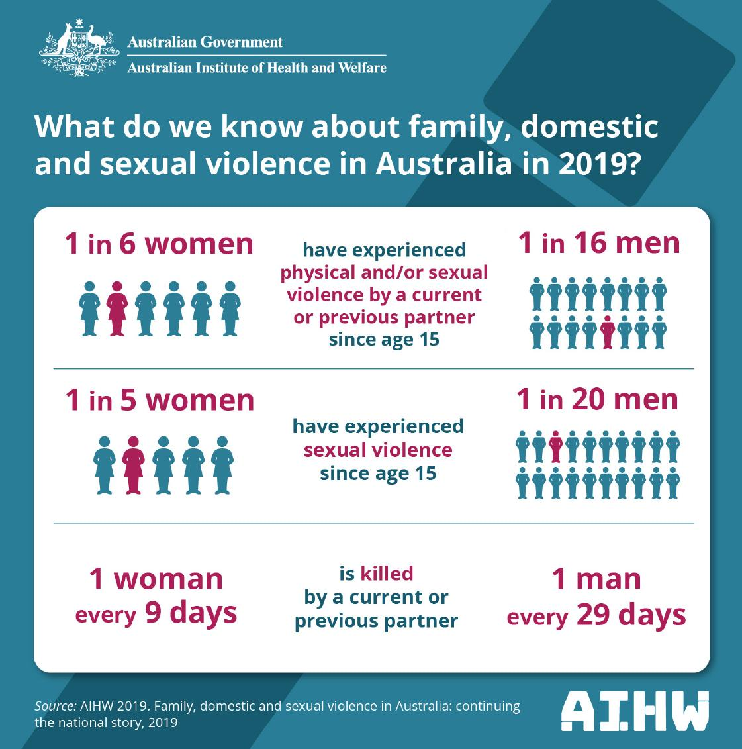

Teacher’s notes: Infographic Key facts on young women and family, domestic – sexual violence in Aust 2019
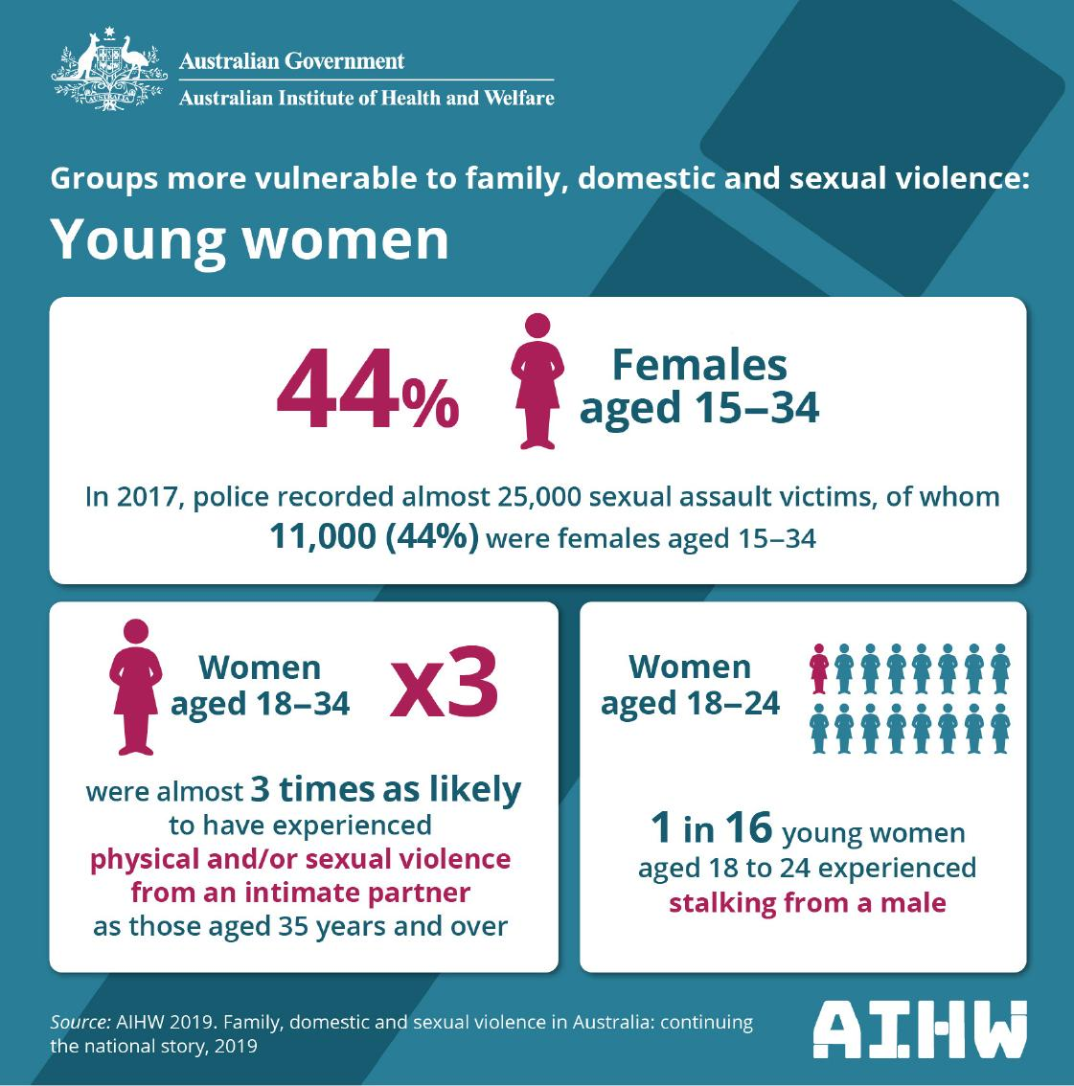

Teacher’s notes: Putting the prevention of violence against women into practise How to change the story
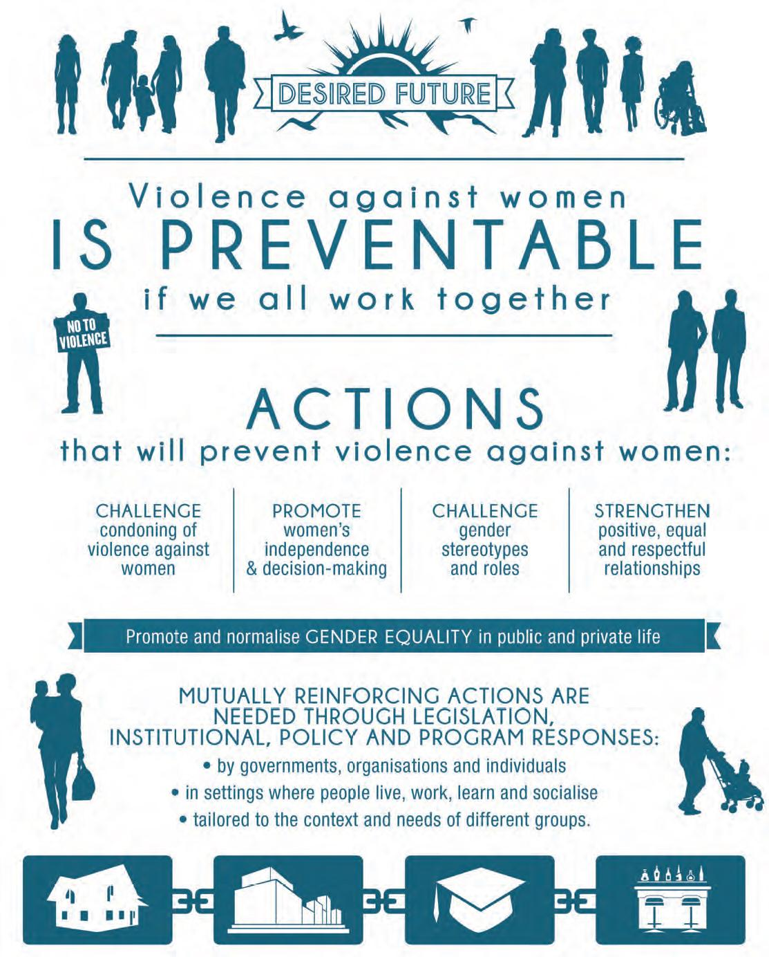

Cards: Media world versus Real world
MEDIA WORLD  The world we see in  places such as films, television, advertising, pornography, music videos and gaming … | REAL WORLD  The world we see around us in real life in places such as homes, schools and neighbourhoods …
BOTH | NEITHER

Most people are white. | Most people are happy.
Most people are beautiful | Things go wrong but it all ends up good in the end.
Good people get what they want. Bad people get punished. | People usually have sex with a partner they have just met.
People’s complexions appear to be perfect. | It’s quite common for women to have cosmetic surgery on their faces, breasts and/or genitals.
Men are entitled to get sex when they want it. | All men have very large penises.
All men want sex  all the time. | Women’s values are based on their looks and sexuality.
Women are for men’s sexual gratification. | Sexual decision making  is not complex or difficult.
Heterosexual sex almost always includes anal sex. | Women don’t have  body hair.
Most women are thin. | Sex often occurs between more than two people  at once.
Violence seems to be sexy. | Sex is for male arousal  and pleasure.
There is no need to be concerned about engaging in unprotected sex with multiple partners. | Women always want sex, even if it doesn’t seem this way initially.
Women orgasm easily from whatever men do to them. | Women love to be called abusive names.
Men are controlling and dominating. | Sex needs to be negotiated with freely given consent.
If sex occurs without the consent of one party it is sexual assault, which is a serious crime and violation of human rights. | Most women enjoy  touching and kissing  in the lead up to sex.
Women and men come  in many shapes,  sizes and colours. | Most women want to  please their partners.
Women want sex to be pleasurable for them. | Most men want to please their partners.
Men want sex to be pleasurable for them. | Most women want sex  to be mutual and respectful.
Men do not always want  to have sex. | Women do not always  want to have sex.
Sex can be creative, tender, loving and genuinely pleasurable for everyone involved. | Most heterosexual sex does not include anal sex.
Unprotected sex is a  health risk. | Sex usually occurs  between two people.
Women and men like to be – and are entitled to be – spoken to respectfully. | Sex often occurs in the context of a relationship.
Sex can be difficult to negotiate. | Free and full consent is crucial to good sex.
Women and men are multidimensional human beings with diverse skills and interests. While they are all sexual beings,
they are much more
than that, too.

Worksheet: Plus 1 activity
RECALL: Watch the short clip Fairy tales to reality TV: how girls and guys are portrayed in movies and TV. Take 3 minutes to record as many key points and important details that you can remember.
Record key points and details | Activity instructions
PASS RIGHT & ADD 1
Add ONE new idea,
elaboration or connection.
→ Elaboration: add a new
detail to an existing item
on the list.
→ New Idea: something
missing from the list
→ Connection: relationship between ideas
REPEAT
Pass the page again and repeat at least 2 times.

REVIEW
Examine your original page, read through and review the additions. Add any new ideas you gained from reading the work of others.
REFLECT
→ What did you find as your read the ideas of others?
→ How did it help you build on the thinking of others?
→ How did it help to build
your understanding of what you just read/ viewed?

