PDHPE

Stage 3: Child Protection Education

Resources

Safe and unsafe relationships

Contents
Cards: Tea party questions 2
Worksheet: Y-chart 4
Cards: Word draw instructions 5
Worksheet: Different relationships 8
Worksheet: Community and online support services 10
Worksheet: Rights scenarios 11
Worksheet: Online scenarios 14
Worksheet: Kanoa and Rhianna 20
Teacher notes: Types of power 22
Cards: Types of power 23
Cards: Use of power 30

Cards: Tea party questions
If we are working together
how can I include you?
If I don’t agree with you
how should I let you know?
If you are upset or angry about something what would you like me to do?
What do other people do
that make you feel important
to our class?
How can I show you respect
in our classroom?
Why is it important to show respect
in our classroom?

Worksheet: Y-chart

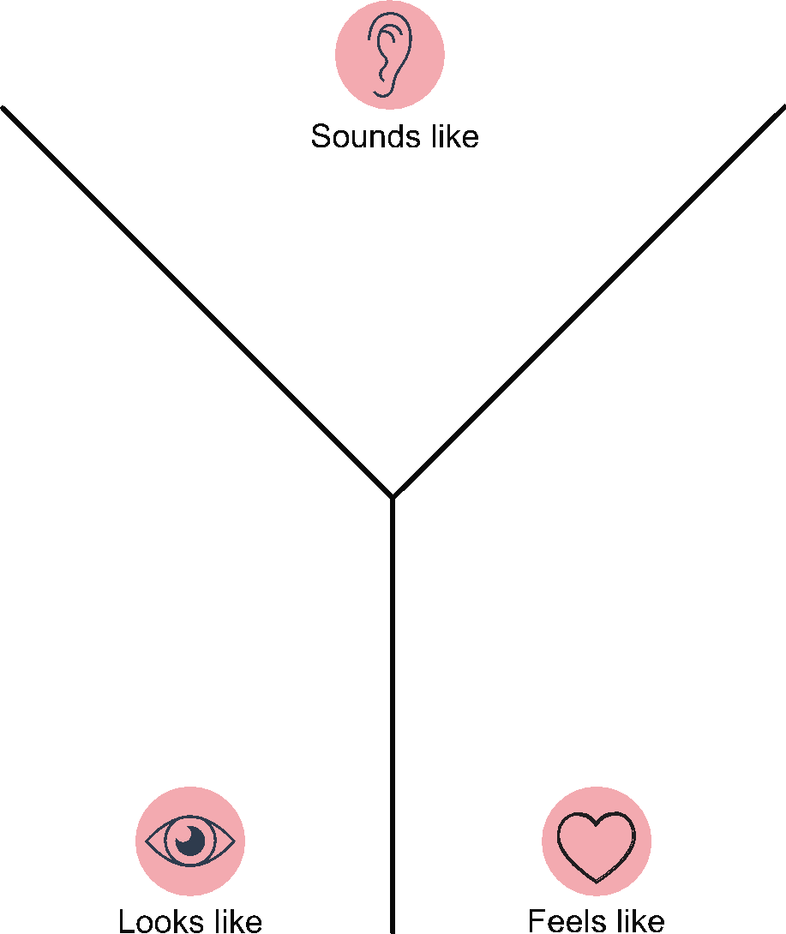

Cards: Word draw instructions
(Adapted from Dirty Tricks: Classroom games for teaching social skills
by Dr Helen McGrath)
The object of the game is for the group to guess as many words as possible that are drawn by one of the group members.
- Each group is given a different pile of cards with different items to draw so groups can’t guess off another team.
- The drawer selects the card on top of the pile and attempts to draw the item for the group to guess.
- Once the word is guessed correctly or passed on, the next card is drawn and the game continues until one group guesses all words.

swan | phone | shoelace
chair | door | rabbit
arrow | scissors | lamp
violin | Rubik's cube | peanut
pocket | chef | rocket
street | rope | bone
stop | pencil | music
sleep | spoon | car
yo-yo | dollar | envelope
planet | dog | light globe
table | sun | turkey
belt | reindeer | bulldozer
haircut | television | apple
jump | cone | thin
screwdriver | wet | drip
fence | dishwasher | peg
earthquake | length | laps
juggle | brain | knight
wrinkle | goat | mirror
fairy | rainbow | laptop
camera | book | glass
tree

Worksheet: Different relationships
- Add your name or a picture to the box labelled ‘Me’.
- Write the names of people you know in different relationships.
- Under each person write what makes this a relationship.
- Colour each box to show how close the relationship is. For example, blue might mean very close, green might mean close and yellow might mean not very close.

Name: | Name: | Name: | Name:
Name: | Me |  | Name:
Name: | Name: | Name: | Name:
Name: | Name: | Name: | Name:
Name: | Name: | Name: | Name:

Worksheet: Community and online support services
Research details of a local community support service and record information in the table below.
Name of support service
Contact details
Website address
Address
Services provided
Research details of a reliable online support service and record information in the table below. Online support services could include: Kids helpline, e-Safetykids from the e-Safety Commissioner Website and Bullying. No Way!
Name of online support service
Website address
Contact details
Services provided
Why do you think this is a reliable online source?

Worksheet: Rights scenarios
Read through the scenarios and answer the questions.
Seb’s Dad had come home angry and was in a really bad mood. Seb spilt his drink at dinner time and his Dad yelled in his face.
- Whose rights are not being respected?
- What right isn’t being met?
- What behaviour or action is not respecting the rights of someone?
- What would you do?
Amy is always told by her Mum that she is hopeless and stupid. Her Mum says that her brother is better than her and wishes she was never born.
- Whose rights are not being respected?
- What right isn’t being met?
- What behaviour or action is not respecting the rights of someone?
- What would you do?
Saxon’s neighbour was taking photos of him while he was playing in his backyard. The neighbour took the photos without Saxon’s permission even when he asked him to stop.
- Whose rights are not being respected?
- What right isn’t being met?
- What behaviour or action is not respecting the rights of someone?
- What would you do?

Worksheet: Online scenarios
Read through the scenario and answer the questions.
Scenario 1
Mahli had been chatting to a friend online called TallDude11. They’d been talking for a while and TallDude11 had asked Mahli to meet him at the local shops. Mahli told her friends about it and when and where they were going to meet.
Mahli didn’t tell her parents because she didn’t think they’d let her meet up with a boy. When Mahli went to meet TallDude11 she couldn’t see any boys her age but there was an older guy waiting where she was supposed to meet TallDude11.
- What were the safe and unsafe behaviours or actions in the scenario?
- What would you do next if you were the person in the scenario?
- Which of your support network adults would you tell if you needed advice or support in this situation?
- What safety messages would you give to someone to increase safety or reduce the risk online?
Read through the scenario and answer the questions.
Scenario 2
Jack kept getting group text messages while he was trying to win a battle on his favourite game. When he checked his phone he’d missed 60 messages. They were all about a photo someone had sent to everyone.
It was a photo of Johan, a kid from school. Someone had started a poll about ways they could bully Johan and posted it for everyone to see, including Johan.
- What were the safe and unsafe behaviours or actions in the scenario?
- What would you do next if you were the person in the scenario?
- Which of your support network adults would you tell if you needed advice or support in this situation?
- What safety messages would you give to someone to increase safety or reduce the risk online?
Read through the scenario and answer the questions.
Scenario 3
Ethan was pretty excited about getting his first phone. The first thing he did was set up a profile on one of the social media apps that his friends were on. He wasn’t too sure how it all worked and didn’t really want to ask his parents so he just had a go.
He had added his name, address, school, age, soccer club and phone number. He remembered he had to set his account to private but he didn’t know how, so he was going to ask one of his friends to show him tomorrow.
Not long after Ethan received a friend request from someone he didn’t know but they said they were friends with one of his friends from school. Ethan accepted the friend request and they started messaging. Ethan didn’t know who he was messaging and was worried this person might not actually know his friend.
- What were the safe and unsafe behaviours or actions in the scenario?
- What would you do next if you were the person in the scenario?
- Which of your support network adults would you tell if you needed advice or support in this situation?
- What safety messages would you give to someone to increase safety or reduce the risk online?
Read through the scenario and answer the questions.
Scenario 4
Peta and George had been taking photos and posting them online. One photo of them together was getting heaps of likes. Then someone started making fun of them saying they were dating and that they loved each other. Someone else made some nasty comments about their looks. Then the nasty comments kept coming.
- What were the safe and unsafe behaviours or actions in the scenario?
- What would you do next if you were the person in the scenario?
- Which of your support network adults would you tell if you needed advice or support in this situation?
- What safety messages would you give to someone to increase safety or reduce the risk online?
Read through the scenario and answer the questions.
Scenario 5
Beth had a few friends over for her birthday. They had been swimming all day and they were getting ready for bed. One of her friends wanted to check out one of the new social media apps Beth had on her phone. Beth had to help her Mum so gave her friend her password to get onto the app.
The next day Beth was looking at the app and noticed there were lots of posts that she hadn’t posted. Some of them were mean and nasty and there was one photo of her that she didn’t want on there. Then she noticed a new post pop up. Someone was controlling her account.
- What were the safe and unsafe behaviours or actions in the scenario?
- What would you do next if you were the person in the scenario?
- Which of your support network adults would you tell if you needed advice or support in this situation?
- What safety messages would you give to someone to increase safety or reduce the risk online?
Read through the scenario and answer the questions.
Scenario 6
Kanoa had many friends on his social media app. He didn’t know them all but he kept his personal information private so he didn’t think it really mattered. There was one girl that messaged him every day and they became really good friends. Her name was Rhianna. She asked him to send a photo. Kanoa thought it was a bit weird but he sent one. Rhianna said he was super cute and she loved the photo and not long after sent him one of her.
Rhianna said he could be a model and that if she had a couple more photos she could send it to her modelling agency. She thought Kanoa would get heaps of money modelling. Not long after Rhianna said she had sent his photo to the modelling agency and they wanted to pay him for more photos and could he send some soon.
- What were the safe and unsafe behaviours or actions in the scenario?
- What would you do next if you were the person in the scenario?
- Which of your support network adults would you tell if you needed advice or support in this situation?
- What safety messages would you give to someone to increase safety or reduce the risk online?

Worksheet: Kanoa and Rhianna
Kanoa had many friends on his social media app. He didn’t know them all but he kept his personal information private so he didn’t think it really mattered.There was one girl that messaged him every day and they became really good friends. Her name was Rhianna. She asked him to send a photo. Kanoa thought it was a bit weird but he sent one.
Rhianna said he was super cute and she loved the photo and not long after sent him one of her. Rhianna said he could be a model and that if she had a couple more photos she could send it to her modelling agency. She thought Kanoa would get heaps of money modelling. Not long after Rhianna said she had sent his photo to the modelling agency and they wanted to pay him for more photos and could he send some soon.
Kanoa felt pretty good thinking that he was good enough to be a model and he was excited about being paid for his photos. He really wanted some new shoes that all his mates had and thought about how he could buy them if he was making money.
Kanoa decided to send another photo to Rhianna and asked when he would get paid. Rhianna replied and said the modelling agency needed a few more photos to set up a profile for Kanoa and then he could start making money. Rhianna sent a few photos of other boys showing the types of photos the modelling agency were after. The photos made Kanoa feel very uncomfortable, he didn’t want to take the types of photos Rhianna had sent him. Rhianna said that he could make really good money and that if he gave her his address the modelling agency would send a little bit of money for the first photo. Not long after Kanoa received $20 in the mail with a letter that said the photos were good but the agency needed more.
The next time Kanoa was online, he saw he had missed a lot of messages from Rhianna. They were all about the money the agency had sent and how they were getting impatient and needed the photos or they would find someone else. Kanoa thought about it and decided the photos they wanted were not ok and he didn’t want to do it anymore, even though he’d get money for it. Rhianna sounded really angry in her next text and told Kanoa he had wasted her time and made her look bad with the modelling agency. She said if he could just send one more photo then she might be able to get him more time. Kanoa didn’t want Rhianna to feel bad and he wanted her to like him. He decided one more photo wouldn’t hurt. Kanoa sent the photo but it didn’t feel right. He regretted sending it instantly and he felt sick in the stomach. Kanoa decided that he wouldn’t send anymore photos.
Rhianna was really happy that Kanoa had sent her the photo and wanted more. Kanoa said he couldn’t do it anymore. Again, Rhianna got angry but Kanoa still said no.
The next message Kanoa got from Rhianna made his body freeze. Rhianna said that if Kanoa didn’t send the photos the agency wanted then they would send his photos to his parents. Kanoa didn’t know what to do.

Discussion questions
- What types of coercion did Rhianna use? (force, bribes, threats, guilt)
- What behaviours, actions or words demonstrate the types of coercion? You can highlight the text to show where this occurred.
- How did Kanoa’s feelings change throughout the scenario?
- Which feelings occurred when Kanoa was being coerced?
- What were Kanoa’s feelings telling him?
- How could Kanoa have resisted each example of coercion?
- Who do you think Rhianna is? Why? Why not?
- What do you think Kanoa should have done and should do now?

Teacher notes: Types of power
Type | Examples | Power in use
size | - Being taller.  - Having a bigger build. | Anhil was shopping with his parents. They were trying to reach something on the top shelve but neither were tall enough. Anhil walked over and reached the item for them.
strength | - Being a stronger athlete.  - Having more physical strength than someone.  - Coping with problems better. | Sharni worked at her Aunty’s grocery store on weekends. A lot of elderly people would shop at her Aunty’s store. Sharni would carry their groceries to their car for them.
age | - Being older. | Coen often looked after his younger sister. He made sure she had something for dinner and got to bed on time.
popularity | - Being popular.  - Having lots of friends. | Sami had a lot of friends at school. When Sami heard that a student at school was very sick, Sami asked everyone to help raise money.
fame | - Being well known like an actor, famous musician or band, reality television star or sports star. | A well-known actor returned to their primary school to talk to the students about bullying on the National Day of Action against Bullying and Violence.
position (authority) | - Being a boss, a religious leader, parent or carer, student representative, team captain, coach, teacher. | The soccer coach ran all team members through a tough training schedule in preparation for their first game of the season.
group size | - Being part of a group, club or organisation. Having a bigger group than others. | Zen’s class was the largest in the school. When the school had a fundraiser, Zen’s class raised the most money and won the pizza reward day.
knowledge or expertise | - Knowing a lot about a certain area such as a car mechanic, doctor, teacher, police officer, lawyer, nurse or scientist. | Georgie and her dad were running through their local park. Georgie’s Dad started to feel unwell and collapsed. A person nearby saw what had happened and came to help. They performed first aid on Georgie’s Dad.
money or possessions | - Being able to buy or owning expensive items like brand name clothes, latest technology, cars, toys or shoes. | Phan’s parents owned a very successful business and they had a lot of money. Phan’s parents donated brand new sports equipment to his school.
connections | - Knowing or being related to someone famous or important. | Alexandra’s Uncle was a member of famous band. When Alexandra had a party everyone wanted to be invited.

Cards: Types of power

Type of power  size | Type of power  strength
Type of power  age | Type of power  popularity
Type of power  fame | Type of power  position (authority)
Type of power  group size | Type of power  knowledge or expertise
Type of power  money or possessions | Type of power  connections

Type of power examples  - Being taller  - Having a bigger build. | Type of power examples  - Being a stronger athlete  - Having more physical strength than someone  - Coping with problems better.
Type of power examples  - Being older. | Type of power examples  - Being popular  - Having lots of friends.
Type of power examples  - Being well known like an actor, famous musician or band, reality television star or sports star. | Type of power examples  - Being a boss, a religious leader, parent or carer, student representative, team captain, coach, teacher.
Type of power examples  - Being part of a group, club or organisation. Having a bigger group than others. | Type of power examples  - Knowing a lot about a certain area such as a car mechanic, doctor, teacher, police officer, lawyer, nurse or scientist.
Type of power examples  - Being able to buy or owning expensive items like brand name clothes, latest technology, cars, toys or shoes. | Type of power examples  - Knowing or being related to someone famous or important.

Power in use
Anhil was shopping with his parents. They were
trying to reach something on the top shelve
but neither were tall enough. Anhil walked over
and reached the item for them.
Power in use
Sharni worked at her Aunty’s grocery store on
weekends. A lot of elderly people would shop
at her Aunty’s store. Sharni would carry their
groceries to their car for them.
Power in use
Coen often looked after his younger sister.
He made sure she had something for dinner
and got to bed on time.
Power in use
Sami had a lot of friends at school. When Sami
heard that a student at school was very sick,
Sami asked everyone to help raise money.
Power in use
A well-known actor returned to their primary
school to talk to the students about bullying
on the National Day of Action against Bullying
and Violence.
Power in use
The soccer coach ran all team members through
a tough training schedule in preparation for
their first game of the season.
Power in use
Zen’s class was the largest in the school. When the
school had a fundraiser, Zen’s class raised the
most money and won the pizza reward day.
Power in use
Georgie and her dad were running through their
local park. Georgie’s Dad started to feel unwell
and collapsed. A person nearby saw what had happened and came to help. They performed
first aid on Georgie’s Dad.
Power in use
Phan’s parents owned a very successful business
and they had a lot of money. Phan’s parents donated
brand new sports equipment to his school.
Power in use
Alexandra’s Uncle was a member of famous band.
When Alexandra had a party everyone wanted
to be invited.

Cards: Use of power
A babysitter always chooses his favourite TV programs. You would sometimes like to have
a turn to choose but you are never allowed.
One member of a group of friends feels
uncomfortable about some of their activities.
The group pressures the person to join in,
or not to be their friend anymore.
Sports monitors make other students line up
to receive sports equipment at lunch time.
Your school plans a fundraising event to support
a student at your school competing at a national
sports level. They make enough money to send the student and their family to the event and
help them pay for accommodation.
A teacher stops two students from fighting
and asks them to come to the office and
discuss their differences.
A popular student asks a classmate who is not
a friend to buy him an ice block from the canteen.
A student who always has the latest phone
makes her friends beg her before she will let them have a turn.
A famous actor supports a local music club to raise money to buy new equipment for young players.
When a child can’t get their own way they often
tell their Mother that they don’t like her.
A local Aboriginal Elder educates a group
of school students on native flora and helps
to establish a native garden at the school.

