PDHPE

Stage 2: Child Protection Education

Resources

Standing up for the rights of myself and others

Contents
Teacher notes: Super powers cards (answers) 2
Cards: Super powers 5
Worksheet: Using power – Alex and Uncle Danny scenario 13
Worksheet: Accident or abuse? 15
Teacher notes: Gender stereotype cards 16
Cards: Gender stereotype 17
Worksheet: Gender-based discrimination scenarios 18
Cards: Body parts 20
Worksheet: Body outlines 21
Teacher notes: What is sexual abuse? Alex and Uncle Danny scenario 23
Cards: Body language charades 25
Worksheet: Bribes – Alex and Uncle Danny 26
Cards: Bullying 28
Cards: Upstander Cards 31
Worksheet: Y-chart 33
Teacher notes: Definition Match cards answer sheet 34
Cards: Definition match 36

Teacher notes: Super powers cards (answers)

Heroes
Superman | He is strong enough to lift almost anything and he can fly. He can run and move faster than a bullet. He has X-ray vision (he can see through walls), and heat vision (he can shoot heat from his eyes). He can freeze things with his frost breath and his super-breath (which allows him to blow super hard). He uses his superpowers to save a lot of people.
Batman | Superpowers aren’t his real super powers but he learned many different ways to fight as he grew up. He wears a costume to scare criminals so that there is less crime in Gotham. He uses many different tools to fight dangerous criminals and villains.
Spiderman | His powers are that of super strength and agility, the ability to cling to almost every surface, the ability to shoot spider-webs using a device that he invented which he calls "web-shooters," and reacting to danger quickly with his "spider-sense". He fights criminals and saves people because he knows it is the right thing to do.
Hulk | He was exposed to Gamma radiation. When he gets mad, he turns into a very strong superhero. He is big and green skinned. When he changes into a superhero all his clothes except his purple shorts rip. He is really, really, strong and is almost invincible. His actions save people and defeat villains.
Iron Man | When he wears his suit he has special superpowers. He can fly and shoot beams from his hands using special technology called "repulsors" in his boots and gloves. There are many versions of his suit, because he keeps making improvements. He often battles to save the world.
Mr Incredible | All this superhero wants to do is save the world but he wants to do it on his own. His superpowers include super strength, super speed, ability to jump to incredible heights, he is not hurt by most things and very sharp senses. He is married to Elastigirl who also has superpowers.
Batgirl | Before she was a superhero she saved Batman from being kidnapped. From then on she helped fight crime as a masked superhero. She helps all the superheroes in Gotham City using her super smartness and her computer hacking skills. She also uses her amazing martial arts skills and her ability to remember and recall anything and everything.
Wonder Woman | She is the one of the first and most famous female superheros. She fights for peace and justice. She can run very fast, is very strong, and she can fly. She also fights crime using special things such as: a lasso of truth that makes people tell the truth; indestructible bracelets that block bullets; a tiara to knock out or trip enemies; and an invisible plane that can fly into outer space.
Storm | This superhero has power over the weather, can fly and can see in the dark. She is part of the X-men team and uses her abilities to help fight evil mutants and evil people. She fights for peace and equality between humans and mutants.
Elastigirl | She can stretch any part of her body to great lengths and mould it into different shapes and sizes. She has three children, Violet, Dash and Jack-Jack who all have their own superpowers. At one point it was illegal for her to use her superpowers and she spent this time raising her children. She eventually returned to help defeat a supervillain that planned to destroy all superheroes so he could take over the world as the one and only superhero.

Villains
Lex Luthor | He uses kryptonite capable of injuring Superman. He has no natural superpowers but his suit gives him super strength and makes it hard to injure him. He wanted to defeat Superman and take over the world but never achieved this. He is the biggest enemy of Superman.
Joker | He fell into a vat of chemical waste, which bleached his skin and turned his hair green and his lips bright red, giving him the appearance of a clown. He uses his venom which causes his victims to laugh uncontrollably. He is the main enemy of Batman.
Syndrome | He wanted to be a superhero but was rejected by his idol so decided to become a supervillain instead. He dedicated his life to defeating superheros and to get revenge on Mr Incredible. His goal was to take over the world as the only superhero. He has no superpowers but uses his intellect and engineering skills to create advanced technologies.
Harley Quinn | She works with the Joker and Poison Ivy. She does whatever she wants. Sometimes she battles Batman and robs jewellery stores and other times she’ll battle the bad guys. She is very strong and extremely smart. Her friend Poison Ivy injected her with a toxin that made her immune to poison and gave her healing powers.
Cat Woman | She has mastered Dragon Style Kung Fu and Karate and has used these skills to defeat Batman more than once. She has the ability to befriend cats and train them and on occasion they have come to her defence. She is sometimes called Batman’s girlfriend and has worked alongside him but also against him. She is a mysterious burglar and jewel thief.
Poison Ivy | She threatens to suffocate all of Gotham City unless she is given what she wants. She has the physical appearance of a plant with the power to talk plants into doing evil things. Her crime-partner is Harley Quinn. She has a deadly touch and is immune to all toxins and diseases.

Cards: Super powers
Match the super power to the hero or villain it belongs to.

Superman
Batman
Spiderman
Hulk
Iron man
Lex Luther
Joker
Syndrome
Mr Incredible
Batgirl
Wonder Woman
Storm
Elastigirl
Harley Quinn
Cat Woman
Poison Ivy

He is strong enough to lift almost anything and he can fly. He can run and move faster than a bullet. He has X-ray vision (he can see through walls), and heat vision (he can shoot heat from his eyes). He can freeze things with his frost breath and his super-breath (which allows him to blow super hard). | Superpowers aren’t his real superpowers but he learned many different ways to fight as he grew up. He wears a costume to scare criminals so that there would be less crime in Gotham. He uses many different tools to fight criminals.
His powers are that of super strength and agility, the ability to cling to almost every surface, the ability to shoot spider-webs using devices that he invented which he calls "web-shooters," and reacting to danger quickly with his "spider-sense". | He was exposed to Gamma radiation. When he gets mad, he turns into a very strong superhero. He is big and green skinned. When he changes into a superhero all his clothes except his purple shorts rip. He is really, really, strong and is almost invincible.
When he wears his suit he has special superpowers. He can fly and shoot beams from his hands using special technology called "repulsors" in his boots and gloves. There are many versions of his suit, because he keeps making improvements. | He uses kryptonite capable of injuring Superman. He has no natural superpowers but his suit gives him super strength and makes it hard to injure him. He wanted to defeat Superman and take over the world but never achieved this. He is the biggest enemy of Superman.
He fell into a vat of chemical waste, which bleached his skin and turned his hair green and his lips bright red, giving him the appearance of a clown. He uses his venom which causes his victims to laugh uncontrollably. He is the main enemy of Batman. | He wanted to be a superhero but was rejected by his idol so decided to become a supervillain instead. He dedicated his life to defeating superheros and to get revenge on Mr Incredible. His goal was to take over the world as the only superhero. He has no superpowers but uses his intellect and engineering skills to create advanced technologies.
All this superhero wants to do is save the world but he wants to do it on his own. His superpowers include super strength, super speed, ability to jump to incredible heights, he is not hurt by most things and very sharp senses. He is married to Elastigirl who also has superpowers. | Before she was a superhero she saved Batman from being kidnapped. From then on she helped fight crime as a masked superhero. She helps all the superheroes in Gotham City using her super smartness and her computer hacking skills. She also uses her amazing martial arts skills and her ability to remember and recall anything and everything.
She is the one of the first and most famous female superheros. She fights for peace and justice. She can run very fast, is very strong, and she can fly. She also fights crime using special things such as: the lasso of truth that makes people tell the truth; indestructible bracelets; a tiara to knock out or trip enemies; and an invisible plane that can fly into outer space. | This superhero has power over the weather, can fly and can see in the dark. She is part of the X-men team and uses her abilities against evil mutants and evil people. She would like peace and equality between humans and mutants.
She can stretch any part of her body to great lengths and mould it into different shapes and sizes. She has three children, Violet, Dash and Jack-Jack who all have their own superpowers. At one point it was illegal for her to use her superpowers and she spent this time raising her children. She eventually returned to help defeat a supervillain that planned to destroy all superheroes so he could take over the world as the one and only superhero. | She works with the Joker and Poison Ivy. She does whatever she wants. Sometimes she battles Batman and other times she’ll battle the bad guys. She is very strong and extremely smart. Her friend Poison Ivy injected her with a toxin that made her immune to poison and gave her healing powers.
She has mastered Dragon Style Kung Fu and Karate and has used these skills to defeat Batman more than once. She has the ability to befriend cats and train them and on occasion they have come to her defence. She is sometimes called Batman’s girlfriend and has worked alongside him but also against him. | She threatens to get rid of all of Gotham City unless she is given what she wants. She has the physical appearance of a plant with the power to talk plants into doing evil things. Her partner is Harley Quinn. She is immune to all toxins and diseases.

Worksheet: Using power – Alex and Uncle Danny scenario
Scenario part 1
Alex was eight. Uncle Danny was older and bigger than Alex. Sometimes Uncle Danny looked after Alex when Alex’s parents went out, like tonight. Alex liked it when Uncle Danny was around because they had lots of fun together.
Uncle Danny told Alex to go and have a shower because it was close to bedtime. Alex didn’t want to shower but Uncle Danny had been left in charge and Alex’s parents had said to be good and do what Uncle Danny said.
Uncle Danny said if Alex had a quick shower it would be ok to stay up a little bit later and watch television. Uncle Danny said this would be their little secret because they would both be in trouble if Alex’s parents found out.
Alex was excited about staying up past bedtime to watch television and quickly got in the shower.

- Who is using their power?
- Why does Uncle Danny have power?
- What is Uncle Danny using power for?
- Did Uncle Danny use power to help or harm?
- How do you feel about the way Uncle Danny used power?
- What might Alex be feeling?
- Is the secret about staying up late a secret Alex should keep or tell?
Scenario part 2
While Alex was showering, Uncle Danny walked into the bathroom and was watching Alex. Alex didn’t like Uncle Danny watching and asked Uncle Danny to leave. Uncle Danny said it was getting late and Alex needed to hurry up or there would be no television. Uncle Danny started to wash Alex’s private parts saying that it would be quicker. Alex got a funny feeling in her tummy and told Uncle Danny to stop (No).

- Who is using their power?
- What is Uncle Danny using power for?
- Did Uncle Danny use power in a way that respected Alex’s rights?
- How do you feel about the way Uncle Danny used Power?
- How do you think Alex might be feeling?
- Does Alex have power?
- When and how did Alex use part of the No-Go-Tell strategy?
- Alex told Uncle Danny to leave and then to stop. What else should Alex do?

Worksheet: Accident or abuse?
Read the situations below and sort into the correct column in the table.

Accident | Abuse

Another student pushes open the door when Harry is in the toilet and tries to touch Harry’s private parts. | Pat is burnt with a cigarette by an angry adult.
Sid falls off his bike as his younger sister runs in front of him. | Mick is chased and kicked by an older student on his way home.
Ellen is regularly told she is ‘dumb’ and ‘ugly’ by people on social media. | May falls over when she is bumped by her father when they are playing a game on a slippery floor.
Sam is knocked over by a classmate running past. | Anne is hit in the face with a basketball thrown from another game.
Ted is often yelled at by his mother and hit with a hairbrush which leaves big welt marks all over his back. | Someone opens the door to the toilet thinking it is empty, when Pam is in there. They quickly close the door.

Teacher notes: Gender stereotype cards

Possible discussion points for card 1  - What do you think it means when someone tells a boy ‘you throw like a girl’?  It is meant as an insult and that girls can’t throw as well as boys.  - Do girls and boys throw differently?  No, different people might throw differently but it is not determined by what gender you are.  - What message do you think this is sending girls? They can’t throw.  - What message do you think this is sending boys? They should be able to throw.  - Do you think these messages are true or fair? | Possible discussion points for card 2  - What message does this send a boy if he likes Lego friends?  - What message does this send a girl if she prefers original Lego?  - Why do you think the 5 main Lego friends characters are all girls?
Possible discussion points for card 3  - Who decides which boys are strong and which boys aren’t?  - Why are the ‘strong’ girls not included?  - What message might this send to boys?  That they should be strong and tough enough to do the hard jobs.  - What message might this send to girls?  That boys are strong and tough and girls can’t lift heavy things. | Possible discussion points for card 4  - Is this meant as an insult?  Yes, it is said to make the male feel bad about not beating a female at something.  - What message might this send to a boy or man?  That they should be better, stronger or faster than a girl or a woman and they should feel bad if they aren’t.  - What message might this send to a girl or woman?  That their gender determines whether they should be good at something or not.

Cards: Gender stereotype

Card 1  Show me how you would ‘Throw like a girl’ and then ‘Throw like a boy’. | Card 2  Lego Friends is often considered as being Lego for girls. Tell us what you think about that.
Card 3  You hear a teacher ask for  4 ‘strong’ boys to carry something. How do you feel about this? | Card 4  Someone at a sports carnival is laughing at their friend and says ‘Oh how do you feel, you got beaten by a girl?’ What do you think this means?

Worksheet: Gender-based discrimination scenarios
Scenario 1
Some Year 1 students were playing a game in the sandpit which included building sandcastles then destroying them with toy cars. Some Year 1 girls started building a sand sculpture. The boys told them to leave because this was their play space and it was not for girls. When the girls said no, the boys came over and jumped on their sculptures and chased them away.

Scenario 2
Some boys were playing football at lunch time. Two girls decided that they wanted to join in. They both kicked some goals quite quickly. One of the boys got annoyed that the girls were getting lots of kicks. He was getting hardly any. He grabbed a few of his friends and told them not to kick to the girls anymore. When the girls complained, he told them to go and play on the equipment with the other girls. It was his football and he did not want any girls to play.

Scenario 3
John and Matteo were teasing Gavin because he was drawing a picture of rainbows and butterflies with some new sparkly pens that he had. They called him a girl and told him he would not get invited to John’s birthday party – because it was only for boys. Some of the other boys thought that Gavin was really good at drawing and they also liked his sparkly pens and the colourful card he was making. But they kept quiet when John and Matteo were teasing Gavin.

Scenario 4
It was Maria’s first day at school. She and a new friend went to play on the adventure playground. Some older boys ran up to them yelling, ‘This is our fort! Girls can’t play here!’ Then they grabbed them and pushed them out.

Scenario 5
Jacinta told Melanie that she could not sit with her anymore because she did not wear a dress to school, and never wore anything pretty in her hair. Her group was for proper girls who know how to look pretty.

Scenario 6
When Amira was standing in the canteen queue to buy an ice-cream, a boy behind her told her it was the boy line and pushed in front of her. Other boys then did the same.

Scenario 7
When the students got a choice during sports to do football or gymnastics, Campbell chose gymnastics straight away. He was the only boy and one of the girls said, ‘You can’t do gymnastics, it’s for girls’.

Scenario 8
Three older girls saw that some Year 2 boys were playing handball on the part of the school ground where the older girls liked to play. They chased them away, saying the place was not for boys. A group of older boys were nearby and saw what had happened.

Cards: Body parts
arms | ear | neck
elbows | eyes | thighs
face | feet | nipples
fingers | hands | breasts
head | knee | anus
legs | lips | bottom
mouth | nose | testicles
shoulder | toes | penis
vulva | vagina

Worksheet: Body outlines
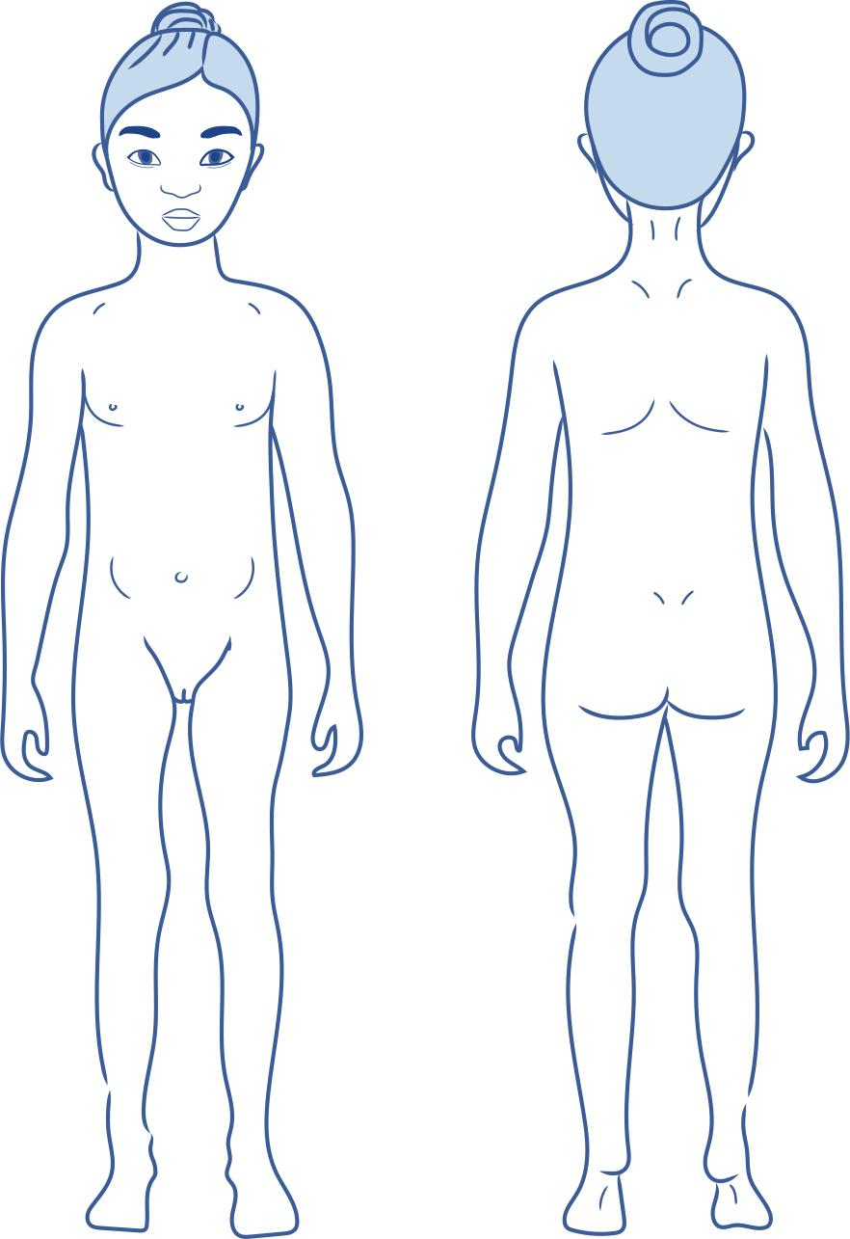
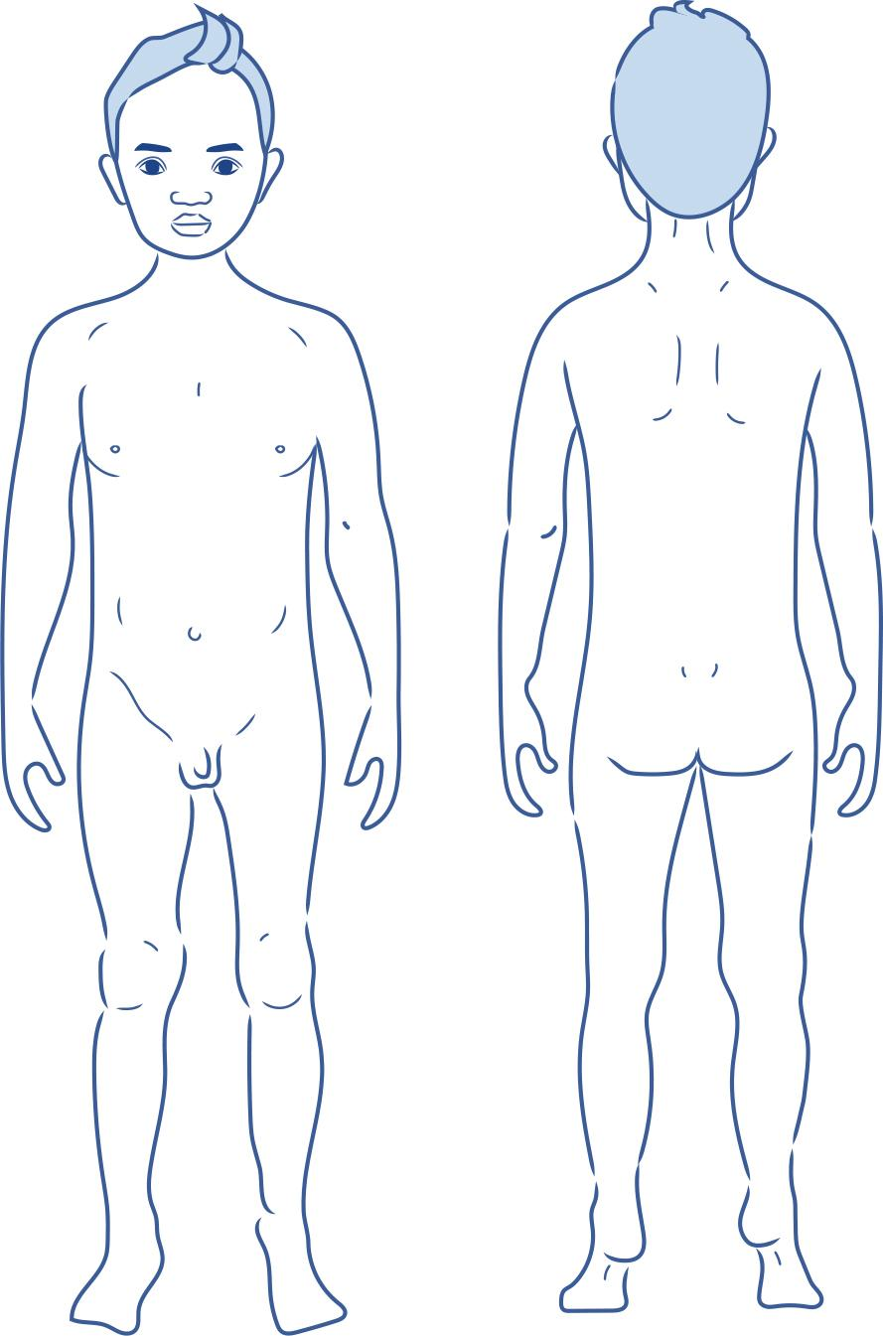

Teacher notes: What is sexual abuse? Alex and Uncle Danny scenario
As a class read through the Alex and Uncle Danny scenario and discuss the questions at the end of the scenario.
Part 1
Alex’s parents owned their own business and they had been really busy lately. It was good that their business was doing well because Alex’s parents seemed a lot happier, but it also meant that they had to work late sometimes. On these nights Uncle Danny would come to look after Alex.
Uncle Danny would make Alex something to eat, help with homework, play games, and help get Alex to bed on time.
Alex liked hanging out with Uncle Danny. Often Uncle Danny would bring something special for Alex like a new toy or a movie to watch.
Every night when it was time for bed Uncle Danny would read a book to Alex before saying goodnight. Uncle Danny always gave Alex a kiss goodnight on the forehead, just like Alex’s parents did.
One night, instead of reading a book, Uncle Danny showed Alex a magazine with pictures of naked men and women. Uncle Danny said it was ok to show Alex these pictures because they were special friends. Alex hadn’t seen a magazine like that before and thought it was funny. That night Uncle Danny kissed Alex goodnight on the lips before saying goodnight. Alex’s body felt a funny kind of hot.
Questions:
- How do you think Alex might be feeling about Uncle Danny? Examples include, confused, angry, scared, worried, mixed feelings, happy, special feelings, cared for, loved. Acknowledge that Alex might not have bad feelings about Uncle Danny. Different people will feel different ways in the same situation and that is ok.
- What did Uncle Danny do that was wrong? Emphasise that Uncle Danny showed Alex pictures of naked men and women and kissed Alex on the lips without permission.
- Did Alex do anything wrong? No.
- What were the warning signs that might indicate Alex was in an unsafe situation? Emphasise that a child being shown pictures of naked men and women is sexual abuse. Alex’s body also felt ‘a funny kind of hot’ which is a body signal.
- How could Alex use No-Go-Tell? Emphasise that Alex could say no, I don’t want you to kiss me and Alex could tell a trusted adult about the magazine and about the funny feeling from the kiss.
Part 2
Uncle Danny came to look after Alex again the next week. Uncle Danny showed Alex the magazine again, but this time Alex’s tummy felt squirmy. Uncle Danny said goodnight and kissed Alex on the lips, but Uncle Danny then reached inside Alex’s pyjama pants and touched Alex’s bottom. Alex felt uncomfortable about Uncle Danny doing this.
Alex told Uncle Danny to stop. Uncle Danny got angry and told Alex that this game was special, and Alex shouldn’t be so selfish. Uncle Danny then said goodnight, kissed Alex on the lips again and got up to leave. Uncle Danny told Alex that the game and the magazine were a secret, and if anyone found out Uncle Danny wouldn’t be able to bring Alex special toys anymore.
Questions:
- What type of abuse is this? Emphasise that this is sexual abuse.
- What do you think about Uncle Danny touching Alex’s bottom? Emphasise that it is not ok. Even though it didn’t hurt Alex, it is never ok for an adult to touch a child’s sexual parts this way.
- Did Alex do anything wrong? Emphasise that Alex didn’t do anything wrong.
- In what ways could this abuse affect Alex? Emphasise that this could affect Alex emotionally. Alex could feel bad about what happened and worry about it.
- What should someone do if something like this happens to them? Emphasise that people should keep saying no and tell them to stop. Tell their parents or another trusted adult and keep telling until someone listens. Emphasise that even though Uncle Danny stopped and left the room, Alex should still tell someone about what happened.
- Why might it be hard for Alex to tell someone? Emphasise it could be hard as Uncle Danny threatened not to bring Alex special toys anymore. Uncle Danny told Alex it was a secret. Alex still liked Uncle Danny. Alex might have mixed feelings about Uncle Danny and about what happened.
Discuss answers and explain to students that even though our bodies might not feel hurt or harm, if an older person shows sexual body parts to a child or stares at or touches a child’s sexual parts, it is sexual abuse.
All students are given a piece of paper for the question box. If students don’t have a question, they can write the answer to the following question:
- What could you do if someone made you feel uncomfortable?

Cards: Body language charades
Happy | Sad
Sad | Excited
Excited | Scared
Excited | Disappointed
Angry | Happy
Frustrated | Confident
Calm | Worried
Shocked | Sad
Bored | Excited
Relaxed | Worried

Worksheet: Bribes – Alex and Uncle Danny
Uncle Danny had bought a gift for Alex. Uncle Danny often bought Alex a gift for no reason and Alex felt excited, happy and special. Alex couldn’t wait to see what it was but Uncle Danny said they had to wait until after dinner.
When dinner had been eaten and everything was cleaned up Uncle Danny said Alex could watch some television. While Alex was watching a really great show, Uncle Danny came over with the gift. Alex’s body was all jumpy with excitement.
Uncle Danny told Alex to come closer and Uncle Danny put an arm around Alex. Uncle Danny asked Alex for a kiss before opening the gift. Alex quickly kissed Uncle Danny on the cheek but Uncle Danny said the kiss had to be on the lips. Alex had a funny feeling but they were friends so Alex kissed Uncle Danny on the lips.
Alex opened the gift and it was a toy that Alex had been wanting for a long time. Alex felt so happy. Uncle Danny said that because Alex had opened the gift they had to kiss again. This time Uncle Danny held Alex tight and kissed Alex for longer. Alex’s tummy began to feel all lumpy. Alex pushed away from Uncle Danny and told Uncle Danny to stop. Uncle Danny said that Alex was being selfish and the gifts would go to someone else if Alex wasn’t going to kiss Uncle Danny.

- Highlight any warning signs in the scenario. These could include behaviours such as threats, bribes and secrets, or body signals and emotional warning signs.
- Discuss the following questions:
- Was Uncle Danny's behaviour ok?
- What do we call Uncle Danny’s request that Alex kiss Uncle Danny on the lips? Why?
- Was this an ok bribe?
- What body signs did Alex have that might help her know this was an unsafe situation?
- What threat did Uncle Danny make?
- Is this behaviour ok?
- What should Alex do?

Cards: Bullying
Two of your friends had a fight. One of them found another group of friends to play with. They have all started staring at you, pointing at you and whispering and laughing each time they see you with your other friend. | Your friends start calling you names and forcing you to give them things. You try to stop them but they just snatch things from you.
A group of kids in your class are spreading hurtful rumours about you. Many kids now won’t play with you or even speak to you. Even your friends are starting to think they may be true. | A group of older kids from another school have been picking on younger students from your school. When they see a child walking home or waiting for the bus alone, they surround them, and take money, food, or toys. They sometimes throw things at them and threaten that they’ll hurt them.
Your classmates have been teasing you and calling you horrible names ever since you started to wear glasses. You didn’t want to wear glasses but you can’t see very well without them. Sometimes other kids try to take your glasses and you know you’d be in a lot of trouble if they got broken. | You had a fight with your friend and now none of your friends will include you. You have asked to play with some other kids at school but no one wants to let you join in. This has happened for a week and has only gotten worse.
Every time you and your friends go out to the oval to play, older students steal your ball and kick it away. They keep telling you that it’s their oval and to go away. | You‘re playing an online game and in the chat space you notice a few of your friends are calling someone horrible names. They are telling this person they are useless at the game and they should get off and play a different game. You start a private chat with this person and they tell you these people say these things to them all the time.
One of your classmates has been pushing younger students around and telling them they can’t play in the handball squares because  they are for the Year 3/4S.  They always throw the younger students tennis balls away when they come into the squares. You’ve noticed that this classmate threatens the younger students when they walk past. | Two of your friends have phones. You don’t have a phone and really wish you did. At a sleepover, one of your friends took a photo of you getting dressed and sent it to the other friend. You were embarrassed and asked them to delete the photo. They said they did but they really didn’t. From then on both of your friends started taking photos  of you when you aren’t expecting it and send them to each other and laugh.

Cards: Upstander Cards
You see a student being pushed by another student. You heard that this happened the day before too. The person being pushed looks scared and upset.

Answer the following questions:
- What could you do to help the person being bullied?
- What if the person doing the bullying was one of your friends? How could you stop the bullying?
A student is teasing a classmate because they have red hair. They call out ‘Ranga’ anytime they are near this person. When they’re in the playground their friends sometimes join in and laugh.

Answer the following questions:
- What could you do to help the person being bullied?
- What if you also had red hair and were younger than these students? Would you do anything differently?
A group of students play soccer at break times every day. One of the boys is continuously called ‘gay’ and is told they don’t know how to play soccer and to go and play with some dolls.

Answer the following questions:
- What could you do to help the person being bullied?
- What if you said something to the group and they started teasing you about being friends with the person being bullied? How could you stop the bullying?
A student is pushed against the wall by another student from an older grade who is much taller. You’ve seen the older student often ‘accidentally’ bump into the younger student. The older student steals the younger student’s bag and throws it up in a tree.

Answer the following questions:
- What could you do to help the person being bullied?
- What if the person doing the bullying had bullied you before? Would you do anything differently?
You were using the computers at school and everyone was supposed to be doing a project. You kept getting messages from other students in the class. They were talking about another student and calling them stupid and other names. You could see this person was getting nasty messages sent to them and was looking very upset. Two students were trying to get everyone to ignore this person at lunchtime so they’d have no one to play with.

Answer the following questions:
- What could you do to help the person being bullied?
- What if you told an adult about the bullying and nothing was done about it? How could you stop the bullying?
You had ridden to the park to meet some friends. When you got there you saw an older person that you knew from your street. This person started pushing your friend around and took their bike off them and rode away. As they rode past they stared at you.

Answer the following questions:
- What could you do to help the person being bullied?
- What if the person doing the bullying threatened you and told you to remember they knew where you lived? How could you stop the bullying?

Worksheet: Y-chart

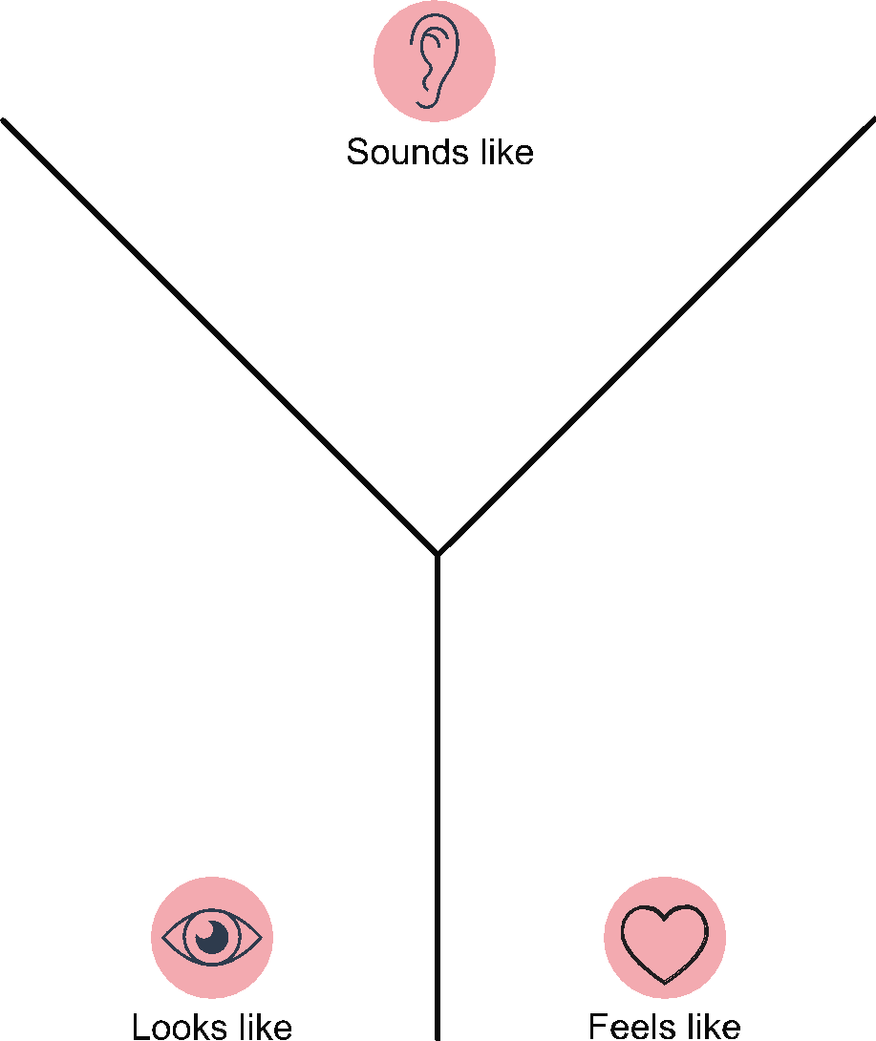

Teacher notes: Definition Match cards answer sheet
Match the word with its meaning.

abuse | Actions that cause hurt, harm or put someone in danger that are not accidental
bribes | To try to make someone do something by offering to give a gift, a favour, a special outing or special privileges.
bullying | Repeatedly using power in an unfair way to purposely hurt, harm or put someone in danger.
bystander | Someone who witnesses someone being bullied.
emotional abuse | Hurt or harm to our thoughts and feelings. Can include name calling, teasing, excluding, yelling at, put downs.
favour | Doing something for someone else.
gender stereotypes | An idea about what it means to be a boy or a girl or a woman or a man and how people will act, based on the group to which they belong.
gift | Something that is given to someone often to show appreciation or gratitude.
harm | Injury or damage to someone or something.
identity | Qualities of a person that make them who they are.
physical harm | Injury or damage to the body.
power | Being able to do something or make something happen or to make other people do something.
protection | Being kept as safe as possible from harm or danger.
respect | It means being caring and kind, and thinking and acting in a way that shows others you care about them and their feelings.
rights | Something you are entitled to have by law and that adults have a responsibility to protect.
safe | Protected from or not exposed to danger or risk.
safety rules | Rules to protect people from harm or injury.
sexual abuse | Looking at, showing or touching the sexual parts of the body without permission.
threats | Words or actions which are meant to force another person to do, or not do, something.
unsafe | In danger of being hurt or harmed.
upstander | Someone who takes action against bullying behaviour to protect someone who is being bullied.

Cards: Definition match
Match the word with its meaning.

abuse | bullying
bribes | bystander
emotional abuse | gender stereotypes
favour | gift
harm | physical harm
identity | power
protection | rights
respect | safe
safety rules | sexual abuse
threats | unsafe
upstander

Actions that cause hurt, harm or put someone in danger that are not accidental | Repeatedly using power in an unfair way to purposely hurt, harm or put someone in danger.
To try to make someone do something by offering to give a gift, a favour, a special outing or special privileges. | Someone who witnesses someone being bullied.
Hurt or harm to our thoughts and feelings. Can include name calling, teasing, excluding, yelling at, put downs. | An idea about what it means to be a boy or a girl or a woman or a man and how people will act, based on the group to which they belong.
Doing something for someone else. | Something that is given to someone often to show appreciation or gratitude.
Injury or damage to someone or something. | Being kept as safe as possible from harm or danger.
Qualities of a person that make them who they are. | It means being caring and kind,  and thinking and acting in a way that shows others you care about them and their feelings.
Injury or damage to the body. | Something you are entitled to  have by law and that adults have  a responsibility to protect.
Being able to do something or make something happen or to make other people do something. | Protected from or not exposed to danger or risk.
Rules to protect people from harm or injury. | In danger of being hurt or harmed.
Looking at, showing or touching the sexual parts of the body without permission. | Someone who takes action against bullying behaviour to protect someone who is being bullied.
Words or actions which are meant to force another person to do, or not do, something.

