PDHPE

Stage 1: Child Protection Education

Resources

Staying safe

Contents
Worksheet: Y-chart 2
Groups I belong to 3
Teacher notes: Strengths cards 5
Cards: Strengths 6
Emotion cards 10
Safe and unsafe situations 13
Persistence images 20
Cards: Body parts 21
Body parts images 22
Body outlines 24
No-go-tell 26
Copyright register 27

Worksheet: Y-chart

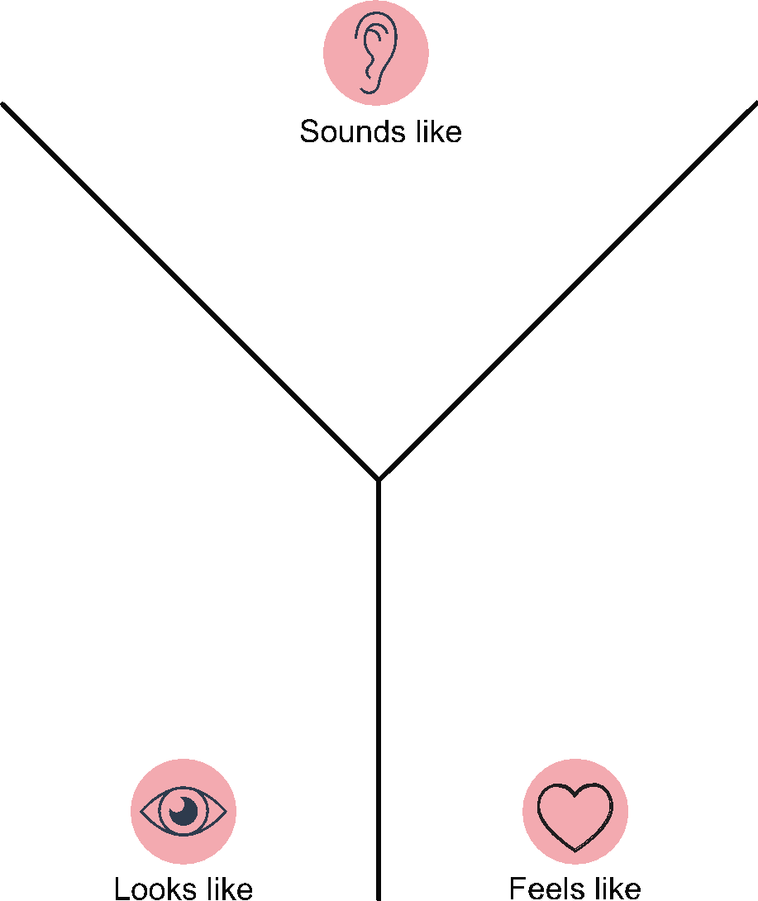

Groups I belong to

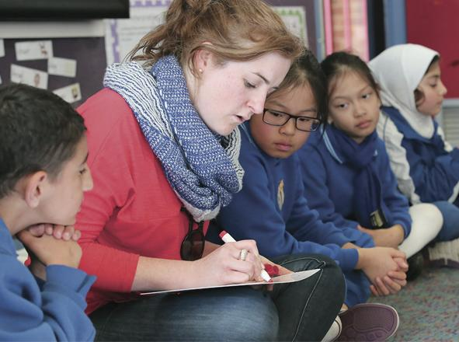 | 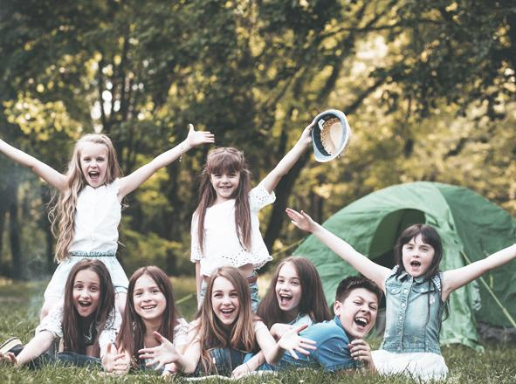  1
Classrooms | Close family friends
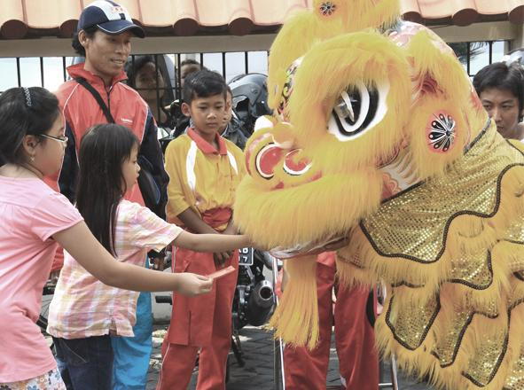2 | 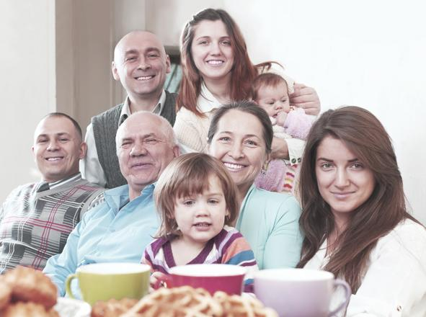  3
Cultural groups | Extended family
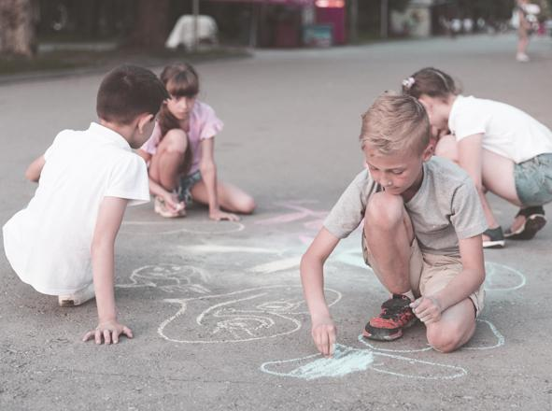  4 | 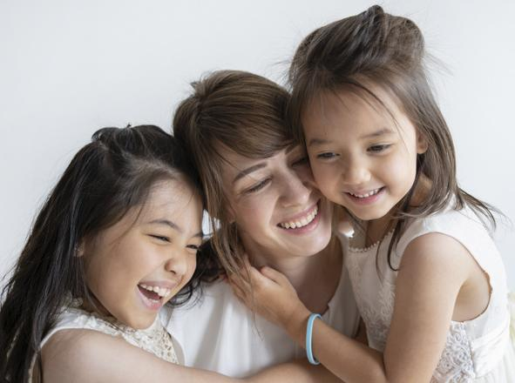  5
Hobby groups | Family
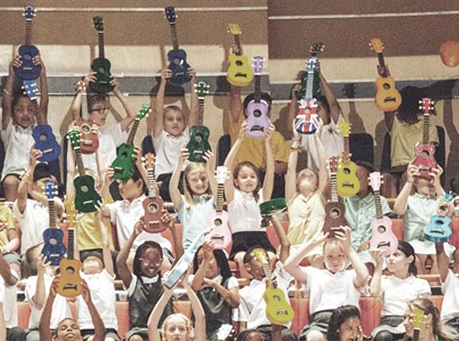  6 | 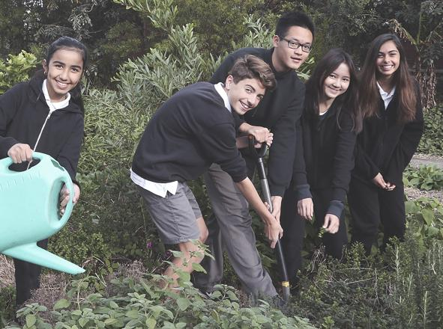
Music groups | Peer groups
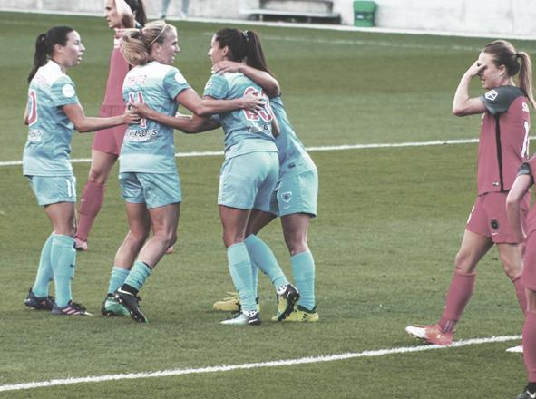  7 | 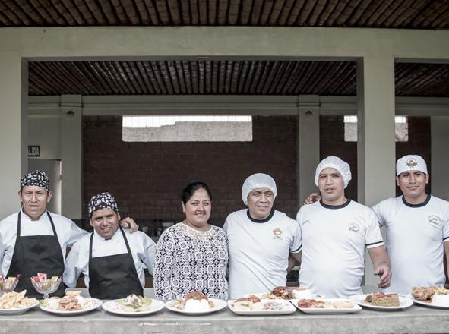8
Sports teams | Work groups

Teacher notes: Strengths cards
Strengths | Definition
Honest | You tell the truth even when it is not easy.
Funny | You try to cheer people up by making them laugh.
Forgiving | You accept others’ apologies.
Kind | You help others and use kind words.
A leader | You help your group work well together.
Brave | You are able to do what is important even when you feel scared.
Self-control | You can do what is important even if you don’t want to.
Notice others | You think of how others might be feeling.
Assertive | You are able to say things in a strong, clear and fair way.
Fair | You include everyone and you follow the rules.
Determined | You keep trying even when it gets hard.
Curious | You like to learn new things and ask questions.
Patient | You can wait for your turn even if it takes a while.
Generous | You are good at sharing and giving.
Creative | You like to come up with new ideas and new ways of doing things.
Persistent | You keep trying even if you fail.
Notice myself | You notice how you are feeling and how that makes you behave.
Good listener | You listen to others ideas and how they feel.

Cards: Strengths
Honest | Fair
Funny | Determined
Forgiving | Curious
Kind | Patient
A leader | Generous
Brave | Creative
Self-control | Persistent
Notice others | Notice myself
Assertive | Good listener

Honest  You tell the truth even when it is not easy. | Fair  You include everyone and you follow the rules.
Funny  You try to cheer people up by making them laugh. | Determined  You keep trying even when it gets hard.
Forgiving  You accept others’ apologies. | Curious  You like to learn new things and ask questions.
Kind  You help others and use kind words. | Patient  You can wait for your turn even if it takes a while.
A leader  You help your group work well together. | Generous  You are good at sharing and giving.
Brave  You are able to do what is important even when you feel scared. | Creative  You like to come up with new ideas and new ways of doing things.
Self-control  You can do what is important even if you  don’t want to. | Persistent  You keep trying even if you fail.
Notice others  You think of how others might be feeling. | Notice myself  You notice how you are feeling and how that makes you behave.
Assertive  You are able to say things in a strong, clear and  fair way. | Good listener  You listen to others ideas and how they feel.

Emotion cards

No feelings
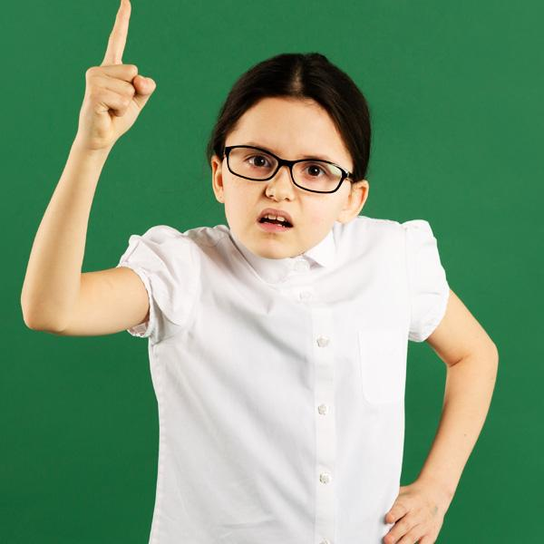36 | 37 | 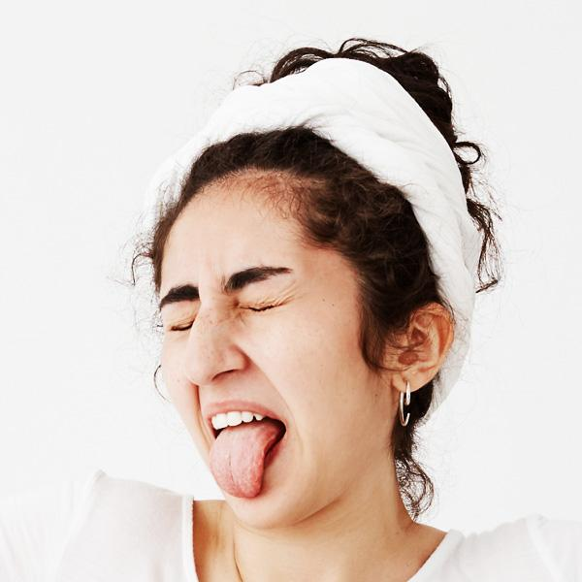38
Angry | Confused | Disgusted
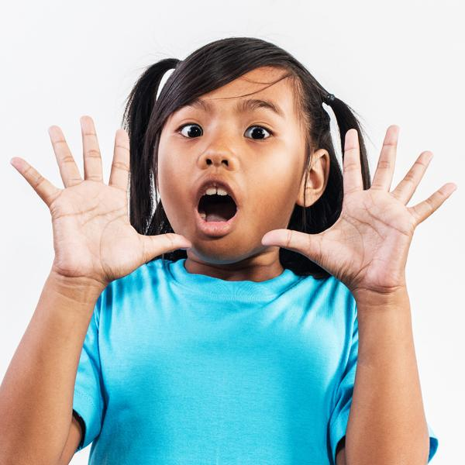39 | 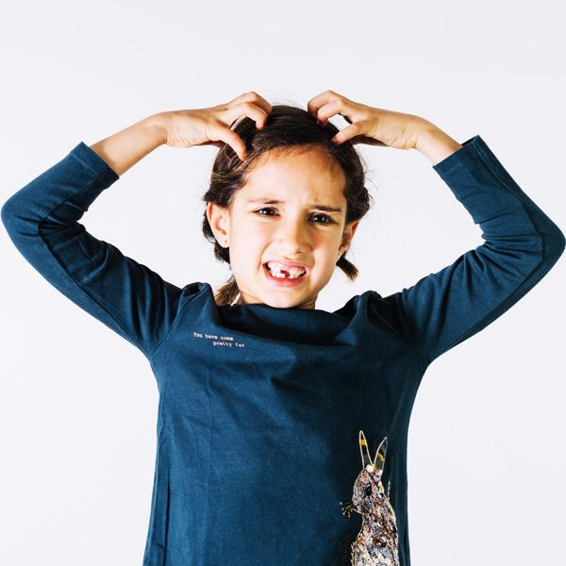40 | 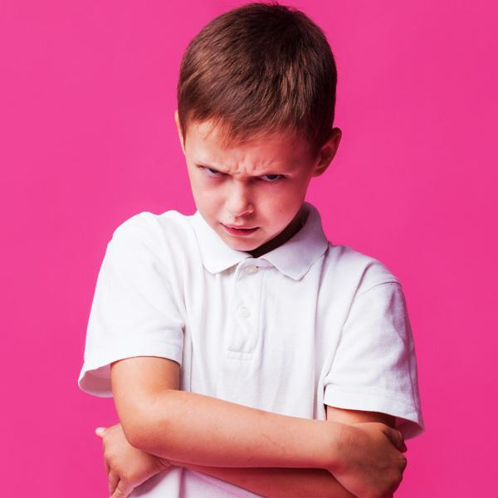41
Frightened, afraid, scared | Frustrated | Grumpy
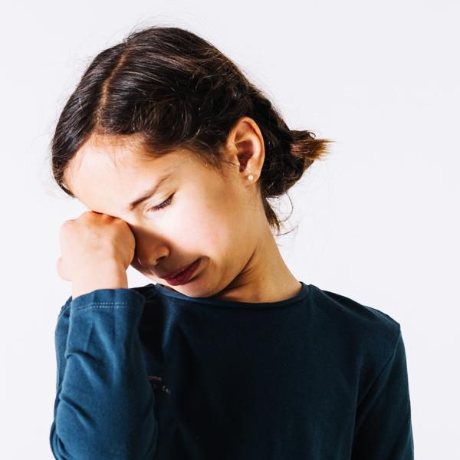42 | 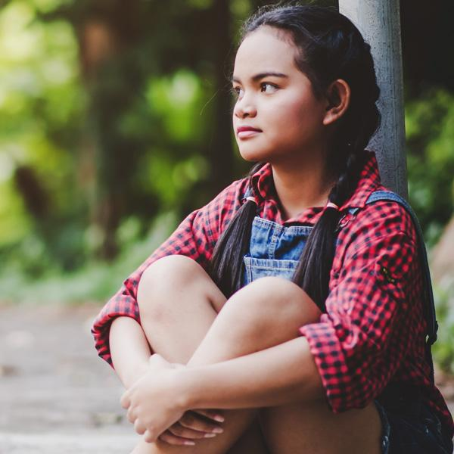43 | 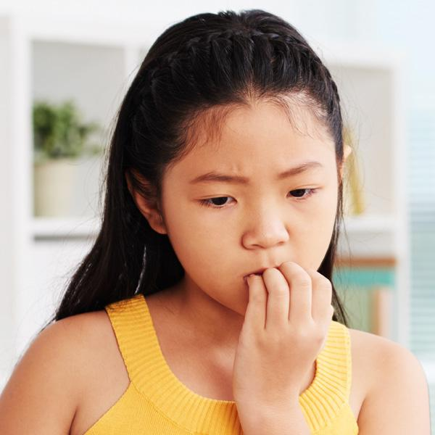44
Hurt | Lonely | Nervous
45 | 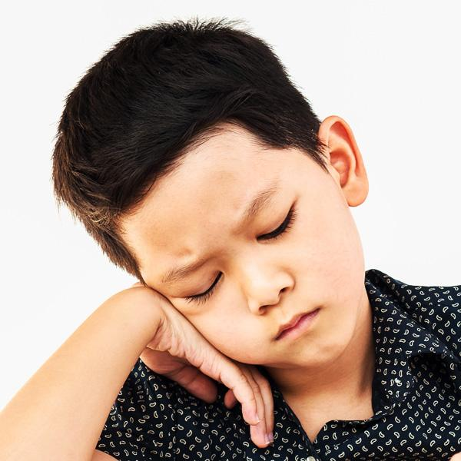46 | 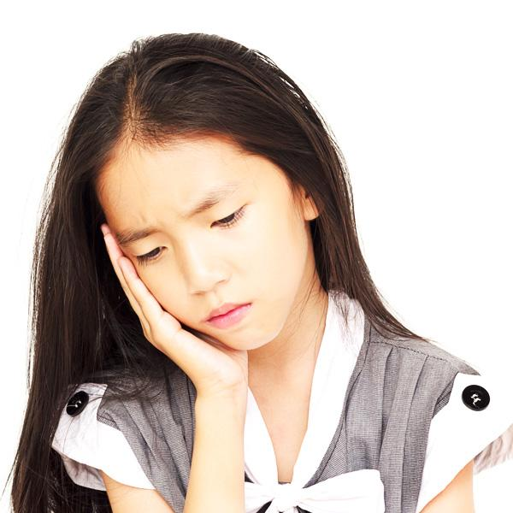47
Shocked | Unhappy, sad | Worried

Yes feelings

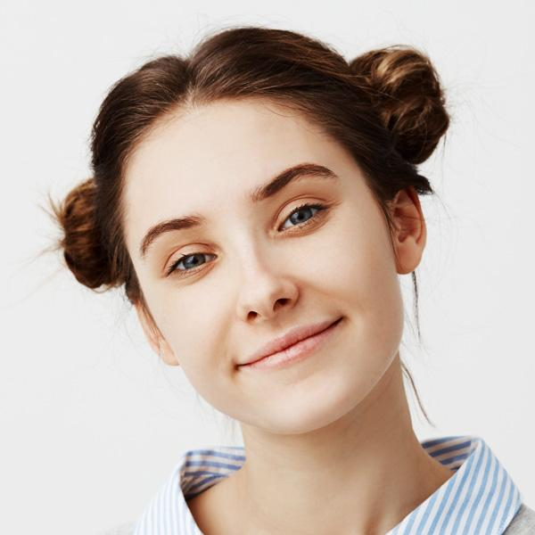48 | 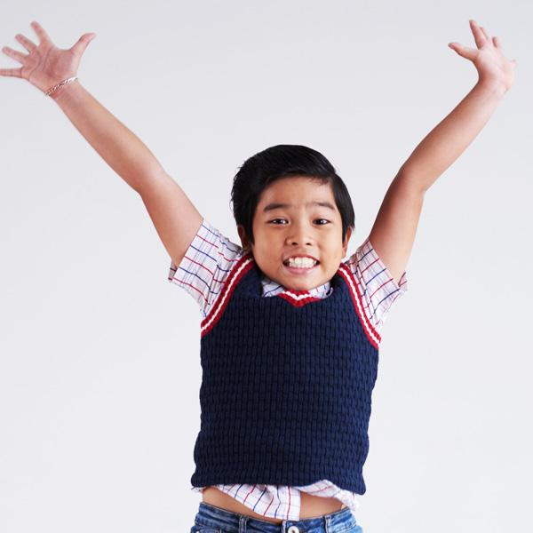49 | 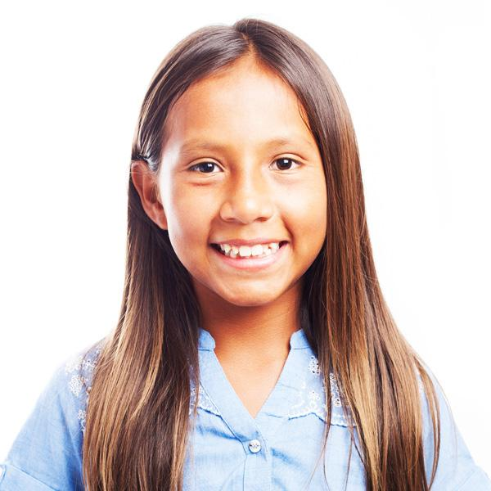50
Peaceful, calm | Excited | Happy, wonderful
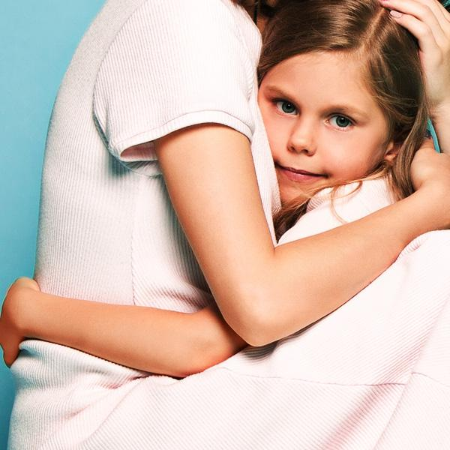51 | 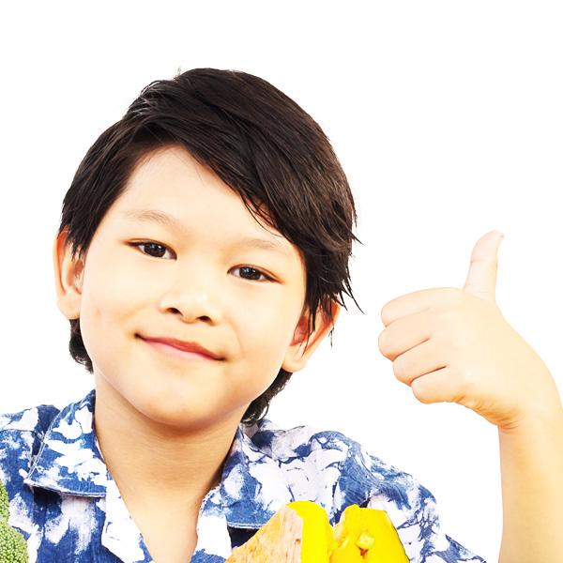52 | 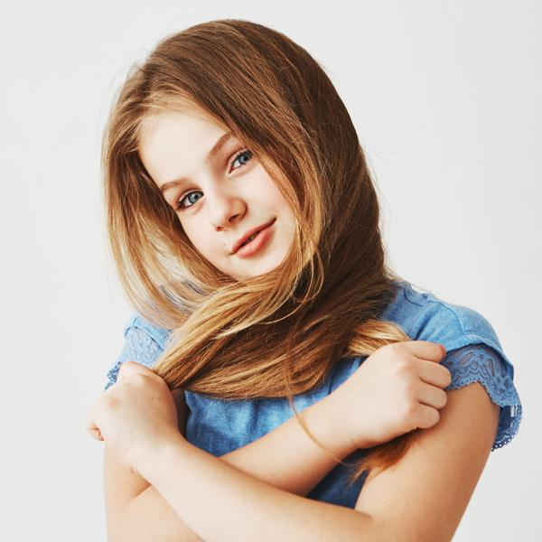53
Loved, safe | Proud | Shy
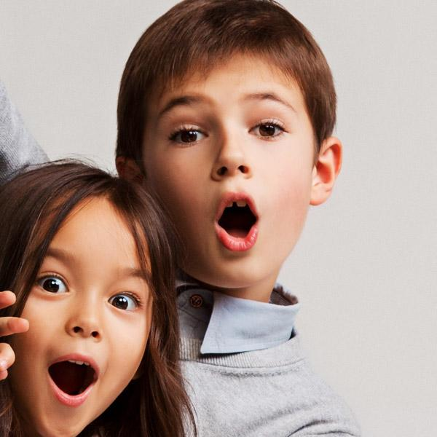54
Surprised

Safe and unsafe situations

Walking to school
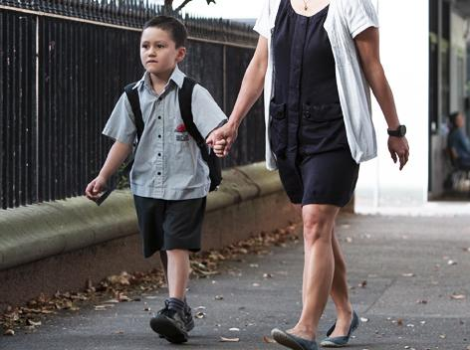  9 | 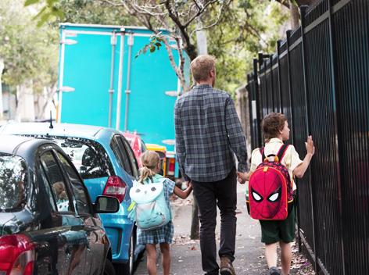  9
Walking to school | Walk on the footpath away from the road and hold an adult’s hand
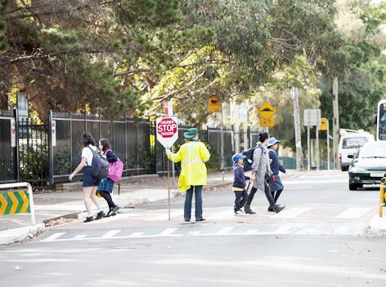10
Walk straight to school

Riding a bike
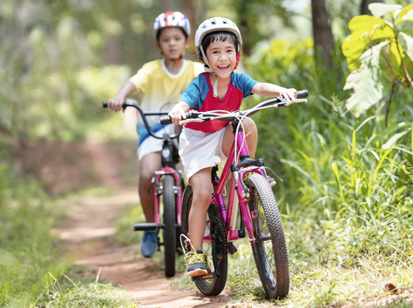  11 | 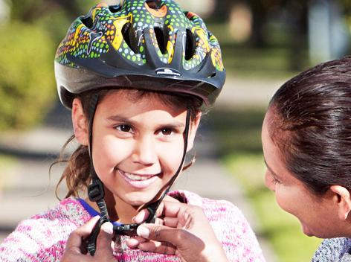  9
Riding a bike | Always wear a helmet
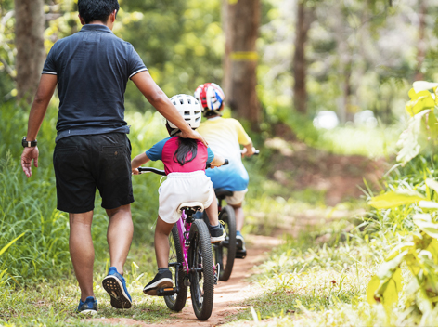  12 | 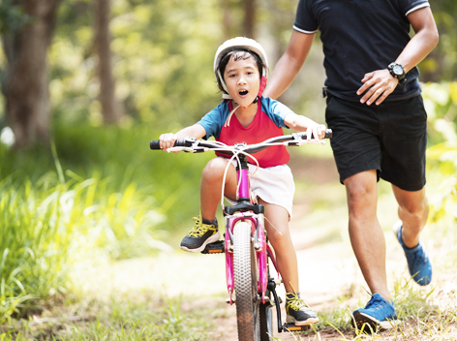  13
Ride your bike away from the road | Find a safe place to ride

Playing a game online
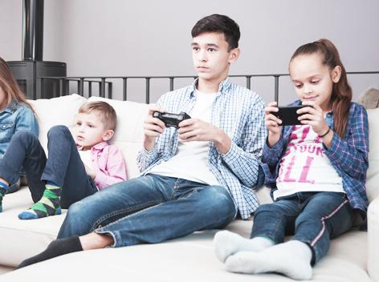  14 | 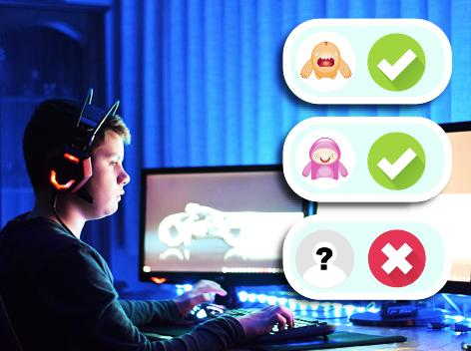  15
Playing a game online | Don’t accept people  you don’t know as friends
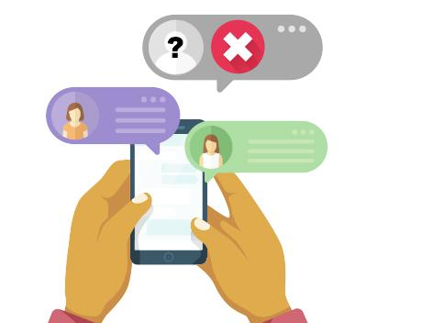  16 | 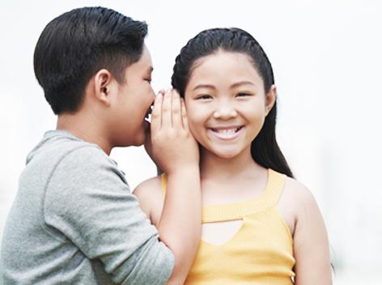  17
Don’t open messages from people you don’t know | Don’t share your password or personal information
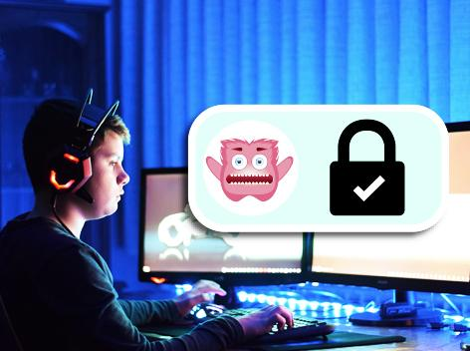
18
Keep your profile private

Cooking dinner
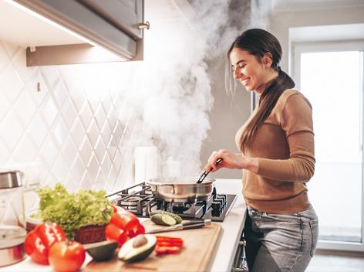  19 | 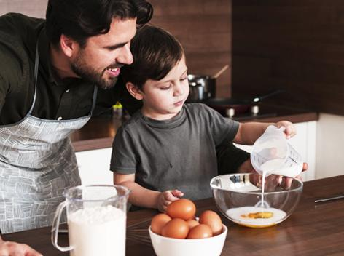  20
Cooking dinner | Cook with an adult
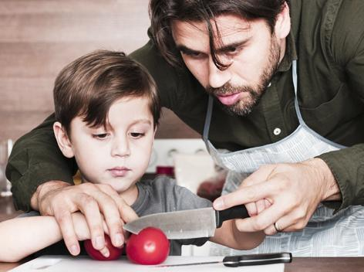  20 | 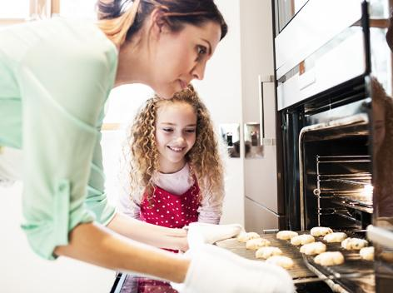  21
Get adults to do the cutting | Wear oven mitts
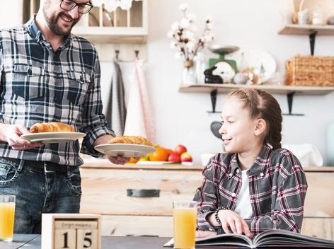  22 | 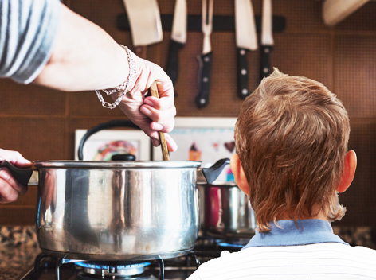  23
Stay out of the way | Don’t touch the stove

In a car or bus
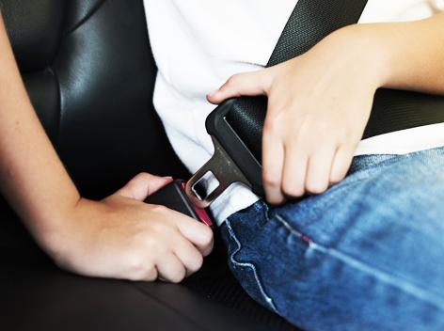  24 | 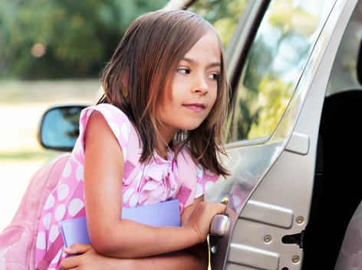  25
Always buckle up safely | Get in and out of the car  on the footpath side
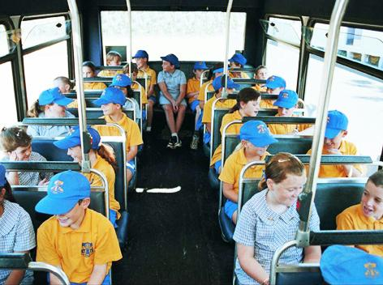  9 | 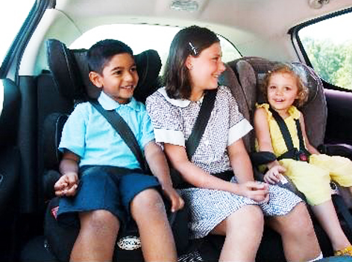  26
Don’t distract the driver | Stay in your seat

Crossing a road
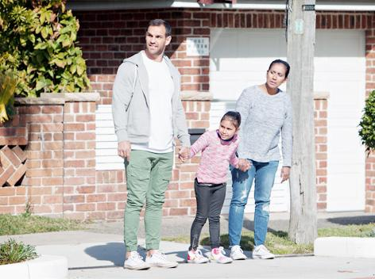  9 | 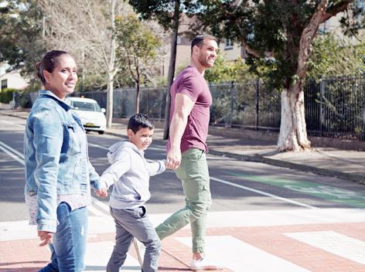  9
Crossing a road | Cross at the crossing
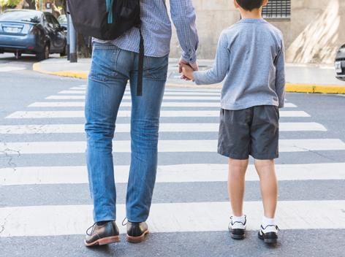  27 | 9
Hold an adult’s hand when you  cross the road | Use a safe place to walk across  the road with an adult
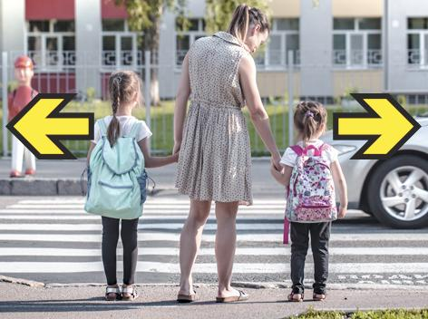
28
Stop! Look! Listen! Think! before crossing the road

Swimming at the beach or in a pool
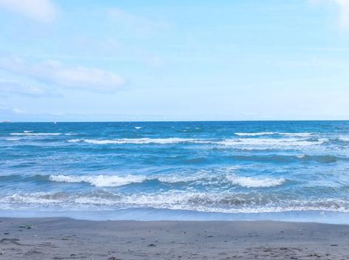  29 | 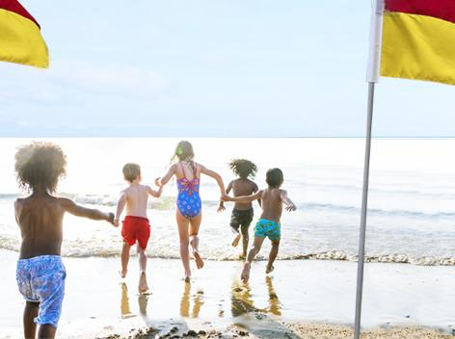  30
Swimming at the beach or pool | Swim between the flags
31 | 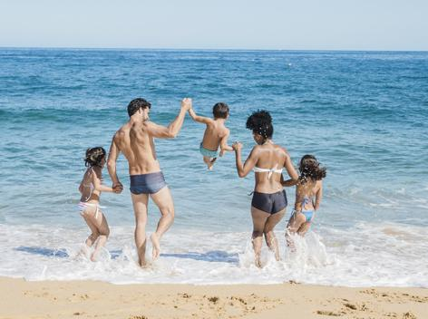  32
Have an adult watching you | Swim with an adult

Persistence images
Try | 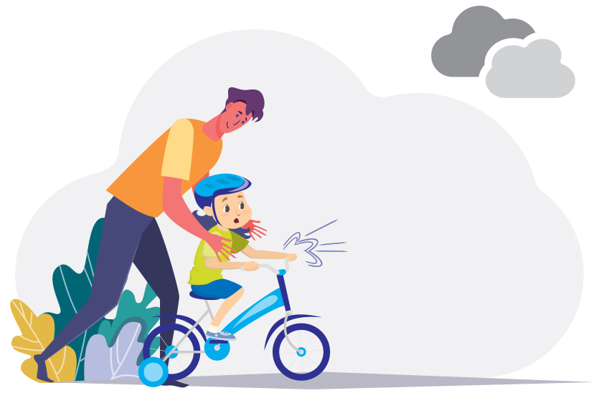33
Persist and succeed | 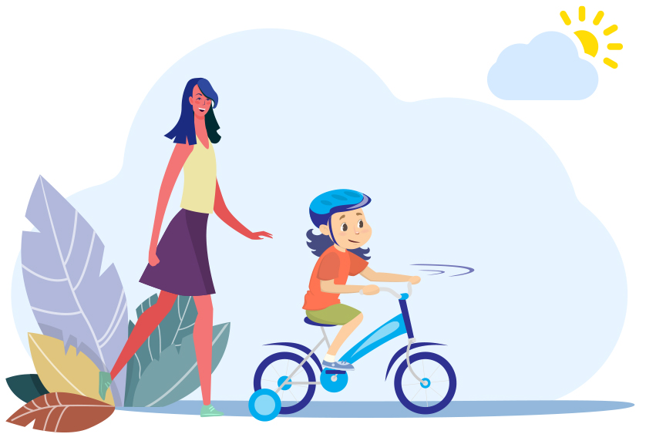34
 | 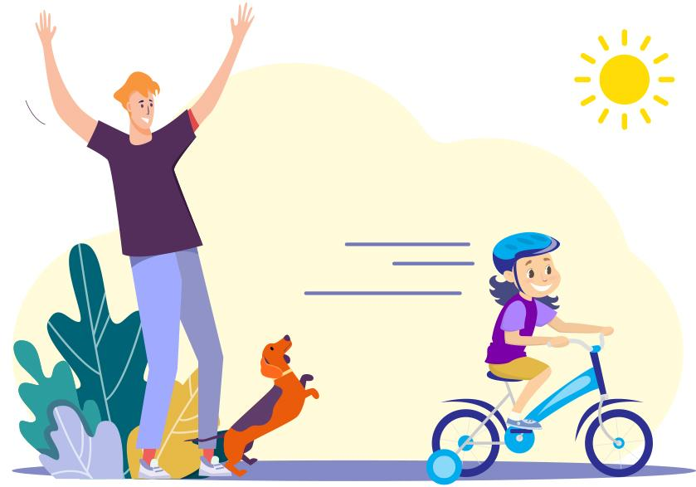35

Cards: Body parts
arms | ear | neck
elbows | eyes | thighs
face | feet | nipples
fingers | hands | breasts
head | knee | anus
legs | lips | bottom
mouth | nose | testicles
shoulder | toes | penis
vulva | vagina

Body parts images
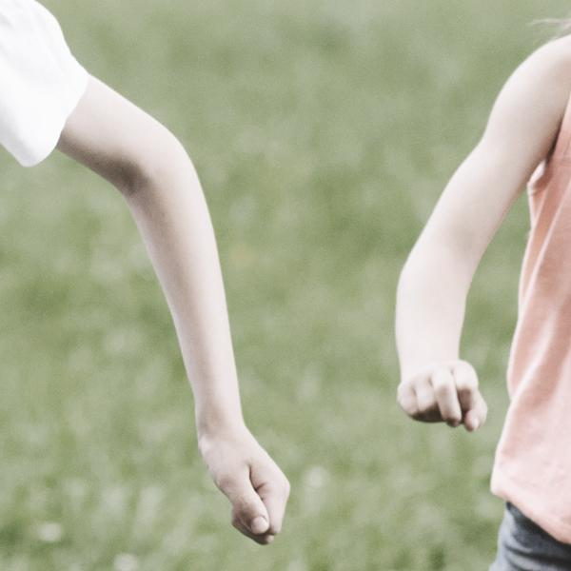 | 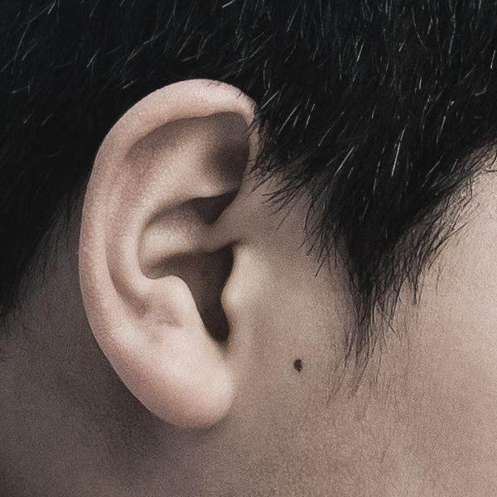 | 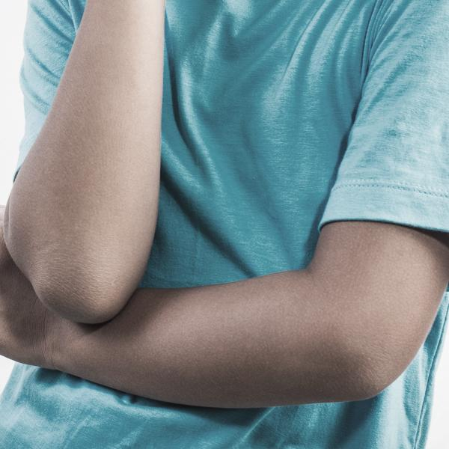
Arms | Ear | Elbows
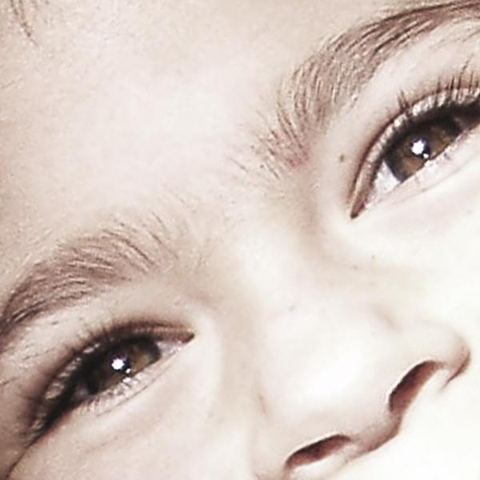 | 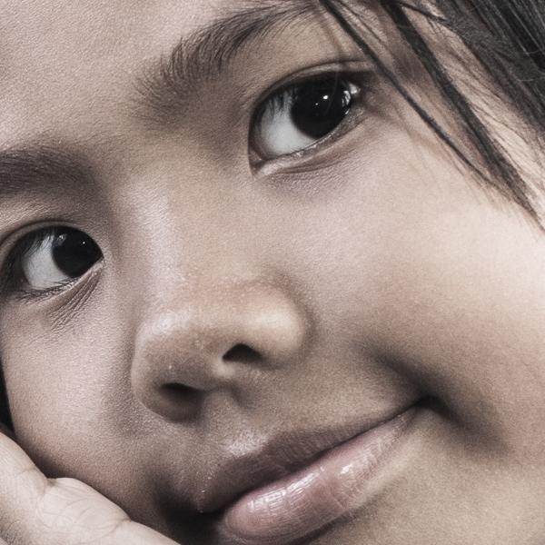 | 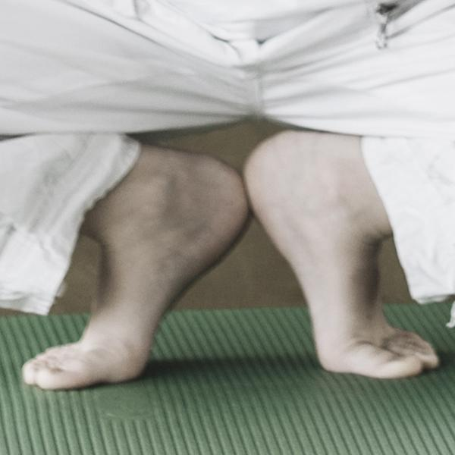
Eyes | Face | Feet
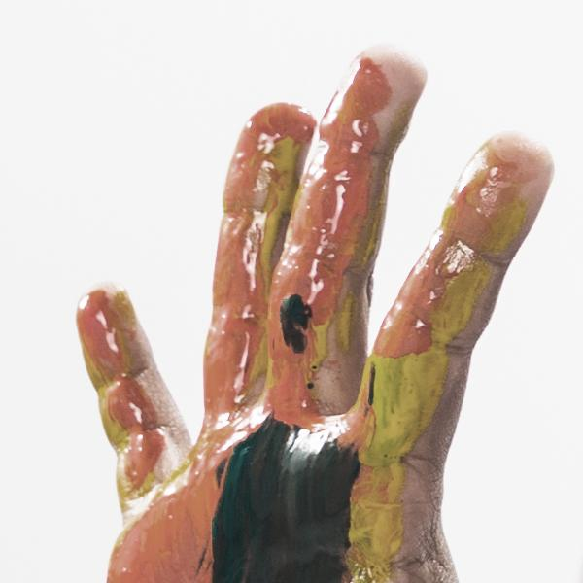 |  | 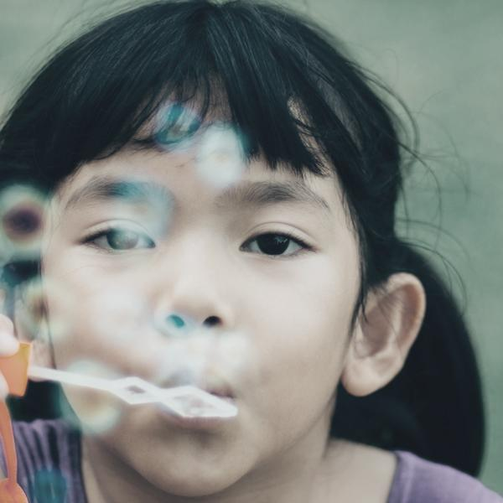
Fingers | Hands | Head
 |  | 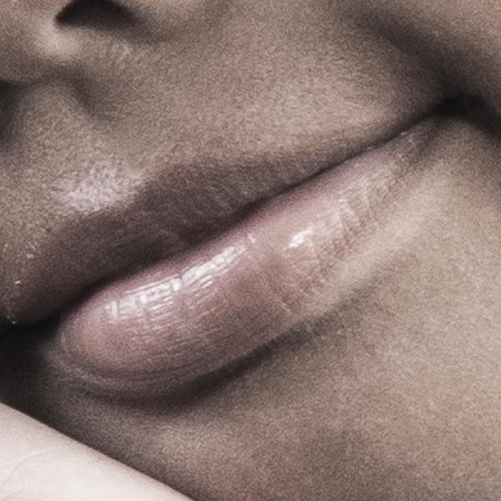
Knee | Legs | Lips
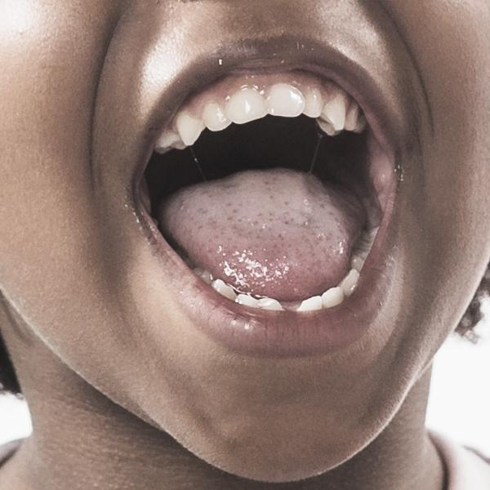 | 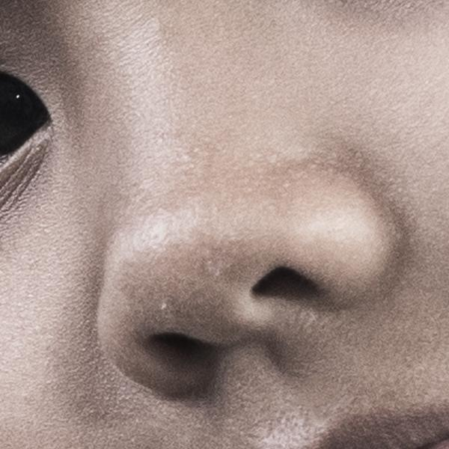 | 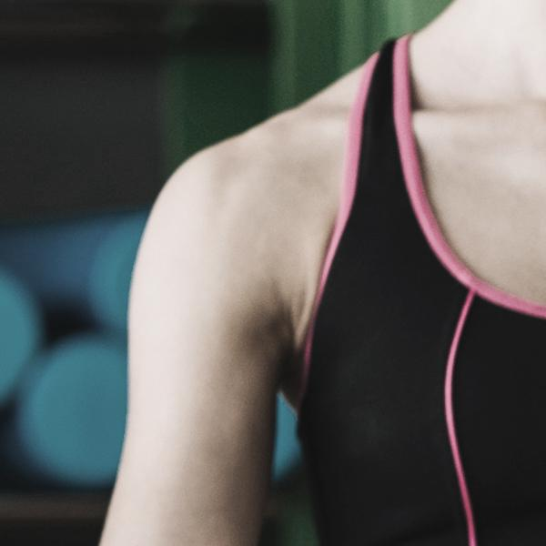
Mouth | Nose | Shoulder
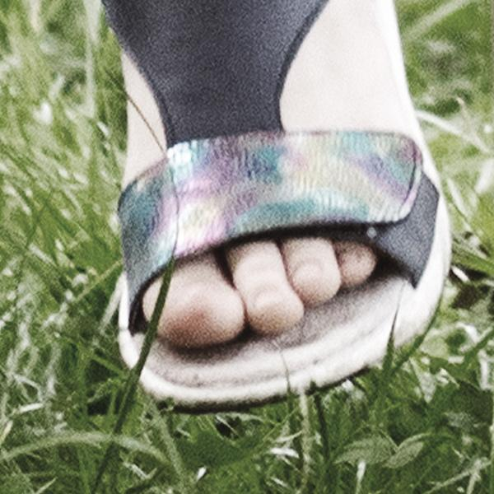
Toes
55

Body outlines
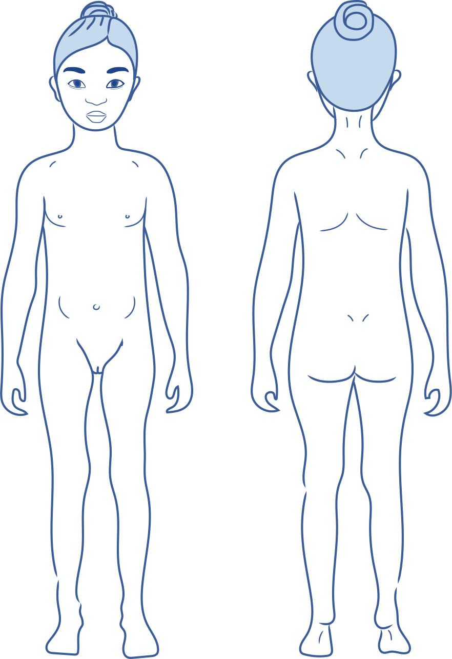
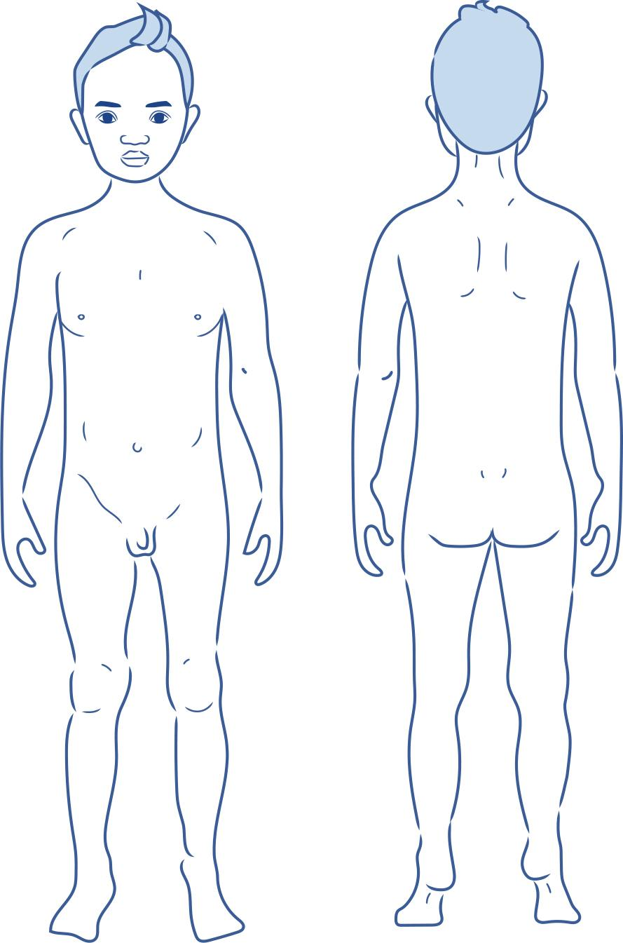

No-go-tell
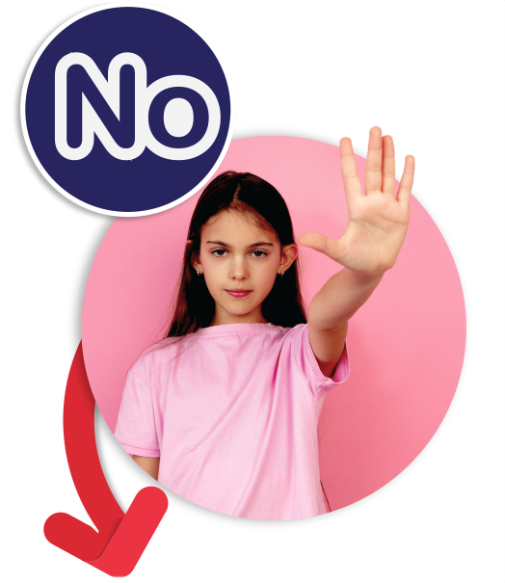56
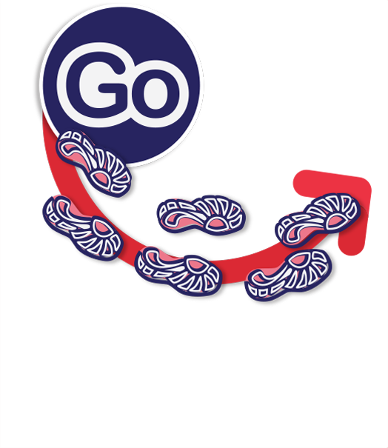57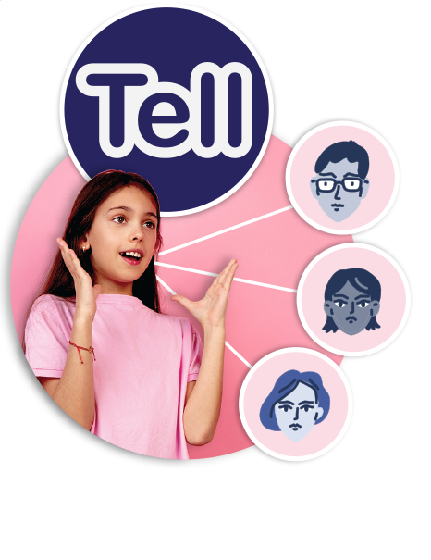58

Copyright register
- Close family friends: School photo created by senivpetro – www.freepik.com
- Cultural groups: WikimediaImages from Pixabay
- Extended family: People photo created by bearfotos – www.freepik.com
- Hobby groups: Kids photo created by freepik – www.freepik.com
- Family: School photo created by katemangostar – www.freepik.com
- Music groups: Nick Stafford from Pixabay
- Sports teams: Milton Galvan from Pixabay
- Work groups: csmy00 from Pixabay
- By Transport for NSW, Safety Town resource – https://www.safetytown.com.au/book-content/es1/image-gallery/pedestrian-safety-image-gallery/
- By Transport for NSW, Safety Town resource – https://www.safetytown.com.au/book-content/es1/image-gallery/pedestrian-safety-image-gallery/
- Riding a bike: School photo created by torwaiphoto – www.freepik.com
- Riding a bike: School photo created by torwaiphoto – www.freepik.com
- Riding a bike: School photo created by torwaiphoto – www.freepik.com
- Kids on couch: Designed by Freepik – www.freepik.com
- Profile of boy with monitors: Image by ExplorerBob from Pixabay
Avatars: Design vector created by macrovector – www.freepik.com
- Messeges: Designed by Freepik – www.freepik.com
Avatars: Design vector created by macrovector – www.freepik.com
- Don’t share personal info: Designed by pressfoto – www.freepik.com
- Profile of boy with monitors: Image by ExplorerBob from Pixabay
Avatars: Design vector created by macrovector – www.freepik.com
- Mum cooking at stove: Food photo created by senivpetro – www.freepik.com
- Cook with an adult: Food photo created by freepik – www.freepik.com
- Wear oven mitts: Food photo created by peoplecreations – www.freepik.com
- Stay out of the way: Book photo created by freepik – www.freepik.com
- Don’t touch stove: Mum cooking: Food photo created by freepik – www.freepik.com
Back of child’s head: School photo created by pressfoto – www.freepik.com
- Use a seatbelt: Designed by rawpixel.com – www.freepik.com
- Girl closing car door: Designed by Freepik – www.freepik.com
- Stay in your seat: By Transport for NSW, Safety Town resource – https://www.safetytown.com.au/book-content/es1/image-gallery/pedestrian-safety-image-gallery/
- Crossing roads: School photo created by pvproductions – www.freepik.com
- Look both ways before crossing: People photo created by freepik – www.freepik.com
- Swimming at the beach: Cloud photo created by wirestock – www.freepik.com
- Swim between flags: People photo created by rawpixel.com – www.freepik.com
- Parents and child at pool: People photo created by rawpixel.com – www.freepik.com
- Family at beach: Designed by Freepik – www.freepik.com
- Try: Designed by pch.vector – www.freepik.com
Weather icons: Designed by Titusurya – www.freepik.com
- Persist: "Designed by pch.vector – www.freepik.com
Weather icons: Designed by Titusurya – www.freepik.com
- Succeed: "Designed by pch.vector – www.freepik.com
Weather icons: Designed by Titusurya – www.freepik.com
- Angry: Education photo created by freepik – www.freepik.com
- Confused: People photo created by cookie_studio – www.freepik.com
- Disgusted: Woman photo created by cookie_studio – www.freepik.com
- Frightened: Kids photo created by freepik – www.freepik.com
- Frustrated: Girl photo created by freepik – www.freepik.com
- Grumpy: Designed by Freepik – www.freepik.com
- Sad/hurt: Girl photo created by freepik – www.freepik.com
- Lonely: People photo created by jcomp – www.freepik.com
- Nervous: Designed by pressfoto – www.freepik.com
- Shocked Designed by Freepik – www.freepik.com
- Unhappy: Designed by jcomp – www.freepik.com
- Worried: Designed by jcomp – www.freepik.com
- Peaceful/calm: Woman photo created by cookie_studio – www.freepik.com
- Excited: People photo created by jcomp – www.freepik.com
- Happy: For websites: Designed by Asier_Relampagoestudio – www.freepik.com
- Loved/safe: Family photo created by master1305 – www.freepik.com
- Proud: Designed by jcomp – www.freepik.com
- Shy: For websites: Designed by cookie_studio – www.freepik.com
- Surprised: People photo created by drobotdean – www.freepik.com
- Body parts: Kids photo created by freepik – www.freepik.com
- No girl: People photo created by master1305 – www.freepik.com
- Go footprints: Background vector created by macrovector_official – www.freepik.com
- Tell girl: People photo created by master1305 – www.freepik.com
Trusted people headshots: People vector created by freepik – www.freepik.com

